***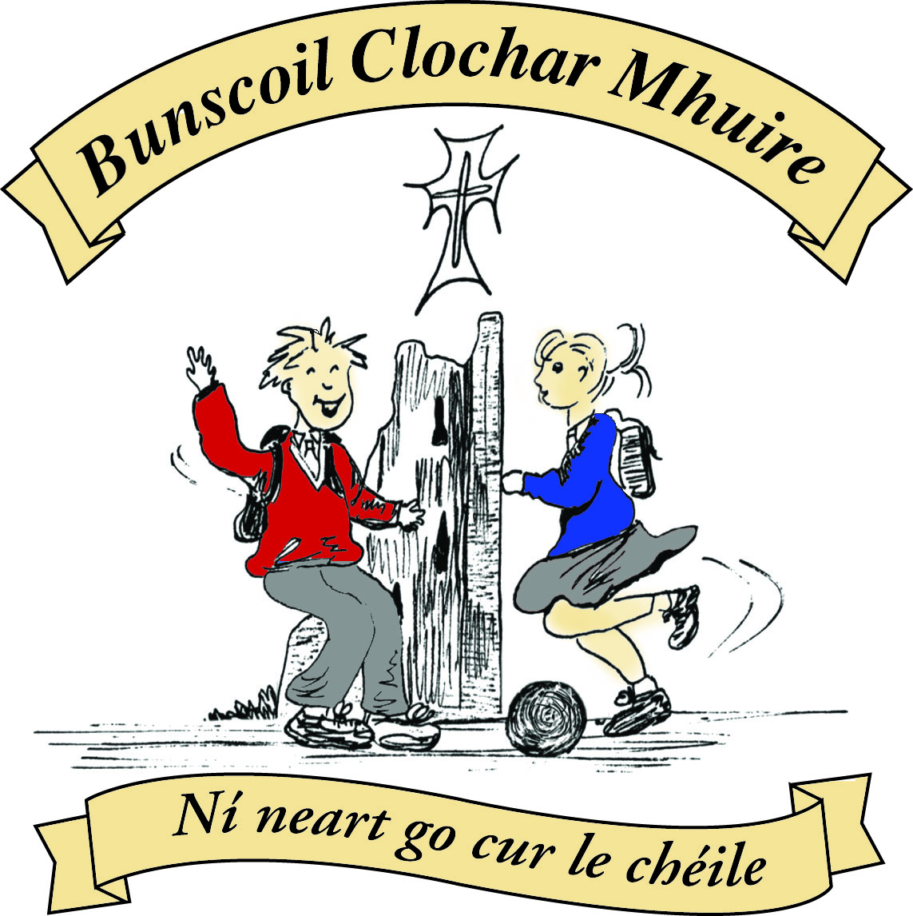* St Mary’s Convent Primary School**

***Bunscoil Clochar Mhuire***

***Trim, Co. Meath.  
Fón: (046) 9431919 ⦁ Faics: (046) 9437942  
Ríomhphost:*** [***marystrim@eircom.net***](mailto:marystrim@eircom.net) ***⦁ Website:*** [***www.stmarystrim.ie***](http://www.stmarystrim.ie) ***Uimhir Rolla: 16646O***

Awarded Green Flag  
June ‘05/’07/11/13

***Imlitir 9***

23rd October, 2017

***Every Day Counts at St Mary’s Convent Primary School***

***18th October - 20th October 2017***

|  |  |  |  |  |  |  |  |
| --- | --- | --- | --- | --- | --- | --- | --- |
| **Room** | **Attendance** | **Room** | **Attendance** | **Room** | **Attendance** | **Room** | **Attendance** |
| 01 | 96.6% | **08** | **100%** | 16 | 98.8% | 26 | 95.1% |
| 02 | 96.6% | 09 | 92.3% | 17 | 98.3% | **27** | **100%** |
| 03 | 96.6% | 10 | 92.3% | 18 | 98.8% | 30 | 96% |
| 04 | 97.6% | **12** | **100%** | 19 | 98.8% | 31 | 94.7% |
| 05 | 86.7% | 13 | 97.9% | 20 | 93.6% |  |  |
| 06 | 93.3% | 14 | 95.2% | 23 & 24 | 98.5% |  |  |
| 07 | 98.6% | 15 | 96.6% |  |  |  |  |

*Well done to rooms 8, 12 & 27 on having full attendance last week. Their teachers will let them know there reward. Please note that notification in writing, with the reason for all absences, to the teacher is required. A letter or note in the homework journal will suffice.*

A chairde,

The Readalong, this year, starts when we return form Mid-term. Sheets will be given out this week with an explanatory letter. It will NOT be a sponsored event this year due to Powerball.

|  |  |  |
| --- | --- | --- |
| TIME | TUESDAY NOVEMBER 7th | WEDNESDAY NOVEMBER 8th |
| **9.30-10.00** | Rooms 23, 24 & 27 L.U. & 5th | Room 19 4th Class |
| **10.00-10.30** | **Room 31 6th Class** | **Room 26 5th Class** |
| **10.30-11.00** | **Room 18 3rd Class** | **Room 16 3rd Class** |
| **11.15-11-45** | **Room 20 4th Class** | **Room 12 1st Class** |
| **11.45-12.15** | **Room 14 2nd Class** | **Room 15 2nd Class** |
| **1.00-1.30** | **Room 13 1st Class** | **Room 30 6th Class** |
| **1.30- 2.30** | **Rooms 1, 2, 3 & 4**  **Junior Infants**  **(with their parents)** | **Rooms 5, 6, 7 & 8**  **Senior Infants**  **(with their parents)** |
| **2.30-3.00** | **Rooms 9 & 10 1st Classes** | **Pupils with money from any classes** |
| **3.00-4.00** | *Open to the public* | *Open to the public* |

Powerball prizes will be given out tomorrow (Tuesday) at going-home time. The final profit made for our MUGA Fund was €5,554.50, bringing our overall total to €84,894.11. Fantastic! Thanks again for all your efforts.

**Book Fair Timetable**

St*Mary’s Annual School Book Fair will take place after the midterm on* ***Tuesday, 7th*** *and* ***Wednesday, 8th of November****.*

*The school runs the Book Fair, in conjunction with our local bookshop, Antonia’s Bookstore. Antonia kindly donates 20% of her book sales back to the school in the form of books and resources for our classrooms and our school library. We greatly appreciate your support and, as November is our Reading Month, the Book Fair is a good opportunity to encourage and develop more reading in the home and in the school.*

*The* ***average price*** *per book at the Book Fair will be €8 approx. but there will be a selection of books on special offer, at a lower price and of course, some more expensive books too.*

***Parents/guardians of children******in Junior and Senior Infants need to******collect their children from their classes, at their allocated times****, and* ***bring them to the Book Fair, if they wish them to attend****. Junior and Senior Infant pupils are invited to bring their teddies with them to the Book Fair for Story Time.*

*Many thanks for your continued support of our Book Fair.*

*M. O’Hare*

***Computer Room:*** *Students are still hard at work participating in Mangahigh. This is an online site that allows students to take up Maths challenges amongst each other online. There is great excitement amongst the students and now we are waiting to see if a school from elsewhere in the world is going to challenge us to a Fai-To competition. Debby Walsh*

**Parent Teacher Meetings** take place on Tuesday 21st and Wednesdays 22nd from 3.00 to 5.30. School closes on both days @ 2.45. Please make the necessary arrangements. Please contact teacher immediately, if you have not got an appointment.

Finally, school closes for the Mid-term Break on Friday and re-opens on Monday November 6th.

Wishing everyone an enjoyable break

Mise le meas,



Cóilín Ó Coigligh, Príomh Oide.

**Green News**

**Community News**

***Nathanna na Seachtaine:*** *Is maith liom Oíche Shamhna!*

***Seanfhocal na Míosa:*** *Níl aon tinteán mar do thinteán féin* (There's no place like home!)

**Dates to Remember**

**Meitheal:** Every Tuesday morning 9.30-10.30.

**Mini-Rounders**: 3rd and 4th Classes - Mondays 3-4pm,

**Rounders**: 5th and 6th Classes - Mondays 3-4pm,

**Drama Club:** Every Thursday 3-4pm 4th – 6th Class

**Banna: Every Tuesday 3 – 4 pm 2nd – 6th Class**

**2nd Class finish at 3.30 until after the Halloween Break**

**Communion: Saturday 5th May @ 11.00**

**Confirmation: Saturday 10th Feb @ 11.00**

**Green News**

*‘Let us say ‘no to an economy of exclusion and inequality, where money rules, rather than service. That economy excludes. That economy destroys Mother Earth’ (Pope Francis)*

It is almost Mid-term. Time is flying! We have launched our new Green Theme which is Global Citizenship- Energy. A global citizen cares passionately about others and the world they live in. An active global citizen takes action to support causes they believe in. Here at St Mary’s we are actively trying to care for our world and our immediate surroundings. We start small but our actions will hopefully have far-reaching effects.

WOW continues every Wednesday. Meet up at Mornington House or at the Matchbox at 9 am. The teachers will escort the pupils to the school from there. Cycling (COW) will resume in the spring.

Recycling continues at St Mary’s. We accept batteries, ink cartridges, mobile phones, card, toilet rolls, cans, footwear and postage stamps. Many charities benefit from our recycling and it is a great habit to cultivate in our pupils.

Our Siopa Glas will be held in November which will go towards funding the school bus for the Flamboyant Special needs school in Zambia. When she visited our school last year, Sr Andrea spoke passionately about the difference the bus has made to the little African children with Special needs, who had no chance of an education until it was provided. If there are any toys or books you are finished with, please keep our Siopa Glas in mind. Remember ‘your junk may be someone else’s treasure!’

Wishing you all a very happy, safe and ‘green’ midterm break!

***Remember Green is cool at home, at school and around the globe!***

St Mary’s Parents’ Association

Many thanks to all who helped with the Christmas Card Templates on Friday last. The artwork this year was lovely to see. Well done to all who participated. We are looking forward now to receiving the sample cards after the mid-term.

As we are back into the swing of school we are also back into the season of unwelcome visitors! The little bugs that leave us all scratching! Nits are nothing to be ashamed about and are a community problem.........they don’t discriminate when looking for hair to infest! So we have included some tips and facts to help minimise the risk ☺

**TIPS & FACTS FOR CATCHING AND TREATING HEAD LICE & EGGS**

* **Nits or eggs are sometimes hard to tell apart from dry scalp. You need to see if they easily fall from hair. If you find they are attached and need to be pulled out along the hair, then this is an egg or nit.**
* **53% of people who have them don’t itch** and if your child doesn’t itch you probably don’t look. To avoid getting caught out do a weekly or fortnightly check with a nit comb so you can catch them early.
* To break this cycle you have to **keep clearing both the nits as well as the lice out of the hair**, day after day. If not, the nits hatch, mature, mate, they lay eggs, those eggs mature, hatch and so on.
* The **average infestation is about 20 lice.** During their 30 day life span, the female louse lays between 5 and 10 nits (eggs) each day, so the issue can **easily escalate to hundreds, and even thousands. As females do not need to mate again this process will keep repeating!**
* **Although it may be stated on the box, eggs/nits are not always killed by treatments or removed with the combs. Even if there are only a couple of eggs left in hair this can cause another outbreak.**

**Irish Pharmacy Union - Prevention and Cure:**

1. **Check children’s hair for lice regularly, ideally twice a week**. Use a wet comb made for the purpose. Combing through wet hair makes the process easier. Good light is important.
2. **Check close to the scalp, behind the ears, around the nape of the neck, top of the head and under the fringe.**
3. **Treat the hair only if live lice or unhatched eggs are present**. Treat the child and other infected family members as soon as possible. Always ask your pharmacist for advice on the most appropriate treatment to use.
4. **Inform**the school, contacts and friends when your child has head lice. The school can then inform other parents that there is an outbreak, so everyone can check and treat their own children.
5. **Head Lice - The Facts: [If going the chemical treatment route]…always follow the instructions** on the treatment pack and any advice given by your pharmacist. Products used to treat head lice do not prevent the infection from occurring and should never be used ‘just in case’.

**Life cycle of Head Lice:**

* Nits, the eggs, take **seven to 11 days to mature** and hatch.
* The baby louse take **nine to 12 days to grow into an adult**. A fully grown adult louse is the size of a sesame seed.
* Once an adult, it needs to **find a mate**.
* **24 hours after pairing the female lays her first eggs** – and then keeps laying them day after day, after day, after day.
* **Head lice die** if they don't have contact to **fresh blood supply** from the scalp within two days.

Regardless of all the differing opinions on how to treat head lice, one thing is unanomous, you need to comb, comb and comb again! If you treat naturally or with chemicals, you need to retreat in 7 days and then comb wet hair every 2-3 days until all eggs are completely gone.

You can then use some preventative measures to minimize reinfection. Tea Tree shampoos, conditioners, sprays and hair bobbins are available in pharmacies. You can also mix tea tree oil (3-4 drops) in a spray bottle filled with water, and spray the hair in the morning. Try to tie hair up or back so it minimizes contact and advise your kids not to share hair accessories, brushes or combs.

Dates for Your Diary:

**October 27th**: Halloween Bun Sale. All children/helpers are invited to dress up for the event. **To coincide with the Green Flag initiative in the school we are asking that all children return to the “good old days” and make their costumes from recycled materials. No Onesies to be worn on the day especially for those in Junior Infants.** Hopefully it will be a fun filled day in school for all! This year we are asking pupils from Junior Infants, 3rd Class and 4th Class to bake for the sale. All children from these classes who bake for the event will be entered into a class draw for a 10euro Voucher for Smyths. A list of Do’s and Don’ts for the bakers is printed below. For those parents/guardians who have volunteered to help please come to the hall as early as you can so we can get tables set up and take names for the draw for vouchers. We hope to get started then at 9.30am.

**Early November:** Sample Christmas cards to be given to each child along with order form.

**November 21st**: Parents Association meeting at 7.30pm in the Staffroom. All Parents/Guardians and friends of the school welcome to attend.

<https://www.facebook.com/stmarysparentsassoc/>

Halloween Bun Sale

**Tips for the bakers;**

**Do's**

Go straight to the hall from 9am onwards with your buns and the Childs name will be taken down for the raffle.

Buns, biscuits, and bars are recommended.

Label any special dietary buns/biscuits and hand them in separately.

Cereal boxes with one side cut as a flap/lid and inside covered in tin foil make great boxes to send buns in and can be disposed of after.

For those who send in tubs, please ensure names are on the boxes, so they can be easily identified.

**Don'ts**

Send in whole cakes, as these can be difficult to cut.

Fresh cream not recommended, as these can be messy and buns are taken away in plastic bags.

Due to the presence of nut allergies in the school, Please do not send in buns/biscuits containing nuts.

Many thanks for your continued support.

Caroline Smith

Secretary

**Community Notices**

**Homework Club** in St Mary’s for children from 1st – 6th Classes. Application Forms are available from Ms Conaty Room 11 or Ms Lynch Room 31.

**Limelight Theatrics** - Performance Singing/Musical Theatre classes.  *Tuesday evening 6.15pm to 7.15pm (Under 12's)  & 7.30pm to 8.30pm (Over 12's) Wednesday 7.15pm to 8.15pm (mixed)

**Go Bounce - bouncy castle hire - 0868398099.** Don't delay, book today to avoid disappointment in May.

Now taking bookings for Holy Communions 2018. Book now and you'll have one less thing to worry about in the run up to the big day. Check out our castles on  [Www.Facebook.com/GoBounceMeath](http://www.facebook.com/GoBounceMeath) or [www.GoBounce.ie](http://www.gobounce.ie/) or call us on 086-8398099

**DRAMA CLASSES**:  Tuesdays  5.15pm to 6.15pm (mixed age)  Wednesday 4.30pm to 5.30pm (mixed age) Wednesday 6pm - 7pm (Over 12's) Classes commence the week of 12th of September. Contact  Carmel McKiernan BA, LIBSD on 0863923334 for further info.

**ZUMBA**: -   Monday / Wednesday 8pm Trim GAA   -  €8 per class,  suitable for all fitness levels,  no booking/experience required.  Contact : Lorraine 086 8693546

**ZUMBA KIDS** :-   OCTOBER TERM NOW BOOKING -  Ages  4-8 Thursdays  2.15pm - 3.00pm,  St. Patrick's Hall Starting 5th October for 4 weeks,  €20 per child.  Contact :  Lorraine 086 8693546 / Jo  086 3381159

**Boyneside Speech & Drama**. Classes take place after school in St Michaels Primary School. And commence on Wed 6th and Thursday 7th September for students from senior infants to leaving cert.

Contact Dorothy on 087-2201981 or email [dorscully@gmail.com](mailto:dorscully@gmail.com)

**AFTER SCHOOL CLUB** Taking place in St. Mary's School Trim from 2-3pm Mon - Friday in room 5 starting on the 18th September Only €6 a day or €25 for 5 days Mon-Fri Application forms available from reception. Booking required a week in advance of start date to insure space, and rebooking and payment made the previous Thursday each week after. Kids will be provided a small snack and entertained with Lego, Art & Craft, Board games, quizzes, card games, puzzles and lots more fun activities! Run by an experienced Childcare Professional Parent who is fully Garda Vetted and Insured. Contact Julie O'Donohue to book your child's space by texting 0868505310, emailing [juliekerins@hotmail.com](mailto:juliekerins@hotmail.com) or via a PM on the Facebookpage:[www.facebook.com/TrimAfterSchoolClub](http://www.facebook.com/TrimAfterSchoolClub)  
  
**Jiggle 'n' Jump** Music & Movement classes for little ones (8mths-4yrs) running upstairs in Trim GAA on Tuesdays 9.45-10.45am €7 a class or 4 class card for €25 Only €5 during September and all money raised on Tuesday 5th September is going to Crumlin Children's Hospital via Jack O'Donohue's A Bit of a Walk Fundraiser.   
  
Also available for Kids Party Entertainment! Various characters and themes with fun games, dancing, face painting and prizes! Clown, Pirate, a number of different Princesses, 80's Disco Diva, sporty Diva and Super Heroes available. Birthdays, Weddings, Christenings or family fun events.......in your home or in a venue, packages to suit any needs or budget. Contact Julie on 0868505310 or on Facebook [www.facebook.com/jigglenjump](http://www.facebook.com/jigglenjump)

