***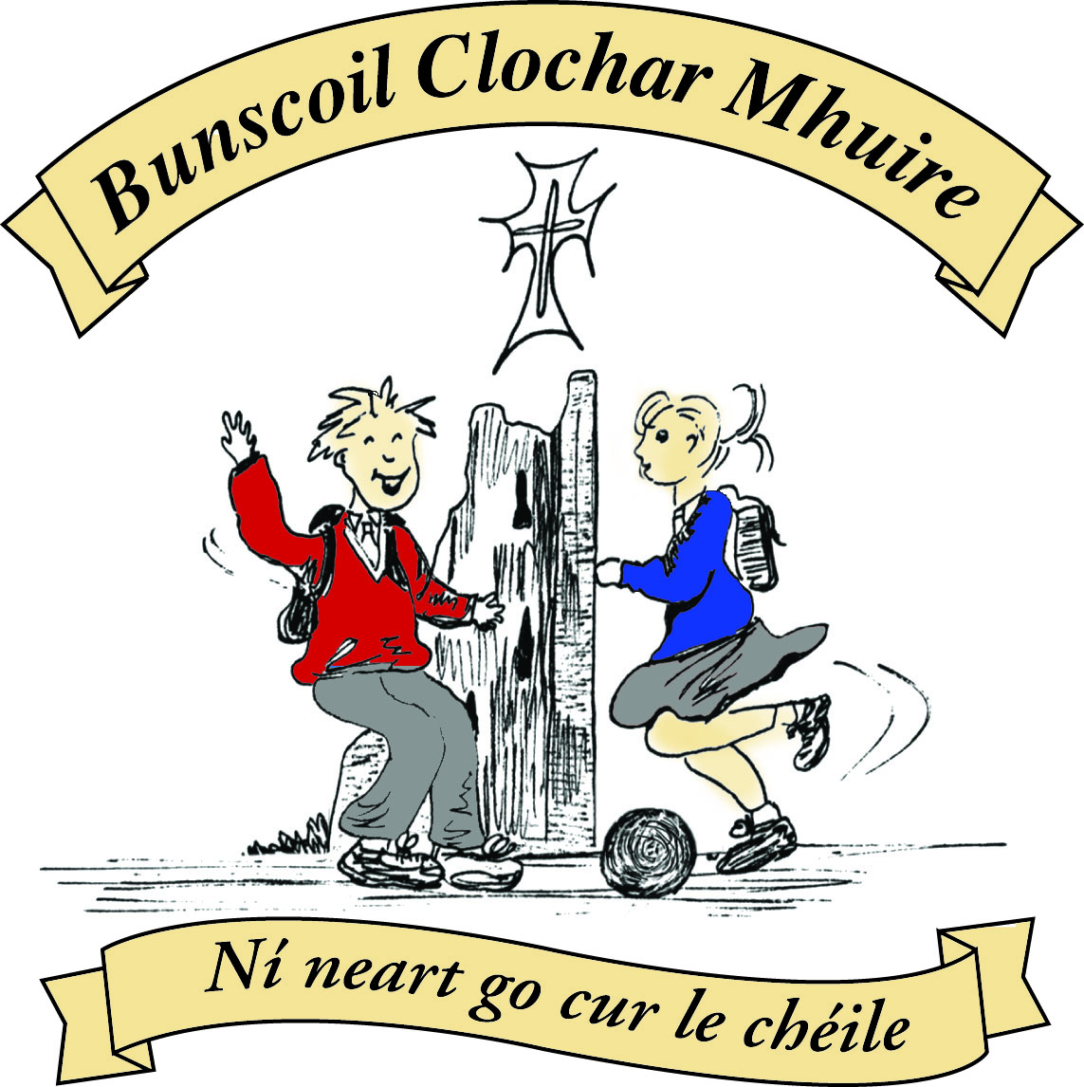* St Mary’s Convent Primary School**

***Bunscoil Clochar Mhuire***

***Trim, Co. Meath.  
Fón: (046) 9431919 ⦁ Faics: (046) 9437942  
Ríomhphost:*** [***marystrim@eircom.net***](mailto:marystrim@eircom.net) ***⦁ Website:*** [***www.stmarystrim.ie***](http://www.stmarystrim.ie) ***Uimhir Rolla: 16646O***

Awarded Green Flag  
June ‘05/’07/11/13

***Imlitir 8***

18th October, 2017

***Every Day Counts at St Mary’s Convent Primary School***

***9th October - 13th October 2017***

|  |  |  |  |  |  |  |  |
| --- | --- | --- | --- | --- | --- | --- | --- |
| **Room** | **Attendance** | **Room** | **Attendance** | **Room** | **Attendance** | **Room** | **Attendance** |
| 01 | 97.2% | 08 | 97.8% | 16 | 90.7% | 26 | 91.1% |
| 02 | 97.9% | 09 | 99.2% | 17 | 88.3% | 27 | 94.6% |
| 03 | 99.3% | 10 | 93.8% | 18 | 97.9% | 30 | 96.8% |
| 04 | 97.9% | 12 | 94.4% | 19 | 93.3% | 31 | 98.4% |
| 05 | 89.6% | 13 | 95% | 20 | 93.8% |  |  |
| 06 | 96.8% | 14 | 97.1% | 23 & 24 | 95% |  |  |
| 07 | 94.8% | 15 | 97.9% |  |  |  |  |

*Well done to rooms 3, 9 & 31 on nearly having full attendance last week. Please note that notification in writing, with the reason for all absences, to the teacher is required. A letter or note in the homework journal will suffice.*

A chairde,

**School Photos**: The last day for ordering photographs is **this Friday 20th**. All photos and money should be

returned to the school by this date.

**Tomorrow** is the last day to send in the **Christmas Card Template.**

School closes for Mid-term Break on Friday October 27th @ 2.00 (Infants) and 3.00 (Others). We re-open on Monday November 6th @ 9.20.

St. Mary’s School annual Book Fair will take place on **Tuesday 7th** and **Wednesday 8th of November** in the school hall. **Book Fair Timetable will be issued next week.**

*This week is* ***Maths Week****.*

*At school, the children will be involved in games/activities which help to promote Maths in a positive and enjoyable manner. Some classes have the opportunity to participate in Mangahigh-on-line Maths Games*

*At home, we can use this opportunity to focus on maths in the environment e.g. shapes of buildings/handling money in the shops/telling the time etc.*

*There are lots of entertaining events taking place around the county which you might like to attend. See* [*www.mathsweek.ie*](http://www.mathsweek.ie) *for more information*

*Hope it will be a fun Maths Week for everyone.*

*Margaret Hoey*

***Christmas Shoebox Appeal in St Mary’s***

*By now, all children should have received an information leaflet about the Christmas Shoebox Appeal. Through the Christmas Shoebox Appeal children in Africa and Eastern Europe can enjoy this special time of year. The children in St Mary’s are once again invited to join in the shoebox appeal sharing Christmas with children who my not receive gifts otherwise. Children in St Mary’s and in Ireland are lucky to have lovely things at home and at school and we have an opportunity to share some kindness with these children who have little and will be so grateful and excited to receive the gift. The shoebox appeal is based on children/families filling a shoebox with* ***4 W's****- something to* ***W****ear(hat, scarf, hairbands etc) something to* ***W****rite with (crayons, pencils, notebooks etc) something to* ***W****ash with(toothbrush, facecloth etc) and something to* ***W****OW (teddy, small toy, sunglasses etc). The appeal also asks for a small donation to cover the transport cost of the gifts. It is a lovely way for children in our school to share with less fortunate children in another country. As previously, it is optional for the children of St Mary’s to get involved with the Shoebox Appeal. Families or friends can pool together gifts to fill one box if they prefer. Míle buíochas for always being so generous with these appeals for very worthy causes.* ***Good things come in small parcels and there are few parcels shared that are as small as a shoebox.*** *Watch the link below to see some very happy faces opening up their shoeboxes.*

*https[://www.teamhope.ie/christmas-shoebox-appeal/#play-video](https://www.teamhope.ie/christmas-shoebox-appeal/" \l "play-video" \t "_blank)*

*Carla Dalton*

***Computer Room:*** *This week is Math’s Week so all classes from 2nd upwards will be participating in Mangahigh. This is an online site that allows students to take up Maths challenges amongst each other online. There is great excitement amongst the students and now we are waiting to see if a school from elsewhere in the world is going to challenge us to a Fai-To competition. Debby Walsh*

***Healthy Eating Policy***

*This is a reminder that treats should not be included in your child’s lunchbox. Treats include –* ***crisps, chewing gum, sweets, bars including cereal bars, cakes, biscuits, lollipops, chocolate, chocolate spread, winders, rice crispie buns and especially peanuts.*** *Cereal bars are not encouraged as they contain a lot of sugar. Water is the best drink to give your child.*

*A consistent whole school approach will be used to monitor and implement our Healthy Eating Policy.*

*If a child, brings any “discouraged” food or drink already listed to school, it will be taken away from them for the duration of the school day. The item will be returned to the child at the end of the day and the child will be reminded of our policy. The parents/guardians of the child will also be informed through a note in the child’s diary or orally.*

*If a child has no other food to eat, they may be permitted to eat the food or the school will provide a scone and drink.*

*If a child persists in bringing unhealthy food to school a letter will be send home. This will include information on what food is not permitted as part of a child’s lunch, the reasons why a healthy lunch is important and also information on healthy lunch ideas for the parent/guardian of the children.*

*It is important that parents are aware of the content of our Healthy Eating Policy. In order for it to be a success we need the cooperation of the whole school community. The policy is available to read on the school website.*

*We will be starting Food Dudes in the near future. This is a healthy eating programme that encourages children to try different fruits and vegetables. More information will follow soon.*

*Sinéad Minogue*

*HPS coordinator*

**Parent Teacher Meetings** take place on Tuesday November 21st and Wednesday November 23rd from 3.00 to 5.30. School finishes for the pupils @ 2.45 on both these days. Letters were issued last week for online appointments. Please book your time/s as soon as possible, especially if there is more than one child involved. If you have not got a letter with an access code, please contact the school immediately.

**Powerball:** A total of just over €5,500 was collected for our MUGA Fund. We still have some counting to finish. The exact amount and corresponding MUGA Fund total will be issued next week. This is a great response, in view of the amount of fundraising involved for our All-Weather Pitch, and we are grateful for everyone’s efforts. Once our revised planning application is approved, we will start building. As well as being a sports facility for our pupils, it will also mean that we will have the use of this space during playtimes, from November to March, when the weather stops us using the grass. It will also mean that pupils can play with a ball in this area, as it is fenced in and will not interfere with other pupils’ play.

**Enrolment Forms** for September 2017 are now available from Helen in the office.

Finally,

***Meitheal*** has restarted on Tuesday mornings. Parents/guardians volunteer to help create resource materials for the children. It lasts about an hour and it a social as well as a work occasion. If interested, please contact Helen or Rebecca.

Mise le meas,



Cóilín Ó Coigligh, Príomh Oide.

[**Green News**](#greennews)

[**Community News**](#communitynews)

***Nathanna na Seachtaine:*  *\_\_\_\_ is ainm dom (My name is \_\_\_\_\_\_\_)***

***Seanfhocal na Míosa:*** *Níl aon tinteán mar do thinteán féin* (There's no place like home!)

**Dates to Remember**

**Meitheal:** Every Tuesday morning 9.30-10.30.

**Mini-Rounders**: 3rd and 4th Classes - Mondays 3-4pm,

**Rounders**: 5th and 6th Classes - Mondays 3-4pm,

**Drama Club:** Every Thursday 3-4pm 4th – 6th Class

**Banna: Every Tuesday 3 – 4 pm 2nd – 6th Class**

**2nd Class finish at 3.30 until after the Halloween Break**

Ms Mary rescued Harry the hedgehog today!

***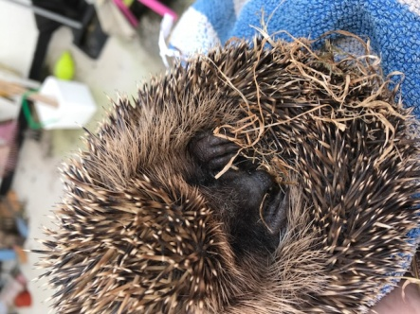***

***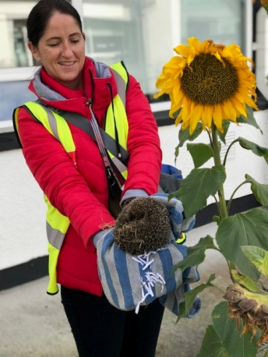***

***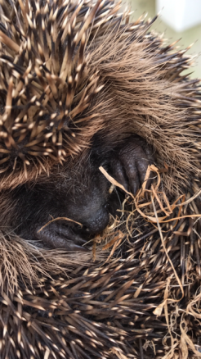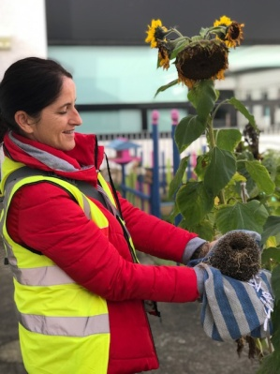***

**‘A prickly situation!’**

**[Green News](#greennews)**

The experts tell us that what we experienced over the past few days is one example of the consequences of climate change. In the past, we associated other parts of the world with devastating weather conditions, but we now know it is our problem too. ‘The world is our common home’ as Pope Francis said. Everything we do has global consequences so we must be vigilant about our living habits. Our green theme is a global one – Global Citizenship: Energy . Over the next two years we will be examining our energy usage at school and challenging ourselves to curtail this. As part of the Global citizenship programme we will be investigating energy on a worldwide basis also. We will revisit some of the Global goals we spoke about last year. You might want to remind yourself of the World’s largest lesson: <https://vimeo.com/178464378> In addition to respecting the world we live in, the seventeen global goals aim towards a cresting a fairer, more equitable world. A global citizen cares passionately about others and the world they live in.

Here at St Mary’s we are actively trying to care for our world and our immediate surroundings. We may start small but our actions will hopefully have far-reaching effects. Recycling continues at school. We recycle many items at school: batteries, card, small plastic bottles, mobile phones, cans, postage stamps and footwear. We also recycle our shredded paper. We are constantly finding creative ways to do this! Now may also be a good time to encourage people to be creative with Halloween costumes and maybe recycle or redesign old clothes.

Some classes have been planting spring flowers. We will look forward to beautiful flowers in the spring.

Our WOW initiative continues every Wednesday, regardless of the conditions! There are many people participating. We would encourage even more pupils to take this healthy approach to getting to school in the mornings. Walkers meet up at Mornington House or down at the Matchbox at 9:00am and the teachers escort the pupils to the school from these meeting points. Thank you to all who make this initiative possible. It is so much more beneficial to walk or cycle to school.

Our School Energy Audit was interrupted by the school closure so we will restart it next week***.***

***Remember Green is cool at home, at school and around the globe!***

St Mary’s Parents’ Association

Welcome to all parents and guardians! We are delighted to be able to update you regarding the activity of the Parents’ Association in the weekly Imlitir! Here we will update you regarding important dates for your diary.

Firstly let us introduce ourselves:

Chairperson: Denise Watson

Vice Chairperson: Julie O’ Donohue

Treasurer: Anne Hughes

Vice Treasurer: Siobhan Allut

Secretary: Caroline Smith

Vice Secretary: Michelle Watson Halo.

Together we hope to work with you all to provide fun fundraising events that will provide the children with facilities/equipment in a school, which is constantly striving to improve the environment in which they learn. As well as our fundraising events we will also work to provide memorable ceremonies for the girls making their communion and confirmation, for the 1st class boys graduating and also for the 6th class girls graduating. It is with continued support from you that allows us to hold these events and the children love them!

Dates for Your Diary:

**October 19th**: **Last date for return of the Christmas Card Templates!** Please ensure your child’s template for their Christmas Card is returned to the teacher. ***No templates will be received after this date, as all templates have to be sorted and posted back to the printers***. Order forms will be sent home when the sample cards have been returned from the printers.

**October 20th**: 9.30am we will be holding a meeting where all parents and guardians are welcome to attend. Christmas Card Templates to be posted to printers

**October 27th**: Halloween Bun Sale. All children/helpers are invited to dress up for the event. A fun filled day in school for all! This year we are asking pupils from Junior Infants, 3rd Class and 4th Class to bake for the sale. All children from these classes who bake for the event will be entered into a class draw for a 10euro Voucher for Smyths. A list of Do’s and Don’ts for the bakers is printed below. If you are in a position to help please leave your details with Helen or Rebecca in the office or you can leave a message on the Parents’ Association Facebook Page.

<https://www.facebook.com/stmarysparentsassoc/>

**Early November:** Sample Christmas cards to be given to each child along with order form.

Halloween Bun Sale

**Tips for the bakers;**

**Do's**

Go straight to the hall from 9am onwards with your buns and the Childs name will be taken down for the raffle.

Buns, biscuits, and bars are recommended.

Label any special dietary buns/biscuits and hand them in separately.

Cereal boxes with one side cut as a flap/lid and inside covered in tin foil make great boxes to send buns in and can be disposed of after.

For those who send in tubs, please ensure names are on the boxes, so they can be easily identified.

**Don'ts**

Send in whole cakes, as these can be difficult to cut.

Fresh cream not recommended, as these can be messy and buns are taken away in plastic bags.

Due to the presence of nut allergies in the school, Please do not send in buns/biscuits containing nuts.

Many thanks for your continued support.

Caroline Smith

Secretary

[**Community Notices**](#communitynews)

Creative Music Fun Castle Arch Hotel 9.30 am – 10.30 am October 7th / 14th / 21st November 4th / 11th / 18th

6 classes of fun to introduce the basics of music through percussion, movement and song. This class is ideal for children from Junior and Senior Infants and First Class. Ideal for children hoping to begin an instrument Limited number of places available Contact Shauna to book a place on 087 2024741 Qualified Music teacher, fully Garda Vetted

**Homework Club** in St Mary’s for children from 1st – 6th Classes. Application Forms are available from Ms Conaty Room 11 or Ms Lynch Room 31.

**Limelight Theatrics** - Performance Singing/Musical Theatre classes.  \*Tuesday evening 6.15pm to 7.15pm (Under 12's)  & 7.30pm to 8.30pm (Over 12's) Wednesday 7.15pm to 8.15pm (mixed)

**Go Bounce - bouncy castle hire - 0868398099.** Don't delay, book today to avoid disappointment in May.

Now taking bookings for Holy Communions 2018. Book now and you'll have one less thing to worry about in the run up to the big day. Check out our castles on  [Www.Facebook.com/GoBounceMeath](http://www.facebook.com/GoBounceMeath) or [www.GoBounce.ie](http://www.gobounce.ie/) or call us on 086-8398099

**DRAMA CLASSES**:  Tuesdays  5.15pm to 6.15pm (mixed age)  Wednesday 4.30pm to 5.30pm (mixed age) Wednesday 6pm - 7pm (Over 12's) Classes commence the week of 12th of September. Contact  Carmel McKiernan BA, LIBSD on 0863923334 for further info.

**ZUMBA**: -   Monday / Wednesday 8pm Trim GAA   -  €8 per class,  suitable for all fitness levels,  no booking/experience required.  Contact : Lorraine 086 8693546

**ZUMBA KIDS** :-   OCTOBER TERM NOW BOOKING -  Ages  4-8 Thursdays  2.15pm - 3.00pm,  St. Patrick's Hall Starting 5th October for 4 weeks,  €20 per child.  Contact :  Lorraine 086 8693546 / Jo  086 3381159

**Boyneside Speech & Drama**. Classes take place after school in St Michaels Primary School. And commence on Wed 6th and Thursday 7th September for students from senior infants to leaving cert.

Contact Dorothy on 087-2201981 or email [dorscully@gmail.com](mailto:dorscully@gmail.com)

**AFTER SCHOOL CLUB** Taking place in St. Mary's School Trim from 2-3pm Mon - Friday in room 5 starting on the 18th September Only €6 a day or €25 for 5 days Mon-Fri Application forms available from reception. Booking required a week in advance of start date to insure space, and rebooking and payment made the previous Thursday each week after. Kids will be provided a small snack and entertained with Lego, Art & Craft, Board games, quizzes, card games, puzzles and lots more fun activities! Run by an experienced Childcare Professional Parent who is fully Garda Vetted and Insured. Contact Julie O'Donohue to book your child's space by texting 0868505310, emailing [juliekerins@hotmail.com](mailto:juliekerins@hotmail.com) or via a PM on the Facebookpage:[www.facebook.com/TrimAfterSchoolClub](http://www.facebook.com/TrimAfterSchoolClub)  
  
**Jiggle 'n' Jump** Music & Movement classes for little ones (8mths-4yrs) running upstairs in Trim GAA on Tuesdays 9.45-10.45am €7 a class or 4 class card for €25 Only €5 during September and all money raised on Tuesday 5th September is going to Crumlin Children's Hospital via Jack O'Donohue's A Bit of a Walk Fundraiser.   
  
Also available for Kids Party Entertainment! Various characters and themes with fun games, dancing, face painting and prizes! Clown, Pirate, a number of different Princesses, 80's Disco Diva, sporty Diva and Super Heroes available. Birthdays, Weddings, Christenings or family fun events.......in your home or in a venue, packages to suit any needs or budget. Contact Julie on 0868505310 or on Facebook [www.facebook.com/jigglenjump](http://www.facebook.com/jigglenjump)

