 St Mary’s Convent Primary School**

***Bunscoil Clochar Mhuire***

***Trim, Co. Meath.  
Fón: (046) 9431919 ⦁ Faics: (046) 9437942  
Ríomhphost:*** [***marystrim@eircom.net***](mailto:marystrim@eircom.net) ***⦁ Website:*** [***www.stmarystrim.ie***](http://www.stmarystrim.ie) ***Uimhir Rolla: 16646O***

Awarded Green Flag  
June ‘05/’07/11/13

***Imlitir 8***

18th October, 2016

***Every Day Counts at St Mary’s Convent Primary School***

***10th October - 14th October 2016***

|  |  |  |  |  |  |  |  |
| --- | --- | --- | --- | --- | --- | --- | --- |
| **Room** | **Attendance** | **Room** | **Attendance** | **Room** | **Attendance** | **Room** | **Attendance** |
|  |  |  |  |  |  |  |  |
| 01 | 95.6 % | 08 | 88.3% | 16 | 96.3% | 26 | 98.4% |
| 02 | 92.3% | 09 | 93.5% | 17 | 92.3% | 27 | 99.2% |
| 03 | 94.8% | 10 | 99.3% | 18 | 96.7% | 30 | 99.2% |
| 04 | 95.6% | 12 | 93.3% | 19 | 93.3% | 31 | 99.3% |
| 05 | 92.3% | 13 | 93.3% | 20 | 98.6% |  |  |
| 06 | 97.6% | 14 | 96.4% | 23 & 24 | 97.1% |  |  |
| 07 | 96.8% | 15 | 94.3% |  |  |  |  |

*Congratulations to Rooms 10,27,30&31 on nearly having full attendance last week. Please note that notification in writing to the teacher is required for all absences. A letter or note in the homework journal will suffice*.

A chairde,

School closes for Mid-term Break on Friday October 28th @ 2.00 (Infants) and 3.00 (Others). We re-open on Monday November 7th @ 9.20.

*This week is* ***Maths Week****. At school the children will be involved in games/activities which help to promote Maths in a positive and enjoyable manner. Some classes have the opportunity to participate in Mangahigh–on–line Maths games.*

*At home, we can use this opportunity to focus on Maths in the environment eg. Shapes of buildings/handling money in the shops / telling the time etc.*

*There are lots of entertaining events taking place around the country, which you might like to attend.*

*See* [*www.mathsweek.ie*](http://www.mathsweek.ie) *for more information.*

*Hope it will be a fun Maths Week for everyone.*

*Margaret Hoey*

**Powerball:** A total of just over €7,000 was collected for our MUGA Fund. The exact amount and corresponding MUGA total will be issued next week. This is the most we have ever collected in a sponsored event and we are grateful for everyone’s efforts. Our plan to have the All Weather Pitch built before the end of 2017 is well on track. As well as being a sports facility for our pupils, it will also mean that we will have the use of this space during playtimes, from November to March, when the weather stops us using the grass. It will also mean that pupils can play with a ball in this area, as it is fenced in and will not interfere with other pupils’ play.

**Enrolment Forms** for September 2016 are now available from Helen in the office.

**School Photos:** Please note that the school photographer will be here this Thursday October 20th.

***Computer Room:*** *This week is Maths Week so students from 2nd – 6th are fortunate enough to be able to use the Mangahigh Online Maths software. Should you have a computer or laptop at home your child will be able to continue with the Maths challenges and earn themselves medals! 1st Class will be doing Maths Made Easy. Debby Walsh*

**Boyne Community School Open Night**​will take place this Thursday, October 20th, between 5.30pm and 7.30pm. All 6th Class pupils and their parents/guardians are invited.

May I remind families of our voluntary contribution for computers, which is due since September last. This enables us to maintain our computer room, replace hardware and software and also employ an assistant for technical and educational support. For example we are able to provide teaching of Scratch, Word, Powerpoint, typing and much more. It is €50 per family, which has not increased for seven years. We would appreciate the assistance of your contribution. We would, however, like to stress that this is not a fee and that it is your choice to make. Fees, on the other hand, have been expended by the teacher and school, and we must collect this money to avoid going into debt ourselves. We understand that a reminder for this voluntary contribution was sent out last week under the heading of “Outstanding Account” and apologise for this error on our part.

St. Mary’s School annual Book Fair will take place on **Tuesday 8th** and **Wednesday 9th of November** in the school hall. **Book Fair Timetable will be issued next week.**

**Parent Teacher Meetings** take place on Wednesdays November 23rd and 30th from 3.00 to 5.30 as per school Calendar.

Mise le meas,



Cóilín Ó Coigligh, Príomh Oide.

**Green News**

**Community News**

**Nath na Seachtaine**: **Cén t-am é? Tá sé a ______ a chlog....**

**Seanfhocal na Míosa: Níl aon tinteán mar do thinteán féin! There’s no place like home!**

**Dates to Remember**

**Assembly: Global Citizenship Prayer Service**

**Friday @ 9.20 1st – 6th Classes All welcome**

**Banna Ceoil:** Every Tuesday @ 3.00

**2nd Class finish @ 3.30pm 3rd-6th  Class @ 4.00pm**

**Meitheal:** Every Tuesday morning 9.30-10.30.

**Camogie:** Please check GAA Notice Board in the Hall for details

**Rounders:** Monday 3.00-4.00 p.m. Third – Sixth Classes

**Drama Group:**  Thursday 15th – Oct 27th for 6th Class

**Communion:**  Sat May 13th @ 11.00

**Confirmation:**  Sat 11th March

**Green News**

Global Citizenship is our Green Theme this year. We are focusing on Waste Management as part of this theme. Already we have identified lots of global links in our school. We have some 27 countries represented in our school community. Some children have researched how waste is treated in other countries where their grandparents and extended families live. It is so exciting having such diversity in our school! One of our international parents from Slovakia came in to show us a lovely art project using autumn leaves. A few classes have tried it since and really produced some lovely bouquets. Thank you Julia. Dakujem!

Next weekend in our parish we will be celebrating Mission Sunday. To mark this occasion, we will have a Global Citizenship Prayer Service on Friday as part of our Green Flag Assembly and we will celebrate the diversity in our school.

Last week we had the honour of meeting Paddy Madden, the retired lecturer from Marino College of Education when he visited our school. He charmed Fourth Class and Senior Infants with his wealth of knowledge and deep passion for nature and he had a good look at our courtyard garden. He helped the Gardening Committee draw up a plan and gave us great ideas for a school plan for planting and harvesting. We will keep you all informed of developments.

WOW continues this week. The WOW teachers will meet anyone who would like to walk down to school from Mornington House every Wednesday at 9am. Remember our other meeting point is down outside the Matchbox. Our Siúlaimis campaign will benefit from our WOW numbers! Thanks to the pupils and teachers who keep this going every week.

COW also continues on Wednesday. Meet inside Steeple Manor estate at 8:55am. Please wear hi-viz vests and helmets. The teachers will escort the cyclists down by the river. There are only two more weeks of Cycling on Wednesday so we would encourage anyone with a bike to ‘get on it’!! Looking forward to seeing a few more cyclists this week. Well done to those teachers and cyclists who have kept the initiative going since September.

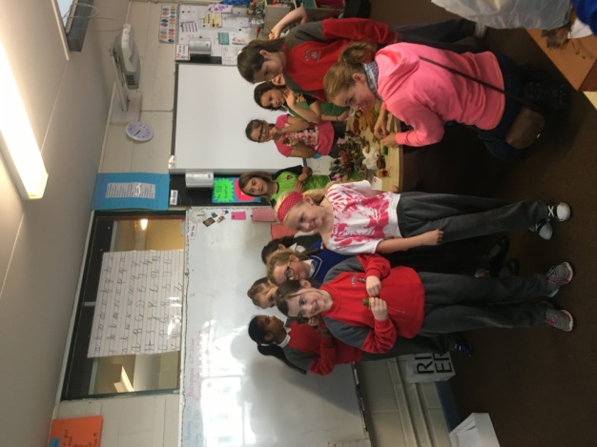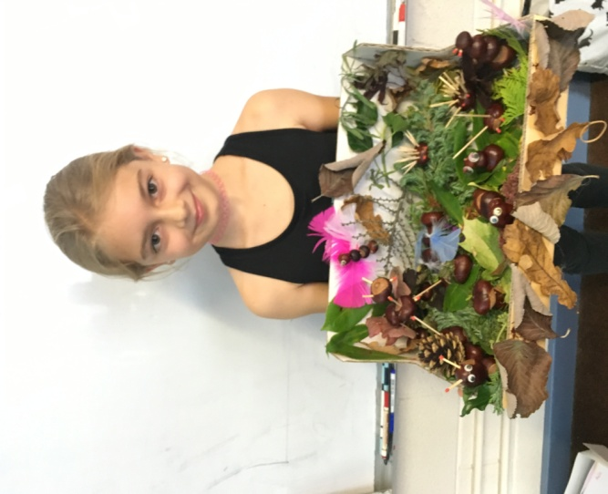

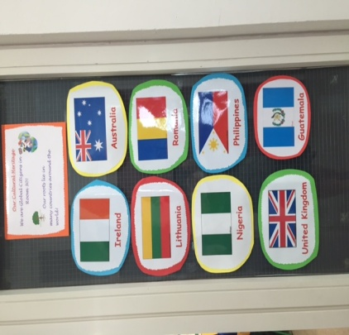

***Remember green is cool at home, at school and around the globe!***

**Community Notices**

**Spooktacular Camp-o-ween** in St Mary’s Primary School. 1st – 4th November 9.30 – 2.30pm. 1 child €50, 2 children or more €40. Please contact Ms McKenna or Ms Cullinane for more details.

**Mini me yoga**  in the breathe studio. Patrick Street. Trim. Junior/senior Infants: 2-2.45pm  
1st class upwards: 3-3.45pm. COLLECTION IS NOW AVAILABLE FROM SCHOOL FOR CLASSES. For more info or book your child's  place for collection pls call/txt Nat on 087-6202199.

**A is for apple playschool**.  Ages 15 months - two and a half. Part time or full time places available. For more info or to have a viewing pls contact Nat on 087-6202199.

ONLY  10  WEEKS  UNTIL  CHRISTMAS !!!   LETS GET OUR PARTY BODIES READY  *:&quot;> blushing

**ZUMBA**  :-    MONDAY  &  WEDNESDAY  8pm  TRIM GAA.  No booking, partner or experience required......just grab your water and your smile and get ready to dance your cares away!   €8 per class   Contact  :  Lorraine  086 8693546

**ZUMBA KIDS** :-    TUESDAY   3.15pm  Trim GAA    No booking required,  just come along any Tuesday that suits  €6 per class      Contact : Lorraine  086 8693546

**AFTER SCHOOL CLUB** Takes place in St. Mary's School Trim from 2-3pm Only €5 a day or €20 for 5 days Mon-Fri Places are limited and need to be booked by the previous Thursday. Kids will be entertained with Lego, Play Doh, Art, Singing, Board games, quizzes, card games, puzzles and lots more fun activities.  Run by two experienced Childcare Professional Parents who are Garda Vetted.  Contact Julie O'Donohue to book your child's space by texting 0868505310, emailing [juliekerins@hotmail.com](mailto:juliekerins@hotmail.com) or via a PM on our Facebook page: [www.facebook.com/TrimAfterSchoolClub](http://www.facebook.com/TrimAfterSchoolClub)

**Coláiste na bhFiann** are running summer courses in 2017. For more information on the network of Irish language youth clubs 'Cumann na bhFiann' please see [www.colaistenabhfiann.ie](http://www.colaistenabhfiann.ie) They run two week courses for 4th, 5th & 6th class students in Droim Rí Óg, Co. Meath (16/07/17 - 29/07/17) & for 10-14 year old students in Gaoth Dobhair Óg, Co. Donegal (02/07/17 - 15/07/17)

**Go Bounce bouncy castle hire**. Based in Trim, fully insured and safety certified. Taking bookings now for 2017. Check out our Facebook page [www.Facebook.com/gobouncemeath](http://www.facebook.com/gobouncemeath), contact us on 086-8398099 or email [enquiries@gobounce.ie](mailto:enquiries@gobounce.is)

Childcare Assistant needed, part time at Daffodils Childminding Trim. Contact Caroline for details 0858589460   
Also places available for breakfast club and afterschool hours only.

