***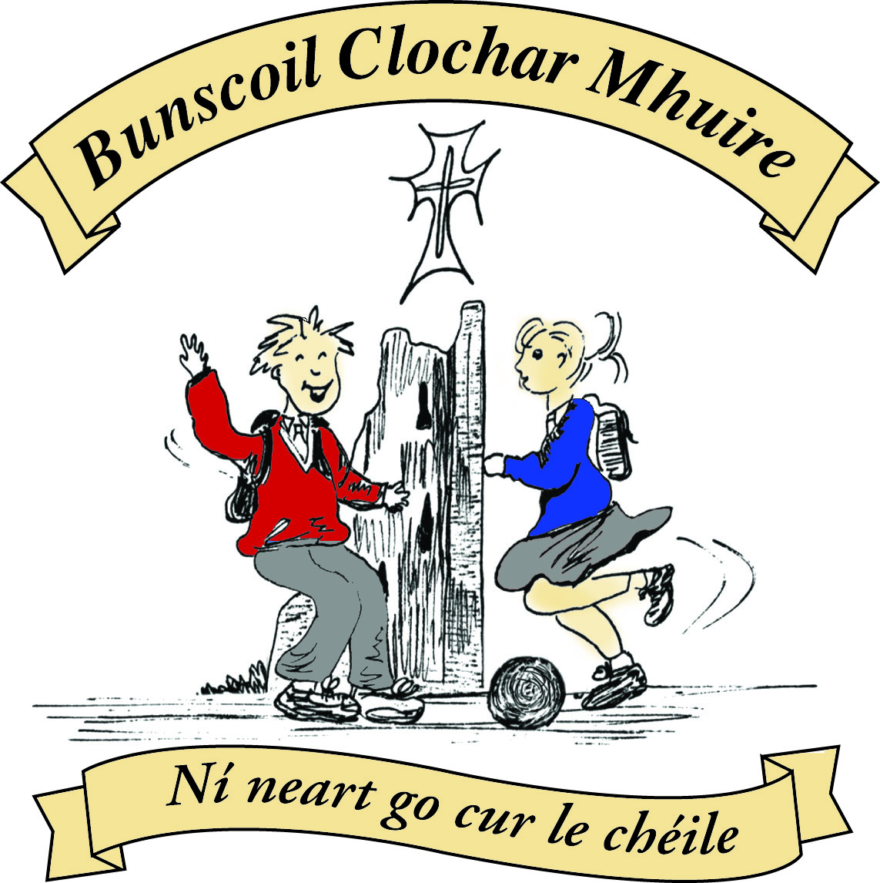* St Mary’s Convent Primary School**

***Bunscoil Clochar Mhuire***

***Trim, Co. Meath.  
Fón: (046) 9431919 ⦁ Faics: (046) 9437942  
Ríomhphost:*** [***marystrim@eircom.net***](mailto:marystrim@eircom.net) ***⦁ Website:*** [***www.stmarystrim.ie***](http://www.stmarystrim.ie) ***Uimhir Rolla: 16646O***

Awarded Green Flag  
June ‘05/’07/11/13

***Imlitir 7***

10th October, 2016

***Every Day Counts at St Mary’s Convent Primary School***

***3rd October - 7th October 2016***

|  |  |  |  |  |  |  |  |
| --- | --- | --- | --- | --- | --- | --- | --- |
| **Room** | **Attendance** | **Room** | **Attendance** | **Room** | **Attendance** | **Room** | **Attendance** |
|  |  |  |  |  |  |  |  |
| 01 | 97 % | 08 | 94.2% | 16 | 92.6% | 26 | 96.8% |
| 02 | 93.8% | 09 | 97.4% | 17 | 95.4% | 27 | 98.3% |
| 03 | 95.7% | 10 | 93.3% | 18 | 91.7% | 30 | 96.2% |
| 04 | 95.6% | 12 | 97.9% | 19 | 97.8% | 31 | 97.9% |
| 05 | 96.2% | 13 | 94.7% | 20 | 97.9% |  |  |
| 06 | 99.2% | 14 | 97.9% | 23 & 24 | 95.7% |  |  |
| 07 | 94.4% | 15 | 98.6% |  |  |  |  |

*Congratulations to Room 6 on nearly having full attendance last week. Please note that notification in writing to the teacher is required for all absences. A letter or note in the homework journal will suffice*.

A chairde,

**Be Healthy Week:** Please note the details below and remember to check out our Healthy Eating Policy on our schools website: [www.stmarystrim.ie](http://www.stmarystrim.ie)

**Yard in Mornings:** Thanks again for your co-operation in the smooth transfer of the children from the yard to the classrooms. Please remember to stand back and to keep the pathways clear for the children. It would be helpful if parents/guardians could leave the yard before the lines leave or failing that, to wait until the lines are ***all*** gone in. Please do not approach another child in the yard for any reason.

**School Photos:** Please note that the school photographer has been changed again to October 20th.

**Parent-Teacher Meetings** this year will be over two days, on Wednesday November 23rd and 30th, as per school calendar. They will be from 3.00 to 5.30 on both days. Appointments will be issued after the Halloween Break.

Please do not send children who are unwell to school, especially if they can pass it on to other children. Thanks.

***Féilire*/School Calendar:** We would again like to thank our sponsors Ted Murtagh Clothing and Footwear for their generosity. If you need a spare copy, please contact them directly.

**Parents’ Association:** There will be a special assembly tomorrow morning when our Parents’ Association will present the school with a cheque for our MUGA Fund. You are all welcome to attend.

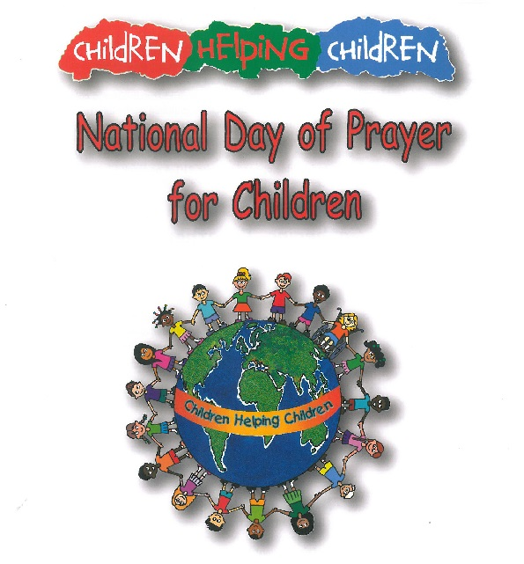

**Oct 14** is National Day of Prayer for children. It is in preparation for **Mission Sunday 23 October**.  In view of our Catholic ethos and the theme of Global Citizenship , the children are learning this poem to celebrate the occasion.

**M**ayall children

**I**n the world

**S**harelove

**S**harefriendship and live

**I**nthe peace

**O**f God's love

**N**owand forever, Amen

***Computers:*** *With another week gone, 6th class have created their letterheads and have completed their letters to a friend telling them all about their products.   This week they will do research into where you register your business name and the cost involved and they will learn how to write a business letter.  4th class will continue to work on their magazine covers and will start to work on the articles for the magazine.  3rd class are working on their 'Write a Book' projects and will start learning about page numbering and chapters.  1st class are still enthusiastic about typing up their news each week.  Very exciting times happening in the Computer Room!*

*Ms Debby*

*Hi all, there is an* ***altar servers meeting*** *taking place this Wed, 12th Oct at 7pm in St Patricks church - this is a meeting for all servers both new starters and existing, the existing servers are requested to attend with one parent/guardian as new consent forms need to be signed and once the form is signed they can leave  - we would request that all new servers stay on so Fr Declan can show them what being an altar server requires.... If you have any queries please txt me....*

*Many thanks*

*Rachel O'Connor (A.S. Parents Committee)*

*It is* ***Be Healthy Week*** *in school this week. The children will be learning about healthy eating, having a healthy mind and a healthy body. it is important that children bring a healthy lunch each day to school - fizzy drinks, crisps, chocolate, chewing gum and sweets are not allowed. You can read our* ***Healthy Eating Policy*** *on the school website.*

*This year we will be participating in* ***The Health Promoting Schools Programme.*** *This programme supports schools to focus on health and wellbeing and involves all members of the school community. Over a period of around 2 school years, in consultation with all members of the school community, schools develop an action plan to address their chosen priority health areas.*

*We would like to invite parent volunteers to join a Health Promoting Schools committee comprising of teachers, students and a health promotion coordinator from the HSE. This committee will meet throughout the two years, during school hours to help implement this programme. If you are interested and would like to be part of this committee please contact the school.*

*Ms. S. Minogue*

*The* ***B.O.M. meeting*** *was held on Tuesday 23rd September. School playground is now completed, up and running. It has been timetabled at breaktimes and is very popular. Planning permission has been granted for the MUGA, a fundraiser will be held in the New Year towards the fund. New members of staff were ratified and welcomed. We have now reached 610 pupils. The school is no longer full. The next B.O.M. meeting will be held on the 22nnd November.*

*Ms B. Munnelly*

***Secondary School Open Nights****: Scoil Mhuire will hold its Open Night on Thursday, October 13th, 6.30-8.30pm. Open Night at Boyne Community School will take place on Thursday, October 20th, 5.30-7.30pm. All 6th Class pupils and parents/guardians are invited to explore both schools and meet the teachers.*

*Mr Galligan*

Below is a list of when pupils will be attending Powerball on Thursday and Friday next, should you wish to attend***.***

Don’t forget to return cards. Many thanks for the great efforts being made. We will update you before the Mid-Term Break on the new total, following this fundraising venture and Parents’ Association donation.

***Powerball Timetable***

|  |  |  |
| --- | --- | --- |
| TIME | **13th Oct**  **Rooms**  **Play** | **14th**  **Rooms**  **Play** |
| **9.25-9.45** | **1+23** | **5** |
| **9.50-10.10** | **2** | **6** |
| **10.15-10.35** | **3** | **7** |
| **10.40-11.00** | **4** | **8** |
| **11.15-11.35** | **9** | **12** |
| **11.40-12.00** | **10+24** | **13** |
| **12.00-12.30** | **16** | **18** |
| **1.10-1.30** | **14** | **15** |
| **1.30-2.00** | **19** | **26** |
| **2.00-2.30** | **20** | **27** |
| **2.30-3.00** | **31** | **30** |

Mise le meas,



Cóilín Ó Coigligh, Príomh Oide.

**Green News**

**Community News**

**Nath na Seachtaine**: **Gabh mo leathscéal (Excuse me)**

**Seanfhocal na Míosa: Níl aon tinteán mar do thinteán féin!**

**There’s no place like home!**

**Dates to Remember**

**Assembly: Monday 17th @ 9.20** Maths Week Room 20 All Welcome

**Banna Ceoil:** Every Tuesday @ 3.00

**2nd Class finish @ 3.30pm 3rd-6th  Class @ 4.00pm**

**Meitheal:** Every Tuesday morning 9.30-10.30.

**Camogie:** Please check GAA Notice Board in the Hall for details

**Rounders:** Monday 3.00-4.00 p.m. Third – Sixth Classes

**Drama Group:**  Thursday 15th – Oct 27th for 6th Class

**Communion:**  Sat May 13th @ 11.00

**Confirmation:**  Sat 11th March

**Green News**

*“WE MUST FOSTER GLOBAL CITIZENSHIP. EDUCATION IS ABOUT MORE THAN LITERACY AND NUMERACY. IT IS ALSO ABOUT CITIZENRY. EDUCATION MUST FULLY ASSUME ITS ESSENTIAL ROLE IN HELPING PEOPLE TO FORGE MORE JUST, PEACEFUL AND TOLERANT SOCIETIES.” Ban Ki-moon, United Nations Secretary-General (2012)*

Global citizenship is our green theme for this year. We are currently on our second year of the programme. We live in an increasingly globalised and interconnected world in which the global is part of our everyday lives. We are linked as never before to other people on every continent through the media, telecommunications, travel and migration. In our school we embrace our cultural diversity and we will be celebrating the various cultures in our school during the year. The main thrust of our Global Citizenship campaign this year is the area of Litter and Waste management. Along with becoming vigilant about our own habits, we will be investigating how other countries deal with their waste.

In St Mary’s we recycle the following materials: batteries, ink cartridges, small plastic bottles, cans, postage stamps, footwear, card and toilet rolls. The children are really great at remembering to keep our recycling centre going in school.

WOW and COW continue this week. Walkers meet up at Mornington House or at The Matchbox at 9am. Cyclists meet inside the entrance to Steeple Manor at 8:55am. Teachers will escort the Cyclists and Walkers to the school. Hi-viz vests and helmets are necessary for safety when cycling. There are only a few weeks remaining during which the weather will be conducive to cycling so we would encourage pupils who are in fourth class and above to give it a go before the end of October. Thanks to all the pupils and teachers who keep both our COW and WOW initiatives going. Ní neart go cur le chéile! The walking and cycling activities are counted as part of the Siúlaimis campaign.

On Tuesday of this week we will be visited by Paddy Madden who is a School Garden expert and a former lecturer from Marino College of Education. He will work with Fourth Class and the Green Committee. He will advise us on how best to plan our school and sensory gardens. Ms Flattery and Ms Finn have planted bulbs and have great plans for a vegetable patch. Remember if there are any parents, grandparents or guardians who would like to lend a hand with our gardening projects, we would be delighted to hear from you.

***Remember green is cool at home, at school and around the globe!***

**Community Notices**

**Spirit of Meath Halloween Festival**

16th October – 6th November. Lots of events including a House of Horrors, Haunted Spooktacular, Farmaphobia, Terrifying Treasure Trails and Pooka Spooka during the day and spine-tingling spooky themed nights.

**Trim Kempo Karate: Tue/Thursday** Beginners/Juniors @ 6.00 Intermediate @ 7.00-8.00 Seniors @ 8.00-9.00 **Saturday** Begineers/Jun @ 10.00 Intermediate @ 11.00 Seniors @ 12.00-1.00. Instructor Mr. Gerry Shanahan 086-3586141/086-8336362

1. **Mini me yoga**  in the breathe studio. Patrick Street. Trim. Junior/senior Infants: 2-2.45pm  
1st class upwards: 3-3.45pm. COLLECTION IS NOW AVAILABLE FROM SCHOOL FOR CLASSES. For more info or book your child's  place for collection pls call/txt Nat on 087-6202199.

2. **A is for apple playschool**.  Ages 15 months - two and a half. Part time or full time places available. For more info or to have a viewing pls contact Nat on 087-6202199.

**ZUMBA  :-**

MONDAY  &  WEDNESDAY  8pm  TRIM GAA.  No booking, partner or experience required......just grab your water and your smile and get ready to dance your cares away!   €8 per class   Contact  :  Lorraine  086 8693546

**ZUMBA KIDS :-**    TUESDAY   3.15pm  Trim GAA    No booking required,  just come along any Tuesday that suits  €6 per class      Contact : Lorraine  086 8693546

**Elegance Gymnastics Club**

We are enrolling girls from 5 – 14 for the Rhythmic Gymnastics in St. Mary’s Primary School Sports Hall. Please contact [elegancegym.15@gmail.com](mailto:elegancegym.15@gmail.com) 087-6339498 or 087-9134334.

**AFTER SCHOOL CLUB** Taking place in St. Mary's School Trim from 2-3pm STARTING MONDAY 3rd OCT Only €5 a day or €20 for 5 days Mon-Fri Places are limited and need to be booked by the previous Thursday. Kids will be entertained with Lego, Play Doh, Art, Singing, Board games, quizzes, card games, puzzles and lots more fun activities.  Run by two experienced Childcare Professional Parents who are Garda Vetted.  Contact Julie O'Donohue to book your child's space by texting 0868505310, emailing [juliekerins@hotmail.com](mailto:juliekerins@hotmail.com) or via a PM on our Facebook page: [www.facebook.com/TrimAfterSchoolClub](http://www.facebook.com/TrimAfterSchoolClub)

**Trim Family Resource Centre** is hosting Shines **"Taking Control Workshop".**on October 13th at TFRC2. The workshop is about practical ways to face life's challenges, whilst maintaining and taking control of your physical and mental wellbeing. The workshop is delivered over the duration of one day, beginning at 9.30am and finishing by 4pm. Registration is essential, if you would like to participate, please contact Trim Family Resource Centre on 046 9438850.



**Coláiste na bhFiann** are running summer courses in 2017. For more information on the network of Irish language youth clubs 'Cumann na bhFiann' please see [www.colaistenabhfiann.ie](http://www.colaistenabhfiann.ie) They run two week courses for 4th, 5th & 6th class students in Droim Rí Óg, Co. Meath (16/07/17 - 29/07/17) & for 10-14 year old students in Gaoth Dobhair Óg, Co. Donegal (02/07/17 - 15/07/17)