***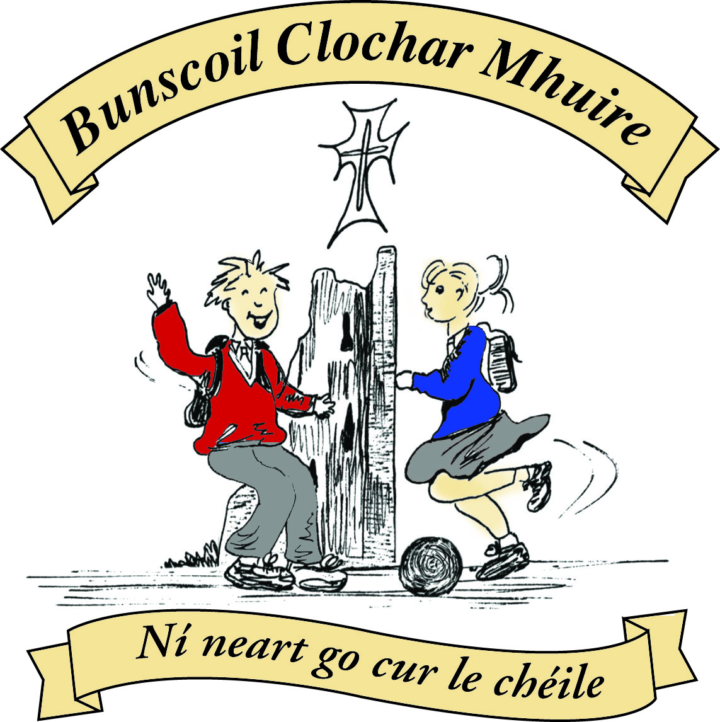* St Mary’s Convent Primary School**

***Bunscoil Clochar Mhuire***

***Trim, Co. Meath.  
Fón: (046) 9431919 ⦁ Faics: (046) 9437942  
Ríomhphost:*** [***marystrim@eircom.net***](mailto:marystrim@eircom.net) ***⦁ Website:*** [***www.stmarystrim.ie***](http://www.stmarystrim.ie) ***Uimhir Rolla: 16646O***

Awarded Green Flag  
June ‘05/’07/11/13

***Imlitir 6***

3rd October, 2016

***Every Day Counts at St Mary’s Convent Primary School***

***26th September –30th September 2016***

|  |  |  |  |  |  |  |  |
| --- | --- | --- | --- | --- | --- | --- | --- |
| **Room** | **Attendance** | **Room** | **Attendance** | **Room** | **Attendance** | **Room** | **Attendance** |
|  |  |  |  |  |  |  |  |
| 01 | 96.3 % | 08 | 95.8% | 16 | 94.1% | 26 | 94.4% |
| 02 | 94.6% | 09 | 98.1% | 17 | 90.8% | 27 | 97.4% |
| 03 | 93.9% | 10 | 99.3% | 18 | 95.8% | 30 | 96.9% |
| 04 | 94.8% | 12 | 93.8% | 19 | 97.8% | 31 | 99.3% |
| 05 | 99.2% | 13 | 92% | 20 | 96.4% |  |  |
| 06 | 98.4% | 14 | 97.8% | 23 & 24 | 99% |  |  |
| 07 | 96.8% | 15 | 99.3% |  |  |  |  |

Congratulations to Rooms 5, 10, 15, 23, 24 & 31 on nearly having full attendance last week.

A chairde,

**First Communion** will be on Saturday, May 13th @ 11.00. Please note in your diaries.

**Powerball:** There has been a very positive reaction to our new fundraiser for our All-Weather pitch. Cards may be brought back from today. Many thanks for all your efforts and please remember not to send your children from house to house unaccompanied. A timetable will be issued closer to the event, if you wish to come in and support your child. Please also note that as this is a sponsored event, a returned sponsorship card is necessary to participate.

**Siúlaimis** ( Let’s Walk!”) has restarted. This is a scheme to promote more walking with our pupils. Cards will be issued shortly and parents/guardians can sign off for their children walking to and from school. Mrs Nally will sign off for WOW and the teachers for walking done in school on our track. Last year, as a school we walked to St Patrick’s School in Koroit, Australia. This year, we aim to walk around the globe. Our route will take us to the capital cities of all our international pupils and we will stop off in St Patrick’s also.

The national strategy **‘Literacy and Numeracy for Learning and Life’** (Department of Education and Skills 2011), includes a range of actions to enable parents and communities to support children’s learning. The strategy recognises that parents who are engaged in their child's learning, have a significant positive impact on a child’s educational achievement - especially in literacy and numeracy.

As part of this strategy, the Department asked the National Adult Literacy Agency (NALA) to highlight the role that parents and communities can play in improving children’s literacy and numeracy, using media, online resources and celebrity endorsements.

To achieve this, NALA has developed **Help My Kid Learn** - a simple website that brings together relevant information for parents and the wider community to support children’s literacy and numeracy development.

The website’s purpose is to provide fun activities that parents can do with their children to develop their literacy and numeracy. It includes general information, fun activities and useful tips. Help My Kid Learn is a website where people can see that supporting a child’s literacy and numeracy development is a natural, easy and fun activity that can be integrated into any part of their day.

<http://www.helpmykidlearn.ie/> This website provides a single reference point for parents and guardians to better understand their role in their children’s literacy and numeracy development.

**Online payments**: We have commissioned a payment system which matches our school administration package-**Aladdin.** Please note that families are now able to use computer, tablet or phone to make payments for monies owed, swimming, school tours etc. For security reasons, we prefer if online payments are used.

The school rents violins and flutes to pupils from Banna Cheoil. You would need to organise your own lessons. Please contact Mrs Mc Gale for further details. Due to an administration error, rent was not collected for last year and that bill will be included in this years! Apologies for any inconvenience caused.

***Computers***

*Students are working away on the various projects that they have been given. 6th Class – their newly created businesses, 4th Class – their Magazines, 2nd and 3rd Class – their ‘Write a Book’ project. For those students who are going home and practising their typing skills – well done. 1st class students seem to really enjoy seeing their work on paper each week – well done to them all for their hard work in class.*

*Ms. Debby*

***St Mary’s Digital Committee – Volunteers Sought***

*A new Digital Committee is being formed at St Mary’s for 2016-2017. The committee will be made up of parents/guardians, pupils and staff. Any parent/guardian wishing to join the committee is asked to contact the school (please note that committee meetings will take place in the mornings before school starts, so that pupils do not lose our on recreation time during lunch break)*

*D. Galligan*

***Daily Lap:*** *Join Ms. Carr for a lap of the track every morning around 9.10. We are being healthy.*

*Ms. Carr*

Finally, don’t forget C.O.W. and W.O.W.!

Mise le meas,



Cóilín Ó Coigligh, Príomh Oide.

**Green News**

**Community News**

**Nath na Seachtaine**: **Go raibh maith agat**

**Seanfhocal na Míosa: Níl aon tinteán mar do thinteán féin!**

**There’s no place like home!**

**Dates to Remember**

**Assembly: Be Healthy** Juniors @ 9.30

**Parent’s welcome**

**Banna Ceoil:** Every Tuesday @ 3.00

**2nd Class finish @ 3.30pm 3rd-6th  Class @ 4.00pm**

**Meitheal:** Every Tuesday morning 9.30-10.30.

**Camogie:** Please check GAA Notice Board in the Hall for details

**Rounders:** Monday 3.00-4.00 p.m. Third – Sixth Classes

**Drama Group:**  Thursday 15th – Oct 27th for 6th Class

**Communion:**  Sat May 13th @ 11.00

**Confirmation:**  Sat 11th March

**Green News**

We have completed one month of school. The weather is becoming a little cooler. Well done to all who walk and cycle (and even flicker) to school. Our WOW and COW will continue this week. Walkers meet up at Mornington House or at the Matchbox at 9 am. Thanks to the teachers who have committed to this initiative and keep it going throughout the year. It would be so encouraging if more pupils joined in and it might inspire others when they see the group walking up to school in the mornings. Cyclists meet up inside the entrance to Steeple Manor at 8:55am. Well done to the weekly cyclists and teachers who help out each week. It is a very energising cycle down by the Boyne and a lovely way to start the day. Perhaps a few more might give it a go before the weather makes it impossible and unsafe to cycle. Remember hi-viz vests and helmets are essential.

In October we will have a visit from Paddy Madden, the School Garden expert and lecturer from Marino Education College. We look forward to having him with us and to learning lots of important gardening facts and practical tips for developing our school and sensory garden.

Global Citizenship is the umbrella term under which we are working on our Litter and Waste Management this year. It is hoped that lots of classes will engage in projects that will educate us in how litter and waste is dealt with in other countries. The theme of Fair Trade will be investigated and we will look at our own consumer behaviour.

We would like to thank all those who contributed to the Clothes Drive last week. It amounted to 205kg. The funds generated will be put into our Green funds. We will be having a Siopa Glas in November. Please keep that in mind when you’re planning to recycle old books, toys etc. The proceeds will go towards an international children’s charity probably a Special Needs School or an orphanage in Chernobyl. We thank you again for your kind generosity as always.

*If we change our thoughts from ‘it’s too late’ to ‘there’s still hope’, we might see some change in the world! (Kellie Elmore)*

***Remember Green is cool, at home, at school and around the Globe!***



26th September, 2016.

**Rainbows Information Letter**

Rainbows is a non-profit International organisation that provides peer support groups for individuals of all ages who have experienced a death, divorce or other painful transition in their family. Children, adolescents and adults experiencing a loss need support as well as healing.

The aim of the programme that Rainbows offers is to furnish participants with an understanding of their new family unit; to assist in building a stronger sense of self-esteem; and to direct them towards healthy acceptance of the changes that have taken place in their lives.

If you wish your child to attend the Rainbows Group, please fill in the form below and send it to Helen in the Office, on or before Friday 7th October. The junior group will meet each Monday from 2.05p.m. – 2.50p.m. The senior group will meet each Monday from 3.05- 3.50p.m. The first meeting will begin in November, if we have sufficient numbers.

Children can benefit greatly from talking about the changes that have taken place in their lives with other children in the same situation. All children and facilitators taking part in the programme sign a Contract of Confidentiality in which they promise not to discuss outside the group what they say or do with their parents or guardians. If you require any further information on the Rainbows Programme, please feel free to contact the school.

------------------------------------------------------------------------------------------------------------

**ENROLMENT**

NAME OF CHILDREN: ___________________________________________________

Age/s: ___________________________________________________

Telephone Number ___________________________________________________

Class/es: ___________________________________________________  
Room/Teachers name: ___________________________________________________

Circumstances of loss (Death, Separation or other):

___________________________________________________________________________________

___________________________________________________________________________________

How long ago? _____________________________________________________________

Signature of Parent/Guardian: ____________________________________ Date:_________________

**Community Notices**

**Spirit of Meath Halloween Festival**

16th October – 6th November. Lots of events including a House of Horrors, Haunted Spooktacular, Farmaphobia, Terrifying Treasure Trails and Pooka Spooka during the day and spine-tingling spooky themed nights.

**Trim Kempo Karate: Tue/Thursday** Beginners/Juniors @ 6.00 Intermediate @ 7.00-8.00 Seniors @ 8.00-9.00 **Saturday** Begineers/Jun @ 10.00 Intermediate @ 11.00 Seniors @ 12.00-1.00. Instructor Mr. Gerry Shanahan 086-3586141/086-8336362

Trim Family Resource Centre & one Family are inviting parents to particpate on **Parenting When Separated Programme** This six week course will take place at: **Where: Trim FRC2, Wellington Ave. Mornington, Trim When: October 3rd Time:  7pm**

**ZUMBA  :**-

MONDAY  &  WEDNESDAY  8pm  TRIM GAA.  No booking, partner or experience required......just grab your water and your smile and get ready to dance your cares away!   €8 per class   Contact  :  Lorraine  086 8693546

**ZUMBA KIDS :-**   NO KIDS CLASS THIS TUESDAY (4th).........class resumes next Tuesday (11th)

**Elegance Gymnastics Club**

We are enrolling girls from 5 – 14 for the Rhythmic Gymnastics in St. Mary’s Primary School Sports Hall. Please contact [elegancegym.15@gmail.com](mailto:elegancegym.15@gmail.com) 087-6339498 or 087-9134334.

**AFTER SCHOOL CLUB** Taking place in St. Mary's School Trim from 2-3pm STARTING MONDAY 3rd OCT Only €5 a day or €20 for 5 days Mon-Fri Places are limited and need to be booked by the previous Thursday. Kids will be entertained with Lego, Play Doh, Art, Singing, Board games, quizzes, card games, puzzles and lots more fun activities.  Run by two experienced Childcare Professional Parents who are Garda Vetted.  Contact Julie O'Donohue to book your child's space by texting 0868505310, emailing [juliekerins@hotmail.com](mailto:juliekerins@hotmail.com) or via a PM on our Facebook page: [www.facebook.com/TrimAfterSchoolClub](http://www.facebook.com/TrimAfterSchoolClub)

**Trim Family Resource Centre** is hosting Shines **"Taking Control Workshop".**on October 13th at TFRC2. The workshop is about practical ways to face life's challenges, whilst maintaining and taking control of your physical and mental wellbeing. The workshop is delivered over the duration of one day, beginning at 9.30am and finishing by 4pm. Registration is essential, if you would like to participate, please contact Trim Family Resource Centre on 046 9438850.



**Coláiste na bhFiann** are running summer courses in 2017. For more information on the network of Irish language youth clubs 'Cumann na bhFiann' please see [www.colaistenabhfiann.ie](http://www.colaistenabhfiann.ie) They run two week courses for 4th, 5th & 6th class students in Droim Rí Óg, Co. Meath (16/07/17 - 29/07/17) & for 10-14 year old students in Gaoth Dobhair Óg, Co. Donegal (02/07/17 - 15/07/17)