***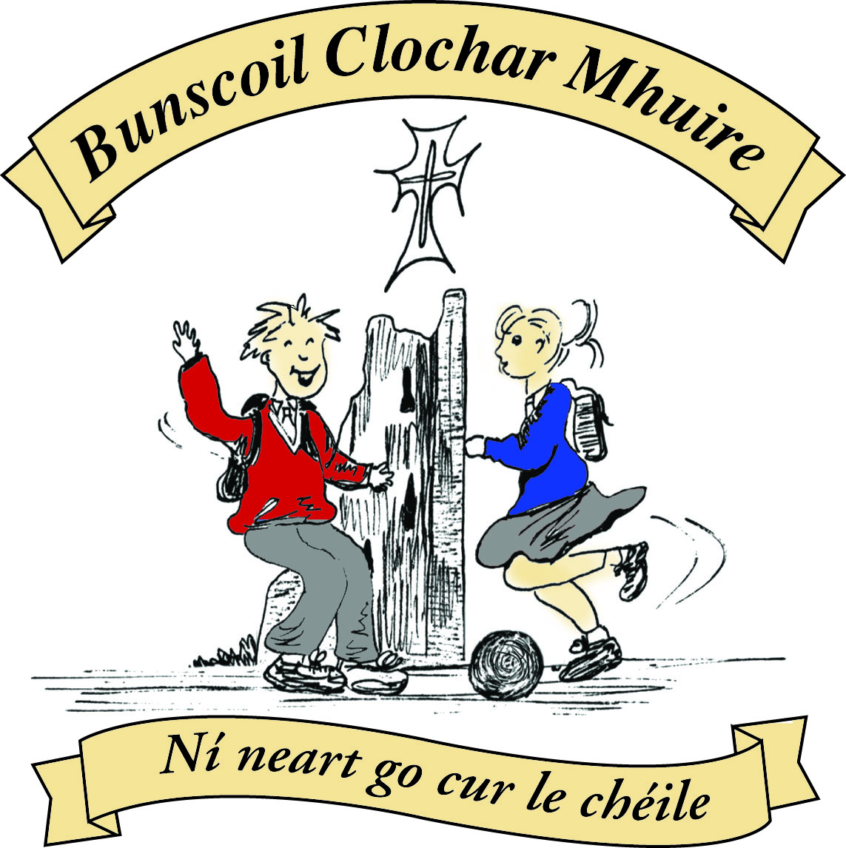* St Mary’s Convent Primary School**

***Bunscoil Clochar Mhuire***

***Trim, Co. Meath.  
Fón: (046) 9431919 ⦁ Faics: (046) 9437942  
Ríomhphost:*** [***marystrim@eircom.net***](mailto:marystrim@eircom.net) ***⦁ Website:*** [***www.stmarystrim.ie***](http://www.stmarystrim.ie) ***Uimhir Rolla: 16646O***

Awarded Green Flag  
June ‘05/’07/11/13

***Imlitir 5***

25th September 2017

***Every Day Counts at St Mary’s Convent Primary School***

***18th September - 22nd September 2017***

|  |  |  |  |  |  |  |  |
| --- | --- | --- | --- | --- | --- | --- | --- |
| **Room** | **Attendance** | **Room** | **Attendance** | **Room** | **Attendance** | **Room** | **Attendance** |
| **01** | **100 %** | 08 | 93.3% | 16 | 95% | 26 | 93.3% |
| 02 | 98.6% | 09 | 95.4% | 17 | 91.6% | 27 | 94.6% |
| 03 | 95.9% | 10 | 97.7% | 18 | 98.6% | 30 | 98.4% |
| 04 | 97.9% | 12 | 95.8% | 19 | 94.1% | 31 | 96.8% |
| 05 | 95.2% | 13 | 98.3% | 20 | 96.2% |  |  |
| 06 | 99.2% | 14 | 91.7% | 23 & 24 | 98.5% |  |  |
| 07 | 99.2% | 15 | 95.9% |  |  |  |  |

*Well done to room 1 on having full attendance last week and to rooms 6 & 7 for nearly making it. Their teacher will let them know their reward. Please note that notification in writing, with the reason for all absences, to the teacher is required. A letter or note in the homework journal will suffice.*

A chairde,

**Powerball:** Sponsorship cards were given out on Thursday last. All profits will be for our All-Weather Pitch (MUGA) Fund. I forgot to mention that the event takes place on October 12th and 13th. A timetable will be given out closer to the time to enable parents/guardians who wish to observe their child’s class participating. The card explains how it works. We hope that all can partake and any amount on the card will be accepted for participation, from First to Sixth classes. Children who do not wish to participate will be supervised in their classrooms. All Junior and Senior Infants may participate. Family combinations for the prizes may be requested from the teacher of the eldest child. We hope that a great fun day will be had by all and at the same time funds will be raised for the All-Weather pitch. Please do not send your children unaccompanied from house to house to get sponsorship.

Parents/guardians are reminded not to park in or drive through our school grounds. This is a Staff Car Park only. The less cars driving in that space, the safer it is for our children.

Thanks to all who supported Jersey Day on Friday September 15th. A total of €670 was raised for our School Sports Fund. The total in the Sports Fund now stands at €1670.88.

***Don’t Be Mean Behind Your Screen:*** On Thursday next at 7.30 in the Dr Eileen Reilly Hall, Paula O Connor will speak to parents/guardians about Cyberbullying and Internet Safety. If you have a child with a mobile phone or who may be getting one in the future, you need to be there!! Paula spoke to us last year and it was eye-opening. She really has her finger on the pulse of what young people are doing online. She will have conducted workshops with the Sixth classes earlier in the day and this is a follow-up to make sure that parents/guardians can re-enforce the message and advice she is giving them. The talk at night is for ***all*** parents, not just the parents of Sixth classes. Paula has been on “Claire Byrne live” in the past.

**Gum Shields**: Please note that we recommend that all players who partake in Football, Camogie or Olympic Handball practice or matches wear gum shields at all times.

**Outstanding Accounts:** Please come in and talk to us if you have accounts outstanding. We can make arrangements to suit your needs. Invoices will be sent this Friday September 29th. Remember we also facilitate online banking, just follow the link on the invoice. Thanks.

**Safety:** Parents are asked not to take home other children after school unless prior arrangements have been made with the other parents. Please also ensure that your children know your contact phone number. They can learn it off or use their homework journals. Thanks.

**School Library:** Many thanks to the parents who volunteered to help out with our school library. We will be contacting you shortly to set up a rota of helpers for Fridays. It is still not too late to volunteer. We are currently purchasing a new cataloguing system and should be open for business very soon.

***Computers***

*This week we will begin to type using Microsoft Word. Students from 2nd – 6th class will spend 10 minutes of each lesson learning to type using all 8 fingers and 2 thumbs ☺. We will then move on to the keys on the keyboard and the icons in Microsoft Word applicable to the lesson of the day.*

*The theme for this week is* ***ALL ABOUT ME****.*

*1st class will type up some sentences where they will fill in the blanks with their own information.*

*2nd – 6th classes work independently on information that they are willing to share about themselves e.g. hobbies, favourite food/movies etc.*

*Please encourage them to show you their work – work will be printed and stuck into their workbooks each week. Also if they have a computer/laptop available at home please encourage them to practise their typing skills.*

*Homework for next week:*

*1st class: Please help your son/daughter to complete some independent sentences about their family. How many cousins do they have? Do they have anyone famous in the family? Did you go on holiday? Who went with you?*

*2nd – 6th classes: Students have been asked to find out as much information about their grandparents/great grandparents as they can. When were they born? How many sisters and brothers did they have? Where did they live? What did they do for a living? Debby Walsh*

*Today we celebrated Mercy Day in our school. We are very proud and mindful of our Mercy roots here at St. Mary’s. We were honoured by the presence of 4 of our local Sisters of Mercy. The pupils sang hymns and participated in a prayerful celebration. Sr. Bríd read the following reflection:*

***The Door of Mercy***

*The door of mercy is double hinged, swinging in and opening out, sturdy yet easily moved.*

*Its single key is kindness, which is always in the lock, faithfulness is its lintel, hope and healing the strong jambs either side.*

*Mostly the door of mercy stands ajar. In spirit you cross its threshold each day, often unmindful but sometimes amazed at its familiarity.*

*Blessing is for all who come and go each day, helper and helped, all belonging and each bestowing.*

*It is said by many “You only have to knock once and you only have to knock lightly for the God of Mercy whose door it is, is always home”.*

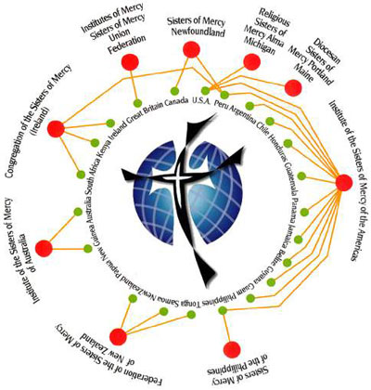

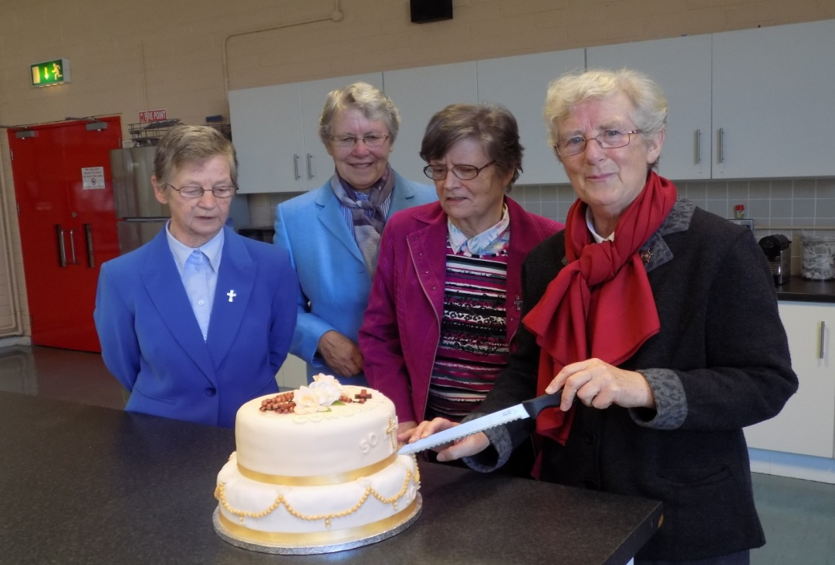

*S. Nally*

***First Holy Communion Class and Do this in Memory Programme 2017/18***

*Dear Parents and Guardians.*

*Your daughter is now in second class and is eligible to receive her First Holy Communion. This is a very special year for the children and indeed for you and your family as well. In order to initiate this programme and inform you of what is involved we invite you to a* ***Meeting of Parents and Guardians in St. Patrick’s Church on Thursday 28th September at 7.00 pm.*** *At this Meeting you will receive all the information you need and we will also set the date for the First Holy Communion next May. We will also endeavour to answer any questions or concerns you may have. There is no pressure but if you wish to enrol your child in the class please make every effort to attend as enrolment forms will be available at the meeting.*

***We look forward to meeting you on Thursday 28th at 7pm in St Patrick’s Church.***

*Fr Sean Henry*

*Fr. Warren Collier*

***Registration for Banna Ceoil***

*Banna Ceoil registration will take place tomorrow Tuesday 26th Sept from 3.00 – 3.30pm in the halla. Banna Ceoil is open to all pupils from 2nd – 6th and all are welcome. We practice most Tuesday’s after school and it’s a great opportunity to learn how to play music together in a fun environment. It is not necessary to be attending instrumental classes outside school, you can bring your tin whistle(feadóg) along. We look forward to seeing you on Tuesday 26th.*

*If you are not available to attend registration, your daughter can collect a form and return it to the school. There is a €5 fee to cover administration costs. The first practice will be the following Tuesday 3rd October. Second class finish at 3.30 until the Halloween break. After that they all finish at 4pm.*

*R McGale*

**Lost and found:** Unclaimed items will be donated to Lenrec this Friday. Please call to the school beforehand to check for missing items.

Finally, our Parents’ Association AGM will be on Thursday October 5th @ 7.00p.m. Parental involvement is crucial to a successful school and we would encourage at least one from each family to attend. It is not necessary for everyone to volunteer to go on the committee but your contribution will still be welcome. Perhaps there is an area of expertise (ICT, Green Initiatives, Gaelbhratach, Be Active, Healthy Schools etc.) which you might be able to offer or ideas to enhance the pupils’ educational experience at St Mary’s. I will address the beginning of the meeting regarding future plans for our school. Please come along.

Mise le meas



Cóilín Ó Coigligh,

Príomh Oide.

**Green News**

**Community News**

***Nathanna na Seachtaine:*** *Le do thoil / Más é do thoil  é (please)*

***Seanfhocal na Míosa:*** *Tús maith, leath na hoibre (A good start is half the battle)*

**Dates to Remember**

**Assembly: Green Flag** Friday 9.20

**Meitheal:** Every Tuesday morning 9.30-10.30.

**Mini-Rounders**: 3rd and 4th Classes - Mondays 3-4pm,

**Rounders**: 5th and 6th Classes - Mondays 3-4pm,

**Camogie: Tuesday 26th Sept 3.00-4.00 p.m. Third – Sixth Classes**

**Drama Club:** Every Thursday 3-4pm 4th – 6th Class

**Green News**

We are delighted to see the increase in numbers in our Walking on Wednesday groups. A big thank you to the WOW teachers and to the parents and pupils for keeping the initiative going. Meet up at Mornington house or at the matchbox at 9 am on Wednesdays.

The numbers for the Cycling campaign aren’t as high so we are going to take a break from cycling until the spring. We appreciated the effort that cyclists and their parents/guardians made as it involved extra organising in the mornings and after school. A sincere thanks also to Ms Buckley and Mr O’Mahoney who cycled with the children in the mornings.

Recycling continues at St Marys. We accept batteries, card, toilet rolls, small plastic bottles, cans, and ink cartridges. Well done to all the pupils who recycle regularly. Next Friday, Oct 6th, we will have a Clothes Recycling Drive. You may drop in any used clothes, textiles or shoes on Thursday Oct 5th. We will remind you again next week.

Our new Green theme is Energy under the Global Citizenship umbrella. This theme will enable us to discover how our Green Schools work has positively influenced people and their local environments worldwide. We will also concentrate on making further improvements to our energy management at school whilst facilitating and promoting active citizenship. We will offer more information every week about the Global Citizenship Energy theme and how we are addressing it at school.

***Remember Green is cool at home, at school and around the globe!***

**Community Notices**

Cyber-bullying Awareness & Internet Safety

Information Evening for Parents

**Facilitator:** **Paula O’Connor**

[](http://archives.jrn.columbia.edu/2011-2012/citybeats.info/wp-content/uploads/2011/12/CyberbullyComputer.jpg)

***“Don’t Be Mean Behind Your Screen”***

**Where?** **Dr. Eileen Reilly Hall, St. Mary’s Primary School**

**When?** **Thursday, Sept. 28th 7.30pm**

**ALL PARENTS/GUARDIANS ARE INVITED**

**Homework Club** in St Mary’s for children from 1st – 6th Classes. Application Forms are available from Ms Conaty Room 11 or Ms Lynch Room 31.

**Limelight Theatrics** - Performance Singing/Musical Theatre classes.  *Tuesday evening 6.15pm to 7.15pm (Under 12's)  & 7.30pm to 8.30pm (Over 12's) Wednesday 7.15pm to 8.15pm (mixed)

**DRAMA CLASSES**:  Tuesdays  5.15pm to 6.15pm (mixed age)  Wednesday 4.30pm to 5.30pm (mixed age) Wednesday 6pm - 7pm (Over 12's) Classes commence the week of 12th of September. Contact  Carmel McKiernan BA, LIBSD on 0863923334 for further info.

**ZUMBA**: -   Monday / Wednesday 8pm Trim GAA   -  €8 per class,  suitable for all fitness levels,  no booking/experience required.  Contact : Lorraine 086 8693546

**ZUMBA KIDS** :-   OCTOBER TERM NOW BOOKING -  Ages  4-8 Thursdays  2.15pm - 3.00pm,  St. Patrick's Hall Starting 5th October for 4 weeks,  €20 per child.  Contact :  Lorraine 086 8693546 / Jo  086 3381159

**Boyneside Speech & Drama**. Classes take place after school in St Michaels Primary School. And commence on Wed 6th and Thursday 7th September for students from senior infants to leaving cert.

Contact Dorothy on 087-2201981 or email [dorscully@gmail.com](mailto:dorscully@gmail.com)

Something for everyone at **Breathe Yoga & pilates**, Mum & Baby yoga Mondays 11.30am, Baby massage Fridays 11.30am, pregnancy yoga Thursdays 7pm. For more info & to book see [www.breatheyogapilates.ie](http://www.breatheyogapilates.ie)

**Grainne Kennedy Stage Academy** is a brand new performing arts school opening in Trim this September. Offering tuition in dance, drama, song and musical theatre to boys and girls aged 3-18, our aim is to build confidence, nurture talent and have fun! Join renowned choreographer Grainne at a FREE trial class on Sep 18th in Trim GAA from 4-5pm to see what's on offer. For more information, call 0863566061 or search GKStageAcademy on Facebook!

**AFTER SCHOOL CLUB** Taking place in St. Mary's School Trim from 2-3pm Mon - Friday in room 5 starting on the 18th September Only €6 a day or €25 for 5 days Mon-Fri Application forms available from reception. Booking required a week in advance of start date to insure space, and rebooking and payment made the previous Thursday each week after. Kids will be provided a small snack and entertained with Lego, Art & Craft, Board games, quizzes, card games, puzzles and lots more fun activities! Run by an experienced Childcare Professional Parent who is fully Garda Vetted and Insured. Contact Julie O'Donohue to book your child's space by texting 0868505310, emailing [juliekerins@hotmail.com](mailto:juliekerins@hotmail.com) or via a PM on the Facebookpage:[www.facebook.com/TrimAfterSchoolClub](http://www.facebook.com/TrimAfterSchoolClub)  
  
**Jiggle 'n' Jump** Music & Movement classes for little ones (8mths-4yrs) running upstairs in Trim GAA on Tuesdays 9.45-10.45am €7 a class or 4 class card for €25 Only €5 during September and all money raised on Tuesday 5th September is going to Crumlin Children's Hospital via Jack O'Donohue's A Bit of a Walk Fundraiser.   
  
Also available for Kids Party Entertainment! Various characters and themes with fun games, dancing, face painting and prizes! Clown, Pirate, a number of different Princesses, 80's Disco Diva, sporty Diva and Super Heroes available. Birthdays, Weddings, Christenings or family fun events.......in your home or in a venue, packages to suit any needs or budget. Contact Julie on 0868505310 or on Facebook [www.facebook.com/jigglenjump](http://www.facebook.com/jigglenjump)

**Go Bounce - bouncy castle hire - 0868398099.**

It's never the wrong time of year for bouncy castles. All of our castles are suitable for indoor use so can be put up in your local sports hall or community centre.

Check us out on [Www.Facebook.com/GoBounceMeath](http://Www.Facebook.com/GoBounceMeath) or [www.GoBounce.ie](http://www.GoBounce.ie) or call us on 086-8398099

**Touch typing course:**

Venue: St Marys NS, Trim,  Day and time :  Monday's @ 4.30 , Date: September 25th. Contact Jackie on 086-3780842

A touch tying course designed to develop the typing skills of children 8 years & upwards in a classroom environment with a qualified tutor. You can join the course any time as your child works at their own pace in a small class environment so each child gets the individual attention they need. Free trial first lesson.

This class is for all children but particularly helpful to kids with learning differences such as Dyslexia, Dyspraxia and Autism.

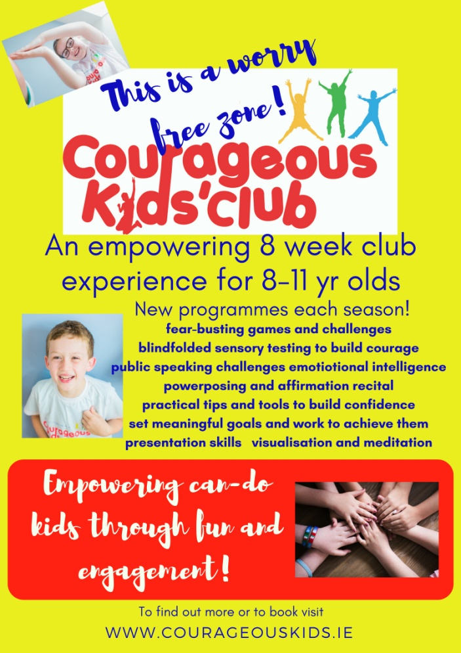

Courageous Kids Club is coming to the Aura Centre in Trim! Our 8 week Autumn/Winter programme aims to boost your child's courage and confidence as well as increase their emotional intelligence.  Your child will learn about fear, set goals, build courage through undertaking a variety of challenges including the blindfold taste test and lots more! Also features visualisation and meditation.  Spaces are limited. To find out more or to book visit [www.courageouskids.ie](http://www.courageouskids.ie)



*Mugendo Martial Arts Academy is a locally run Family martial arts school operating in Trim since 2007. Mu-gen-do Kickboxing is a new and fun way for children and adults to stay healthy and safe, while learning at the same time to have respect for themselves and others.  We conduct our classes in Aura Leisure centre Trim Monday to Friday for adults and children.*

*For a Free trial class please see the voucher.*

**Would you like to learn English? **



**Fáilte Isteach is a community based project which involves volunteers welcoming migrants to the community through conversational English Classes**

**Come and meet others who are learning too. Learn English in a relaxed atmosphere & make new friends along the way.**

**Contact: Rita Peacock Fáilte Isteach coordinator Trim 046-9438850**

**When: Thursday evenings (7pm-9pm) Starting 14th September**

**Where: Trim FRC2, Wellington avenue, Mornington Heights, Trim**

**Cost: € 2 (towards tea & coffee) € 5 for a book (if needed)**

**Levels: Beginners – Intermediate – Advanced**