 St Mary’s Convent Primary School**

***Bunscoil Clochar Mhuire***

***Trim, Co. Meath.  
Fón: (046) 9431919 ⦁ Faics: (046) 9437942  
Ríomhphost:*** [***marystrim@eircom.net***](mailto:marystrim@eircom.net) ***⦁ Website:*** [***www.stmarystrim.ie***](http://www.stmarystrim.ie) ***Uimhir Rolla: 16646O***

Awarded Green Flag  
June ‘05/’07/11/13

***Imlitir 39***

22nd June, 2016

***Every Day Counts at St Mary’s Convent Primary School***

***13th June - 17th June 2016***

|  |  |  |  |  |  |  |  |
| --- | --- | --- | --- | --- | --- | --- | --- |
| **Room** | **Attendance** | **Room** | **Attendance** | **Room** | **Attendance** | **Room** | **Attendance** |
|  |  |  |  |  |  |  |  |
| 01 | 93.8 % | 08 | 94.3% | 16 | 94.8% | 26 | 93.3% |
| 02 | 88% | 09 | 85.9% | 17 | 90% | 27 | 91.4% |
| 03 | 96.8% | 10 | 91.4% | 18 | 91.4% | 30 | 91% |
| 04 | 94.6% | 12 | 93.6% | 19 | 99.2% | 31 | 85.5% |
| 05 | 86.4% | 13 | 87.7% | 20 | 85% |  |  |
| 06 | 93.6% | 14 | 90.8% | 23 | 97% |  |  |
| 07 | 90.4% | 15 | 96% | 24 | 93.3% |  |  |

*Please note that notification in writing to the teacher is required for all absences. A letter or note in the homework journal*

*will suffice*.

A Chairde,

**School reports** were posted on Monday and also emailed, the same day. Next year we hope to do the majority by email and only post on request. If you have not received this year’s, please contact the school. If you have concerns about the report, feel free to make an appointment with teacher to discuss your concerns.

We ask you not to post any reports on Facebook etc. and if you have done so to please take it down. Thanks.

**Graduation Night** for the Sixth Classes will be on Thursday June 23rd @ 7.30 p.m for the girls and Friday June 24th for the 1st Class boys.

The total collected for **Jersey Day** on June 13th was €476.00. That brings our total in the Sports Fund over drawn by €835.29. Today’s Jersey Day should alleviate some of the overdraft.

**MUGA Update**: The total in our fund is €44,797.66. We are planning an “Oscars Night” early in 2017 to raise further funds. If our application for grant assistance through lottery funds is successful before this time next year, we hope to be in a position to start building the all-weather pitch then. We are currently applying for planning permission to ensure that this will not be an issue.

**Special Ed Playground:** The good news is that we will have a new playground completed when we return in September. Thanks to Ms Munnelly, Ms Finn and Ms Foley for all their assistance and to our BoM for approving the business plan to fund same.

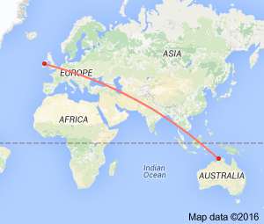

**Siúlaimis (Let’s Walk!)**

As a school we have walked 14,275 km

which means we have just arrived in Darwin, Australia

on our journey to St Patrick’s Primary School,

Koroit, Victoria, Australia.

Only another 3,000 km to go.

We can do it next week!

Is Féidir Linn!

Mise le meas,



Cóilín Ó Coigligh, Príomh Oide.

**Please keep the calendar below in mind while arranging vacations next year**

|  |  |
| --- | --- |
| **School Calendar 2016/2017** | |
| Return: | Wednesday 31st August 2016 |
| Mid-Term: | Monday 31st October - Friday 4th November 2016 |
| Christmas Break: | Friday 23rd December - Friday 6th January 2017 |
| Spring Mid-term Break | Thursday 23rd - Friday 24th February 2017 |
| Mid-term: | Monday 13th - Friday 17th March 2017 |
| Easter Break | Monday 10th April - Friday 21st April 2017 |
| May Bank Holiday: | 1st May 2017 |
| June Bank Holiday: | 5th June 2017 |
| School closes | Friday 30th June 2017 |

**Green News**

**Community News**

**Nath na Seachtaine**:  **Tá tuirse orm**

**Seanfhocal na Míosa:**  **Giorraíonn beirt bother/ Two shorten the journey**

**Dates to Remember**

**Meitheal:** Every Tuesday morning 9.30-10.30.

**School Choir:** Friday 3.00 – 4.00p.m

**Camogie:** Wednesday 3.00-4.00 p.m. Third – Sixth Classes

**First Class Boys Graduation:** Friday June 24th

**Sixth Class Graduation:** Thursday June 23rd

**Green News**

We are nearing the end of another year at St Mary’s. This year was Part I of the two year Global Citizenship theme which we will investigate further in September. The emphasis this year was on litter and waste. Here at school we promote a culture of recycling and reusing. Our Ceantar Glas accepts cans, batteries, ink cartridges, plastic bottles, postage stamps and cardboard. In the classrooms there is a bin for clean, reusable and recyclable materials and a bin for other waste. Our Green areas show our pledges to date. We will be composing one for Global Citisenship, so those of you who like to think up jingles and slogans may like to start thinking of ideas.

WOW has been very successful all year. We introduced a new meeting point at the Matchbox which has proven to be a good idea. Well done to all those who walk to school and a special thank you to the teachers who make that special effort every week to be at the meeting points to accompany the pupils up to the school.

COW has also resumed since the weather improved. Unfortunately not as many pupils participate in the cycling initiative. We appreciate that organising bicycles and bags on Wednesdays and getting to Steeple Manor isn’t feasible for everyone. We would like to congratulate the few cyclists that do make the effort every week and again a big thank you to the teachers who make the initiative possible.

Our garden is thriving after all the recent rain. The little sapling that came in the post which Frank planted last September has defied all odds and is really doing well. We will attach a before and after photo below. Sincere thanks to Frank and the gardening committee for all their time and attention to the garden. We are very proud of our Pride of Place achievement and we look forward to developing our wild flower and sensory garden next year.

As we close another year at St Mary’s we wish you all a safe, happy and green summer holidays. Hopefully we will all return rejuvenated, refreshed and ready for more green projects.

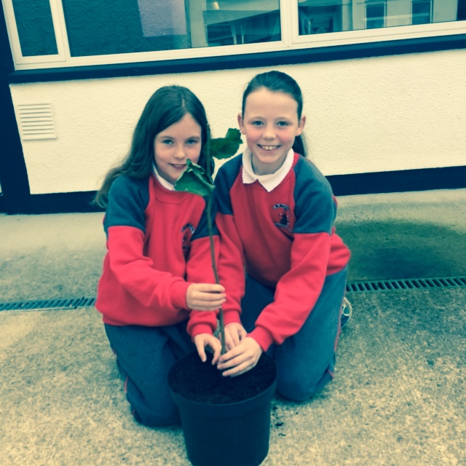

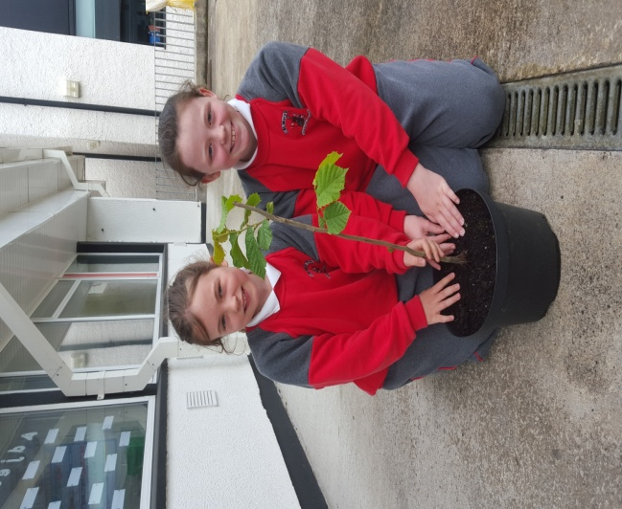

***Before After***

***Remember Green is cool, at home and at school and around the globe!***

**Community Notices**

**SUMMER CAMP** – St Mary’s Primary School July 4th – 8th 10.00am – 2.30pm. cost: €60. Activities include: Arts & Crafts, Baking and Science. For bookings contact The Office or Ms Carr/Ms Leavy.

**SUNSHINE SUMMER CAMP@TRIM GAA CLUBHOUSE** is back again this summer from 11th -15th July for five days of fun! There will be lots of sport, art, crafts, baking, dance, crazy science, pet corner, painting and lots lots more. Cost €60 (discounts apply for siblings) Call or Text Carla/Elaine on 0857497004/ 0861905362 for more information and find us on Facebook for more updates@ **Sunshine Summer Camp Trim**

**WHIZZ KIDZ SUMMER CAMP** – St. Mary’s Primary School, Trim from Monday 11th – Friday 15th July, 10.00 am – 2.00pm. Computer & ICT based activities, including: mini-movie making, podcasts, presentations and outdoor games. Cost: €60. For bookings contact Ms. Coakley (Room 26)

**Little Folks Academy, Knightsbrook.** Now taking bookings for limited ECCE places for September/January. Morning and afternoon spaces available. We cater for children from 3 months. Full time, part time, sessional and after school. Also running fun filled summer camps: Week 1: July 4th – 7th, Week 2 July 11th – 14th, Week 3 July 18th – 21st, Week 4 July 25th – 28th. €50 per child. For further information call 046-9486720/083 4354307

**ZUMBA**: -   No experience, partner or booking required -      **SUMMER IS JUST AROUND THE CORNER**:- MONDAY   8pm   Trim GAA,   €8 per class     Contact :  Lorraine  086 8693546

**ZUMBA KIDS** :-        Ages 5-10   TUESDAY    3.15pm    TRIM GAA   €6 per class  (Sibling rate €5)

Zumba,  Hip-Hop,  Rock 'n Roll,  Jive.............        Contact :  Lorraine  086 8693546 / JoJo  086 3381159

**Summer Stars Programme.** Meath County CouncilLibrary Service will run the Summer Stars Reading Programme for children in Trim Library during the summer holidays. It is a free programme and allchildren and families are invited to join in.See[**www.librariesireland.ie/summer-stars**](http://www.librariesireland.ie/summer-stars)for more details.

**JIGGLE 'N' JUMP** - has moved to the Trim GAA from April 5th. Music and Movement classes will be held in the front room upstairs (Where the parent & toddler group takes place) on a Tuesday at 9.45am and Saturdays at 10.30am. There will also be a new class starting for ASD kids or kids who suffer with anxiety, offering a more routine class where parents can see the progress each week. This will be held on Saturdays at 9.30am. Classes also on Wednesday 10am in Summerhill Community Centre. Please call Julie to enquire or book in! 0868505310.

**Antonia’s Bookstore** Drop your primary, secondary or third level school booklist into Antonia's Bookstore, Navangate, Trim as soon as you get it and we will start putting everything together for you - books, copies etc. and text you when it's ready for collection.

**SPECIAL OFFERS:**

Offer 1 - Pay in full by June 30th and qualify for free book covers.

Offer 2 - Pay in full by July 31st and qualify for half price book covers.

All school book orders whether paid in full or paid over the summer will get a back to school gift. Orders and payments can also be taken over the phone on 0469437532.

**Carney School of Irish Dancing** Classes in St. Patricks Hall every Tuesday. 2pm – 3pm & 3pm – 4pm. Every Friday @ 5.30pm. Infants and Senior infants can be collected from class rooms @ 2pm and left back to the buses @ 3pm. €5 per pupil per class. Contact Ann Carney 087-6336495

**Dance Force Academy Summer Camp**. 5-9yrs 11th - 14th July €50 and 10-13yrs 15th – 18th August €55

Contact 086-3591790

**Spar School Supply Centre** One stop shop for all your stationery needs. Free book covering for orders collected and paid for by July 15th 2016. Free €5 stationery voucher for every €25 spent on stationery up to July 15th 2016.