***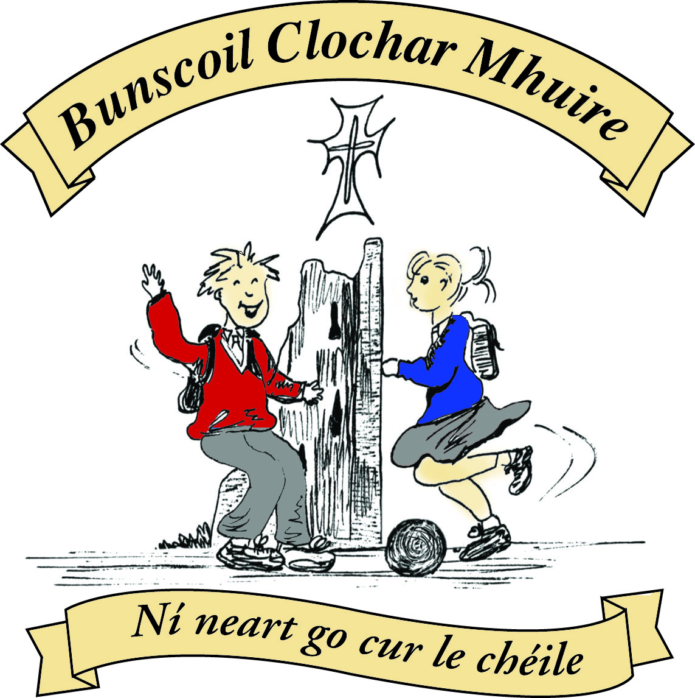* St Mary’s Convent Primary School**

***Bunscoil Clochar Mhuire***

***Trim, Co. Meath.  
Fón: (046) 9431919 ⦁ Faics: (046) 9437942  
Ríomhphost:*** [***marystrim@eircom.net***](mailto:marystrim@eircom.net) ***⦁ Website:*** [***www.stmarystrim.ie***](http://www.stmarystrim.ie) ***Uimhir Rolla: 16646O***

Awarded Green Flag  
June ‘05/’07/11/13

***Imlitir 38***

14th June, 2016

***Every Day Counts at St Mary’s Convent Primary School***

***6th June - 10th June 2016***

|  |  |  |  |  |  |  |  |
| --- | --- | --- | --- | --- | --- | --- | --- |
| **Room** | **Attendance** | **Room** | **Attendance** | **Room** | **Attendance** | **Room** | **Attendance** |
|  |  |  |  |  |  |  |  |
| 01 | 78.2 % | 08 | 88.1% | 16 | 87.7% | 26 | 86.4% |
| 02 | 90.7% | 09 | 87.7% | 17 | 96.9% | 27 | 91.7% |
| 03 | 85.3% | 10 | 95.2% | 18 | 92.9% | 30 | 93.1% |
| 04 | 94.9% | 12 | 96% | 19 | 98.7% | 31 | 83.9% |
| 05 | 91.7% | 13 | 87.2% | 20 | 91.7% |  |  |
| 06 | 92.9% | 14 | 91% | **23** | **100%** |  |  |
| 07 | 88.9% | 15 | 96% | 24 | 72.2% |  |  |

*Congratulations to Room* ***23*** *on having full attendance last week and to Room* ***19*** *who almost made it! Please note that notification in writing to the teacher is required for all absences. A letter or note in the homework journal will suffice*.

A Chairde,

Huge congratulations to the 5th and 6th Class Rounder’s team who won the Division 1 final yesterday against Cannistown at Navan O’Mahony’s. They were absolutely fantastic and did themselves and the school very proud. You’re all stars! Well done girls!

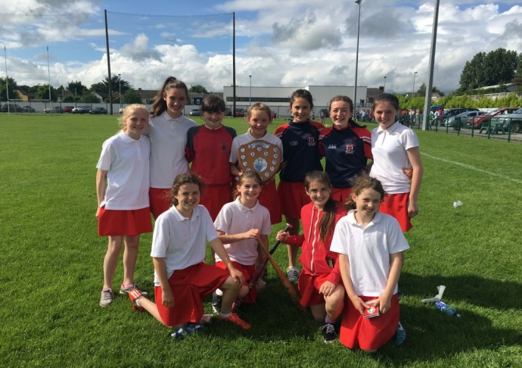

**Information Evening:** for new parents/guardians tomorrow Wednesday Night @ 8.00. Thursday (the next day) the pupils visit @ 2.15.

**School reports** will be available in advance, by email, on request only. Requests to [marystrim@eircom.net](mailto:marystrim@eircom.net)

Please let us know by email or phone call or note if your child will not be returning to us next September (excepting Sixth Classes and First Class boys).

**Talent Show** has been deferred until Monday June 27th.

A huge thank you to all in our school and community who have helped us secure our **Be Active Flag** which was raised by world championship swimmer and past pupil Eleanor Murray yesterday (see below).

Thanks to all who helped secure our **Pride of Place** award also (see below).

**Graduation Night** for the Sixth Classes will be on Thursday June 23rd @ 7.30 p.m. We will also be having a Graduation for First Class Boys on Friday 24th June @ 1.30p.m. This is during the school day to enable the girls wish them well also. More details to follow from the relevant class teachers.

***Active School Flag***

*A big thank you to everyone who took part in the raising of the Active School Flag on Monday 13th June. The Active School Flag is a Department of Education initiative which recognises schools that strive to achieve a physical active school community, by awarding them with an Active School Flag. (ASF)*

*The rain kindly stayed away as Ms Murray and Mr O Coigligh addressed the crowd. Our local hero Eleanor Murray along with Meath GAA development officer Christine O Brien, Rugby development coach Rory Bond and Meath hurler Ciaran O Rourke were present on the day to show their support. Eleanor hoisted the flag, the children Dropped Everything and Danced to Pop See Koo and the Banna finished up with Amhràn na bhFiann. A big thank you to the ASF committee, parents, teachers, pupils and our special guests for support on the day. Remember to keep ACTIVE during the summer holidays.*

*Ms Maguire, Ms Murray, Mr Galligan*

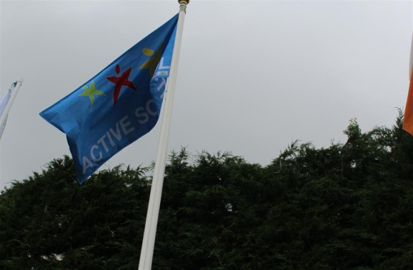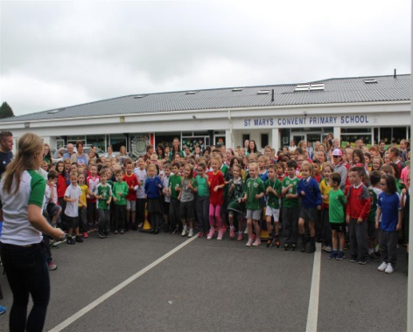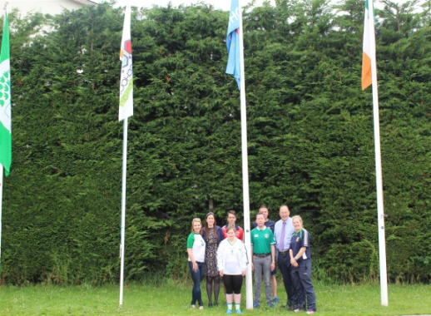

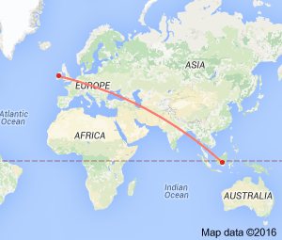**Siúlaimis (Let’s Walk!)**

As a school we have walked 11,900 km

which means we are just off the coast of Indonesia

on our journey to St Patrick’s Primary School,

Koroit, Victoria, Australia.

We will keep you updated in this Imlitir.

Mise le meas,



Cóilín Ó Coigligh, Príomh Oide.

**Please keep the calendar below in mind while arranging vacations next year**

|  |  |
| --- | --- |
| **School Calendar 2016/2017** | |
| Return: | Wednesday 31st August 2016 |
| Mid-Term: | Monday 31st October - Friday 4th November 2016 |
| Christmas Break: | Friday 23rd December - Friday 6th January 2017 |
| Spring Mid-term Break | Thursday 23rd - Friday 24th February 2017 |
| Mid-term: | Monday 13th - Friday 17th March 2017 |
| Easter Break | Monday 10th April - Friday 21st April 2017 |
| May Bank Holiday: | 1st May 2017 |
| June Bank Holiday: | 5th June 2017 |
| School closes | Friday 30th June 2017 |

**Green News**

**Community News**

**Nath na Seachtaine**:  **Tá mé i mo chónaí i mBaile Átha Troim**

**Seanfhocal na Míosa:**  **Giorraíonn beirt bother/ Two shorten the journey**

**Dates to Remember**

**Meitheal:** Every Tuesday morning 9.30-10.30.

**School Choir:** Friday 3.00 – 4.00p.m

**Camogie:** Wednesday 3.00-4.00 p.m. Third – Sixth Classes

**First Class Boys Graduation:** Friday June 24th

**Sixth Class Graduation:** Thursday June 23rd

**Green News**

Last week St Marys was awarded a Pride of Place award for the beautiful herb and vegetable garden which the pupils and Staff created in our courtyard. The adjudicator was suitably impressed by the children’s explanation of the work that was involved with their gardening project and he loved the scarecrows created by Rang a 5. Congratulations to all the gardeners! Check out the photos below!

This week is National Cycle to School week. We would encourage as many people as possible to make the effort this week. Wednesday is our COW day so we would really like to see lots of people out on their bikes that day. Meet inside Steeple Manor at 8:55am. Remember to wear your hi-viz vest and helmets!

WOW will also go ahead for those of you who would like to walk on Wednesday. Meet the teachers at either Mornington House or beside the Matchbox at 9 am.

Recycling also continues at St Marys. We recycle batteries, cardboard, small plastic bottles, postage stamps, ink cartridges and cans. Well done to all those who recycle regularly!

Global Citizenship is the Green theme for this year and next. Our emphasis is on litter and waste. We will be learning more about this over the next school year.

This is the last week of Springwatch 2016. Some of the classes have been keeping an eye on the four cameras. You will be fascinated by the behaviour in the nests. Modern technology has made it possible to get right in to these habitats, to see how eggs hatch and how the birds survive. To access the website click on the link below:

<http://www.bbc.co.uk/programmes/b007qgm3>

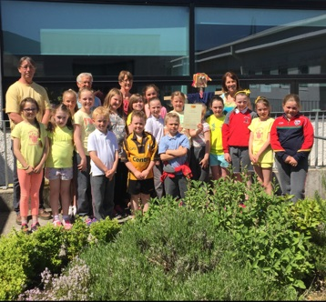

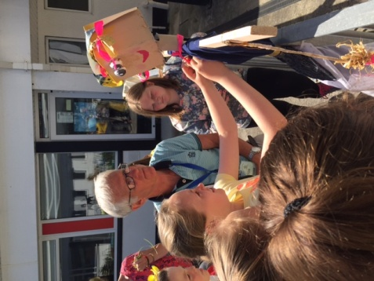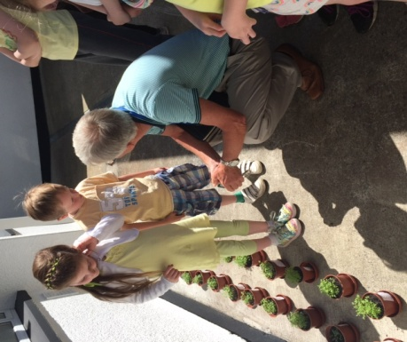

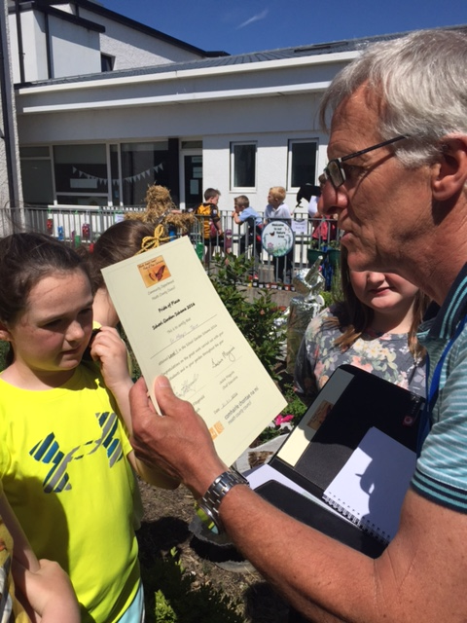

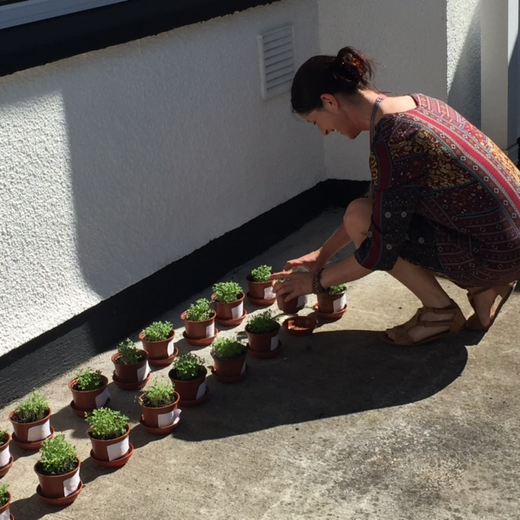

***Remember Green is cool at home and at school and around the globe!***

**Community Notices**

**Starcamp Summer Camp.** Open to ALL boys & girls aged 4-13 of ALL levels and abilities.

9.30 – 2.30 for 5 days. Free t-shirt, certificate & surprises. Fully trained, Garda-vetted professional leaders. €90 per child, €160 for 2 siblings, €220 for 3 siblings. Book now at [www.starcamp.ie](http://www.starcamp.ie) or ring 021-4377900.

**SUNSHINE SUMMER CAMP@TRIM GAA CLUBHOUSE** is back again this summer from 11th -15th July for five days of fun! There will be lots of sport, art, crafts, baking, dance, crazy science, pet corner, painting and lots lots more. Cost €60 (discounts apply for siblings) Call or Text Carla/Elaine on 0857497004/ 0861905362 for more information and find us on Facebook for more updates@ **Sunshine Summer Camp Trim**

**SUMMER CAMP** – St Mary’s Primary School July 4th – 8th 10.00am – 2.30pm. cost: €60. Activities include: Arts & Crafts, Baking and Science. For bookings contact The Office or Ms Carr/Ms Leavy.

**WHIZZ KIDZ SUMMER CAMP** – St. Mary’s Primary School, Trim from Monday 11th – Friday 15th July, 10.00 am – 2.00pm. Computer & ICT based activities, including: mini-movie making, podcasts, presentations and outdoor games. Cost: €60. For bookings contact Ms. Coakley (Room 26)

**ZUMBA**: -   No experience, partner or booking required -      **SUMMER IS JUST AROUND THE CORNER**:- MONDAY   8pm   Trim GAA,   €8 per class     Contact :  Lorraine  086 8693546

**ZUMBA KIDS** :-        Ages 5-10   TUESDAY    3.15pm    TRIM GAA   €6 per class  (Sibling rate €5)

Zumba,  Hip-Hop,  Rock 'n Roll,  Jive.............        Contact :  Lorraine  086 8693546 / JoJo  086 3381159

**JIGGLE 'N' JUMP** - has moved to the Trim GAA from April 5th. Music and Movement classes will be held in the front room upstairs (Where the parent & toddler group takes place) on a Tuesday at 9.45am and Saturdays at 10.30am. There will also be a new class starting for ASD kids or kids who suffer with anxiety, offering a more routine class where parents can see the progress each week. This will be held on Saturdays at 9.30am. Classes also on Wednesday 10am in Summerhill Community Centre. Please call Julie to enquire or book in! 0868505310.

**Antonia’s Bookstore** Drop your primary, secondary or third level school booklist into Antonia's Bookstore, Navangate, Trim as soon as you get it and we will start putting everything together for you - books, copies etc. and text you when it's ready for collection.

**SPECIAL OFFERS:**

Offer 1 - Pay in full by June 30th and qualify for free book covers.

Offer 2 - Pay in full by July 31st and qualify for half price book covers.

All school book orders whether paid in full or paid over the summer will get a back to school gift. Orders and payments can also be taken over the phone on 0469437532.

**Carney School of Irish Dancing** Classes in St. Patricks Hall every Tuesday. 2pm – 3pm & 3pm – 4pm. Every Friday @ 5.30pm. Infants and Senior infants can be collected from class rooms @ 2pm and left back to the buses @ 3pm. €5 per pupil per class. Contact Ann Carney 087-6336495

**Dance Force Academy Summer Camp**. 5-9yrs 11th - 14th July €50 and 10-13yrs 15th – 18th August €55

Contact 086-3591790

**Spar School Supply Centre** One stop shop for all your stationery needs. Free book covering for orders collected and paid for by July 15th 2016. Free €5 stationery voucher for every €25 spent on stationery up to July 15th 2016.