***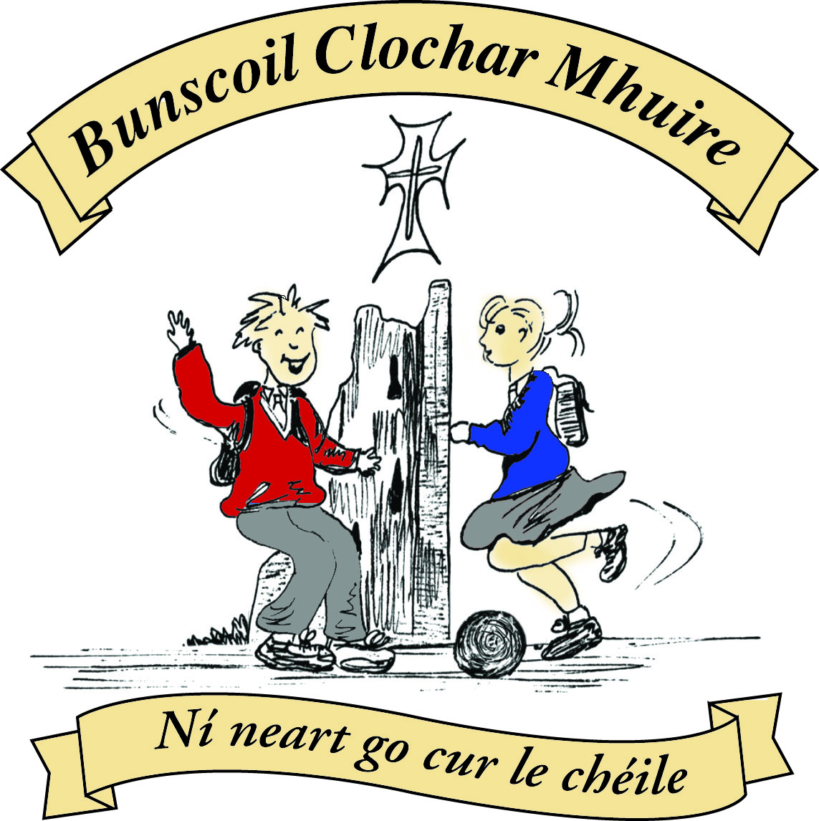* St Mary’s Convent Primary School**

***Bunscoil Clochar Mhuire***

***Trim, Co. Meath.  
Fón: (046) 9431919 ⦁ Faics: (046) 9437942  
Ríomhphost:*** [***marystrim@eircom.net***](mailto:marystrim@eircom.net) ***⦁ Website:*** [***www.stmarystrim.ie***](http://www.stmarystrim.ie) ***Uimhir Rolla: 16646O***

Awarded Green Flag  
June ‘05/’07/11/13

***Imlitir 37***

27th June, 2017

***Every Day Counts at St Mary’s Convent Primary School***

***19th June – 23rd June 2017***

|  |  |  |  |  |  |  |  |
| --- | --- | --- | --- | --- | --- | --- | --- |
| **Room** | **Attendance** | **Room** | **Attendance** | **Room** | **Attendance** | **Room** | **Attendance** |
| 01 | 86.9% | 08 | 92.8% | 16 | 88.1% | 26 | 92% |
| 02 | 95.2% | 09 | 93.5% | 17 | 96.9% | 27 | 85% |
| 03 | 92.2% | 10 | 97.1% | 18 | 96.7% | 30 | 94.6% |
| 04 | 85.2% | 12 | 89.3% | 19 | 91.4% | 31 | 94.3% |
| 05 | 81.5% | 13 | 98.7% | 20 | 80.7% |  |  |
| 06 | 92.3% | 14 | 85.7% | 23 & 24 | 98.5% |  |  |
| 07 | 88.8% | 15 | 85% |  |  |  |  |
|  |  |  |  |  |  |  |  |

***Annual Attendance from 31.08.2016 - 23.06.2017***

|  |  |  |  |  |  |  |  |
| --- | --- | --- | --- | --- | --- | --- | --- |
| **Room** | **Attendance** | **Room** | **Attendance** | **Room** | **Attendance** | **Room** | **Attendance** |
| 01 | 94.7% | 08 | 94.4% | 16 | 94.1% | 26 | 95.7% |
| 02 | 91.2% | 09 | 94.8% | 17 | 92.4% | 27 | 95.2% |
| 03 | 93.7% | 10 | 95.1% | 18 | 96.4% | 30 | 96.1% |
| 04 | 92.7% | 12 | 95.4% | 19 | 94.7% | 31 | 95.8% |
| 05 | 94.2% | 13 | 95.5% | 20 | 95.1% |  |  |
| 06 | 94.8% | 14 | 96.1% | 23 & 24 | 95.1% |  |  |
| 07 | 95.8% | 15 | 95.6% |  |  |  |  |
|  |  |  |  |  |  |  |  |

Congratulations to **Room 18** on having the best attendance this year and to Rooms **14 and 31** who almost made it! You will be mentioned at Final Assembly Friday @ 9.30. Thanks to all the classes for their efforts. Our School attendance has grown from 92% in 2012/13 to 94% last year to 94.8 this year.

A chairde,

School finishes for all pupils at 12.30 p.m. on Friday next 30th June. I am sure that we will all enjoy our well-earned rest and return refreshed on 31st August @ 9.20 a.m. Every good wish to those who are not returning, especially our First Class boys who graduated on Friday last and Sixth Class girls who will graduate on Wednesday night.

Two staff are retiring this year: Ms Beggy and Miss Catherine. I would like, on your behalf and on behalf of the children they have worked with, to thank them for the fantastic service they have given St Mary’s. I would like also to wish them all the best in the next chapter of their lives. *Go gcumhdhaí Dia iad* – may God always protect them.

We have just heard that Ms Thomas has secured a job in Cork and will not be returning to St Mary’s. We would like to thank her for her dedicated service to our school and to wish her every success in the rest of her teaching career.



**Siúlaimis (Let’s Walk!)**

Our total for the Siúlaimis was 27,675km which means we reached our target of walking around the world.

An-mhaith ar fad.

Congratulations to everybody.

Now, where to next year?

As we come to the end of another productive year in St Marys, it is time to reflect. I am not going to list all the excellent **extra-curricular activities** that we are involved in, as it is a very long list, but I would like to thank the teachers for the extra time and commitment that they give to enable our children to have a wide range of extra-curricular experiences. A special word of congratulations to our Rounder’s team who became Meath Champions for the second year running and the pupils who won medals in the Meath Cross Country and Meath Athletics. Our annual **Christmas Pageant** in The Dr Eileen Reilly Hall, performed this year by our Fifth and Sixth Classes was spectacular. A total of €1,473 was raised for Trim St Vincent de Paul and Trim Meals on Wheels through this Pageant and the many Nativity Plays which took place in the classrooms. Our Communion, Confirmation preparations, Cór (choir) and Banna were excellent. We are fortunate to have both a band and a choir in St Mary’s and they, as well as exposing our pupils to the joys and rigours of public performances, add so much to so many of our school occasions. I would like to thank the pupils for their efforts with **Banna** and **Cór**. On behalf of the children and parents, a big “thank you” to the many teachers who gave so generously of their time and expertise from a very musically proud principal!

Our Annual **Talent Show** took place on Friday 2nd June and there was much excitement around the place. €681.65 raised will be donated to *Childline and Dogs Trust Ireland* . Well done to all who had the courage to stand up and perform in front of a full hall.

In terms of technology, this year we have continued initiatives with the introduction of Pro-bots and the purchase of six Raspberry Piis**. Our Digital Fair takes place on Thursday next from 1.00-3.30.** First and Second Classes will be demonstrating Bee-Bots; Third Classes Augmented Reality; Fourth Classes Podcasts; Fifth Classes 3-D printing and Sixth Classes Pro-Bots. There will also be demonstrations of Powerpoint and Scratch. Many thanks to all staff who helped keep ICT to the fore in our school and in particular to Ms Debby our ICT teacher and support technician.

I have enclosed copies of our school standardised tests results. The overall school score in the teaching of Irish, as assessed in standardised tests administered in May, showed that our school was well above the national average. *Táimid lán sásta le sin*. If you look at the enclosed chart you will see that the school scores in red are well ahead of the national average in blue. Indeed if you look at our standardised test results in English and Maths, we are also ahead of the curve nationally.

This year we were awarded our seventh **Green Flag** and have continued our work towards **Healthy Schools**, **Active Schools and Gaelbhratach**. Thanks again to the many committee members of staff, pupils and parents for their great efforts. Our new Sensory Garden was awarded the **Pride of Place Award** from An Taisce and it is great to see pupils using it on a daily basis.

A big thank you to our **Parents’ Association** for their support and assistance this year. It is greatly valued and appreciated. Thanks also to the parents who volunteered as “Listeners” *Meitheal*, Library etc. This is an invaluable support for our school. A big “thank you” to Frank, Helen, Rebecca, Monica, Bernie and Jenny, SNAs and teachers who make up such a great staff.

We are most grateful to Miss Cathy and Ms Denise for all the work they did for our school as part of the Tús Scheme this year. We wish them all the best in whatever the future holds for them.

As we approach the end of the school year, we are also coming to the end of another successful year of our lunchtime **Book Club** for students from 4th-6th classes. They meet for the last term and completed two books in that time. I would like to take this opportunity to thank teacher and also the girls for participating and giving some great feedback. The **Drama Club** met on Thursdays 3.00-4.00 and over 60 signed up! They did improvisation, script reading and other drama activities associated with process drama rather than performances. Our **Be Active** after school initiative was a resounding success also. Thanks again to the teachers and students for their efforts.

We had another busy year on the fundraising front and are delighted to be able to proceed next year with the construction of our All-Weather Pitch and Ball Wall. On behalf of the present and future pupils of our school, I wish to thank our whole school community for their efforts in making this a reality. Our thanks also to our Board of Management for enabling us to proceed immediately with the project and for sharing in our vision.

Please note that next year’s Junior Infants finish @ 12.00 for the first two weeks and next year’s First Class finish @ 2.00p.m. for the same time.

Listed underneath are the teachers and their classes (subject to change) for next year 2017/2018:

|  |  |  |
| --- | --- | --- |
| Rang | Seomra | Múinteoir |
| N. Bheaga | 1 | Ms Cullinane |
| N. Bheaga | 2 | Mr O Mahony |
| N. Bheaga | 3 | Múinteoir Nua |
| N. Bheaga | 4 | Ms O’Brien |
| N. Mhora | 5 | Múinteoir Nua |
| N. Mhora | 6 | Ms McKenna |
| N. Mhora | 7 | Ms O’Connor |
| N. Mhora | 8 | Ms Carr |
| Rang 1 | 9 | Ms Dalton |
| Rang 1 | 10 | Múinteoir Nua |
| SET 1 | 11 | Ms Conaty |
| Rang 1 | 12 | Ms Maguire |
| Rang 1 | 13 | Ms Mulvihill |
| Rang 2 | 14 | Ms Roche |
| Rang 2 | 15 | Ms McGale |
| Rang 3 | 16 | Ms Coakley |
| SET | 16a | Ms Foley |
| Mixed Class | 17 | Ms Finn |
| Rang 3 | 18 | Ms O’Hare |
| Rang 4 | 19 | Ms Dixon |
| Rang 4 | 20 | Ms Hoey |
| SET 2 | 21 | Ms Flattery |
| SET 3 | 22 | Ms Harte/Ms Minogue |
| Language 1 | 23 | Ms Rickard |
| Language 2 | 24 | Ms Dully |
| SET | 25 | Ms Murray |
| Rang 5 | 26 | Ms Leavy |
| Rang 5 | 27 | Ms Dineen |
| SET | 28 | Ms Buckley |
| SET | 29 | Múinteoir Nua |
| Rang 6 | 30 | Mr Galligan |
| Rang 6 | 31 | Ms Lynch |
| SET | Seomra Nua | Ms Munnelly |

Following is our annual ***estimated*** statement of Computer Contribution spending. Our thanks again to Ms. Debby who teaches computers, does our technical support and acquires many donations of free computers and components. She is a very valuable and much appreciated asset to our school.

|  |  |  |
| --- | --- | --- |
| **Details** | **Credits** | **Debits** |
| **Balance Forward Sept 2016** |  | **€0.00** |
| Voluntary Family Contribution | €13,065.49 |  |
| Equipment |  | €486.31 |
| Tech Support & Wages |  | €13,115.65 |
| **TOTAL** | **€13,065.49** | **€13,601.96** |
|  |  |  |
| **Balance to be paid by Board of Management** | **-€536.47** |  |

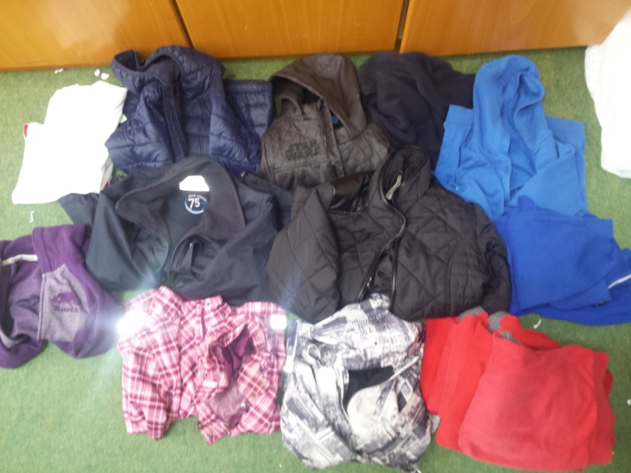

**Lost and found:** Unclaimed items will be donated to the St Vincent De Paul, at the end of June. Please call to the school before we close to check for missing items.

We are indebted to **Fr Declan** our Chaplain who was most generous with his time. His frequent presence enriched, in no small way, our pupils’ engagement with both the Sacraments and religious education.

To finish, our school has been complimented many times in relation to the fabulous resources that we have, but the best resources we have are the people, big and small, who make up the human element that produces such wonderful results. Through the efforts of our pupils, nourished by the talents of the staff and supported by the parents/guardians, we can be truly proud of a wonderful year. *Dia go deo libh ar fad.* May God’s blessings be with you always.

|  |  |
| --- | --- |
| **School Calendar 2017/2018** | |
| Return: | Thursday 31st August 2017 |
| Mid-Term: | Monday 30th October –Friday 3rd Nov 2017 |
| Christmas Break: | Monday 25th Dec 2017 - Friday 5th January 2018 |
| Feb Mid-term Break | Thursday 15th & Friday 16th Feb 2018 |
| St. Patrick’s Day | 19th March 2018 (Monday) |
| Easter Break | Monday 26th March – Friday 6th April 2018 |
| May Bank Holiday: | Week Monday 7th – Friday 11th May 2018 |
| June Bank Holiday: | Monday 4th June 2018 |
| School closes | Friday 29th June 2018 |
|  |  |

*Bíodh samhradh deas agaibh go léir.*



Cóilín Ó Coigligh, Príomh Oide.

**Green News**

**Community News**

**Nathanna na Seachtaine:** Slán agus Beannacht

**Seanfhocal na Míosa:** Ní chronaítear an t-uisce go dtriomaítear an tobar

**Dates to Remember**

**Whole School Assembly: Friday @ 9.30**

**School Closes @ 12.30 Friday 30th for Summer Holidays**

**Green News**

We are nearing the end of another year at St Mary’s. This year was Part 2 of the two year Global Citizenship themefor which we were awarded our 7th Green Flag. The emphasis this year was on litter and waste but we revised all our other themes and developed our school garden.

Here at school we promote a culture of recycling and reusing. Our Ceantar Glas accepts cans, batteries, ink cartridges, plastic bottles, postage stamps and cardboard. In the classrooms there is a bin for clean, reusable and recyclable materials and a bin for other waste. Our Green areas show our pledges to date. Well done to the pupils who religiously recycle and practise green habits at home too.

WOW has been very successful all year. Our new meeting point at the Matchbox has proven to be a good idea. Well done to all those who walk to school and a special thank you to the WOW teachers (Ms Finn, Ms Heffernan and Ms Flattery) who make that special effort every week to be at the meeting points to accompany the pupils up to the school.

COW (Cycling on Wednesdays) needs a bit of a boost. Unfortunately not as many pupils participate in the cycling initiative. We appreciate that organising bicycles and bags on Wednesdays and getting to Steeple Manor isn’t feasible for everyone. We would like to congratulate the few cyclists that did make the effort and we hope that we will get the initiative going again in September. Again a big thank you to the teachers who make the initiative possible, Mr O’Mahoney, Ms Buckley, Ms O’Hare and our secretary Rebecca.

Sincere thanks to our gardening committee for all their time and attention to the garden. We are very proud of our Pride of Place achievement this year and the beautiful sensory garden we have created.

All are welcome at 10:30 on Thursday for our **Flag Raising Ceremony**. Aidan Gray from An Taisce will do the honours. We thank him and Brian Heffernan of Trim Tidy Towns for their continuous support of our Green initiatives.

As we close another year at St Mary’s we wish you all a safe, happy and green summer holidays. Hopefully we will all return rejuvenated, refreshed and ready for more green projects. Remember to keep Trim tidy during the summer months. Many visitors come through our beautiful town during the summer and marvel at it. Be proud, be green and be grateful!

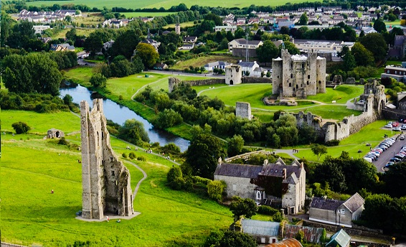

**Remember Green is cool at home and at school and around the globe!**

**SUMMER CAMP** – St Mary’s Primary School July 3rd – 7th 10.00am – 2.30pm. cost: €65 (Family discounts apply). Activities include: Arts & Crafts, Sports, Music & Dance, Baking and Science. For bookings contact The Office or Ms Carr/Ms Leavy.

**Limelight Theatrics** - Registering now for September. Speech, drama and singing classes. Classes are held on Tuesday & Wednesday. Contact  Carmel McKiernan BA, LIBSD on 0863923334 or through the Limelight Theatrics Facebook page, class times are listed on Facebook.

**Zumbathon Charity Event** for School Building Project in Kenya. Monday 12th June Trim G.A.A. 7.30 – 9.30 pm tickets €10 per person. All proceeds to Friends from Ireland. Contact Lorraine 086-8693546, Jo 0863381159 or Fionnuala 086-8225277.

**Jiggle 'n' Jump**

Music & Movement classes for little ones (8mths-4yrs) running upstairs in Trim GAA on Tuesday 9.45-10.45am  €7 a class or 4 class card for €25

Also available for **Kids Party Entertainment!**

Various characters and themes with fun games, dancing, face painting and prizes! Clown, Pirate, Princess, 80's Disco Diva, Sporty Diva and Super Hero available.  New Party Package insures 2 hours of non stop entertainment, with face painting by Linda (Flawless Facepaint) while I entertain the kids with singing, dancing, party games and non stop fun!!  Contact Julie on [0868505310](tel:0868505310) or on Facebook [www.facebook.com/jigglenjump](http://www.facebook.com/jigglenjump)

**Go Bounce** Looking for ideas to keep the children entertained during the holidays? Check out our range of bouncy castles on [www.Facebook.com/GoBounceMeath](http://www.Facebook.com/GoBounceMeath) or [www.GoBounce.ie](http://www.GoBounce.ie). All castles are safety certified & insured and are available at very reasonable rates.

**Stage Stars Summer Camp:** The camp is running from July 24-28 from 10.00 - 2.00 in Scoil Mhuire (with an optional earlier drop off time) and is open to girls and boys aged 4-12. It will be an action packed week of singing, dancing, drama and arts and crafts with finishing certificates and an end of week performance for family and friends! The camp is €80 per child with sibling discounts as well as an early bird offer if booked and paid in full by June 9th. Guaranteed to be the most fun filled week of your summer! For more information call 0863566061 or see Facebook.com/stagestarssummercamp

**Trim Tennis Club**: Summer programme starts on 4th July. It runs every Tuesday and Thursday for the month of July. Under 10’s: 10am – 12 noon. Over 10’s & Teenagers 2pm – 4pm. This programme is run by the club coach Margaret Drew. It is pay-as-you-go. Daily rate €5 for members and €7 per non members. No pressure to attend every week.

**Kids Camp: A sunny camp for sunny champs. St Mary’s School Monday 17th – Friday 21st July. 9.30 – 2.30pm. Arts & Crafts, Sports and sports league, treasure hunts, music & dance, summer picnic, science experiments. €55 per child or 2 or more €50.**

**Camp Kilimanjaro**  
All Primary school children are invited to Camp Kilimanjaro, running from Monday 3rd to Friday 7th July 10am – 1pm. In this Safari themed camp adventure children will do crafts and science experiments, games, songs, snacks, and a short teaching time about wisdom from the Book of Proverbs. The camp is €15 for the first child, €25 per family. Online registration at [www.livinghope.ie](http://www.livinghope.ie) or register on Monday morning at the venue. Venue: Living Hope Church, NavanGate St. For more information visit [www.livinghope.ie](http://www.livinghope.ie) or phone Ciaran at 086 346 5224.

**Drumcondra Irish 2016/20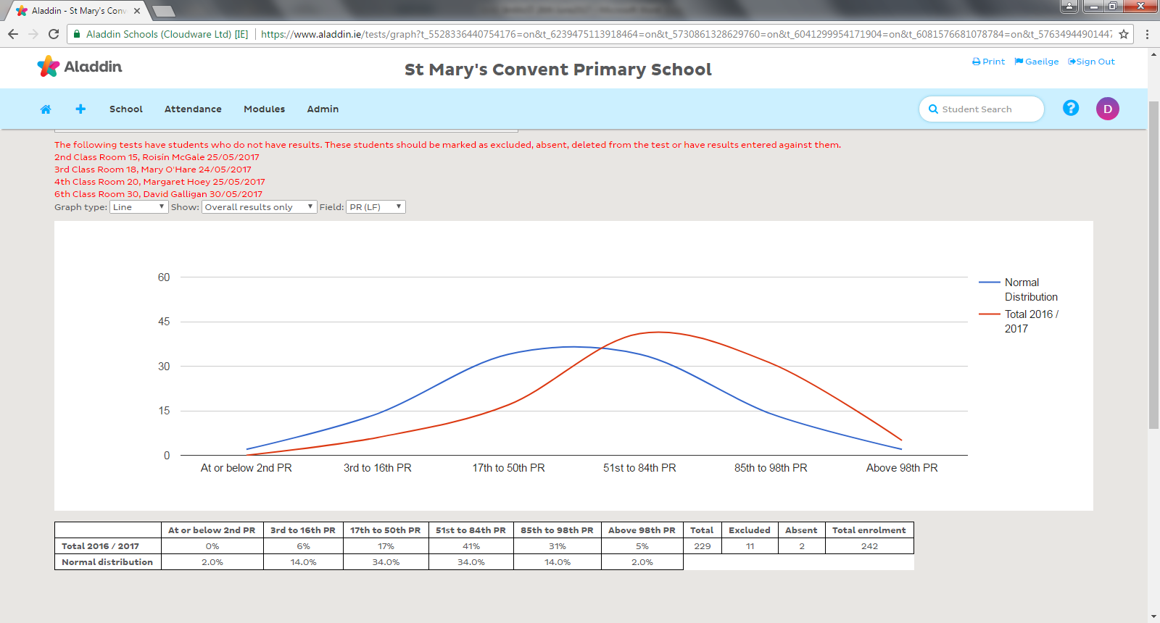17**

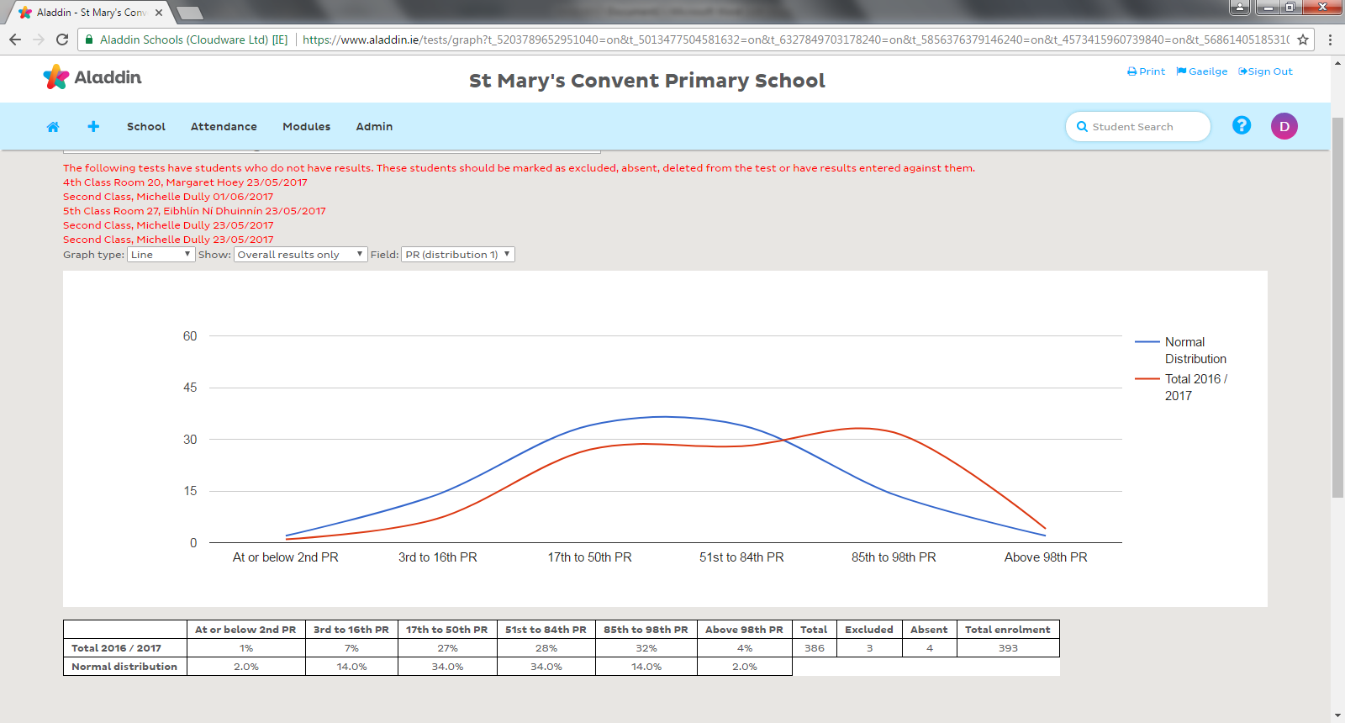

**Drumcondra Reading 2016/2017**

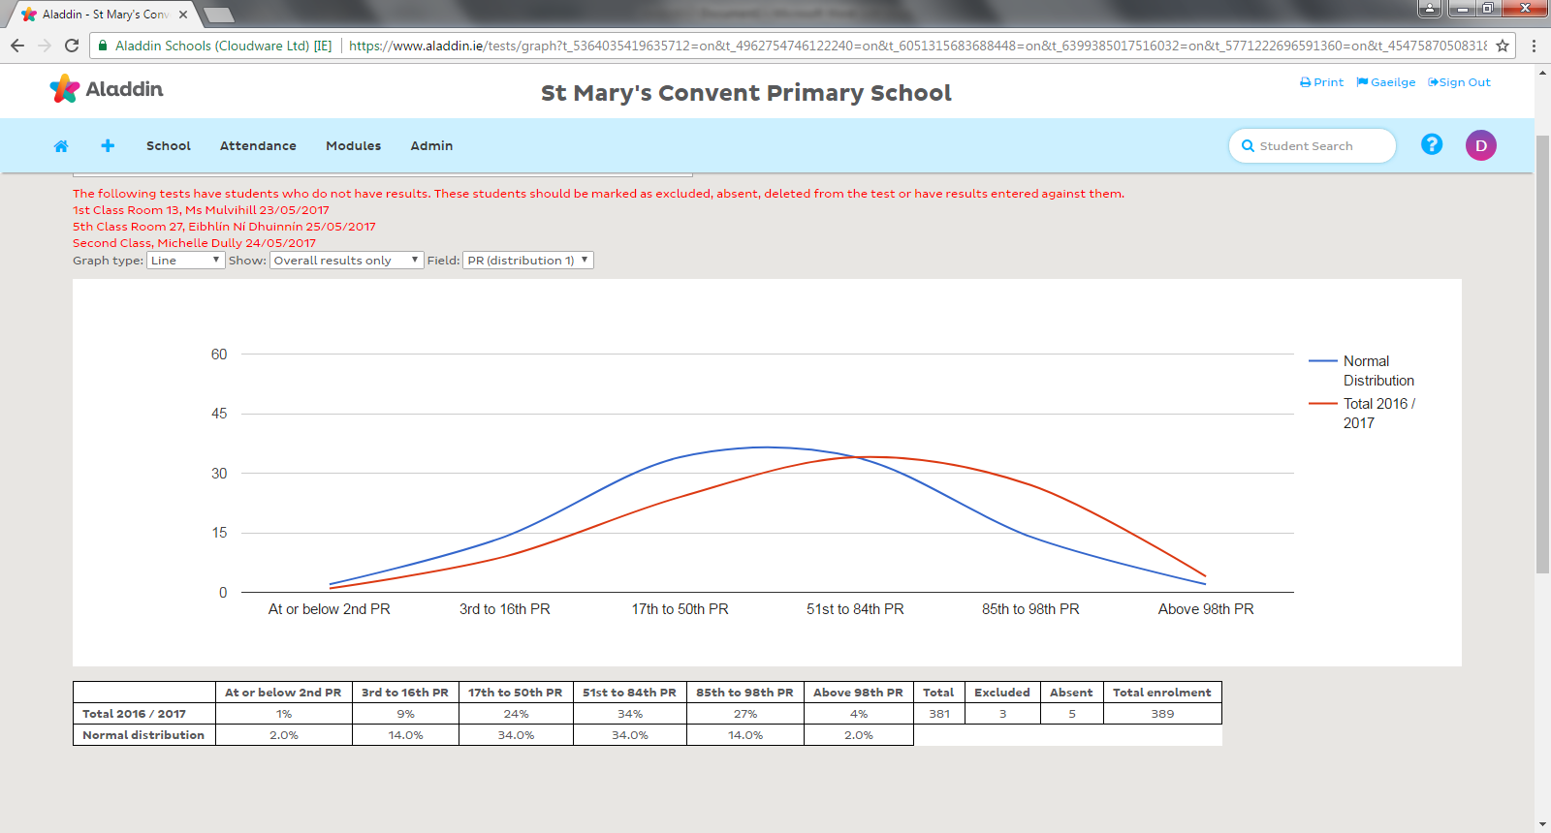**Drumcondra Maths 2016/2017**