***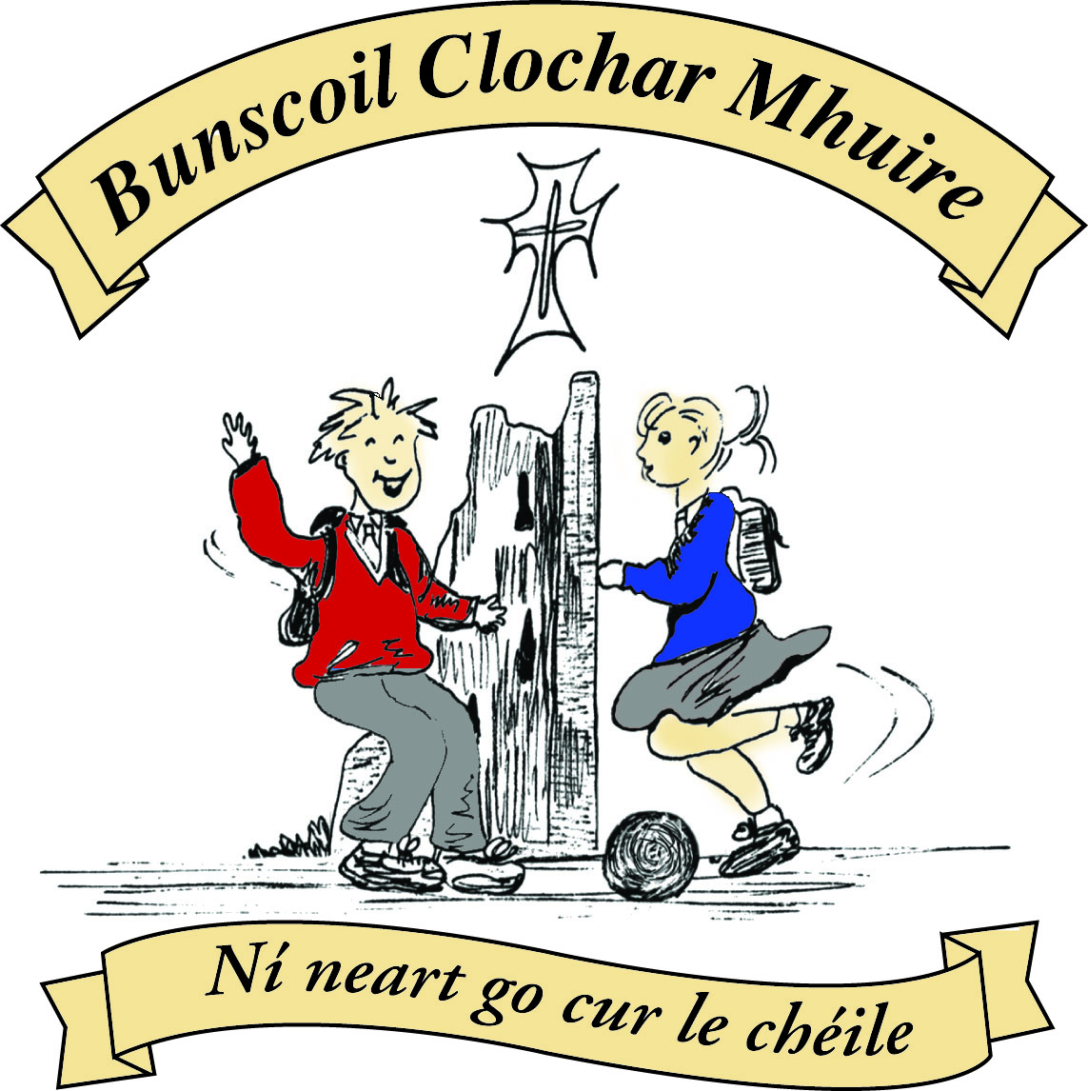* St Mary’s Convent Primary School**

***Bunscoil Clochar Mhuire***

***Trim, Co. Meath.  
Fón: (046) 9431919 ⦁ Faics: (046) 9437942  
Ríomhphost:*** [***marystrim@eircom.net***](mailto:marystrim@eircom.net) ***⦁ Website:*** [***www.stmarystrim.ie***](http://www.stmarystrim.ie) ***Uimhir Rolla: 16646O***

Awarded Green Flag  
June ‘05/’07/11/13

***Imlitir 36***

30th May, 2016

***Every Day Counts at St Mary’s Convent Primary School***

***23rd –27th May, 2016***

|  |  |  |  |  |  |  |  |
| --- | --- | --- | --- | --- | --- | --- | --- |
| **Room** | **Attendance** | **Room** | **Attendance** | **Room** | **Attendance** | **Room** | **Attendance** |
|  |  |  |  |  |  |  |  |
| 01 | 96.2 % | 08 | 96.4% | 16 | 97% | 26 | 94.1% |
| 02 | 91.2% | 09 | 97.8% | 17 | 96% | 27 | 95% |
| 03 | 99.2% | 10 | 97.9% | 18 | 94.3% | 30 | 99.3% |
| 04 | 93.8% | 12 | 90.8% | 19 | 97.6% | 31 | 92% |
| 05 | 95% | 13 | 87.7% | 20 | 98.3% |  |  |
| 06 | 93.6% | 14 | 96.2% | **23** | **100%** |  |  |
| 07 | 97% | 15 | 97.6% | **24** | **100%** |  |  |

A Chairde,

Congratulations to Room **23 &** **24** on having full attendance last week and to Room **3 and 30** who almost made it! Please note that notification in writing to the teacher is required for all absences. A letter or note in the homework journal will suffice.

Our **First Holy Communion** on Saturday was magnificent and we all have very happy memories of the special day the girls received the Body of Christ for the first time. Fr Declan presided over a most prayerful ceremony. The girls can be very proud of their participation in the Mass with beautiful singing, prayers and offertory procession. Many thanks to Mrs McGale and Mrs Roche who prepared the children so well; to Helen, Rebecca and Ms Debby who produced the booklet, to Frank our caretaker, and to Mrs Nally, Ms McKenna, Ms O’Connor, Ms Murray, Ms Brennan, Mrs O Brien and Ms Cullinane who did wonderful work with the choir and band. The choir and band were outstanding. A big thank you to the girls who gave generously of their time at practice and on the day. Our thanks also to the Parents’ Association and the First Class parents, who provided catering in the school afterwards and helped create a great sense of community celebration. It was a huge amount of work but is greatly appreciated. Thanks again to the **Do This in Memory of Me Committee** for their assistance not just last week but during the whole year.

**Active Schools’ Flag:** We are delighted to announce that we have been awarded our latest flag and will officially launch and raise it on Monday June 13th. Congrats to all who helped, especially those on the committee. More details from Ms Murray to follow.

**Yellow Day:** We currently have a child receiving treatment for cancer in Crumlin Hospital and would like to do some fundraising for this cause. On Thursday June 2, children may come to school dressed in yellow, if they wish to make a donation.

**End of year Reports:** will be posted on Monday June 20th . This will allow you time to make an appointment to see us, before school closes, should you have any concerns. Please contact us by the Wednesday if you have not received yours. This year, for the first time, we are offering an email only service. If you wish to be a “friend of the earth” and save a few trees in the Amazon or if you cannot wait for the post, please request by email only (marystrim@eircom.net) and we will email you on Monday June 20th.

***Intercultural Week :*** *This week (Mon. 30th May – Thursday 2nd June) is a chance for all of us, parents, teachers and children, to learn about the many different countries, languages and cultures in our school. If any parents /minders/grandparents are available to read a story in your own home language (Polish, Lithuanian, Tagalog, Malayalam etc ) please contact the school. We have some beautiful picture books in two languages in the school. If you have any other traditions or customs that you would like to demonstrate we would love to hear from you. You might like to talk to a class about your home country or send in some costumes/photos/pictures.*

*R.McGale*

***Sport’s Day 2016****: Last Wednesday, May 25th, was Sport’s Day at St Mary’s. Over 600 pupils took part in a wide variety of fun and energetic events.*

*The day began with a Treasure Hunt around the school grounds for pupils in Junior Infants and Senior Infants. After the morning break, all classes were brought outside to participate in activities which were set up in the form of stations – these included penalty kicks, obstacle races, basketball shots, sack races, beanbag hops, dribbling, accuracy throws, tyre rolling, tunnel ball and many others. Classes moved from station to station with their teachers, earning points for their relevant teams – red, white, blue and yellow.*

*Pupils took part in class races and/or games after lunch. Mr Ó Coigligh announced the winning team on the steps of the PE Hall before the junior classes went home and the yellow team were victorious. Zumba Dancing provided the entertainment for the final hour and it proved to be a massive hit with all present. A selection of photos capturing the day’s activities has been uploaded onto the school website –*[*www.stmarystrim.ie*](http://www.stmarystrim.ie/)*. Feel free to check them out!*

Míle buíochas*to everybody who helped, in any way, shape or form, to make our Sport’s Day the great day that it was! D. Galligan*

***Be Active Week.*** *We had a very successful week, with all of the children doing different physical activities every day. A huge thank you to all of our volunteers:*

* *For the use of their facilities – Trim Tennis Club*
* *Ronan Marmion – coaching tennis*
* *Lyndsey Barnewell (LB Fitness) – doing exercises with Junior Infants*
* *Rory Bond – Coaching Tag Rugby*
* *Mien Ronney: Yoga*
* *Ciarán O’Rourke – GAA*
* *Pauline Dwyer – Fun Stretching*
* *Lorraine Pidgeon – Zumba*

*Thank you to all our staff also, particularly Ms. Carr & Ms. Coakley (outdoor & Adventure activities), Ms. McKenna (skipping skills) and Mr. Galligan (wonderful Sports’ Day), our fantastic Transition Year Students and the Parent’s Association.*

*I hope everyone enjoyed it. If there is anyone who would like to volunteer for next year’s Be Active Week, please get in touch!*

*Ms. E. Murray*

**BOOK GRANT SCHEME**: If any parent has a genuine need due to neither parent/guardian working or prolonged illness, they may apply for help with buying books for the next school year. All applicants may be means tested. Please apply on the form below and return to the school no later than FRIDAY 10th JUNE. No forms will be accepted after that date.

Mise le meas,



Cóilín Ó Coigligh, Príomh Oide.

**Information for Class Planning 2016/2017**

In order for the school to have accurate information for forward planning for 2016/2017, please complete and return the following sheet. This information is not binding, it is for class planning purposes.

Surname: __________________________

Student/s Name/s: __________________________

__________________________

__________________________

**will not** be returning to St. Mary’s in September 2016.

Signed:_____________________________________ Parent/Guardian

|  |  |
| --- | --- |
| **School Calendar 2016/2017** | |
| Return: | Wednesday 31st August 2016 |
| Mid-Term: | Monday 31st October - Friday 4th November 2016 |
| Christmas Break: | Friday 23rd December - Friday 6th January 2017 |
| Spring Mid-term Break | Thursday 23rd - Friday 24th February 2017 |
| Mid-term: | Monday 13th - Friday 17th March 2017 |
| Easter Break | Monday 10th April - Friday 21st April 2017 |
| May Bank Holiday: | 1st May 2017 |
| June Bank Holiday: | 5th June 2017 |
| School closes | Friday 30th June 2017 |

**Green News**

**Community News**

**Nath na Seachtaine**: **Tá an ghrian ag taitneamh**

**Seanfhocal na Míosa:**  **Giorraíonn beirt bother/ Two shorten the journey**

**Dates to Remember**

**Meitheal:** Every Tuesday morning 9.30-10.30.

**Banna Ceoil:** Every Tuesday @ 3pm in the Dr. Eileen Reilly Hall

**School Choir:** Friday 3.00 – 4.00p.m

**Mini-Rounders:** 3rd & 4th Classes Mondays 3.00-4.00p.m.

- D. Galligan & S. Conaty, Teachers

**Rounders:** 5th & 6th Classes Mondays 3.00-4.00p.m.

– Ms Coakley & Mrs Munnelly, Teachers.

Thursdays lunchtime in Dr. Eileen Reilly Hall

**Camogie:** Wednesday 3.00-4.00 p.m. Third – Sixth Classes

**First Class Boys Graduation:** Friday June 24th

**Sixth Class Graduation:** Thursday June 23rd

**Green News**

We have our garden looking beautiful! Ms Finn, Mrs Flattery, Frank and some diligent green- thumbed pupils worked tirelessly in our courtyard garden and have transformed it. See the photos below. We will have radishes, cabbages, lettuce, beetroot and lots of herbs in the future. Our gardeners also planted some beautiful flowering plants so there will plenty of colour out there too. Frank Dalton our local gardener came in to talk to the children about growing vegetables from seed. He was marvellous and we all learned a lot! Rang a 5 made five very creative scarecrows. You will see them below in the photos. They will certainly scare away the crows. Pity they wouldn’t scare away the slugs!! Bail ó Dhia ar an obair!

Recycling continues at school. We accept batteries, ink cartridges, cardboard, postage stamps, cans, plastic bottles and footwear. Sincere thanks to all those who recycle and help us make a difference.

WOW continues this week. The WOW teachers will meet anyone who would like to walk down to school from Mornington House every Wednesday at 9am. Remember our other meeting point also is down outside the Matchbox.

COW also continues on Wednesday. Meet inside Steeple Manor estate at 8:55 am. Please wear hi-viz vests and helmets. The teachers will escort the cyclists down y the river.

This weather is very conducive to walking and cycling. We would encourage everyone to make the effort! It’s good for the environment and good for us!

Global Citizenship is our green theme this year with the specific emphasis on litter and waste management. This is Intercultural week. We are so lucky to have a diverse pupil population. We can learn so much about other cultures. We look forward to having parents from different countries visit our school this week.

***Remember Green is cool at home and at school and around the globe!***

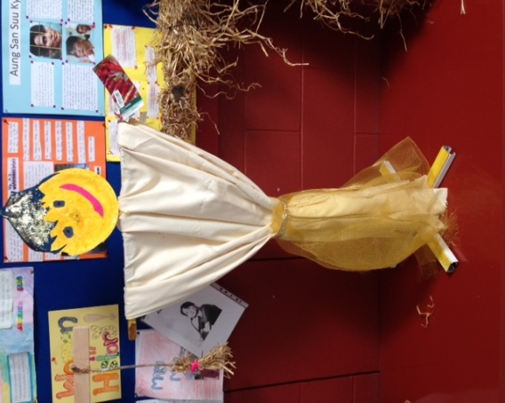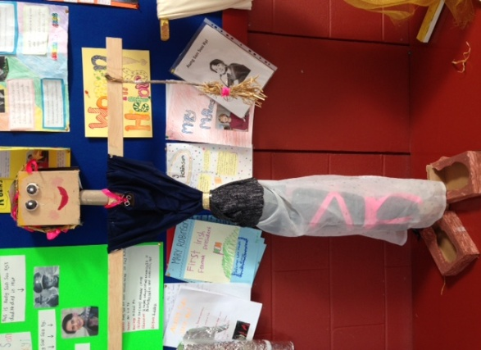

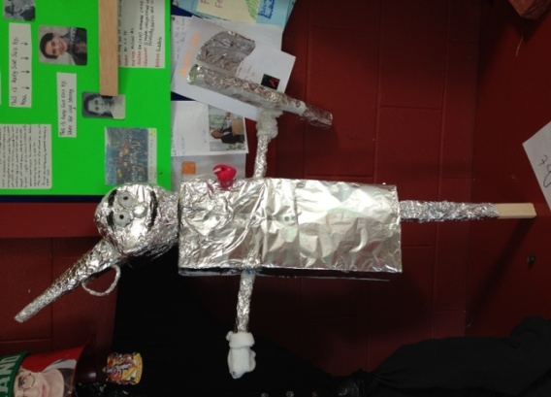

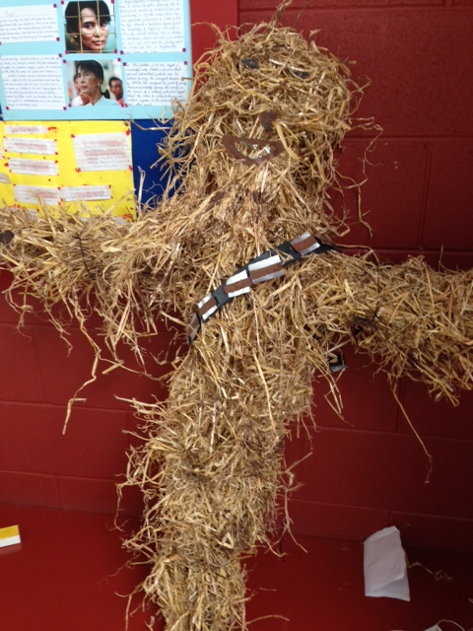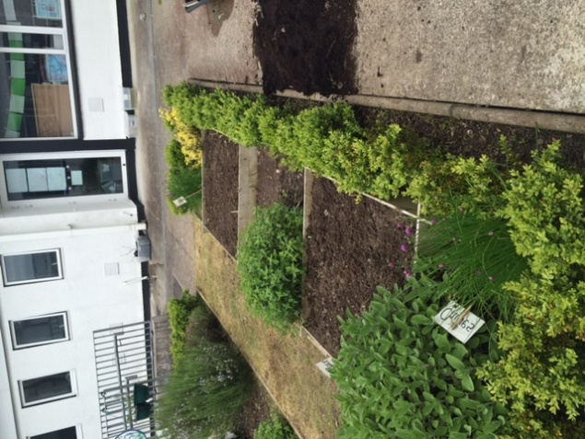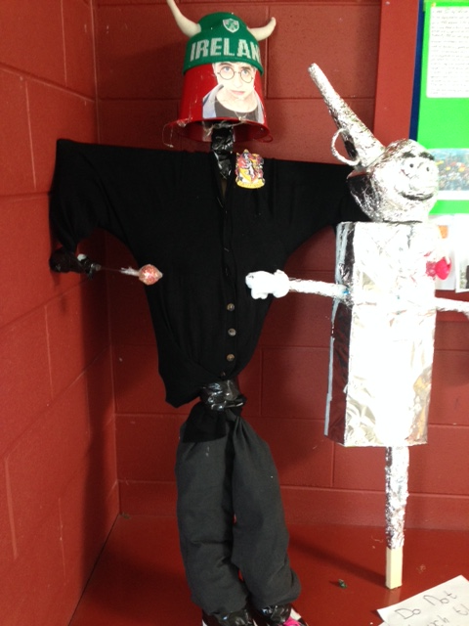

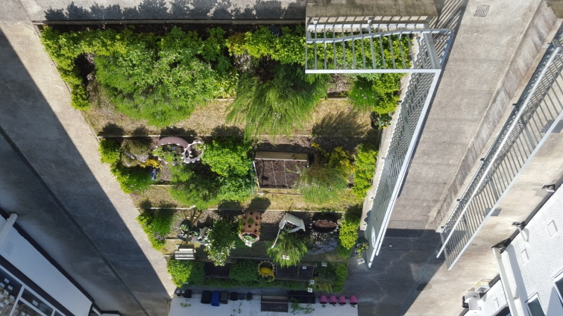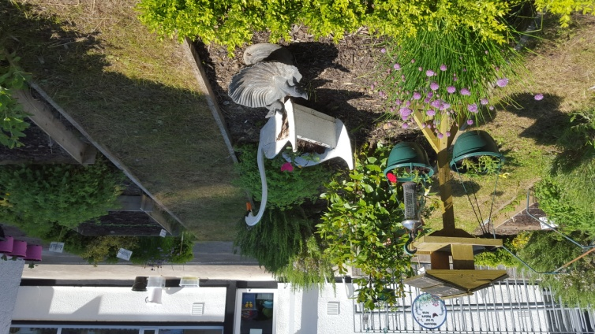

**Community Notices**

**6th Class Tag Rugby Mixed Tournament.** Starting in Athboy RFC @ 7pm, June 3rd, every Friday, for 6 weeks. €3 per person with BBQ and mineral. For more information contact Rory on 087-4610516 or see facebook page Athboy

RFC

**Starcamp Summer Camp.** Open to ALL boys & girls aged 4-13 of ALL levels and abilities.

9.30 – 2.30 for 5 days. Free t-shirt, certificate & surprises. Fully trained, Garda-vetted professional leaders. €90 per child, €160 for 2 siblings, €220 for 3 siblings. Book now at [www.starcamp.ie](http://www.starcamp.ie) or ring 021-4377900.

**SUNSHINE SUMMER CAMP@TRIM GAA CLUBHOUSE** is back again this summer from 11th -15th July for five days of fun! There will be lots of sport, art, crafts, baking, dance, crazy science, pet corner, painting and lots lots more. Cost €60 (discounts apply for siblings) Call or Text Carla/Elaine on 0857497004/ 0861905362 for more information and find us on Facebook for more updates@ **Sunshine Summer Camp Trim**

**SUMMER CAMP** – St Mary’s Primary School July 4th – 8th 10.00am – 2.30pm. cost: €60. Activities include: Arts & Crafts, Baking and Science. For bookings contact The Office or Ms Carr/Ms Leavy.

**WHIZZ KIDZ SUMMER CAMP** – St. Mary’s Primary School, Trim from Monday 11th – Friday 15th July, 10.00 am – 2.00pm. Computer & ICT based activities, including: mini-movie making, podcasts, presentations and outdoor games. Cost: €60. For bookings contact Ms. Coakley (Room 26)

**ZUMBA**: -   No experience, partner or booking required -      **SUMMER IS JUST AROUND THE CORNER**:- MONDAY   8pm   Trim GAA,   €8 per class     Contact :  Lorraine  086 8693546

**ZUMBA KIDS** :-        Ages 5-10   TUESDAY    3.15pm    TRIM GAA   €6 per class  (Sibling rate €5)

Zumba,  Hip-Hop,  Rock 'n Roll,  Jive.............        Contact :  Lorraine  086 8693546 / JoJo  086 3381159

**JIGGLE 'N' JUMP** - has moved to the Trim GAA from April 5th. Music and Movement classes will be held in the front room upstairs (Where the parent & toddler group takes place) on a Tuesday at 9.45am and Saturdays at 10.30am. There will also be a new class starting for ASD kids or kids who suffer with anxiety, offering a more routine class where parents can see the progress each week. This will be held on Saturdays at 9.30am. Classes also on Wednesday 10am in Summerhill Community Centre. Please call Julie to enquire or book in! 0868505310.

**Carney School of Irish Dancing** Classes in St. Patricks Hall every Tuesday. 2pm – 3pm & 3pm – 4pm. Every Friday @ 5.30pm. Infants and Senior infants can be collected from class rooms @ 2pm and left back to the buses @ 3pm. €5 per pupil per class. Contact Ann Carney 087-6336495



**BOOK GRANT SCHEME**

If any parent has a genuine need due to neither parent/guardian working or prolonged illness, they may apply for help with buying books for the next school year. **All applicants may be means tested.** Please apply on the form below and return to the school no later than FRIDAY 10th JUNE. No forms will be accepted after that date.

**-----------------------------------------------------------------**

**APPLICATION FORM**

I wish to apply for assistance from the Book Grant Scheme for the year 2016/2017 due to the following circumstances:

Signed: _______________________ Parent/Guardian. Date: ________________

|  |  |  |
| --- | --- | --- |
| **Child’s Name** | **Present Child’s Class**  **June 2016**  **(e.g. Junior Infants,**  **Senior Infants,**  **1st Class………)** | **Present Room Number**  **June 2016** |
|  |  |  |
|  |  |  |
|  |  |  |
|  |  |  |