***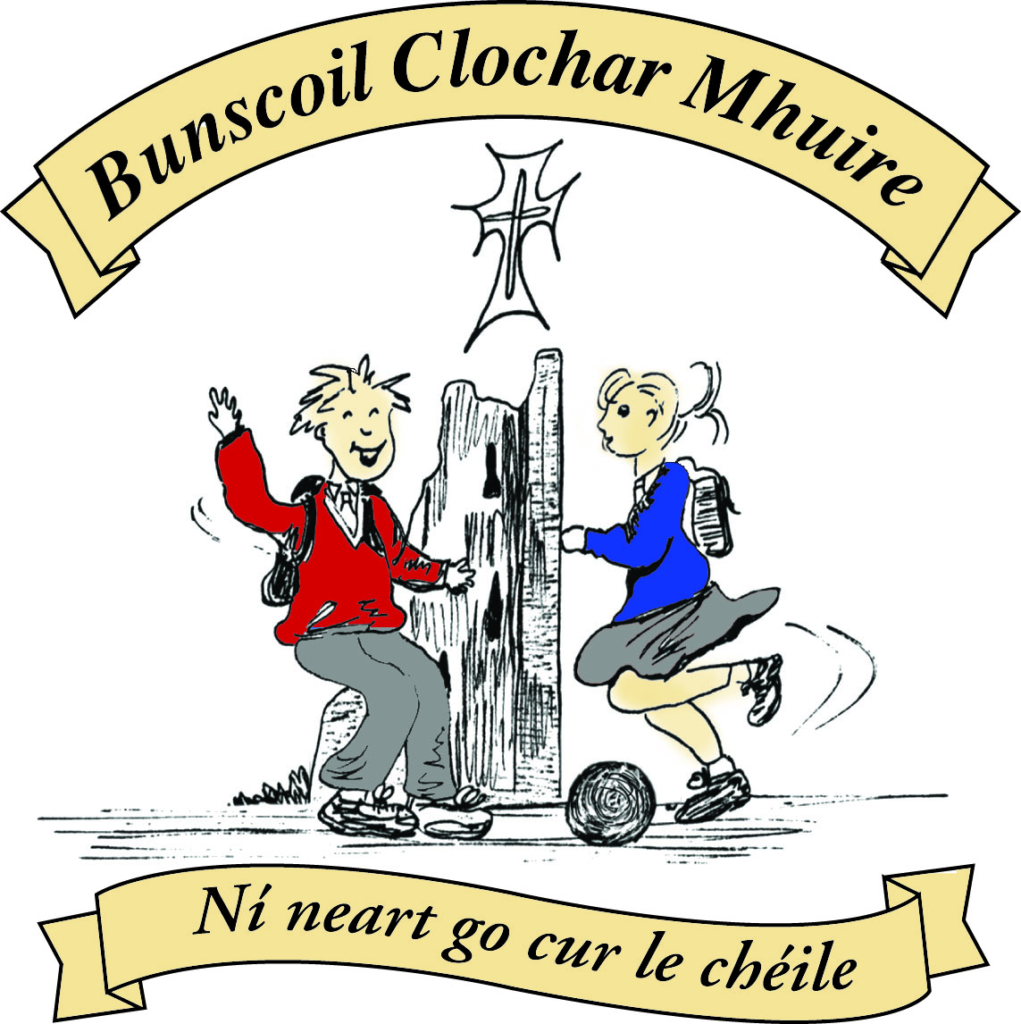* St Mary’s Convent Primary School**

***Bunscoil Clochar Mhuire***

***Trim, Co. Meath.  
Fón: (046) 9431919 ⦁ Faics: (046) 9437942  
Ríomhphost:*** [***marystrim@eircom.net***](mailto:marystrim@eircom.net) ***⦁ Website:*** [***www.stmarystrim.ie***](http://www.stmarystrim.ie) ***Uimhir Rolla: 16646O***

Awarded Green Flag  
June ‘05/’07/11/13

***Imlitir 36***

20th June, 2017

***Every Day Counts at St Mary’s Convent Primary School***

***12th June – 16th June 2017***

|  |  |  |  |  |  |  |  |
| --- | --- | --- | --- | --- | --- | --- | --- |
| **Room** | **Attendance** | **Room** | **Attendance** | **Room** | **Attendance** | **Room** | **Attendance** |
| 01 | 85.4% | 08 | 96% | 16 | 97.8% | 26 | 90.4% |
| 02 | 91.2% | 09 | 94.2% | 17 | 87.7% | 27 | 84.2% |
| 03 | 93% | 10 | 92.1% | 18 | 98.3% | 30 | 95.4% |
| 04 | 88.9% | 12 | 90.7% | 19 | 95.7% | 31 | 95% |
| 05 | 90.8% | 13 | 95.3% | 20 | 90% |  |  |
| 06 | 93.1% | 14 | 97.9% | 23 & 24 | 97.1% |  |  |
| 07 | 91.2% | 15 | 90% |  |  |  |  |
|  |  |  |  |  |  |  |  |

*Please note that notification in writing to the teacher is required for all absences. A letter or note in the homework journal will suffice.*

A Chairde,

**School reports** and **Booklists** will be emailed on Friday next unless a paper copy has been requested from the teacher in advance. Please contact the school if you do not receive yours. If you have concerns about the report, feel free to make an appointment with teacher to discuss your concerns.

We ask you not to post any reports on Facebook etc. and if you have done so to please take it down. Thanks.

**Graduation Night** for the Sixth Classes will be on Wednesday June 28th @ 7.30 p.m for the girls and Friday June 23rd for the 1st Class boys.

**MUGA Update**: As announced last week, our BoM has agreed that we may move ahead with a modified, less expensive All-Weather Pitch/MUGA. This will require some in-house fundraising in the next two years and they have agreed to give an advance on this money and to cover any shortfall. Our thanks to them. They were anxious to ensure that the pitch be built as soon as possible, to enable the children currently enrolled to get benefit from it. Children from St Michael’s will be invited back to use it, also. The inhouse fundraising will be as follows:

2017/2018: Powerball on October 12th and 13th and an Easter Raffle.

2018/2019: Bingo before Christmas and a Sponsored Walk after Easter.

The next stage is that we complete the tender process and prepare the site by knocking the surrounding trees and removing the tree stumps. The foliage from the trees would be a health and safety hazard. This will also create extra space. Then we will build the Ball Wall (which may require planning permission) before proceeding with the company, who were successful in the tendering process, to build the pitch and fencing. This is the most cost efficient way for us.

So, many thanks to you all for assisting with the fundraising and we hope that we will see the benefits very soon indeed.

**Board of Management Agreed Report:** by Mr Galligan

***A meeting of the Board of Management at St Mary’s took place on Tuesday, June 13th. Seven board members attended the meeting.***

*1. The minutes from the previous BOM meeting were proposed by John Leonard and seconded by Fr Declan Kelly respectively.*

*2. Vote of thanks and best wishes were extended to Áine Beggy (Teacher), Catherine Flattery (SNA) and Francis (Bus Escort) will retire at the end of this academic year.*

*3. There was unanimous agreement with the SENO’s recommendation regarding the slight increase in SNA hours at St Mary’s in 2017-2018.*

*4. Interviews will be held in July to fill any teaching vacancies that have arisen in the school.*

*5. The following policies were sanctioned by the board – Protected Disclosure Policy, Code of Behaviour, Healthy Eating Policy and the Draft Equality of Opportunity Policy.*

*6. This year’s school-specific Standardised Test scores were discussed. Graphs presented at the meeting illustrated that the overall scores at St Mary’s have been very high in English, Maths and Irish.*

*7. Circular 32/2017 (school uniforms, book rental etc.) was discussed briefly at the meeting – it was decided to discuss this matter further at next BOM meeting.*

*8. It was agreed that the MUGA development is now ready to progress to the next stage. Some further in-house fundraising will be required in the future, but no large-scale funding will be required.*

*9. Two additional Special Ed. and one mainstream classroom are being sought for the school. This matter is ongoing.*

*10. Questions arose at the meeting with regard to insurance and liability responsibilities during times when the school is used by the State as a polling station. It was agreed that a letter seeking clarification on this matter should be sent by the BOM to the registrar of elections as soon as possible.*

*11. A letter has been sent by the BOM to the Dept. of Ed. and the county council regarding the Traffic Plan for Trim and the implications for the school and its community. The BOM is awaiting a detailed response.*

*Mr Galligan*

This is the link for Circular 32/2017 <http://www.education.ie/en/Circulars-and-Forms/Active-Circulars/cl0032_2017.pdf>

As you have seen above, we have been granted permission to build three new rooms. We are currently in discussions with an architect to draw up plans that do not entail any loss of playground space.

There will be a Final Assembly on the last day of school at 9.20, you are all invited.

On Thursday June 29th we will be having a **Digital Fair**. Pupils from our Digital Schools Committee will be demonstrating Scratch, Raspberry Pii, Bee-Bots, Pro-Bots, Augmented Reality, Powerpoint etc. It will be on in The Dr. Eileen Reilly hall from 1.00-3.30. All welcome.

***Book rental forms*** *need to be returned, in a closed envelope, by Wednesday 21st June.*

Finally, we are taking pre-orders for OsKaR DVDs for €10. We will distribute them on Friday.

Mise le meas,



Cóilín Ó Coigligh, Príomh Oide.

**Nathanna na Seachtaine:** Tá tart orm / Tá ocras orm / Tá tuirse orm

 (I am thirsty / I am hungry / I am tired....)

**Seanfhocal na Míosa:** Ní chronaítear an t-uisce go dtriomaítear an tobar

**Dates to Remember**

**Meitheal:** Every Tuesday morning 9.30-10.30.

**Rounders:** From Mon 12th June - 4th & 5th Classes only

**School Choir:** Friday 3.00 – 4.00p.m

**Green News**

Last Friday we had our beautiful sensory garden blessed by Fr Declan. Many past members of staff came back to admire it and celebrate the occasion. We extend another heartfelt message of thanks to Rosie Hackett who designed and tirelessly worked with our gardening committee and other volunteers to create this beautiful area. Room 3 are currently painting stones as an added feature which will be a lovely visual aspect when finished.

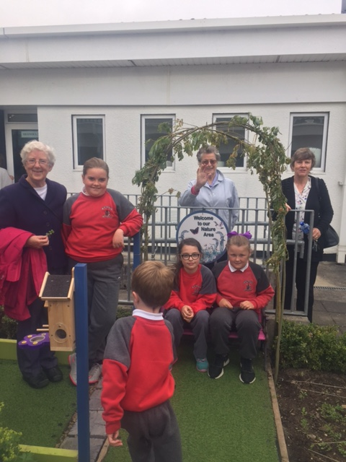Next Thursday June 29th we will raise our Green Flag for Global Citizenship. Aidan Gray from An Taisce, who is also a parent and has been very supportive of all our green initiatives, will officially raise our flag at 10:30am. All are welcome.

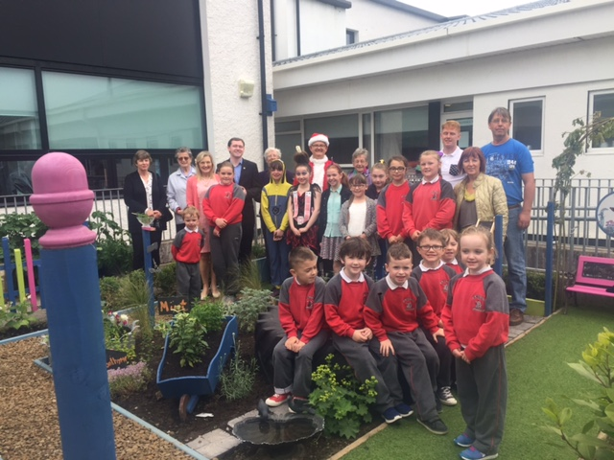

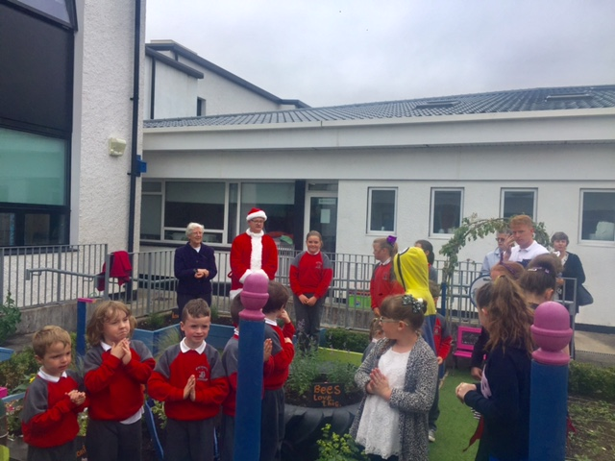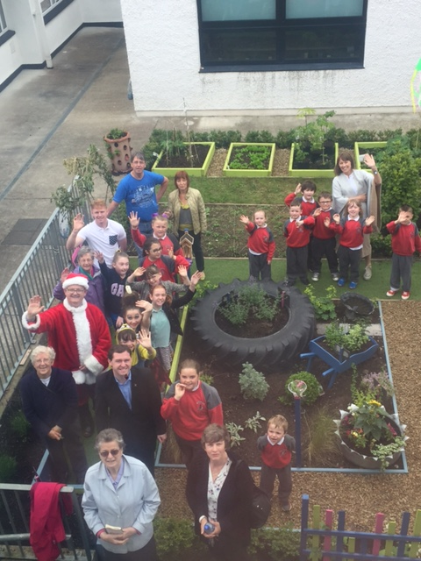

**Community Notices**

**SUMMER CAMP** – St Mary’s Primary School July 3rd – 7th 10.00am – 2.30pm. cost: €65 (Family discounts apply). Activities include: Arts & Crafts, Sports, Music & Dance, Baking and Science. For bookings contact The Office or Ms Carr/Ms Leavy.

**Sunshine Summer Camp** @ Trim GAA in back this year from 8th – 11th August for a week of fun & games, summer art, crafts, baking, experiments and lots more. €55 per child (sibling discounts apply) contact Ms Maguire/Ms Dalton on 086-1905362/085-7497004 or check us out of Facebook for more info. Sunshine Summer Camp @ Trim GAA clubhouse.

**Junior Sailing Course** at Lough Owel 3rd – 21st July. Age 11yrs and over, Basic sailing skills to level 4, a fun way to learn to sail. Fully qualified instructors, course places are limited, if you wish to apply please fill out the application form on [www.msail.net/Junior%20sailing.html](http://www.msail.net/Junior%20sailing.html) or call 087-2903586.

**Ballet Summer Camp.** Navan School of Ballet. Solstice Arts Centre July 3rd – 7th. Ballet, Modern, Theatre Dance, Mime, Rhythm, Costumes, Stage Crafts, Face Paint and much more. Tel: 087-6874503. [www.navanballet.com](http://www.navanballet.com)

**Art & Baking Camp** Week 1 = 10th - 14th July, Week 2 = 14th – 18th August. 11am – 3pm Contact Christine on 087-9803395

**Limelight Theatrics** - Registering now for September. Speech, drama and singing classes. Classes are held on Tuesday & Wednesday. Contact  Carmel McKiernan BA, LIBSD on 0863923334 or through the Limelight Theatrics Facebook page, class times are listed on Facebook.

**Jiggle 'n' Jump**

Music & Movement classes for little ones (8mths-4yrs) running upstairs in Trim GAA on Tuesday 9.45-10.45am  €7 a class or 4 class card for €25

Also available for **Kids Party Entertainment!**

Various characters and themes with fun games, dancing, face painting and prizes! Clown, Pirate, Princess, 80's Disco Diva, Sporty Diva and Super Hero available.  New Party Package insures 2 hours of non stop entertainment, with face painting by Linda (Flawless Facepaint) while I entertain the kids with singing, dancing, party games and non stop fun!!  Contact Julie on [0868505310](tel:0868505310) or on Facebook [www.facebook.com/jigglenjump](http://www.facebook.com/jigglenjump)

**Stage Stars Summer Camp:** The camp is running from July 24-28 from 10.00 - 2.00 in Scoil Mhuire (with an optional earlier drop off time) and is open to girls and boys aged 4-12. It will be an action packed week of singing, dancing, drama and arts and crafts with finishing certificates and an end of week performance for family and friends! The camp is €80 per child with sibling discounts as well as an early bird offer if booked and paid in full by June 9th. Guaranteed to be the most fun filled week of your summer! For more information call 0863566061 or see Facebook.com/stagestarssummercamp



**Information for Class Planning 2017/2018**

In order for the school to have accurate information for forward planning for 2017/2018, please complete and return the following sheet. This information is not binding, it is for class planning purposes.

Surname: __________________________

Student/s Name/s: __________________________

__________________________

__________________________

**will not** be returning to St. Mary’s in September 2017.

Signed:_____________________________________ Parent/Guardian