***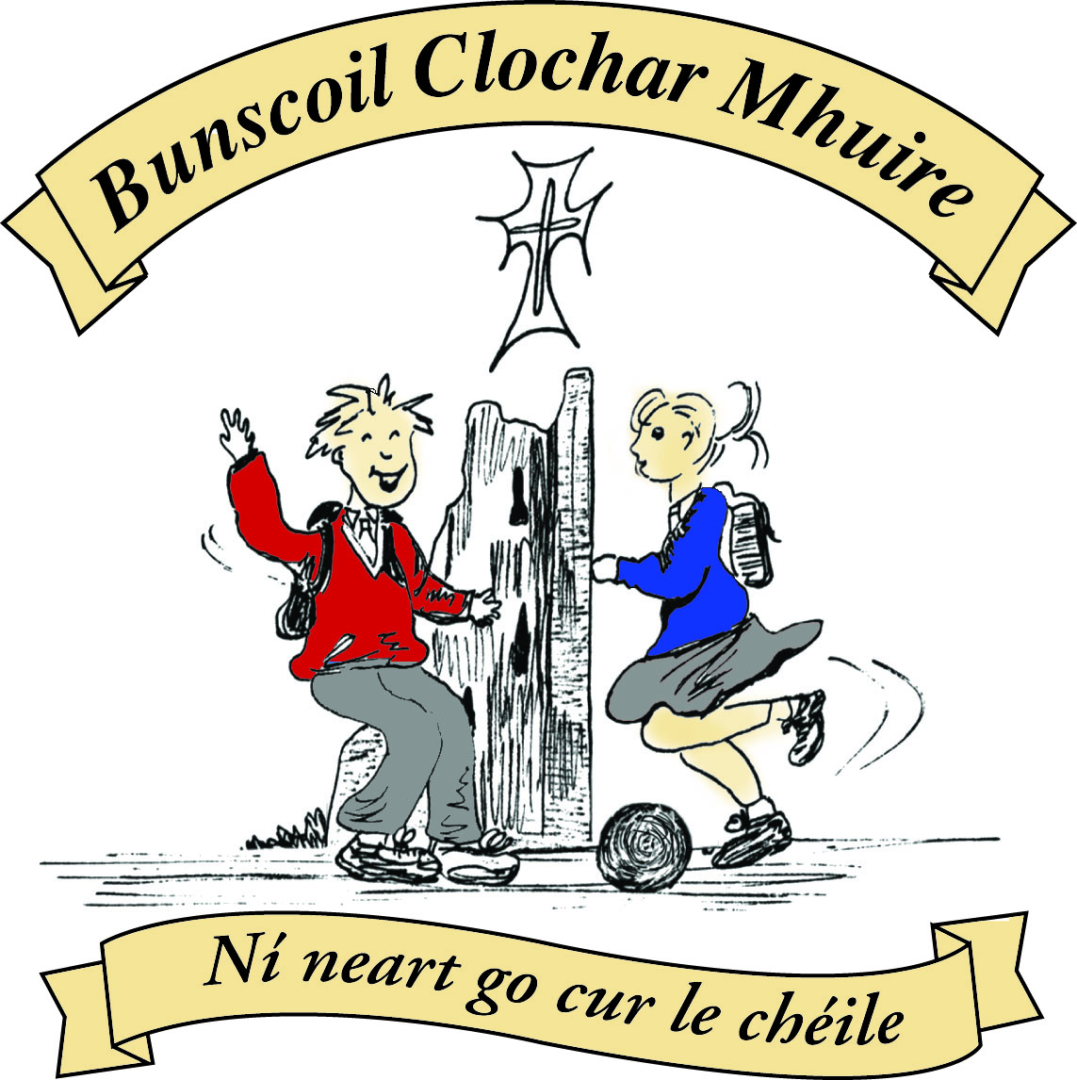* St Mary’s Convent Primary School**

***Bunscoil Clochar Mhuire***

***Trim, Co. Meath.  
Fón: (046) 9431919 ⦁ Faics: (046) 9437942  
Ríomhphost:*** [***marystrim@eircom.net***](mailto:marystrim@eircom.net) ***⦁ Website:*** [***www.stmarystrim.ie***](http://www.stmarystrim.ie) ***Uimhir Rolla: 16646O***

Awarded Green Flag  
June ‘05/’07/11/13

***Imlitir 35***

12th June, 2017

***Every Day Counts at St Mary’s Convent Primary School***

***6th June – 9th June 2017***

|  |  |  |  |  |  |  |  |
| --- | --- | --- | --- | --- | --- | --- | --- |
| **Room** | **Attendance** | **Room** | **Attendance** | **Room** | **Attendance** | **Room** | **Attendance** |
| 01 | 85.6% | 08 | 86% | 16 | 89.8% | 26 | 98% |
| 02 | 91% | 09 | 91.9% | 17 | 93.8% | 27 | 94.8% |
| 03 | 94.6% | 10 | 94.6% | 18 | 96.9% | 30 | 94.2% |
| 04 | 93.5% | 12 | 96.7% | 19 | 98.2% | 31 | 88.4% |
| 05 | 85.6% | 13 | 96.7% | 20 | 91.1% |  |  |
| 06 | 91.3% | 14 | 93.8% | 23 & 24 | 84.3% |  |  |
| 07 | 99% | 15 | 91.1% |  |  |  |  |
|  |  |  |  |  |  |  |  |

*Congratulations to room 7 on nearly having full attendance last week. Please note that notification in writing to the teacher is required for all absences. A letter or note in the homework journal will suffice.*

A chairde,

We have two more **Oskars** related events before the end of the year. On Thursday night next @ 8.oo we are showing the movies in The Dr Eileen Reilly Hall. Further details under community notices below. On Friday next we are showing the following OsKaR movies:

Fr Ted

Forrest Gump

Sister Act

They will be shown in the hall during the day. Crisps will be provided and we are asking for a donation of €3 per pupil. They may also dress up as a movie character. Monies may be brought in from today to the class teacher.

Our **Be Active Week and Sports Day** were a fantastic success. Huge thanks are due to Mr Galligan and the organising committee for giving everyone such an action-packed and fun time.

**Parents' Information Night**, for parents/guardians of new pupils starting in September, takes place @ 8.00 on Wednesday June 14th. New pupils have their **Orientation Day** on Thursday June 15th @ 2.15.

**Cór**, our school choir, are having their end of year concert @ 7.00 on Wednesday 14th also.

**School Reports and Booklists** will be emailed on Friday June 20th. Hard copies by request only. Contact relevant teacher.

Please let us know by email or phone call or note if your child will not be returning to us next September (excepting Sixth Classes and First Class boys).

***Be Active Afterschool Programme*** *for 2nd Class. Monday 12th, 19th & 26th from 3.00 – 3.50. This programme if Free and run by teachers to promote children getting more active in their daily life.*

*Ms Maguire*

*[](https://www.google.ie/url?sa=i&rct=j&q=&esrc=s&source=images&cd=&cad=rja&uact=8&ved=0ahUKEwj7gJ3d_t3TAhXGD8AKHQWaBlIQjRwIBw&url=http://offalysports.ie/events/active-school-week&psig=AFQjCNGYYAYmeVfwHS6Xgbnzgs_ASXHHoQ&ust=1494253632935785)*

**Be Active Week and Sport Day 2017 come to an end**

*Míle buíochas to everyone who helped make our recent Be Active Week a great success. The week itself was launched on June 2nd with a whole-school “Boyne Walk”. During the week beginning June 6th, the pupils were involved in a host of physical activities including soccer, fitness circuits, basketball, dancing, olympic handball, swimming, orienteering and yard games. Linking up with the local community is an essential part of the Active School Programme. Our Be Active Committee would like to express sincere appreciation to Suzanne Keegan and Kevin Comiskey who visited the school to do yoga and boxercise respectively with numerous classes. Sports Day went ahead last Friday and thankfully the storm clouds remained at sea. The morning was action packed with treasure hunts, 10@10 and Go Noodle. This was followed up with indoor and outdoor activity stations from 10.40am until lunch time. After lunch, pupils were involved in class races on the pitch and energetic dancing in the hall. Heartiest congratulations to all the participants of Sports Day, but most especially to the overall winners, the Blue Team! Special thanks is extended to three groups – firstly, to our Parents’ Association, who provided us with a host of healthy refreshments on the day; secondly, to the secondary students, who spent the week with us and assisted with all the sporting events; and last, but by no means least, to the 6th Class pupils, who came in at the crack of dawn on Sports Day to help set up the activity stations around the school grounds! A broad selection of photos from Be Active Week and Sports Day can be viewed at* [*www.stmarystrim.ie*](http://www.stmarystrim.ie) *. Why not check them out!*

*Mr Galligan and St Mary’s Be Active Committee*

***Choir****. There will be an End of year Choir performance on Wed 14th @ 7.00pm in the Dr Eileen Reilly Hall. All parents are invited to attend.*

*Ms McKenna*

|  |  |
| --- | --- |
| **School Calendar 2017/2018** | |
| Return: | Thursday 31st August 2017 |
| Mid-Term: | Monday 30th October –Friday 3rd Nov 2017 |
| Christmas Break: | Monday 25th Dec 2017 - Friday 5th January 2018 |
| Feb Mid-term Break | Thursday 15th & Friday 16th Feb 2018 |
| St. Patrick’s Day | 19th March 2018 (Monday) |
| Easter Break | Monday 26th March – Friday 6th April 2018 |
| May Bank Holiday: | Week Monday 7th – Friday 11th May 2018 |
| June Bank Holiday: | Monday 4th June 2018 |
| School closes | Friday 29th June 2018 |
|  |  |

Please keep the above dates in mind while arranging holidays next year.

Mise le meas,



Cóilín Ó Coigligh, Príomh Oide.

**Green News**

**Community News**

**Nathanna na Seachtaine:** Is féidir liom rith/siúl/imirt/snámh....

**Seanfhocal na Míosa:** Ní chronaítear an t-uisce go dtriomaítear an tobar

**Dates to Remember**

**Meitheal:** Every Tuesday morning 9.30-10.30.

**Rounders:** From Mon 12th June - 4th & 5th Classes only

**School Choir:** Friday 3.00 – 4.00p.m

**Green News** **Flash**

We are delighted to announce that St. Mary’s was awarded Level 2 in the Pride of Place Competition. Well done to all on the Committee!

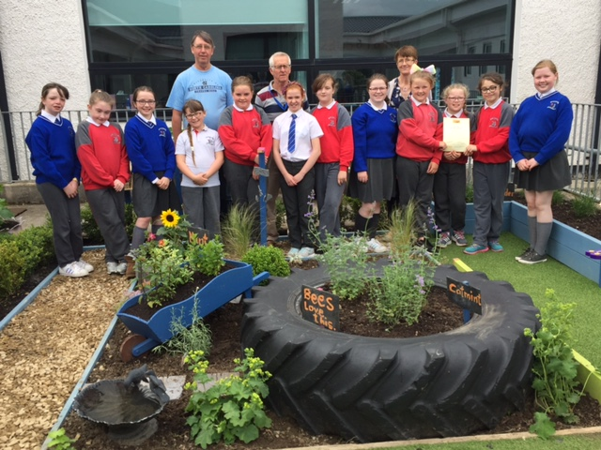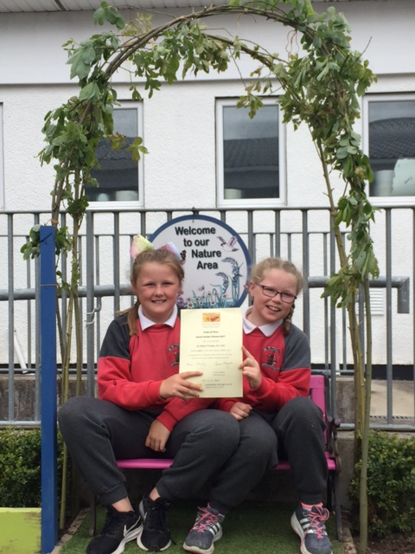

**Remember Green is cool at home and at school and around the globe!**

**Community Notices**

St Mary’s Convent Primary School

presents

The OsKars Movie Night

Thursday 15th June

In The Dr Eileen Reilly Hall (School Hall)

Doors 7.30pm Show commences 8.00pm

Movies to be shown on the night:

**A Few Good Men**

**Absolutely Fabulous**

**Fr Ted**

**Forrest Gump**

**Jerry Maguire**

**Sister Act**

**The Snapper**

Some of the Movies come with a PG/15 rating

Tickets €5 for Adults, Minors and OAPs €3

Family tickets €10. (2 adults and 2 minors)

Calling all children between the ages of 6 - 12 Trim Family Resource  Centre Invites you to get your running shoes on and join us in **The Junior  Braveheart Run** on Friday 16th June at 7pm in the Porchields. In            preparation for this event we will be holding 'light' training sessions every Tuesday & Thursday on the pitch in Mornington Heights between 4pm -5pm. The training is free of charge  however pre-booking is essential. Call Lisa or Colette in the office on  046-9438850.

**SUMMER CAMP** – St Mary’s Primary School July 3rd – 7th 10.00am – 2.30pm. cost: €65 (Family discounts apply). Activities include: Arts & Crafts, Sports, Music & Dance, Baking and Science. For bookings contact The Office or Ms Carr/Ms Leavy.

**Limelight Theatrics** - Registering now for September. Speech, drama and singing classes. Classes are held on Tuesday & Wednesday. Contact  Carmel McKiernan BA, LIBSD on 0863923334 or through the Limelight Theatrics Facebook page, class times are listed on Facebook.

**Zumbathon Charity Event** for School Building Project in Kenya. Monday 12th June Trim G.A.A. 7.30 – 9.30 pm tickets €10 per person. All proceeds to Friends from Ireland. Contact Lorraine 086-8693546, Jo 0863381159 or Fionnuala 086-8225277.

**Jiggle 'n' Jump**

Music & Movement classes for little ones (8mths-4yrs) running upstairs in Trim GAA on Tuesday 9.45-10.45am  €7 a class or 4 class card for €25

Also available for **Kids Party Entertainment!**

Various characters and themes with fun games, dancing, face painting and prizes! Clown, Pirate, Princess, 80's Disco Diva, Sporty Diva and Super Hero available.  New Party Package insures 2 hours of non stop entertainment, with face painting by Linda (Flawless Facepaint) while I entertain the kids with singing, dancing, party games and non stop fun!!  Contact Julie on [0868505310](tel:0868505310) or on Facebook [www.facebook.com/jigglenjump](http://www.facebook.com/jigglenjump)

**Stage Stars Summer Camp:** The camp is running from July 24-28 from 10.00 - 2.00 in Scoil Mhuire (with an optional earlier drop off time) and is open to girls and boys aged 4-12. It will be an action packed week of singing, dancing, drama and arts and crafts with finishing certificates and an end of week performance for family and friends! The camp is €80 per child with sibling discounts as well as an early bird offer if booked and paid in full by June 9th. Guaranteed to be the most fun filled week of your summer! For more information call 0863566061 or see Facebook.com/stagestarssummercamp



**Information for Class Planning 2017/2018**

In order for the school to have accurate information for forward planning for 2017/2018, please complete and return the following sheet. This information is not binding, it is for class planning purposes.

Surname: __________________________

Student/s Name/s: __________________________

__________________________

__________________________

**will not** be returning to St. Mary’s in September 2017.

Signed:_____________________________________ Parent/Guardian