***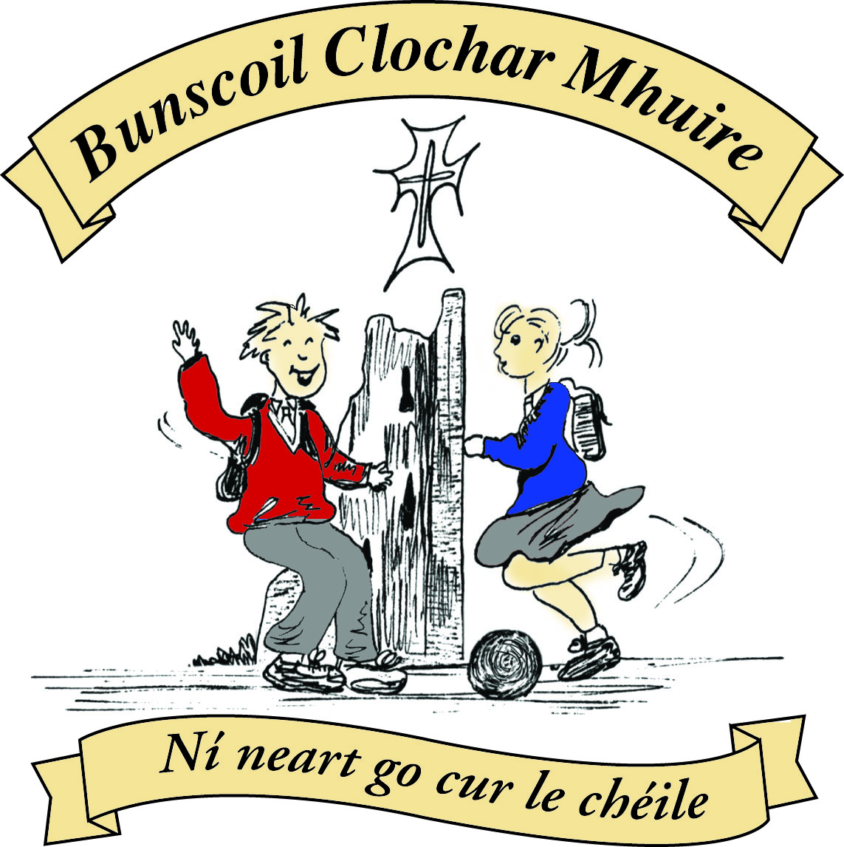* St Mary’s Convent Primary School**

***Bunscoil Clochar Mhuire***

***Trim, Co. Meath.  
Fón: (046) 9431919 ⦁ Faics: (046) 9437942  
Ríomhphost:*** [***marystrim@eircom.net***](mailto:marystrim@eircom.net) ***⦁ Website:*** [***www.stmarystrim.ie***](http://www.stmarystrim.ie) ***Uimhir Rolla: 16646O***

Awarded Green Flag  
June ‘05/’07/11/13

***Imlitir 34***

30th May, 2017

***Every Day Counts at St Mary’s Convent Primary School***

***22nd – 26th May 2017***

|  |  |  |  |  |  |  |  |
| --- | --- | --- | --- | --- | --- | --- | --- |
| **Room** | **Attendance** | **Room** | **Attendance** | **Room** | **Attendance** | **Room** | **Attendance** |
| 01 | 97.7% | 08 | 96.8% | 16 | 91.9% | **26** | **100%** |
| 02 | 96% | 09 | 91% | 17 | 95.3% | 27 | 93.3% |
| 03 | 86.1% | 10 | 96.4% | 18 | 98.3% | 30 | 98.5% |
| 04 | 93.3% | 12 | 91.3% | 19 | 96.4% | 31 | 95% |
| 05 | 98.5% | 13 | 84.7% | 20 | 95.7% |  |  |
| 06 | 90% | 14 | 97.9% | **23 & 24** | **100%** |  |  |
| 07 | 93.6% | 15 | 95.7% |  |  |  |  |
|  |  |  |  |  |  |  |  |

*Well done to room 23, 24 & 26 on having full attendance last week and to room 30 for nearly making it. Please note that notification in writing to the teacher is required. A letter or note in the homework journal will suffice.*

A chairde,

**End of year Reports:** will be sent by email on Friday June 23rd . This will allow you time to make an appointment to see us, before school closes, should you have any concerns. Please contact us by the Wednesday June 28th, if you have not received yours. This year, as outlined last year, we are sending all reports and booklists by email. Hard copies will only be issued on requests made on or before Friday June 16th and will be posted on Friday June 23rd. This letter is being sent by hard copy. If you have not received it by email also, please contact the school to ensure that we have the correct email.

Please note for health and safety reasons fidget spinners are not allowed in school.

Banna finishes for the year today (Tuesday) with a recital @ 3.30 in The Dr Eileen Reilly Hall. All welcome. Many thanks to Mrs McGale, Mrs Nally, Ms O Connor, Ms Cullinane and Mr Duff who gave so generously of their time to teach the children.

**BOOK GRANT SCHEME**: If any parent has a genuine need due to neither parent/guardian working or prolonged illness, they may apply for help with buying books for the next school year. All applicants may be means tested. Please apply on the form below and return to the school no later than FRIDAY 9th JUNE. No forms will be accepted after that date.

***School Council Talent Show*** *Our annual School Council Talent Show will take place this Friday, 2nd June in the School Hall. Pupils from Fourth, Fifth and Sixth class will be performing and it should be a very entertaining event. There will be a morning show for Junior classes at 10 a.m. and an afternoon show at 1.15 p.m. for the Senior classes. An admission fee of €2 is requested as all proceeds from the show go to charities nominated by the pupils. This year the nominated charities are Childline and Dogs Trust Ireland. Parents, guardians and relations are welcome to attend the shows. Many thanks for your continued support of this event. Mary O'Hare*



**Siúlaimis (Let’s Walk!)**

Our total for the Siúlaimis was 27,675km which means we have reached our target of walking around the world.

An-mhaith ar fad.

Congratulations to everybody.

|  |  |
| --- | --- |
| **School Calendar 2017/2018** | |
| Return: | Thursday 31st August 2017 |
| Mid-Term: | Monday 30th October –Friday 3rd Nov 2017 |
| Christmas Break: | Monday 25th Dec 2017 - Friday 5th January 2018 |
| Feb Mid-term Break | Thursday 15th & Friday 16th Feb 2018 |
| St. Patrick’s Day | 19th March 2018 (Monday) |
| Easter Break | Monday 26th March – Friday 6th April 2018 |
| May Bank Holiday: | Week Monday 7th – Friday 11th May 2018 |
| June Bank Holiday: | Monday 4th June 2018 |
| School closes | Friday 29th June 2018 |
|  |  |

Please keep the above dates in mind while arranging holidays next year.

Mise le meas,



Cóilín Ó Coigligh, Príomh Oide.

**Green News**

**Community News**

**Nathanna na Seachtaine: Ná bí buartha! (Don't be worried!)**

**Seanfhocal na Míosa:** Bíonn Cluasa Móra ag Muca Beaga

**Dates to Remember**

**Assembly: Thursday** 9.40 Be Active

**Banna Ceoil:** Final Class this Tuesday 3.00-4.00

**Football Training:** Wednesday 3.00 - 4.00 for 3rd – 6th Classes

**Meitheal:** Every Tuesday morning 9.30-10.30.

**Rounders:** From Mon 12th June - 4th & 5th Classes only

**School Choir:** Friday 3.00 – 4.00p.m

**Green News**

Last Thursday St Mary’s was awarded the Green Flag for Global Citizenship in a lovely ceremony in Gormanstown, Co. Meath. It was a very proud day for our school and especially for the two Green delegates who travelled there to collect the flag on our behalf. Alanna and Charlie proudly accepted the award for our work on Global Citizenship over the past two years. It was significant that two of our youngest Green Flag members did the honours, as here at St Mary’s, as with all our initiatives, the Green Schools’ Programme is a whole-school project and impacts on the whole school community. We would like to take this opportunity once again to congratulate and thank you all for your support of the programme and hope that you will continue to embrace the good green habits that you have formed. Next year we will start the new green theme of Energy, under the Global Citizenship umbrella.

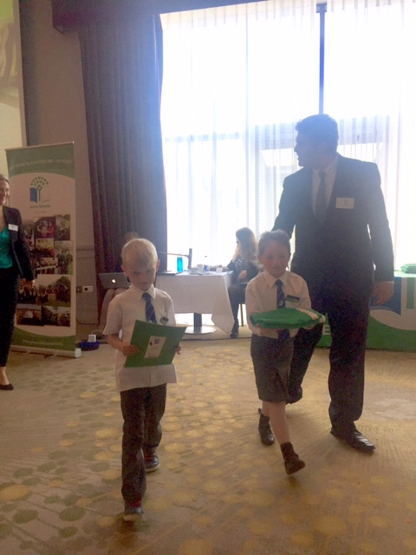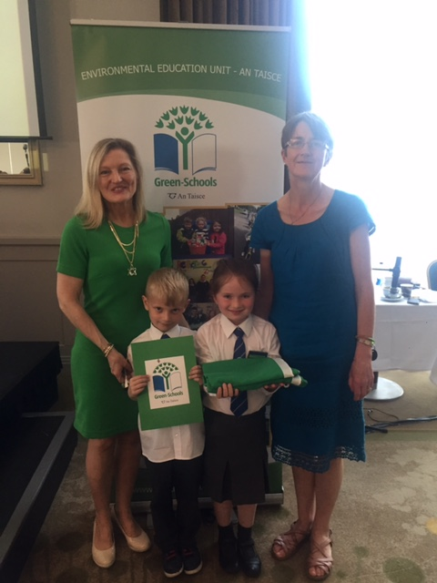

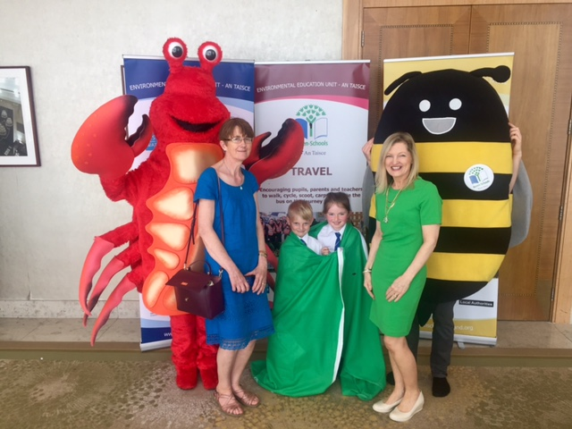 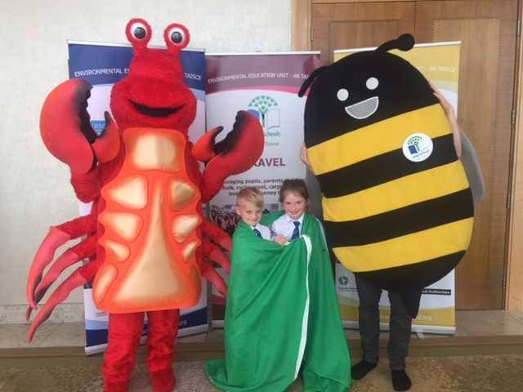

WOW continues every Wednesday but COW will be postponed until June 7th when we hope to have a big School Cycling Day as part of Be Active Week.

Global Citizenship was our green theme over the past two years with a specific emphasis on litter and waste management. Here at St Mary’s, we have been emphasising to the pupils the importance of separating their classroom waste into recyclable and non-recyclable items. We recycle some items at school which the children bring in from home: batteries, ink cartridges, postage stamps, card, small plastic bottles and cans.

There is great work being done in the garden. Room 23 were busy planting and watering last week. Rosie our volunteer gardener has done trojan work in our garden and it certainly is looking beautiful. See the photos attached! We’ll keep you posted on our progress.

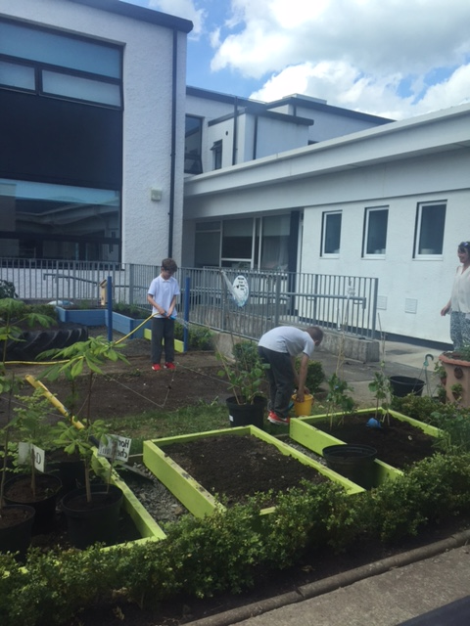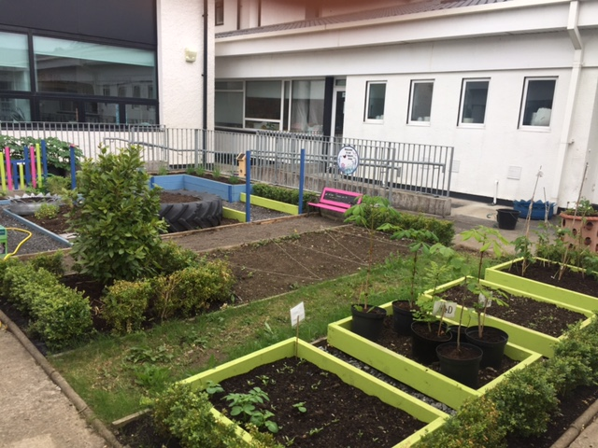

**Remember Green is cool at home and at school and around the globe!**

**Community Notices**

Calling all children between the ages of 6 - 12 Trim Family Resource  Centre Invites you to get your running shoes on and join us in **The Junior  Braveheart Run** on Friday 16th June at 7pm in the Porchields. In            preparation for this event we will be holding 'light' training sessions every Tuesday & Thursday on the pitch in Mornington Heights between 4pm -5pm beginning this Thursday 1st June. The training is free of charge  however pre-booking is essential. Call Lisa or Colette in the office on  046-9438850.

**SUMMER CAMP** – St Mary’s Primary School July 3rd – 7th 10.00am – 2.30pm. cost: €65 (Family discounts apply). Activities include: Arts & Crafts, Sports, Music & Dance, Baking and Science. For bookings contact The Office or Ms Carr/Ms Leavy.

**Bird Watch Ireland.** Tuesday 30th May @ 7.30 **Free event**

Walk with Brian Caffery from Bird Watch Ireland . To identify bird songs along the Boyne and swift nest sites in Trim . Meeting at OPW offices beside playground. All welcome . Wrap up warm .

**Jiggle 'n' Jump**

Music & Movement classes for little ones (8mths-4yrs) running upstairs in Trim GAA on Tuesday 9.45-10.45am  €7 a class or 4 class card for €25

Also available for **Kids Party Entertainment!**

Various characters and themes with fun games, dancing, face painting and prizes! Clown, Pirate, Princess, 80's Disco Diva, Sporty Diva and Super Hero available.  New Party Package insures 2 hours of non stop entertainment, with face painting by Linda (Flawless Facepaint) while I entertain the kids with singing, dancing, party games and non stop fun!!  Contact Julie on [0868505310](tel:0868505310) or on Facebook [www.facebook.com/jigglenjump](http://www.facebook.com/jigglenjump)

**Stage Stars Summer Camp:** The camp is running from July 24-28 from 10.00 - 2.00 (with an optional earlier drop off time) and is open to girls and boys aged 4-12. It will be an action packed week of singing, dancing, drama and arts and crafts with finishing certificates and an end of week performance for family and friends! The camp is €80 per child with sibling discounts as well as an early bird offer if booked and paid in full by June 9th. For more information call 0863566061 or see Facebook.com/stagestarssummercamp

 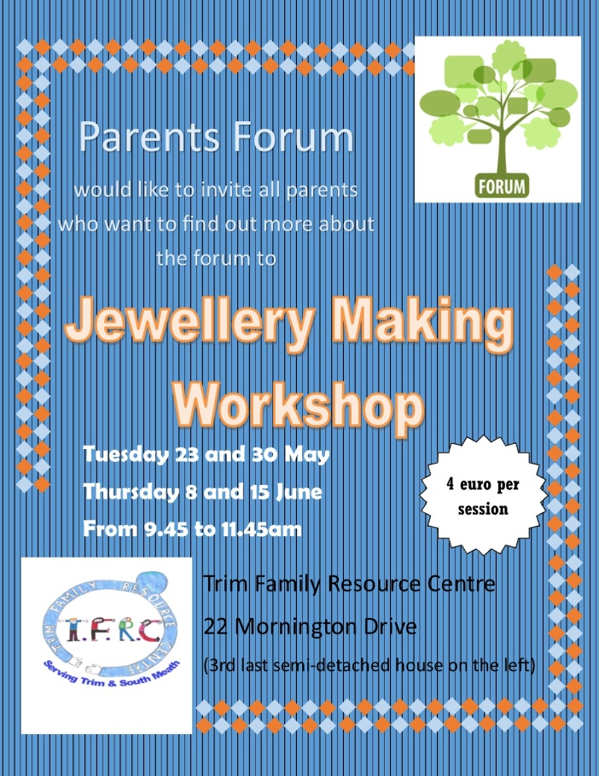



## BOOK GRANT SCHEME

If any parent has a genuine need due to neither parent/guardian working or prolonged illness, they may apply for help with buying books for the next school year. **All applicants may be means tested.** Please apply on the form below and return to the school no later than FRIDAY 9TH JUNE. No forms will be accepted after that date.

**-----------------------------------------------------------------**

**APPLICATION FORM**

I wish to apply for assistance from the Book Grant Scheme for the year 2017/2018 due to the following circumstances.

Signed: _______________________ Parent/Guardian. Date: ________________

|  |  |  |
| --- | --- | --- |
| **Child’s Name** | **Present Child’s Class**  **June 2017**  **(e.g. Junior Infants,**  **Senior Infants,**  **1st Class………)** | **Present Room Number**  **June 2017** |
|  |  |  |
|  |  |  |
|  |  |  |
|  |  |  |

**Information for Class Planning 2017/2018**

In order for the school to have accurate information for forward planning for 2017/2018, please complete and return the following sheet. This information is not binding, it is for class planning purposes.

Surname: __________________________

Student/s Name/s: __________________________

__________________________

__________________________

**will not** be returning to St. Mary’s in September 2017.

Signed:_____________________________________ Parent/Guardian