***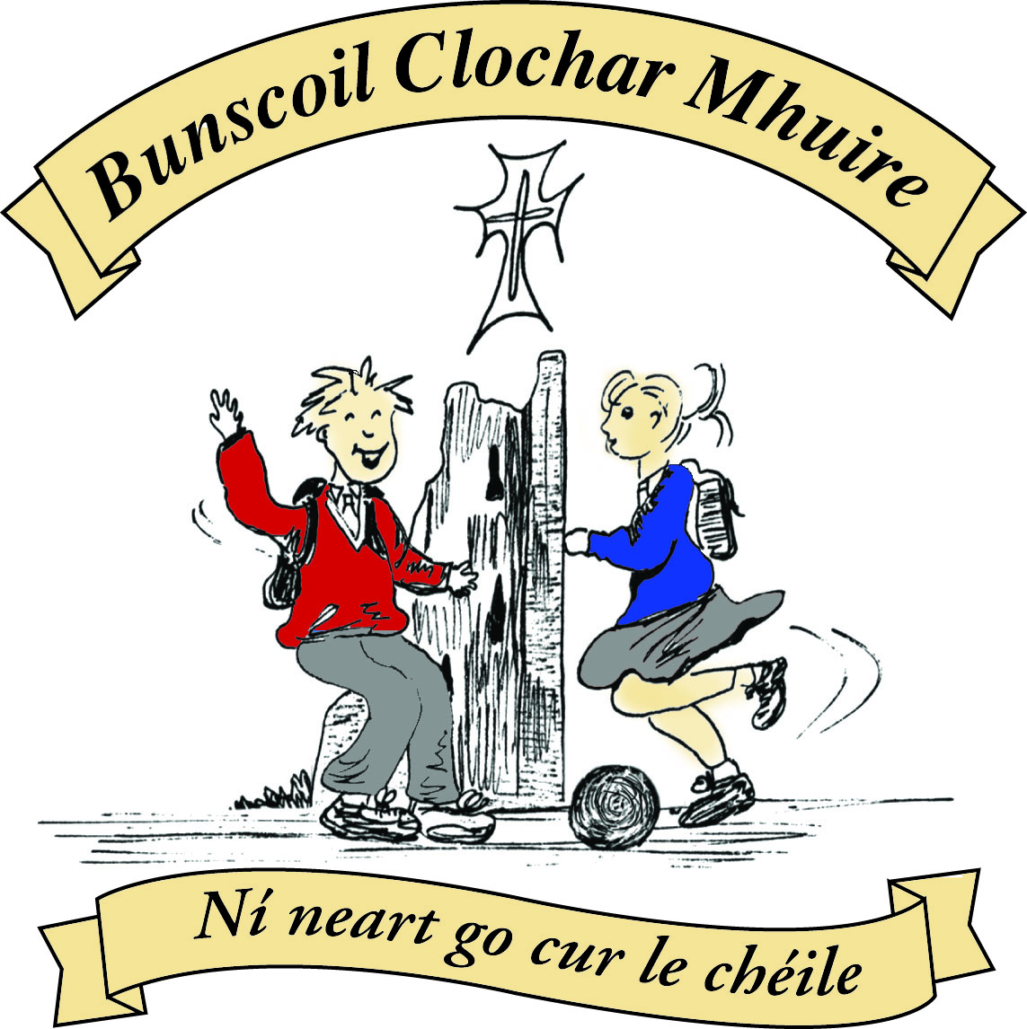* St Mary’s Convent Primary School**

***Bunscoil Clochar Mhuire***

***Trim, Co. Meath.  
Fón: (046) 9431919 ⦁ Faics: (046) 9437942  
Ríomhphost:*** [***marystrim@eircom.net***](mailto:marystrim@eircom.net) ***⦁ Website:*** [***www.stmarystrim.ie***](http://www.stmarystrim.ie) ***Uimhir Rolla: 16646O***

Awarded Green Flag  
June ‘05/’07/11/13

***Imlitir 34***

23rd May, 2016

***Every Day Counts at St Mary’s Convent Primary School***

***16th –20th May, 2016***

|  |  |  |  |  |  |  |  |
| --- | --- | --- | --- | --- | --- | --- | --- |
| **Room** | **Attendance** | **Room** | **Attendance** | **Room** | **Attendance** | **Room** | **Attendance** |
|  |  |  |  |  |  |  |  |
| 01 | 97.7 % | 08 | 98.6% | 16 | 95.6% | 26 | 94.8% |
| 02 | 88% | 09 | 97% | 17 | 94% | 27 | 95% |
| 03 | 96% | 10 | 96.4% | 18 | 97.1% | 30 | 95.2% |
| 04 | 96.2% | 12 | 89.2% | 19 | 95.2% | 31 | 95.2% |
| 05 | 92.9% | 13 | 93.1% | 20 | 99.2% |  |  |
| 06 | 97.1% | 14 | 96.9% | 23 | 97.1% |  |  |
| 07 | 94.1% | 15 | 96.8% | **24** | **100%** |  |  |

A Chairde,

Congratulations to Room **24** on having full attendance last week and to Room **20** who almost made it! Please note that notification in writing to the teacher is required for all absences. A letter or note in the homework journal will suffice.

This Wednesday (weather permitting) will be our **Sport For All Day** and all this week is **Be Active Week.** More details from Mr Galligan below.

During Sport For All Day, the children will partake in a variety of indoor and outdoor sports. Should you wish to come and support them, anytime after 11.00 a.m. would be suitable. Parents/Guardians who can help out on the day, please let your child’s teacher know. Children should come to school in their school tracksuit and also bring their school bags in case the weather changes. Check with class teacher if they do not know what colour to wear. We recommend that your children wear sun cream on this day. All are welcome.

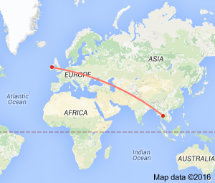One of our Be Active initiatives is *Siúlaimís* (Let’s Walk!) when we record walking on our school track, WOW and walking to and from school. Each class put their overall score on a map of Ireland. The starting point is St Mary’s and we are pleased to announce that the furthest travelled is 1,625 km by Room 14. As a school we have walked 9,450 km which is as far as Bangkok, Thailand on our journey to St Patrick’s Primary School, Koroit, Victoria, Australia. We will keep you updated in this Imlitir every week.

On Friday June 3rd, our school will be closed for the pupils, to enable the staff to undertake training and planning for the new Primary Language Curriculum. Please mark on your calendar.

We are delighted to announce that due to the reduction in the pupil teacher ratio in the last budget, we no longer have a waiting list for admission to our school.

Best wishes to our Second classes who make their First Holy Communion on Saturday next and a big thank you to all who have helped prepare them.

***Weekly ICT Update:*** *Students continue to work on Scratch during their computer time with the older classes creating animated ‘Fun Facts’ projects. This involves them working between Scratch and the internet to get images and the facts needed. They will present these Scratch projects to each other within the next week or two.*

*Ms. Debby*

**Be Active Week 2016*:****This year,*Be Active Week*runs from Monday May 23rd through to Friday May 27th. A wide variety of activities have been planned to keep everyone active. We'll have Orienteering, Soccer, Gaelic Football, Olympic Handball, Camogie, Tennis, Yoga, Zumba Dancing, Skipping, Cycling, Circuits and Fun Stretching. A huge ‘Thank You’ to all in the local community who kindly accepted our invitation to share their physical skills with the pupils during*Be Active Week*.  The whole week promises to be an enjoyable experience for all! St Mary’s*Be Active*Committee*

***Sport’s Day 2016:****Our annual Sport’s Day will take place on Wednesday, May 25th during*Be Active Week*. Parents are invited to come and watch from 10.45am that morning. Junior and Senior Infants will be in the Green Area and Yard behind the PE Hall and the rest of the school will use the field behind the school grounds. Pupils are encouraged to wear sunscreen (the sun might make an appearance!) and to bring extra drinks with them so they remain hydrated. The Parents Association will provide refreshments during the morning activities and we thank them for that. We hope everyone enjoys the fun-filled day!*

*D Galligan*

**BOOK GRANT SCHEME**: If any parent has a genuine need due to neither parent/guardian working or prolonged illness, they may apply for help with buying books for the next school year. All applicants may be means tested. Please apply on the form below and return to the school no later than FRIDAY 10th JUNE. No forms will be accepted after that date.

Finally, all our “Strictly” money has been collected and the final total profit is €37,411.52. This brings our overall MUGA Fund to €44,797.66. Many, many thanks to all who helped. Our Parents’ Association will be making a donation to this fund before the end of the year and we have planned a major fundraising venture, similar to “Strictly” for next year. We will also be doing a “Powerball” event in late October in place of our November Readalong. More details closer to the time. We would love to build the All-weather pitch sometime in the following school year but it will depend on a grant application also.

Mise le meas,



Cóilín Ó Coigligh, Príomh Oide.

**Information for Class Planning 2016/2017**

In order for the school to have accurate information for forward planning for 2016/2017, please complete and return the following sheet. This information is not binding, it is for class planning purposes.

Surname: __________________________

Student/s Name/s: __________________________

__________________________

__________________________

**will not** be returning to St. Mary’s in September 2016.

Signed:_____________________________________ Parent/Guardian

|  |  |
| --- | --- |
| **School Calendar 2016/2017** | |
| Return: | Wednesday 31st August 2016 |
| Mid-Term: | Monday 31st October - Friday 4th November 2016 |
| Christmas Break: | Friday 23rd December - Friday 6th January 2017 |
| Spring Mid-term Break | Thursday 23rd - Friday 24th February 2017 |
| Mid-term: | Monday 13th - Friday 17th March 2017 |
| Easter Break | Monday 10th April - Friday 21st April 2017 |
| May Bank Holiday: | 1st May 2017 |
| June Bank Holiday: | 5th June 2017 |
| School closes | Friday 30th June 2017 |

**Green News**

**Community News**

**Nath na Seachtaine**: **Is maith liom peil/camógaíocht/sacar**

**ach is fearr liom bheith ag snámh/ag rith/ag damhsa**

**Seanfhocal na Míosa:**  **Giorraíonn beirt bother/ Two shorten the journey**

**Dates to Remember**

**Meitheal:** Every Tuesday morning 9.30-10.30.

**Banna Ceoil:** Every Tuesday @ 3pm in the Dr. Eileen Reilly Hall

**School Choir:** Friday 3.00 – 4.00p.m

**Mini-Rounders:** 3rd & 4th Classes Mondays 3.00-4.00p.m.

- D. Galligan & S. Conaty, Teachers

**Rounders:** 5th & 6th Classes Mondays 3.00-4.00p.m.

– Ms Coakley & Mrs Munnelly, Teachers.

Thursdays lunchtime in Dr. Eileen Reilly Hall

**Camogie:** Wednesday 3.00-4.00 p.m. Third – Sixth Classes

**First Communion:** Saturday 28th May @ 11.00 a.m.

**First Class Boys Graduation:** Friday June 24th

**Sixth Class Graduation:** Thursday June 23rd

**Green News**

As Be Active week starts in St Mary’s, we are very excited to report that activity has already started in our courtyard herb and vegetable garden! The beds are nicely tidied up and ready for planting. The overgrown herbs have been cut back and we have great plans for a scarecrow and a bird feeder design competition! It is really a weather-dependent activity but we will seize every possible opportunity. Frank, our green delegates and other teachers with green thumbs have been watching the skies and have made great strides in the garden. Bail ó Dhia ar an obair!

WOW was a big event last week when over 383 stepped it out to mark National Walk to School Day! The Gardaí were out to assist with the big crowd as it moved up Emmet Street towards the school. Well done to all who participated! It was a great lead up to Be Active Week at St Mary’s.

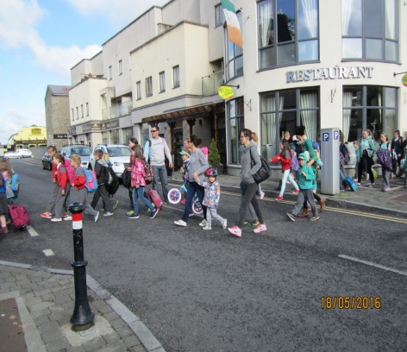

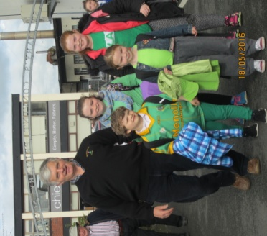 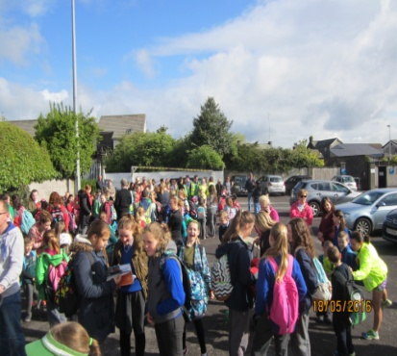

This week in addition to WOW (Walking on Wednesday), we will resume COW (Cycling on Wednesday). It is also Sports Day! Remember to wear sun screen, helmets and high viz vests if you are cycling. Meet inside the entrance to Steeple Manor at 8:55 am. Walkers meet up at Mornington House or at the Matchbox at 9am.

Recycling continues at school. We accept batteries, ink cartridges, cardboard, postage stamps, cans, plastic bottles and footwear. Sincere thanks to all those who recycle and help us make a difference.

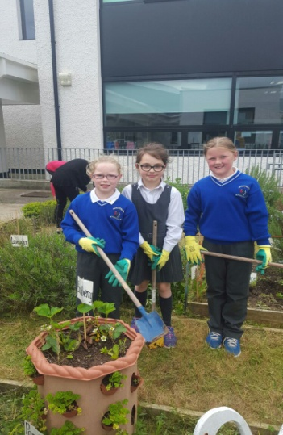Global Citizenship is our green theme this year (and next). We will be concentrating on litter and waste management. We will also be celebrating the global cultures represented in our school population during Intercultural week. Please notify your child’s teacher if you are interested in sharing information about your culture.

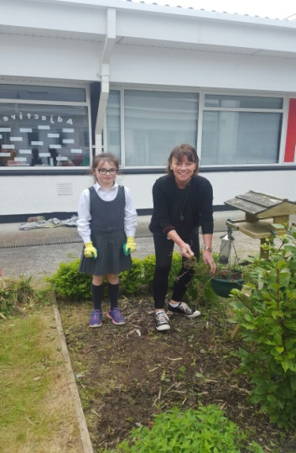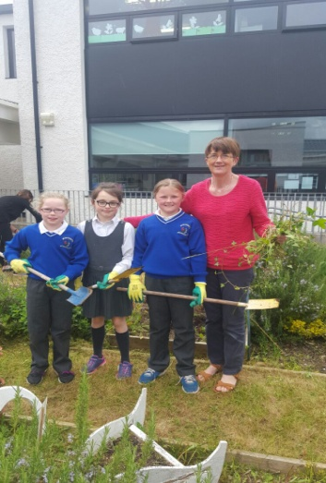

***Remember Green is cool, at home and at school and around the globe***

**Community Notices**

**SUNSHINE SUMMER CAMP@TRIM GAA CLUBHOUSE** is back again this summer from 11th -15th July for five days of fun! There will be lots of sport, art, crafts, baking, dance, crazy science, pet corner, painting and lots lots more. Cost €60 (discounts apply for siblings) Call or Text Carla/Elaine on 0857497004/ 0861905362 for more information and find us on Facebook for more updates@ **Sunshine Summer Camp Trim**

**SUMMER CAMP** – St Mary’s Primary School July 4th – 8th 10.00am – 2.30pm. cost: €60. Activities include: Arts & Crafts, Baking and Science. For bookings contact The Office or Ms Carr/Ms Leavy.

**Whizz Kidz Summer Camp** – St. Mary’s Primary School, Trim from Monday 11th – Friday 15th July, 10.00 am – 2.00pm. Computer & ICT based activities, including: mini-movie making, podcasts, presentations and outdoor games. Cost: €60. For bookings contact Ms. Coakley (Room 26)

**ZUMBA**: -   No experience, partner or booking required -      **SUMMER IS JUST AROUND THE CORNER**:- MONDAY   8pm   Trim GAA,   €8 per class     Contact :  Lorraine  086 8693546

**ZUMBA KIDS**:-        Ages 5-8   TUESDAY    3.15pm    TRIM GAA    €6 per class  (Sibling rate €5)

Zumba,  Hip-Hop,  Rock 'n Roll,  Jive.............             Contact :  Lorraine  086 8693546 / JoJo  086 3381159

**JIGGLE 'N' JUMP** - has moved to the Trim GAA from April 5th. Music and Movement classes will be held in the front room upstairs (Where the parent & toddler group takes place) on a Tuesday at 9.45am and Saturdays at 10.30am. There will also be a new class starting for ASD kids or kids who suffer with anxiety, offering a more routine class where parents can see the progress each week. This will be held on Saturdays at 9.30am. Classes also on Wednesday 10am in Summerhill Community Centre. Please call Julie to enquire or book in! 0868505310.

**Carney School of Irish Dancing** Classes in St. Patricks Hall every Tuesday. 2pm – 3pm & 3pm – 4pm. Every Friday @ 5.30pm. Infants and Senior infants can be collected from class rooms @ 2pm and left back to the buses @ 3pm. €5 per pupil per class. Contact Ann Carney 087-6336495



**BOOK GRANT SCHEME**

If any parent has a genuine need due to neither parent/guardian working or prolonged illness, they may apply for help with buying books for the next school year. **All applicants may be means tested.** Please apply on the form below and return to the school no later than FRIDAY 10th JUNE. No forms will be accepted after that date.

**-----------------------------------------------------------------**

**APPLICATION FORM**

I wish to apply for assistance from the Book Grant Scheme for the year 2016/2017 due to the following circumstances:

Signed: _______________________ Parent/Guardian. Date: ________________

|  |  |  |
| --- | --- | --- |
| **Child’s Name** | **Present Child’s Class**  **June 2016**  **(e.g. Junior Infants,**  **Senior Infants,**  **1st Class………)** | **Present Room Number**  **June 2016** |
|  |  |  |
|  |  |  |
|  |  |  |
|  |  |  |