***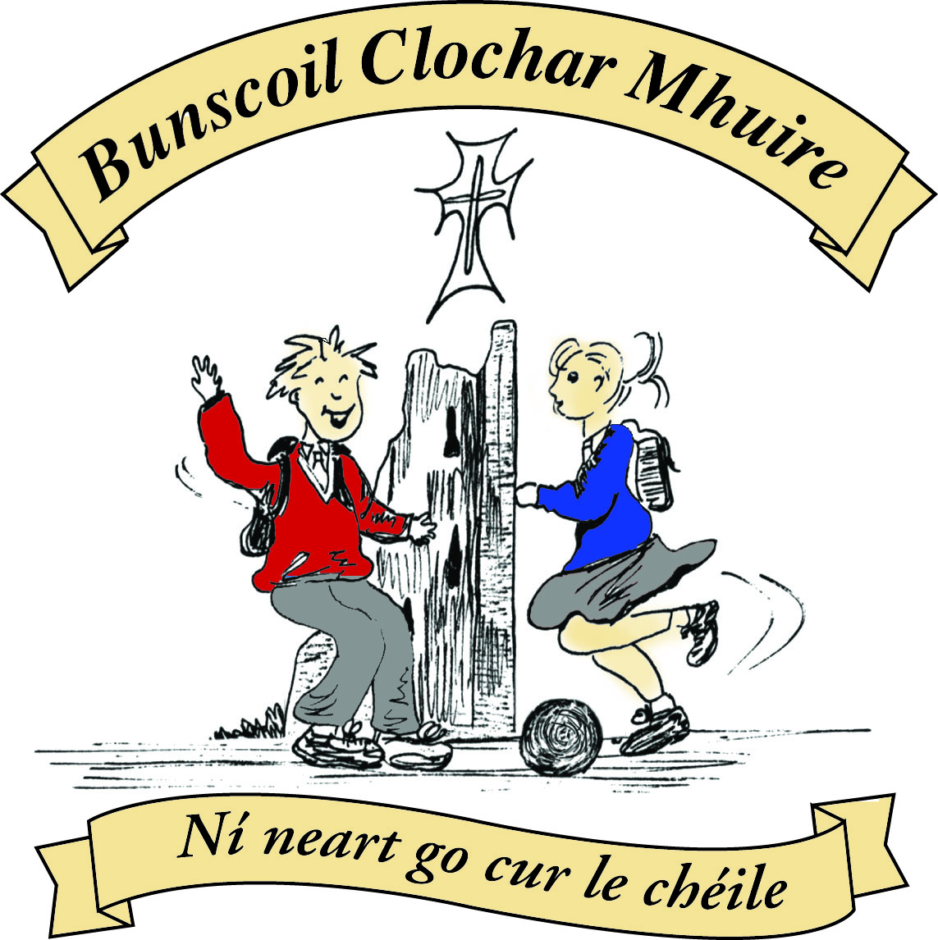* St Mary’s Convent Primary School**

***Bunscoil Clochar Mhuire***

***Trim, Co. Meath.  
Fón: (046) 9431919 ⦁ Faics: (046) 9437942  
Ríomhphost:*** [***marystrim@eircom.net***](mailto:marystrim@eircom.net) ***⦁ Website:*** [***www.stmarystrim.ie***](http://www.stmarystrim.ie) ***Uimhir Rolla: 16646O***

Awarded Green Flag  
June ‘05/’07/11/13

***Imlitir 33***

23rd May, 2017

***Every Day Counts at St Mary’s Convent Primary School***

***15th – 19th May 2017***

|  |  |  |  |  |  |  |  |
| --- | --- | --- | --- | --- | --- | --- | --- |
| **Room** | **Attendance** | **Room** | **Attendance** | **Room** | **Attendance** | **Room** | **Attendance** |
| 01 | 90% | 08 | 92% | 16 | 93.3% | 26 | 96.8% |
| 02 | 92.8% | 09 | 96.8% | 17 | 83.7% | 27 | 96.7% |
| 03 | 90.4% | 10 | 94.3% | 18 | 97.5% | 30 | 99.2% |
| 04 | 96.3% | 12 | 94.7% | 19 | 97.1% | 31 | 97.1% |
| 05 | 92.3% | 13 | 95.3% | 20 | 96.4% |  |  |
| 06 | 88.5% | 14 | 98.6% | **23 & 24** | **100%** |  |  |
| 07 | 92.8% | 15 | 92.9% |  |  |  |  |
|  |  |  |  |  |  |  |  |

*Well done to room 23&24 on having full attendance last week and to room 30 for nearly making it. Please note that notification in writing to the teacher is required. A letter or note in the homework journal will suffice.*

A chairde,

Best wishes to our School Football team in the Meath Semi-final today against Dunboyne. Many thanks to the large group of teachers who have given so generously of their time to train them.

We had a great night on Friday last at the OsKaRs. The quality of the movies and atmosphere were brilliant. We are most grateful the 53 actors, huge number of extras, local businesses and the community of Trim for all their support. Our organising committee and Parents' Association did fantastic work. Congrats to all the OsKaR winners. The true winners are the children in St Mary's and we hope to have the Astro-turf/All-weather/MUGA built by this time next year. A final decision will be made at the June Board of Management meeting. We do not plan on having any similar *large* fundraising events for the near future, but will need to do smaller events in order to reach the amount required to build the new facility. We have booked Powerball again for next October and will also do an Easter Raffle next year. The following year we will look at similar type fundraising events. We will still require a loan against this and future rental income from our BoM, as well as some financial assistance. But we want to build the facility as soon as possible, so that as many as possible of the children of those who helped build it can use it.

**Green Flag Award Ceremony** takes place on Thursday May 25th in Gormanstown. We will be presented with our seventh Green Flag which is a huge honour to our school. Congrats to Mrs Nally and the Green Flag Committee and to all who help maintain the green ethos in our school. We will have a flag raising ceremony in late June.

***Weekly ICT Update:*** *Over the past two months work from 1st class upwards has continued in Scratch with conversations being completed between characters, backgrounds being copied from the internet to enhance the projects and new sprites being created by the students. This past week has seen 2 of the senior infant classes start to type up a recipe in Word with a view to creating a sandwich and then cutting it into shapes in Scratch using the pen down option.*

*Three girls attended a coding fund raiser in the Boyne Community School this past Sunday. The girls spent the day coding in Scratch and then went on to learn about 3D printing. It is wonderful to see the enthusiasm shown by the students in the school towards learning how to program in Scratch.*

*Ms. Debby*

**BOOK GRANT SCHEME**: If any parent has a genuine need due to neither parent/guardian working or prolonged illness, they may apply for help with buying books for the next school year. All applicants may be means tested. Please apply on the form below and return to the school no later than FRIDAY 9th JUNE. No forms will be accepted after that date.

*There will be a Parents’ Association Meeting this Friday 26th @ 9.30 in the Staff Room. All welcome to attend. Caroline Smith*

***Fleadh na Mí***

*Fleadh na Mí took place last Sunday 21st in Scoil Mhuire , Trim . A great day was had by all at the many different competitions , solo , grúpaí and céilí bands. Many of our very own pupils and past pupils from St Mary's played feadóg , fidil , cruit , consairtín as well as singing .*

*Comhghairdeachas mór to all who entered .......some of them as young as 7 years of age. It takes a lot of courage , hard work and dedication to perform solo in front of a crowd . We should be very proud of the achievements of all . Many medals and trophies were awarded and some of our pupils will be progressing to the Leinster Fleadh in July where they will face competition from musicians from Dublin , Kildare , Westmeath to name but a few. There will be pupils from St Mary's in the grúpaí ceoil and banna céilí bands in July as well as the solo competitions. We are hopeful that our local Trim branch will be well represented also at the Fleadh Ceoil na hEireann in Ennis in August .*

*Well done to all for the hard work...we all know it takes practice and patience to learn an instrument and we look forward to encouraging many other pupils in our own Banna Ceoil to progress on to another instrument as they are doing so well at the feadóg . Remember you can talk to me if you are interested in renting an instrument from  the school  and we can advice on music teachers also. This is a good time of the year to plan for September when lessons start up .*

*Many thanks also to the Board of Management of St Mary's who accommodated practices and were very helpful anytime they were asked . Thanks also to Fr Declan who facilitated the Fleadh Mass on Saturday evening ....it was great to hear the cúpla focail at the Aifreann .*You can check out the Trim Comhaltas and Trim Fleadh na Mí facebook pages for photos of the day .*Ní neart go cuir le chéile !!*

*Ms McGale*

|  |  |
| --- | --- |
| **School Calendar 2017/2018** | |
| Return: | Thursday 31st August 2017 |
| Mid-Term: | Monday 30th October –Friday 3rd Nov 2017 |
| Christmas Break: | Monday 25th Dec 2017 - Friday 5th January 2018 |
| Feb Mid-term Break | Thursday 15th & Friday 16th Feb 2018 |
| St. Patrick’s Day | 19th March 2018 (Monday) |
| Easter Break | Monday 26th March – Friday 6th April 2018 |
| May Bank Holiday: | Week Monday 7th – Friday 11th May 2018 |
| June Bank Holiday: | Monday 4th June 2018 |
| School closes | Friday 29th June 2018 |
|  |  |

Mise le meas,



Cóilín Ó Coigligh, Príomh Oide.

## BOOK GRANT SCHEME

If any parent has a genuine need due to neither parent/guardian working or prolonged illness, they may apply for help with buying books for the next school year. **All applicants may be means tested.** Please apply on the form below and return to the school no later than FRIDAY 9TH JUNE. No forms will be accepted after that date.

**-----------------------------------------------------------------**

**APPLICATION FORM**

I wish to apply for assistance from the Book Grant Scheme for the year 2017/2018 due to the following circumstances.

Signed: _______________________ Parent/Guardian. Date: ________________

|  |  |  |
| --- | --- | --- |
| **Child’s Name** | **Present Child’s Class**  **June 2017**  **(e.g. Junior Infants,**  **Senior Infants,**  **1st Class………)** | **Present Room Number**  **June 2017** |
|  |  |  |
|  |  |  |
|  |  |  |
|  |  |  |

**Green News**

**Community News**

**Nathanna na Seachtaine:**  **Tá an ghrian ag taitneamh /Tá sé te (The sun is shining / It is hot)**

**Seanfhocal na Míosa:** Bíonn Cluasa Móra ag Muca Beaga

**Dates to Remember**

**Assembly: Friday** 9.30 Water Safety Junior Classes

**Banna Ceoil:** Tuesday 3.00-4.00

**Football Training:** Wednesday 3.00 - 4.00 for 3rd – 6th Classes

**Meitheal:** Every Tuesday morning 9.30-10.30.

**Rounders:** Mondays for 3rd to 6th Classes 3.00 – 4.00pm

**School Choir:** Friday 3.00 – 4.00p.m

**Green News**

It’s a very exciting week as we are going to be receiving our 7th Green Flag – The Flag for Global Citizenship. Mrs Nally, Ms Flattery, Charlie and Alanna will collect the flag in Gormanstown on Thursday. Stay tuned – photos next week!

There is great work being done in the garden. The girls from 6th Class were busy painting last week and two lovely lads from The Boyne Community School kindly gave up their time to help do some of the heavier work. See the photos attached! We’ll keep you posted on our progress.

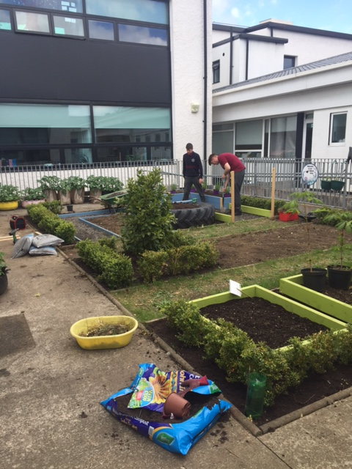

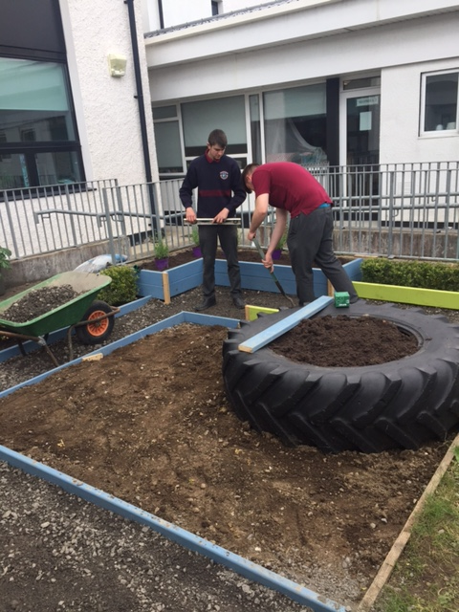

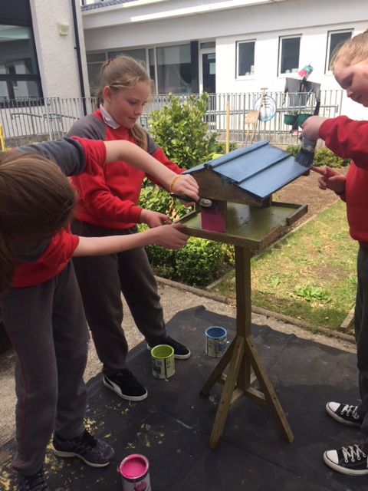

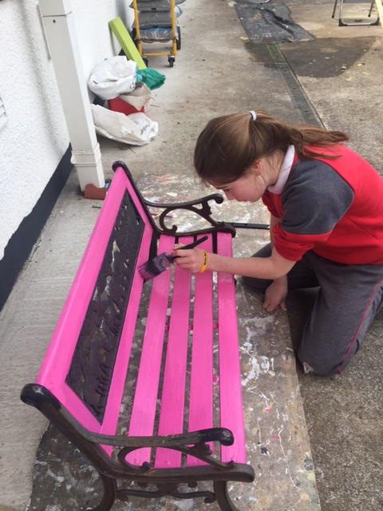

**Community Notices**

**Serendipity for Charity, Watergate Street, Trim**.We are looking for volunteers at the moment to help out in our shop in Trim. We support various local charities each year. If you are interested in giving a couple of hours during the week please contact Miriam on 0868548202. You can also find us on Facebook at Serendipity for Charity.

**Jiggle 'n' Jump**

Music & Movement classes for little ones (8mths-4yrs) running upstairs in Trim GAA on Tuesday 9.45-10.45am  €7 a class or 4 class card for €25

Also available for **Kids Party Entertainment!**

Various characters and themes with fun games, dancing, face painting and prizes!

Clown, Pirate, Princess, 80's Disco Diva, Sporty Diva and Super Hero available.

New Party Package insures 2 hours of non stop entertainment, with face painting by Linda (Flawless Facepaint) while I entertain the kids with singing, dancing, party games and non stop fun!!

Contact Julie on [0868505310](tel:0868505310) or on Facebook [www.facebook.com/jigglenjump](http://www.facebook.com/jigglenjump)

**BIG BOUNCE**

For the very best in high quality inflatable entertainment and giant garden games in Meath, Big Bounce is the place to go!  We are a family run Bouncy Castle hire based in Trim, Co. Meath.

Perfect for Christenings, Birthdays, Family Events, BBQ's etc.  Contact Johnny on 0851479896

Also working with face painter and kids Entertainer for added fun for all!

**Stage Stars Summer Camp:** The camp is running from July 24-28 from 10.00 - 2.00 (with an optional earlier drop off time) and is open to girls and boys aged 4-12. It will be an action packed week of singing, dancing, drama and arts and crafts with finishing certificates and an end of week performance for family and friends! The camp is €80 per child with sibling discounts as well as an early bird offer if booked and paid in full by June 9th. For more information call 0863566061 or see Facebook.com/stagestarssummercamp

 