***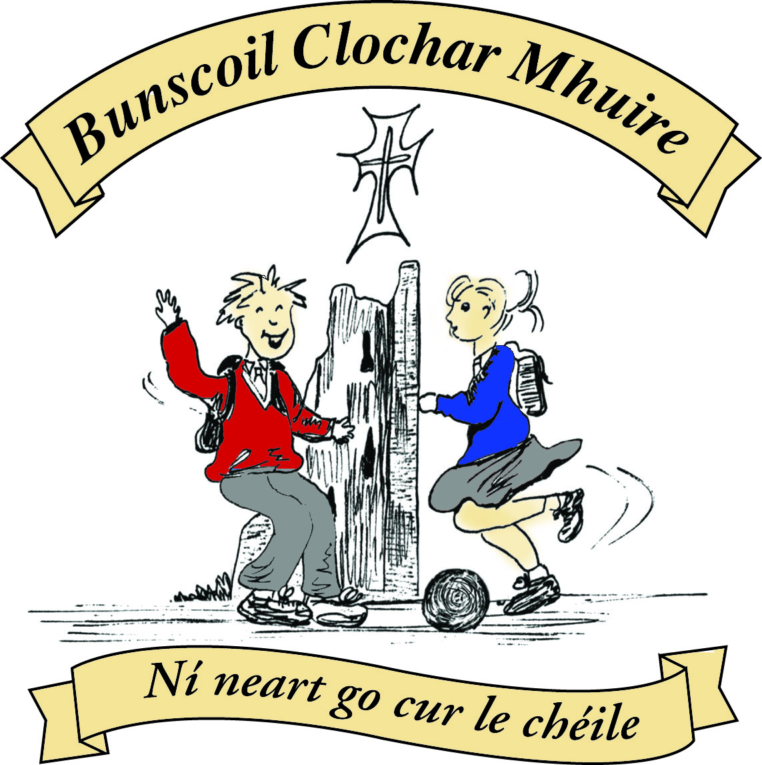* St Mary’s Convent Primary School**

***Bunscoil Clochar Mhuire***

***Trim, Co. Meath.  
Fón: (046) 9431919 ⦁ Faics: (046) 9437942  
Ríomhphost:*** [***marystrim@eircom.net***](mailto:marystrim@eircom.net) ***⦁ Website:*** [***www.stmarystrim.ie***](http://www.stmarystrim.ie) ***Uimhir Rolla: 16646O***

Awarded Green Flag  
June ‘05/’07/11/13

***Imlitir 33***

16th May, 2016

***Every Day Counts at St Mary’s Convent Primary School***

***9th – 13th May, 2016***

|  |  |  |  |  |  |  |  |
| --- | --- | --- | --- | --- | --- | --- | --- |
| **Room** | **Attendance** | **Room** | **Attendance** | **Room** | **Attendance** | **Room** | **Attendance** |
|  |  |  |  |  |  |  |  |
| 01 | 93.8 % | 08 | 93.6% | 16 | 92.6% | 26 | 93.3% |
| 02 | 92.8% | **09** | **100%** | 17 | 82% | 27 | 95% |
| 03 | 99.2% | 10 | 95.7% | 18 | 95.7% | 30 | 93.8% |
| 04 | 87.7% | 12 | 90.8% | 19 | 91.1% | 31 | 89.7% |
| 05 | 97.1% | 13 | 92.3% | 20 | 99.2% |  |  |
| 06 | 97.9% | 14 | 96.2% | 23 | 94.3% |  |  |
| 07 | 97% | 15 | 97.6% | **24** | **100%** |  |  |

A Chairde,

Congratulations to Rooms **9 & 24** on having full attendance last week and to Rooms 3 & 20 who almost made it! Please note that notification in writing to the teacher is required for all absences. A letter or note in the homework journal will suffice.

Today, we are having our Be Active Schools’ visit when all the initiatives of the past two years will be assessed and hopefully we will be awarded an Active Schools’ Flag. Mr Galligan has posted an update below. I would like to thanks all the pupils, parents and huge number of teachers involved for the great work that has happened these past few years. Further proof of our school motto: *Ní neart go cur le chéile* (There is strength in togetherness).

**Mobile Phones**: Please note that they should not be switched on, once pupils enter the school grounds.

*“If it’s out, it’s on. If it’s on it’s gone!”*

Phones will only be returned to parents/guardians.

**Graduation Night** for the Sixth Classes will be on Thursday June 23rd. We will also be having a Graduation for First Class Boys on Friday June 24th. This will be during the school day to enable the girls wish them well also. More details to follow.

**BOOK GRANT SCHEME**: If any parent has a genuine need due to neither parent/guardian working or prolonged illness, they may apply for help with buying books for the ***next*** school year. All applicants may be means tested. Please apply on the form below and return to the school no later than FRIDAY 10th JUNE. No forms will be accepted after that date.

We have a large amount of clothes in **Lost & Found** at the moment. Please check for any missing items by Monday 13th June. All unclaimed items will be donated to charity.

**Active School Flag*Visitor****: Ger McDonnell, a representative of the national Active School Initiative, paid a visit to St Mary’s today to find out what the school has been doing to promote and encourage greater physical activity in our school community. A Junior Active Assembly, led by Mr O’Mahony’s First Class pupils, was held in the hall. The assembly itself was buzzing with a get-up-and-go attitude. Upstairs, the two 6th Classes performed some energetic dance moves for Ger, with the help of Go Noodle and Just Dance. Ms Murray’s Fifth Class demonstrated their fitness levels by doing the back-breaking Plank Challenge. Back in the PE Hall, Ms Coakley’s 5th Class displayed their flexibility in a variety of gymnastic movements. Ms Carr’s Senior Infants headed outside into the May sunshine for some Outdoor and Adventure Activities. The Junior Infant pupils, Ms McKenna’s Senior Infant Class, as well as some boys and girls from the Mixed and Language Classes made use of the good weather by taking to the yard. The Junior Infants, led by 6th Class, walked and jogged around*Slí na Sláinte*(our Walking Track), while the Senior Infant pupils enjoyed playing some yard games with 6th Class girls. During Big Lunch, Ger spent time speaking with the enthusiastic pupils on the Be Active Committee along with a group of parents representing the school’s Parent Focus Group. Afterwards, she was taken to view our numerous “active” displays, our vast array of PE equipment and other resource material. Finally, the folder laden down with our surveys, interviews, action plan, initiatives and evidence of improvement was carefully examined. We will find out in due course if Ger was suitably impressed! Fingers crossed!   D. Galligan (on behalf of St Mary’s Be Active Committee)*

***St Mary's Be Active Blog****- Don't forget to have a look at our Be Active Blog to see all of the wonderful activities we have been getting up to in St Mary's this year.* [*stmarysbeactive.wordpress.com*](http://stmarysbeactive.wordpress.com)

*Ms Dalton*

***Bun Sale:*** *Thank you to all the children and families who baked for the bun sale on Friday, all your hard work and contribution was so gratefully appreciated. There were some beautiful creations and very tasty looking buns!! We had such a massive response and to show our appreciation, we decided to add 2 more €20 smyths vouchers to the draw totalling 5 draws. A big congratulations to the following children, who's names were pulled out of the raffle.*

*Draw 1; Ethan Beirne Pononmarev, Senior Infants, Room 7.*

*Draw 2; Sophie Doyle, Junior Infants, Room 2.*

*Draw 3; Lauren Herdman, Sixth class, Room 31.*

*Draw 4; Alex Darby, 1st class, Room 9.*

*Draw 5; Katie Fox, 3rd class, Room 16.*

*Well done and we hope you have great fun choosing something nice!*

*Emma Fox*

*Chairperson*

|  |  |
| --- | --- |
| **School Calendar 2016/2017** | |
| Return: | Wednesday 31st August 2016 |
| Mid-Term: | Monday 31st October - Friday 4th November 2016 |
| Christmas Break: | Friday 23rd December - Friday 6th January 2017 |
| Spring Mid-term Break | Thursday 23rd - Friday 24th February 2017 |
| Mid-term: | Monday 13th - Friday 17th March 2017 |
| Easter Break | Monday 10th April - Friday 21st April 2017 |
| May Bank Holiday: | 1st May 2017 |
| June Bank Holiday: | 5th June 2017 |
| School closes | Friday 30th June 2017 |

**Information for Class Planning 2016/2017**

In order for the school to have accurate information for forward planning for 2016/2017, please complete and return the following sheet. This information is not binding, it is for class planning purposes.

Surname: __________________________

Student/s Name/s: __________________________

__________________________

__________________________

**will not** be returning to St. Mary’s in September 2016.

Signed:_____________________________________ Parent/Guardian

Mise le meas,



Cóilín Ó Coigligh, Príomh Oide.

**Green News**

**Community News**

**Nath na Seachtaine**: **Ná bí buartha! (Don't worry!)**

**Seanfhocal na Míosa:**  **Giorraíonn beirt bother/ Two shorten the journey**

**Dates to Remember**

**Assembly:** Be Active Committee Talk. Juniors 9.20 Seniors 9.40

**Meitheal:** Every Tuesday morning 9.30-10.30.

**Banna Ceoil:** Every Tuesday @ 3pm in the Dr. Eileen Reilly Hall

**School Choir:** Friday 3.00 – 4.00p.m

**Mini-Rounders:** 3rd & 4th Classes Mondays 3.00-4.00p.m.

- D. Galligan & S. Conaty, Teachers

**Rounders:** 5th & 6th Classes Mondays 3.00-4.00p.m.

– Ms Coakley & Mrs Munnelly, Teachers.

Thursdays lunchtime in Dr. Eileen Reilly Hall

**Camogie:** Wednesday 3.00-4.00 p.m. Third – Sixth Classes

**First Communion:** Saturday 28th May @ 11.00 a.m.

**Green News**

COW (Cycling on Wednesdays) resumed last Wednesday. Well done to those who came along. It wasn’t a very sunny morning but it nevertheless a group of cyclists took to the river walk to launch St Mary’s COW 2016. This week is National Walk to School week. It is hoped to help the national tally of walkers reach an all-time high on Wednesday, May 18th, so we would encourage as many of you as possible to walk to school that day. You might like to meet up with us all in the car park behind the Matchbox and we will proceed up from there. It is always quite a spectacle when we walk en masse like that. As we are a Green School, we will walk in 40 shades of green that day! Looking forward to seeing everyone out in style! If for some reason, it is wet, we will still walk and we will call it our ‘Umbrella Walk.’ Meet at the same place and we will process up with our umbrellas. And there will be a homework pass for everyone in the audience!!!

Remember we recycle footwear, batteries, plastic bottles, cardboard, toilet rolls, stamps and ink cartridges in school. Thanks to all who participate in our recycling drives.

Our Green theme this year is Global Citizenship. Our intercultural week will be coming up soon. Please let your child’s teacher know if you would be available to come in to share some information about your culture and country. Thank you. We always look forward to learning about other cultures and we are so lucky to have lots of nationalities represented in our school.

***Remember Green is cool, at home and at school and around the globe***

**Community Notices**

**SUNSHINE SUMMER CAMP@TRIM GAA CLUBHOUSE** is back again this summer from 11th -15th July for five days of fun! There will be lots of sport, art, crafts, baking, dance, crazy science, pet corner, painting and lots lots more. Cost €60 (discounts apply for siblings) Call or Text Carla/Elaine on 0857497004/ 0861905362 for more information and find us on Facebook for more updates@ **Sunshine Summer Camp Trim**

**SUMMER CAMP** – St Mary’s Primary School July 4th – 8th 10.00am – 2.30pm. cost: €60. Activities include: Arts & Crafts, Baking and Science. For bookings contact The Office or Ms Carr/Ms Leavy.

**Trim Juvenile GAA Club:** Table Quiz on Friday 20th May @ 8pm. Table of 4 €40. Raffle & Spot prizes on the night.

**GLUAIS**: Showcase Concert 2016. Dreamer our journey so far. Wednesday 18th May in St Marys Primary School @ 7.30pm. Admission €8/€10

**ZUMBA**: -   No experience, partner or booking required -      **SUMMER IS JUST AROUND THE CORNER**:- MONDAY   8pm   Trim GAA,   €8 per class     Contact :  Lorraine  086 8693546

**ZUMBA KIDS**:-        Ages 5-8   TUESDAY    3.15pm    TRIM GAA    €6 per class  (Sibling rate €5)

Zumba,  Hip-Hop,  Rock 'n Roll,  Jive.............             Contact :  Lorraine  086 8693546 / JoJo  086 3381159

**JIGGLE 'N' JUMP** - has moved to the Trim GAA from April 5th. Music and Movement classes will be held in the front room upstairs (Where the parent & toddler group takes place) on a Tuesday at 9.45am and Saturdays at 10.30am. There will also be a new class starting for ASD kids or kids who suffer with anxiety, offering a more routine class where parents can see the progress each week. This will be held on Saturdays at 9.30am. Classes also on Wednesday 10am in Summerhill Community Centre. Please call Julie to enquire or book in! 0868505310.

Jiggle 'n' Jump also provide party entertainment, in your home, the GAA or other venue. Various characters available for Face Painting, Tattoos, Nails, Singing, Dance Routines, fun Bingo, Pass the Parcel and lots of other fun party games! :)

**Carney School of Irish Dancing** Classes in St. Patricks Hall every Tuesday. 2pm – 3pm & 3pm – 4pm. Every Friday @ 5.30pm. Infants and Senior infants can be collected from class rooms @ 2pm and left back to the buses @ 3pm. €5 per pupil per class. Contact Ann Carney 087-6336495



**BOOK GRANT SCHEME**

If any parent has a genuine need due to neither parent/guardian working or prolonged illness, they may apply for help with buying books for the next school year. **All applicants may be means tested.** Please apply on the form below and return to the school no later than FRIDAY 10th JUNE. No forms will be accepted after that date.

**-----------------------------------------------------------------**

**APPLICATION FORM**

I wish to apply for assistance from the Book Grant Scheme for the year 2016/2017 due to the following circumstances:

Signed: _______________________ Parent/Guardian. Date: ________________

|  |  |  |
| --- | --- | --- |
| **Child’s Name** | **Present Child’s Class**  **June 2016**  **(e.g. Junior Infants,**  **Senior Infants,**  **1st Class………)** | **Present Room Number**  **June 2016** |
|  |  |  |
|  |  |  |
|  |  |  |
|  |  |  |