***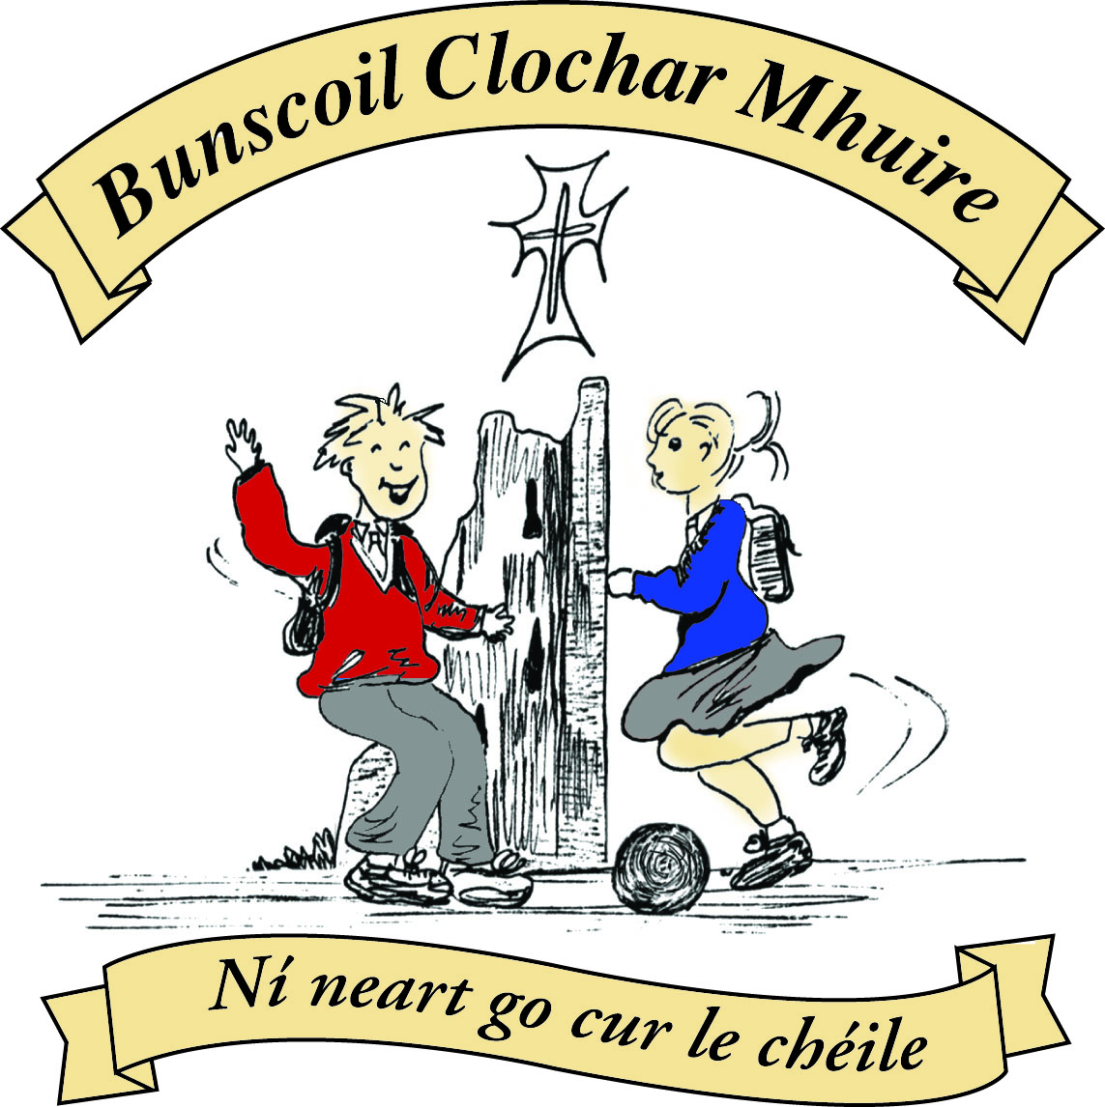* St Mary’s Convent Primary School**

***Bunscoil Clochar Mhuire***

***Trim, Co. Meath.  
Fón: (046) 9431919 ⦁ Faics: (046) 9437942  
Ríomhphost:*** [***marystrim@eircom.net***](mailto:marystrim@eircom.net) ***⦁ Website:*** [***www.stmarystrim.ie***](http://www.stmarystrim.ie) ***Uimhir Rolla: 16646O***

Awarded Green Flag  
June ‘05/’07/11/13

***Imlitir 32***

10th May, 2016

***Every Day Counts at St Mary’s Convent Primary School***

***25th – 29th April, 2016***

|  |  |  |  |  |  |  |  |
| --- | --- | --- | --- | --- | --- | --- | --- |
| **Room** | **Attendance** | **Room** | **Attendance** | **Room** | **Attendance** | **Room** | **Attendance** |
|  |  |  |  |  |  |  |  |
| 01 | 83 % | 08 | 95% | 16 | 94.8% | 26 | 94.1% |
| 02 | 90.8% | 09 | 94.1% | 17 | 88% | 27 | 94.3% |
| 03 | 96% | 10 | 95% | 18 | 97.9% | 30 | 95.2% |
| 04 | 93.8% | 12 | 97.7% | 19 | 96.7% | 31 | 93.8% |
| 05 | 92.1% | 13 | 93.1% | 20 | 95% |  |  |
| 06 | 98.6% | 14 | 93.8% | **23** | **100%** |  |  |
| 07 | 86.7% | 15 | 95.2% | 24 | 93.3% |  |  |

A Chairde,

Congratulations to Room **23** on having full attendance last week.

*Fáilte ar ais* (Welcome back). I trust that everyone had a good mid-term break and is ready for the remaining busy weeks of term.  **Active Schools’ Week** this year will befrom May 23rd – 27th.Our **Sport For All Day** will be the Wednesday of that week and not the date on our school calendar.

**School Uniform:** May I remind parents and pupils that fashion shoes and fashion socks/tights are not part of our school uniform. Shoes with very high heels and non-supportive runners also present a safety risk.

**Gaelbhratach:** We were awarded our second flag two weeks ago. *Go raibh mile maith agat* to everybody who helped. Check out our website ([www.stmarystrim.ie](http://www.stmarystrim.ie)) for a lovely photo of two of our pupils on the committee with Bláithnead Ní Choffaigh, taken at the presentation. We will have an official launch date in June.

In relation to our **all-weather pitch**, we intend applying for a government grant and have a few local clubs on board. If you are involved in a local club that may like to be included, please contact me for further information.

Thanks to all who supported and organised the recent fundraising **Skipathon**. A total of €2,885 was raised and will be donated to our all-weather pitch fund. At the end of the year, our Parents’ Association will present a cheque to the school. Please support the Parents’ Association Bun Sale this Friday.

Finally, St Michael’s have asked me to remind parents/guardians not to park in their school grounds or to obstruct their gateway. May I also remind you not to park in the identified special needs parking bays. Thanks.

***Rounders League 2016****: Congratulations to the 5th and 6th Class pupils who recently took part in our school’s Rounders League. The league itself generated great excitement and enthusiasm among the pupils in the senior classes. A healthy rivalry developed between the four teams – Funky Monkeys, Bull Dogs, Wild Cats and Jelly Belly Spuds. The league final took place between Wild Cats and Bull Dogs before mid-term, with Wild Cats coming out on top. Medals and certificates were distributed to the forty-eight participants in the league before the May holiday. Well done to one and all!*

*D. Galligan*

*St Marys Parents Association will be having a bun sale on Friday May 13th in the hall from 9.45 until 11.30.  Each class will be assigned a time, as per an agreed timetable and will be escorted by their teacher. Each bun will cost 50c and all proceeds will go towards the school MUGA fund.  
 Children from****Junior, Senior and 6th****class are being asked to provide buns for the sale open to all classes, however all classes are welcome to donate buns.***RAFFLE** *There will be a raffle for* ***3 x  €20 Smyths vouchers*** *for all children who provide buns for the sale and the draw will take place after the bun sale.*   
 *Emma Fox  
 Chairperson*

|  |  |
| --- | --- |
| **School Calendar 2016/2017** | |
| Return: | Wednesday 31st August 2016 |
| Mid-Term: | Monday 31st October - Friday 4th November 2016 |
| Christmas Break: | Friday 23rd December - Friday 6th January 2017 |
| Spring Mid-term Break | Thursday 23rd - Friday 24th February 2017 |
| Mid-term: | Monday 13th - Friday 17th March 2017 |
| Easter Break | Monday 10th April - Friday 21st April 2017 |
| May Bank Holiday: | 1st May 2017 |
| June Bank Holiday: | 5th June 2017 |
| School closes | Friday 30th June 2017 |

**Information for Class Planning 2016/2017**

In order for the school to have accurate information for forward planning for 2016/2017, please complete and return the following sheet. This information is not binding, it is for class planning purposes.

Surname: __________________________

Student/s Name/s: __________________________

__________________________

__________________________

**will not** be returning to St. Mary’s in September 2016.

Signed:_____________________________________ Parent/Guardian

Mise le meas,



Cóilín Ó Coigligh, Príomh Oide.

**Green News**

**Community News**

**Nath na Seachtaine**: **Tá sé go breá ...... Is féidir linn dul amach!**

**Seanfhocal na Míosa:**  **Giorraíonn beirt bother/ Two shorten the journey**

**Dates to Remember**

**Cake Sale:** Friday 13th May

**Meitheal:** Every Tuesday morning 9.30-10.30.

**Banna Ceoil:** Every Tuesday @ 3pm in the Dr. Eileen Reilly Hall

**School Choir:** Friday 3.00 – 4.00p.m

**Mini-Rounders:** 3rd & 4th Classes Mondays 3.00-4.00p.m.

- D. Galligan & S. Conaty, Teachers

**Rounders:** 5th & 6th Classes Mondays 3.00-4.00p.m.

– Ms Coakley & Mrs Munnelly, Teachers.

Thursdays lunchtime in Dr. Eileen Reilly Hall

**Camogie:** Wednesday 3.00-4.00 p.m. Third – Sixth Classes

**First Communion:** Saturday 28th May @ 11.00 a.m.

**Green News**

Finally the promise of some good weather! We hope to launch our **COW 2016** campaign this week. We hope that we will have lots of new cyclists taking part. Pupils from Fourth Class up to Sixth Class are invited to participate. If younger pupils would like to take part, they must be accompanied by an adult. Two teachers will accompany the pupils along the route. Our meeting point is just outside the first house of Steeple Manor estate. It is much safer to convene here as there can be a lot of traffic on the Lackanash Rd. Please remember safety is paramount and helmets and hi-viz vests are necessities. A teacher will collect the school bags and bring them down to the school. The actual cycle route is along the river which is a wonderful start to the day! It’s healthy for the environment and healthy for you!

WOW will continue as always. There are two meeting points....One up at Mornington House and the other down at the Matchbox on Emmet Street. You can meet up with the WOW gang at 9am at either of these points. Sincere thanks to the dedicated teachers who sustain this initiative by being there to walk with the children every week. Numbers have been steady. Now that the weather is improving, perhaps more children might get involved. Next week is National Walk to School Week. It might be a good incentive to try to make that effort. On Wednesday May 18th, the Green School Travel team in An Taisce want to reach a target of 20,000 people walking to school that day. Let’s help them achieve this!

Our recycling continues at school. We accept batteries, cardboard, small plastic bottles, ink cartridges, Nespresso coffee pods, footwear, toilet rolls and postage stamps.

Global Citizenship is our Green theme for this year. Our specific emphasis is on Litter and Waste Management. April was Clean-up month. Some of our Green Committee got together with their Secondary School counterparts and worked on cleaning up our environs and disposing of our litter in the correct and most green way. There are some photos below.

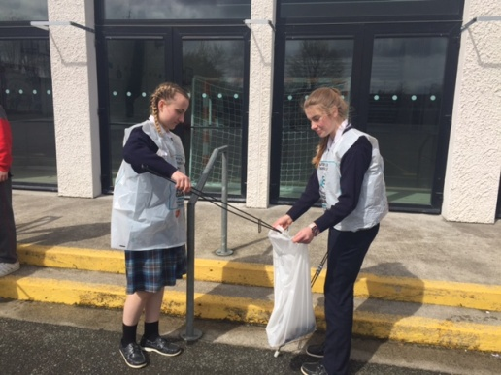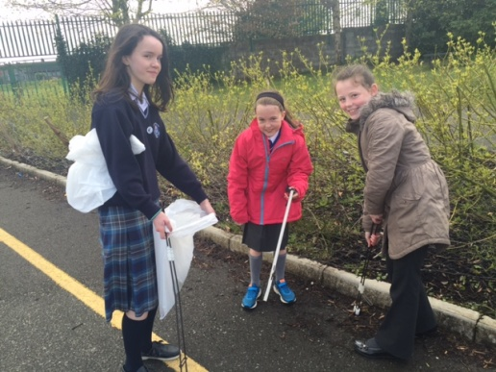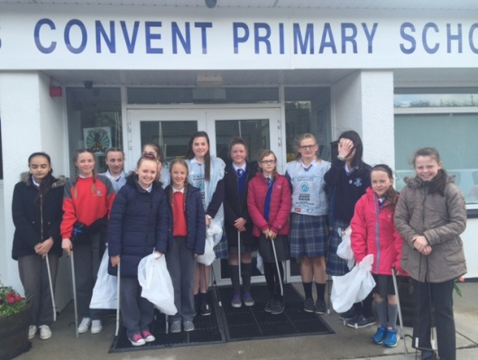

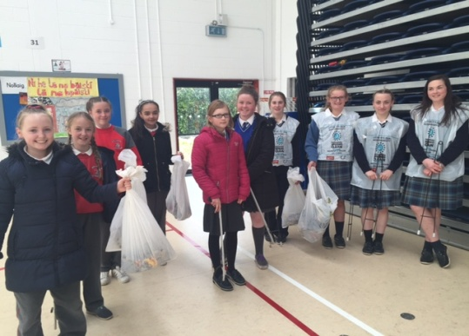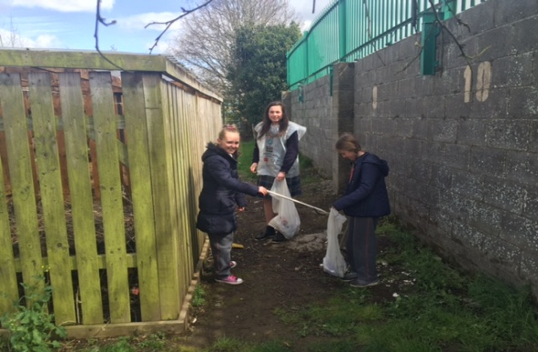

***Remember Green is cool, at home and at school and around the globe***

**Community Notices**

**SUMMER CAMP** – St Mary’s Primary School July 4th – 8th 10.00am – 2.30pm. cost: €60. Activities include: Arts & Crafts, Baking and Science. For bookings contact The Office or Ms Carr/Ms Leavy.

**ZUMBA**  :-   No experience, partner or booking required -      **SUMMER IS JUST AROUND THE CORNER**:- MONDAY   8pm   Trim GAA,   €8 per class     Contact :  Lorraine  086 8693546

**ZUMBA  KIDS**:-        Ages 5-8   TUESDAY    3.15pm    TRIM GAA    €6 per class  (Sibling rate €5)

Zumba,  Hip-Hop,  Rock 'n Roll,  Jive.............             Contact :  Lorraine  086 8693546 / JoJo  086 3381159

**JIGGLE 'N' JUMP** - has moved to the Trim GAA from April 5th. Music and Movement classes will be held in the front room upstairs (Where the parent & toddler group takes place) on a Tuesday at 9.45am and Saturdays at 10.30am. There will also be a new class starting for ASD kids or kids who suffer with anxiety, offering a more routine class where parents can see the progress each week. This will be held on Saturdays at 9.30am. Classes also on Wednesday 10am in Summerhill Community Centre. Please call Julie to enquire or book in! 0868505310.

Jiggle 'n' Jump also provide party entertainment, in your home, the GAA or other venue. Various characters available for Face Painting, Tattoos, Nails, Singing, Dance Routines, fun Bingo, Pass the Parcel and lots of other fun party games! :)

**Carney School of Irish Dancing** Classes in St. Patricks Hall every Tuesday. 2pm – 3pm & 3pm – 4pm. Every Friday @ 5.30pm. Infants and Senior infants can be collected from class rooms @ 2pm and left back to the buses @ 3pm. €5 per pupil per class. Contact Ann Carney 087-6336495

**Mindfulness Meditation Workshop** for 8-12 years old. 3.30pm to 5.30pm Thursday 12th of May with Elfreda Manahan-Vaughan at the Elements Holistic Centre 1 Oaktree Business Park, Trim. €12. To book email [info@metta-morphics.com](mailto:info@metta-morphics.com) or phone 0868373582, only 6 places left.