***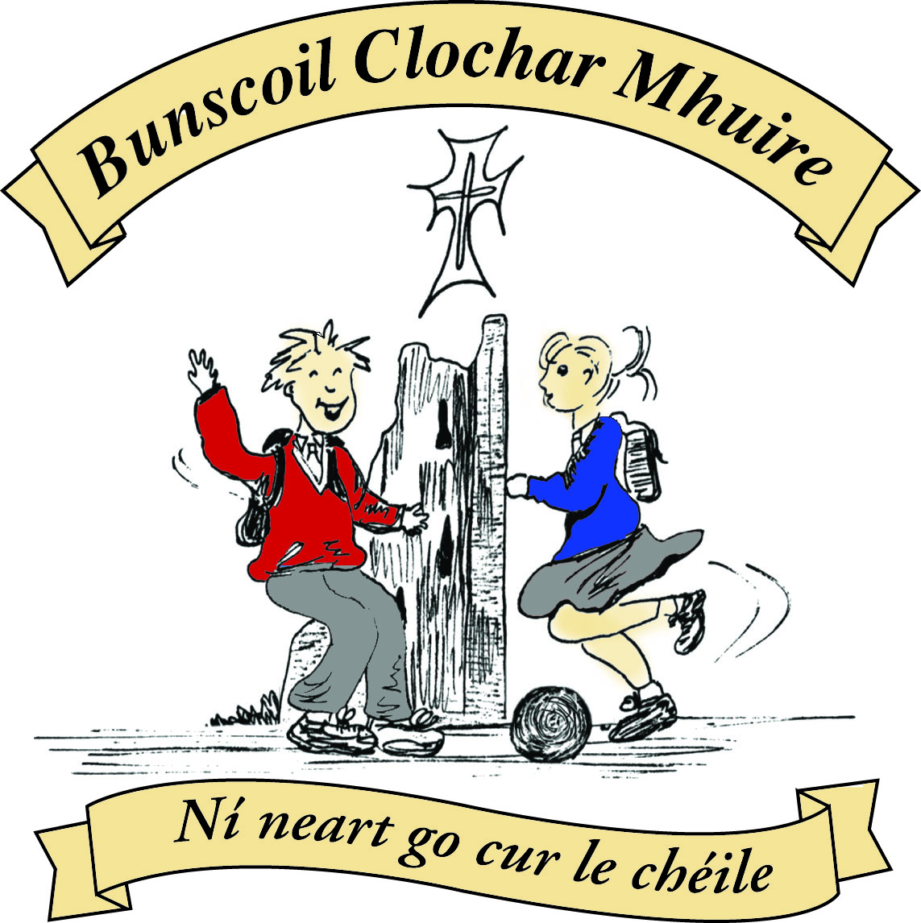* St Mary’s Convent Primary School**

***Bunscoil Clochar Mhuire***

***Trim, Co. Meath.  
Fón: (046) 9431919 ⦁ Faics: (046) 9437942  
Ríomhphost:*** [***marystrim@eircom.net***](mailto:marystrim@eircom.net) ***⦁ Website:*** [***www.stmarystrim.ie***](http://www.stmarystrim.ie) ***Uimhir Rolla: 16646O***

Awarded Green Flag  
June ‘05/’07/11/13

***Imlitir 32***

21st May, 2018

***Every Day Counts at St Mary’s Convent Primary School***

***14th May - 18th May 2018***

|  |  |  |  |  |  |  |  |
| --- | --- | --- | --- | --- | --- | --- | --- |
| **Room** | **Attendance** | **Room** | **Attendance** | **Room** | **Attendance** | **Room** | **Attendance** |
| 01 | 91.7% | 08 | 98.5% | 16 | 95.3% | 26 | 85.2 % |
| 02 | 99.3% | 09 | 85.4% | 17 | 98.3% | 27 | 96.3% |
| 03 | 95.2% | 10 | 98.4% | 18 | 93.6% | 30 | 91.2% |
| 04 | 96.6% | 12 | 93.3% | 19 | 99.3% | 31 | 89.2% |
| 05 | 98.5% | 13 | 98.3% | 20 | 91.5% |  |  |
| 06 | 93.3% | 14 | 95.7% | 23 & 24 | 94.2% |  |  |
| 07 | 75.8% | 15 | 97.2% |  |  |  |  |

*Congratulations to rooms 2 & 19 on nearly having full attendance last week. Please note that notification in writing, with the reason for all absences, to the teacher is required. A letter or note in the homework journal will suffice.*

A chairde,

We have a big week coming up this week when the pupils in Fifth and Sixth classes perform Seussical Jnr-The Musical. Please purchase tickets in advance, from the Office, as we expect two of the nights to book out. Tickets are €10 for adults, €8 for children and a Family Ticket (2 adults and two children) is €30. The shows start at 7.30 Thursday, Friday and Saturday nights, in The Dr Eileen O Reilly Hall. I have seen some of the rehearsals and it’s really good, reflecting the hours and hours off practice and singing that have gone into it. It will be a great night’s entertainment.

Please note that school will be closed on Friday next due to the Referendum. Please make the necessary arrangements.

**BOOK GRANT SCHEME**: If any parent has a genuine need due to neither parent/guardian working or prolonged illness, they may apply for help with buying books for the next school year. All applicants may be means tested. Please apply on the form below, attach a copy of your Medical Card and return to the school no later than FRIDAY 8th JUNE. No forms will be accepted after that date.

There will be a Parents’ Association Meeting this Thursday 24th @ 9.30 in the Staff Room. All welcome to attend. Caroline Smith

**School Closures:** Referendum: Friday May 25th

New Language Curriculum Training: Tuesday May 29th

|  |  |
| --- | --- |
| **School Calendar 2018/19** | |
| Return: | Monday 3rd September 2018 |
| Mid-Term: | Monday 29th October - Friday 2nd November 2018 |
| Christmas Break: | Monday 24th December – Friday 4th January 2019 |
| Spring Mid-term Break | Thursday 21st – Friday 22nd February 2019 |
| St Patrick’s Day: | Friday 15th – Tuesday 19th March 2019 |
| Easter Break | Monday 15th April - Friday 26th April 2019 |
| May Bank Holiday: | Monday 6th May 2019 |
| June Bank Holiday: | Monday 3rd June 2019 |
| School closes | Friday 28th June 2019 |

Mise le meas,



Cóilín Ó Coigligh, Príomh Oide.

**Green News**

**Community News**

***Nath na Seachtaine:***Tá sé in am ....... don lón/ dul amach/ dul abhaile

***Seanfhocal na Míosa:* Bíonn cluasa fada ag muca beaga**

**Dates to Remember**

**Meitheal:** Every Tuesday morning 9.30-10.30.

**Drama Club:** Every Thursday 3-4pm for 5th Class

**Banna:** Tuesday 3.00 – 4.00

**Mini Rounders:** Monday for 3rd & 4th Class 3.00 – 4.00pm

**Referendum:**  Friday 25th May **School Closed**

**New Language Curriculum In-service:** Tuesday May 29th **School Closed for pupils**

**1st Class Boys Graduation Ceremony:** Friday 22nd June

**6th Class Girls Graduation Ceremony:** Wed 27th June

**Sports for all day:**  June 8th

**Green News**

The weather is quite mixed at the moment however WOW (Walking on Wednesday) will continue as usual this week. Meet up at Mornington House or at the Matchbox at 9:00am. The teachers will escort pupils to the school from there.

As COW (Cycling on Wednesday) is difficult to expedite, it is hoped to do a big Cycle Day during Be Active Week where classes from 3rd to 6th will be invited to bring their bikes to school and will participate in a Boyne Cycle. You might like to check your brakes and tyres before then. Be active week is June 11th – 15th.

Recycling continues at St Mary’s. We accept batteries, cans, small plastic bottles, postage stamps, card, toilet rolls and mobile phones. Many thanks to all the pupils who contribute to this initiative.

Our garden is ‘faoi bhláth’ at the moment. It is looking beautiful. Ms Flattery, Ms Finn, Frank and the gardening enthusiasts have been busy planting and tidying up the garden. They have planted strawberries, radishes, lettuce, potatoes, beetroot, mint, beans and peas. Bail ó Dhia ar an obair!

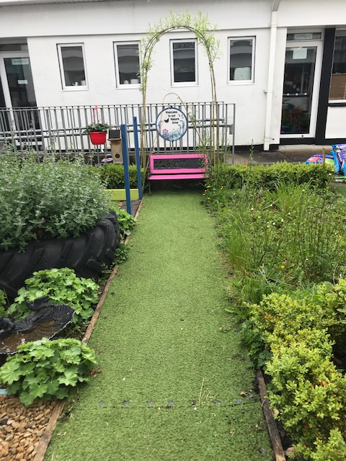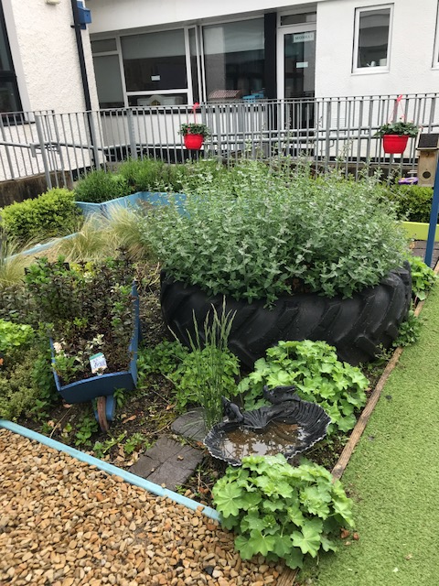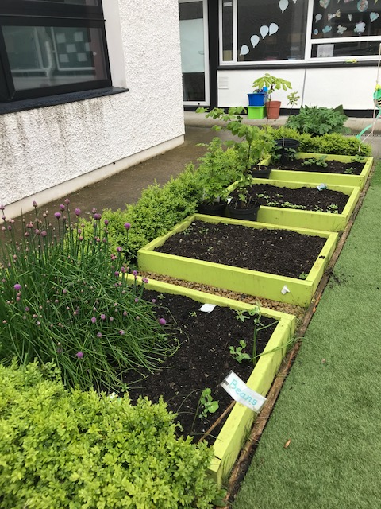

St Mary’s Parents’ Association

Parent’s Association meeting in the Staff room on Thursday 24th May @ 9.30. All welcome.

<https://www.facebook.com/stmarysparentsassoc/>

Caroline Smith

Secretary

**Community Notices**

**St Marys Summer Camp**: We will be running our Summer Camp again! Dates 2nd – 6th July €65 family discounts will apply. We look forward to seeing all our little friends aged between 4 – 12 again.

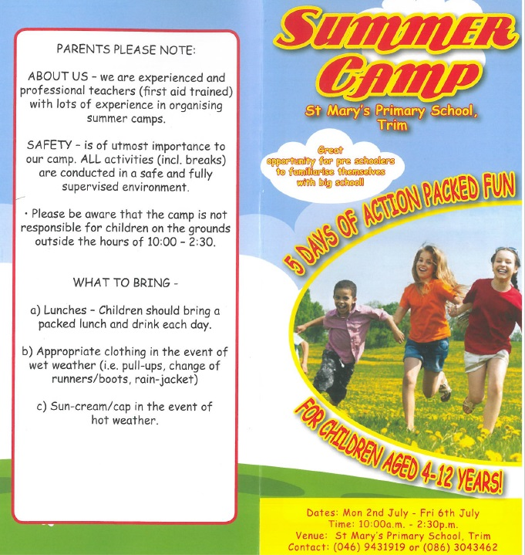

ZUMBA  :   MONDAY / WEDNESDAY  8pm  TRIM GAA,   €8 per class pay as you go,  suitable for all fitness levels  Contact : Lorraine 086 8693546

ZUMBA KIDS  :  New 3 week term beginning Thursday 17th May, St. Patrick's hall (under snooker club)

2.15pm - 3pm,   €15 for 3 weeks,  school pick-up available.    Contact :  Lorraine  086 8693546

**AFTER SCHOOL CLUB** Taking place in St. Mary's School Trim from 2-3pm Mon - Friday in room 5. Only €6 a day or €25 for 5 days Mon-Fri Application forms available from reception. Booking required a week in advance of start date to insure space, and rebooking and payment made the previous Thursday each week after. Kids will be provided a small snack and entertained with Lego, Art & Craft, Board games, quizzes, card games, puzzles and lots more fun activities! Run by an experienced Childcare Professional Parent who is fully Garda Vetted and Insured. Contact Julie O'Donohue to book your child's space by texting 0868505310, emailing [juliekerins@hotmail.com](mailto:juliekerins@hotmail.com) or via a PM on the Facebookpage:[www.facebook.com/TrimAfterSchoolClub](http://www.facebook.com/TrimAfterSchoolClub)

|  |
| --- |
| **Information for Class Planning 2018/2019**    In order for the school to have accurate information for forward planning for 2018/2019, please complete and return the following sheet.  This information is not binding, it is for class planning purposes.    Surname:                __________________________  Student/s Name/s:   __________________________  __________________________  __________________________  **will not** be returning to St. Mary’s in September 2018.    Signed:_____________________________________ Parent/Guardian |

## BOOK GRANT SCHEME

If any parent has a genuine need due to neither parent/guardian working or prolonged illness, they may apply for help with buying books for the next school year. **All applicants may be means tested.** Please apply on the form below, attach a copy of your Medical Card and return to the school no later than FRIDAY 8TH JUNE. No forms will be accepted after that date.

**-----------------------------------------------------------------**

**APPLICATION FORM**

I wish to apply for assistance from the Book Grant Scheme for the year 2018/2019 due to the following circumstances.

Signed: _______________________ Parent/Guardian. Date: ________________

|  |  |  |
| --- | --- | --- |
| **Child’s Name** | **Present Child’s Class**  **June 2018**  **(e.g. Junior Infants,**  **Senior Infants,**  **1st Class………)** | **Present Room Number**  **June 2018** |
|  |  |  |
|  |  |  |
|  |  |  |
|  |  |  |