 St Mary’s Convent Primary School**

***Bunscoil Clochar Mhuire***

***Trim, Co. Meath.  
Fón: (046) 9431919 ⦁ Faics: (046) 9437942  
Ríomhphost:*** [***marystrim@eircom.net***](mailto:marystrim@eircom.net) ***⦁ Website:*** [***www.stmarystrim.ie***](http://www.stmarystrim.ie) ***Uimhir Rolla: 16646O***

Awarded Green Flag  
June ‘05/’07/11/13

***Imlitir 32***

18th May, 2017

***Every Day Counts at St Mary’s Convent Primary School***

***8th – 11th May 2017***

|  |  |  |  |  |  |  |  |
| --- | --- | --- | --- | --- | --- | --- | --- |
| **Room** | **Attendance** | **Room** | **Attendance** | **Room** | **Attendance** | **Room** | **Attendance** |
| 01 | 93.3% | 08 | 90% | 16 | 96.3% | 26 | 94% |
| 02 | 97% | 09 | 96.8% | 17 | 84.6% | 27 | 99% |
| 03 | 92.4% | 10 | 96.4% | 18 | 92.7% | 30 | 99% |
| 04 | 92.6% | 12 | 97.5% | 19 | 97.3% | 31 | 95.5% |
| 05 | 95.2% | 13 | 98.3% | 20 | 96.4% |  |  |
| 06 | 97.1% | 14 | 98.2% | 23 & 24 | 98.6% |  |  |
| 07 | 99% | 15 | 97.3% |  |  |  |  |
|  |  |  |  |  |  |  |  |

*Well done to rooms 7,27 & 30 on nearly having full attendance last week. Please note that notification in writing to the teacher is required. A letter or note in the homework journal will suffice.*

A chairde,

**First Holy Communion:** Congratulations to all the girls in Second Class who received the Body of Jesus for the first time on Saturday last. Thanks also to Fr Declan who celebrated this special occasion with the children and for all the time that he gives to faith formation in our school. We are most grateful to all staff who helped make this a special day:

* Mrs Roche and Mrs Mc Gale had everything and everybody prepared to perfection
* Ms Patricia and Ms Rhona for all their assistance
* Ms Mc Kenna and Ms O Connor; Mrs Nally; Ms Cullinane and Mr Duff who did such a wonderful job with the choir and music
* Helen, Rebecca and Ms Debby for all their help with the booklet and posters etc.
* Frank, our Caretaker, for all "the running around"!

**Other helpers**:

* The girls in *Cór* (School Choir) and *Banna* (School Band) who gave so generously of their time at practices and on the day
* Do This in Memory of Me Committee for the sacramental preparation
* Our Parents' Association and the volunteer parents from First Class who organised the celebration in The Dr Eileen Reilly Hall after the ceremony-a very important social occasion in the life of our school.
* *An Chomhairle Scoile* (Student Council) who greeted everyone at the school and escorted them to the hall
* Nick Nally for his help with the sound
* The altar servers
* Bernie the church Sacristan.
* The Lay Ministers

I would also like to thank Mrs Nally for all the support she gave everyone, in my absence, leading up to and including the day.

**Security:** Please note that a release slip is required to be handed to the teacher prior to children being released, but that for Sports Day, group release will be facilitated. It must be done in the classroom and nowhere else. The children will return to their classes before 2.00 and be released from there. Teacher will have a sheet to be signed.

**OsKaRs:** All the filming was completed at the weekend and we are now all looking forward to a night on the Red Carpet on Friday next. Tickets are still available through the school @ €25. Contact Helen or Rebecca. Thanks to all who supported our recent Dress Sale, Table Quiz and Open Mic. I have included "Before" and "After" photos to give people an idea of what the new Astro-turf Pitch and Ball Wall will look like.

**Before After**

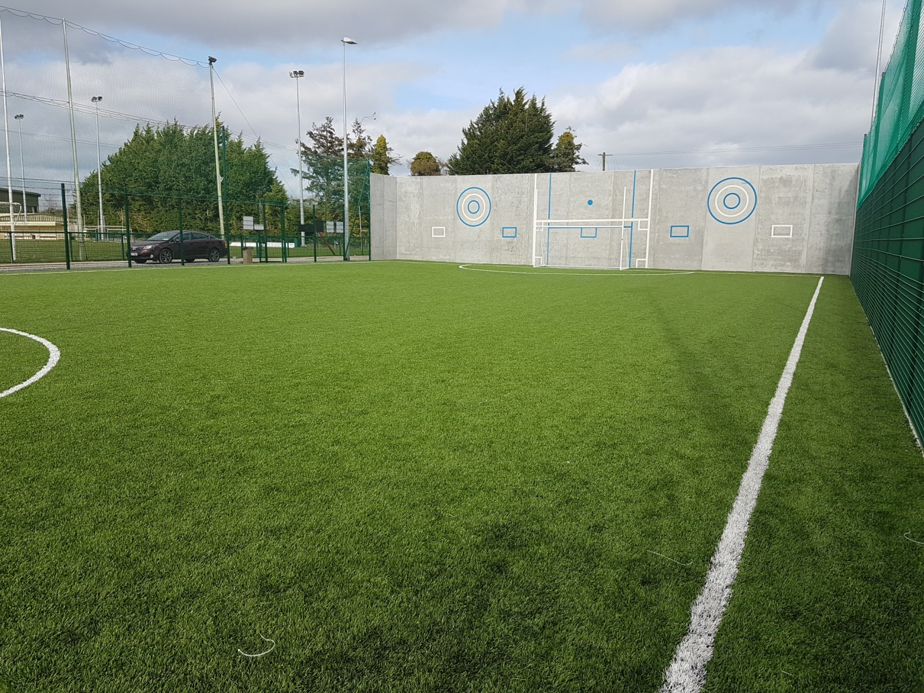



This is what the fundraising monies will build. It will be worth it!

*Congratulations to Katie Rose Devine (Fourth Class) who won first prize in the recent Art Competition sponsored by Supermacs in conjunction with Papa John's Pizza Restaurant. The prize was a whole class visit to Supermacs where each child had a chance to make, bake and eat their very own pizza. Mmmm... delicious! You can see lots of happy smiley faces on their Facebook page. M. Hoey.*

**Mobile Phones**: Please note that they should not be switched on, once pupils enter the school grounds.

*“If it’s out, it’s on. If it’s on it’s gone!”* Phones will only be returned to parents/guardians.

**BOOK GRANT SCHEME**: If any parent has a genuine need due to neither parent/guardian working or prolonged illness, they may apply for help with buying books for the ***next*** school year. All applicants may be means tested. Please apply on the form below and return to the school no later than FRIDAY 9th JUNE. No forms will be accepted after that date.

We have a large amount of clothes in **Lost & Found** at the moment. Please check for any missing items by Monday 15th June. All unclaimed items will be donated to charity.

***Rounders League****: Our annual Rounders League has started at St Mary's. Six teams from within the school are taking part. Each team of twelve players comprises four pupils from 4th Class, four from 5th Class and four from 6th Class. All we need now is a spell of dry weather!   Mr. Galligan*

|  |  |
| --- | --- |
| **School Calendar 2017/2018** | |
| Return: | Thursday 31st August 2017 |
| Mid-Term: | Monday 30th October –Friday 3rd Nov 2017 |
| Christmas Break: | Monday 25th Dec 2017 - Friday 5th January 2018 |
| Feb Mid-term Break | Thursday 15th & Friday 16th Feb 2018 |
| St. Patrick’s Day | 19th March 2018 (Monday) |
| Easter Break | Monday 26th March – Friday 6th April 2018 |
| May Bank Holiday: | Week Monday 7th – Friday 11th May 2018 |
| June Bank Holiday: | Monday 4th June 2018 |
| School closes | Friday 29th June 2018 |
|  |  |

**Information for Class Planning 2017/2018**

In order for the school to have accurate information for forward planning for 2017/2018, please complete and return the following sheet. This information is not binding, it is for class planning purposes.

Surname: __________________________

Student/s Name/s: __________________________

__________________________

__________________________

**will not** be returning to St. Mary’s in September 2017.

Signed:_____________________________________ Parent/Guardian

Mise le meas,



Cóilín Ó Coigligh, Príomh Oide.

## BOOK GRANT SCHEME

If any parent has a genuine need due to neither parent/guardian working or prolonged illness, they may apply for help with buying books for the next school year. **All applicants may be means tested.** Please apply on the form below and return to the school no later than FRIDAY 9TH JUNE. No forms will be accepted after that date.

**-----------------------------------------------------------------**

**APPLICATION FORM**

I wish to apply for assistance from the Book Grant Scheme for the year 2017/2018 due to the following circumstances.

Signed: _______________________ Parent/Guardian. Date: ________________

|  |  |  |
| --- | --- | --- |
| **Child’s Name** | **Present Child’s Class**  **June 2017**  **(e.g. Junior Infants,**  **Senior Infants,**  **1st Class………)** | **Present Room Number**  **June 2017** |
|  |  |  |
|  |  |  |
|  |  |  |
|  |  |  |

**Green News**

**Community News**

**Nathanna na Seachtaine:** Dia linn! (God bless us.... said when someone sneezes!)

**Seanfhocal na Míosa:** Bíonn Cluasa Móra ag Muca Beaga

**Dates to Remember**

**Meitheal:** Every Tuesday morning 9.30-10.30.

**Mini-Rounders:** Mondays for 3rd to 6th Classes 3.00 – 4.00pm

**Green News**

Next week we will be receiving our Green Flag for Global Citizenship! It is a huge achievement for us and great that we are continuing on the legacy of ‘Greenness’ that previous Green Flag Committees have left us with.

WOW continues next Wednesday but COW will be postponed until June 7th when we hope to have a big School Cycling Day as part of Be Active Week.

Global Citizenship was our green theme over the past two years with a specific emphasis on litter and waste management. Here at St Mary’s, we have been emphasising to the pupils the importance of separating their classroom waste into recyclable and non-recyclable items. We recycle some items at school which the children bring in from home: batteries, ink cartridges, postage stamps, card, small plastic bottles and cans. Even as part of our OsKars Fundraiser, one of the casts involved had a re-used dress sale and it’s amazing how well it was supported.

The garden is making great strides. Rosie, our volunteer gardener has drawn up a lovely plan and the children and Frank have been busy painting, planting and preparing for our Pride of Place assessment later in the term. Two lovely gentlemen from Youth Reach Trim (Quality Centre for Education), Seán and Reece, came along and did a lot of the heavy work to prepare the soil for the sensory garden. We are very grateful to them.

**Community Notices**

**Serendipity for Charity, Watergate Street, Trim**.We are looking for volunteers at the moment to help out in our shop in Trim. We support various local charities each year. If you are interested in giving a couple of hours during the week please contact Miriam on 0868548202. You can also find us on Facebook at Serendipity for Charity.

**Jiggle 'n' Jump**

Music & Movement classes for little ones (8mths-4yrs) running upstairs in Trim GAA on Tuesday 9.45-10.45am  €7 a class or 4 class card for €25

Also available for **Kids Party Entertainment!**

Various characters and themes with fun games, dancing, face painting and prizes!

Clown, Pirate, Princess, 80's Disco Diva, Sporty Diva and Super Hero available.

New Party Package insures 2 hours of non stop entertainment, with face painting by Linda (Flawless Facepaint) while I entertain the kids with singing, dancing, party games and non stop fun!!

Contact Julie on [0868505310](tel:0868505310) or on Facebook [www.facebook.com/jigglenjump](http://www.facebook.com/jigglenjump)

**BIG BOUNCE**

For the very best in high quality inflatable entertainment and giant garden games in Meath, Big Bounce is the place to go!  We are a family run Bouncy Castle hire based in Trim, Co. Meath.

Perfect for Christenings, Birthdays, Family Events, BBQ's etc.  Contact Johnny on 0851479896

Also working with face painter and kids Entertainer for added fun for all!

**Stage Stars Summer Camp:** The camp is running from July 24-28 from 10.00 - 2.00 (with an optional earlier drop off time) and is open to girls and boys aged 4-12. It will be an action packed week of singing, dancing, drama and arts and crafts with finishing certificates and an end of week performance for family and friends! The camp is €80 per child with sibling discounts as well as an early bird offer if booked and paid in full by June 9th. For more information call 0863566061 or see Facebook.com/stagestarssummercamp

