 St Mary’s Convent Primary School**

***Bunscoil Clochar Mhuire***

***Trim, Co. Meath.  
Fón: (046) 9431919 ⦁ Faics: (046) 9437942  
Ríomhphost:*** [***marystrim@eircom.net***](mailto:marystrim@eircom.net) ***⦁ Website:*** [***www.stmarystrim.ie***](http://www.stmarystrim.ie) ***Uimhir Rolla: 16646O***

Awarded Green Flag  
June ‘05/’07/11/13

***Imlitir 31***

25th April, 2016

***Every Day Counts at St Mary’s Convent Primary School***

***18th – 22nd April, 2016***

|  |  |  |  |  |  |  |  |
| --- | --- | --- | --- | --- | --- | --- | --- |
| **Room** | **Attendance** | **Room** | **Attendance** | **Room** | **Attendance** | **Room** | **Attendance** |
|  |  |  |  |  |  |  |  |
| 01 | 91.1 % | 08 | 91.4% | 16 | 90.4% | 26 | 99.3% |
| 02 | 93.8% | 09 | 99.3% | 17 | 96% | 27 | 97.1% |
| 03 | 94.4% | 10 | 90.7% | 18 | 96.4% | 30 | 98.6% |
| 04 | 96.2% | 12 | 93.8% | 19 | 96.7% | 31 | 89.7% |
| 05 | 95.7% | 13 | 92.3% | 20 | 95.8% |  |  |
| 06 | 95% | 14 | 92.3% | **23** | **100%** |  |  |
| 07 | 94.1% | 15 | 96.8% | 24 | 96.7% |  |  |

A Chairde,

Congratulations to Room **23** on having full attendance last week, and to Room 9 who almost made it!

Please note that our school closes for the mid-term break at 2.00/3.00 on Friday next. We re-open on Monday May 9th.

A big thank you to Andrius Asmontas who donated a 3D printer to our school. We were able to make a model of “Almondo” last week and look forward to many exciting possibilities in the future.

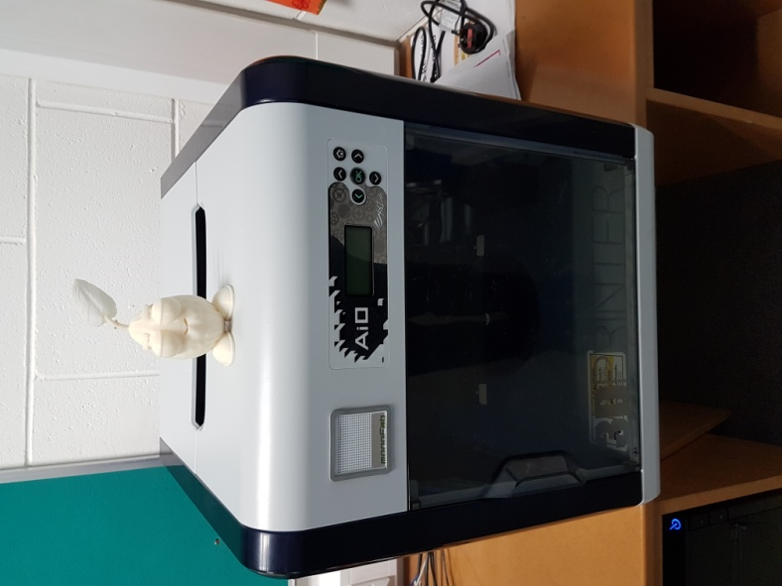

*Comhghairdeachas* to our *Gaelbhratach* committee and the school on securing our second flag, being one of only five schools in Ireland to do so. The presentation takes place in St Patrick’s College Drumcondra *Dé Céadaoin seo, 27ú Aibreán. Go n-éirí go geal leo.*

Please note the change in our Sport For All Day to Wednesday May 25th in order to be included in our Be Active Week. In our School Self Evaluation we have identified pupil physical and emotional wellbeing and the Be Active Week is one of our initiatives to promote this. Please note also the Mindfulness Workshop in the Community Notices.

Our many **extra-curricular activities** have restarted, please check the days, times and age groups below.

**Enrolments for next year:** We are pleased to report that our school is no longer full and presently in a position to accept enrolments for all classes.

Please note that **school begins at 9.20** and pupils are required to be on time and to line up in the yard not outside the classroom doors. Your co-operation is earnestly requested.

**Aquatics for First Class** children will commence on Monday 9th May and will continue for 6 weeks. The cost is €24.00. This payment can be made in full or by installments through our Banking Online System or to the teacher, on or before Wednesday 27th April.

***Rounders League****: St Mary's Rounders League commenced in full last week and involves 5th and 6th Class pupils in rooms 26, 27, 30 and 31. This is a pilot initiative and if it is deemed successful, we will build upon it during the next academic year. Each classroom has a team - a panel of twelve, nine batters and three subs. Pupils have gone as far as to name their teams and display mascots, while their classmates have created supportive chants and dance routines. We have now reached the semi-final stage of the competition with Room 26 against Room 27 and Room 30 against Room 31. The winners of each semi-final will go through to the League Final. Watch this space!*

*D Galligan*

|  |  |
| --- | --- |
| **School Calendar 2016/2017** | |
| Return: | Wednesday 31st August 2016 |
| Mid-Term: | Monday 31st October - Friday 4th November 2016 |
| Christmas Break: | Friday 23rd December - Friday 6th January 2017 |
| Spring Mid-term Break | Thursday 23rd - Friday 24th February 2017 |
| Mid-term: | Monday 13th - Friday 17th March 2017 |
| Easter Break | Monday 10th April - Friday 21st April 2017 |
| May Bank Holiday: | 1st May 2017 |
| June Bank Holiday: | 5th June 2017 |
| School closes | Friday 30th June 2017 |

**Information for Class Planning 2016/2017**

In order for the school to have accurate information for forward planning for 2016/2017, please complete and return the following sheet. This information is not binding, it is for class planning purposes.

Surname: __________________________

Student/s Name/s: __________________________

__________________________

__________________________

**will not** be returning to St. Mary’s in September 2016.

Signed:_____________________________________ Parent/Guardian

Mise le meas,



Cóilín Ó Coigligh, Príomh Oide.

**Green News**

**Community News**

**Nath na Seachtaine**: **Cá bhfuil tú i do chónaí? ......Tá mé i mo chónaí i mBaile Atha Troim**

**Seanfhocal na Míosa: Ní chrónaítear an t-uisce go dtriomaítear an tobar**

**(We don't miss the water until the well runs dry)**

**Dates to Remember**

**Assembly:** Friday @ 9.30 for Juniors

**Meitheal:** Every Tuesday morning 9.30-10.30.

**Banna Ceoil:** Every Tuesday @ 3pm in the Dr. Eileen Reilly Hall

**School Choir:** Friday 3.00 – 4.00p.m

**Mini-Rounders:** 3rd & 4th Classes Mondays 3.00-4.00p.m.

- D. Galligan & S. Conaty, Teachers

**Rounders:** 5th & 6th Classes Mondays 3.00-4.00p.m.

– Ms Coakley & Mrs Munnelly, Teachers.

Thursdays lunchtime in Dr. Eileen Reilly Hall

**Camogie:** Wednesday 3.00-4.00 p.m. Third – Sixth Classes

**First Communion:** Saturday 28th May @ 11.00 a.m.

**Green News**

WOW will continue on Wednesdays. Meet up at either Mornington House or at the side of the Matchbox. Teachers will meet up with you there and escort pupils up to the school. The Score on the Door competition has been very successful especially among the senior classes. Some of the Junior classes are also trying very hard, so we might have a Junior and a Senior winner from now on. Well done to all and a special word of thanks to the WOW teachers who make the initiative possible.

COW (Cycle on Wednesday) will resume after the week off. We will keep our fingers crossed for kinder weather that will allow us to cycle every Wednesday! Please remember that it is imperative to wear a helmet and a hi-viz vest when cycling.

April is National Clean-Up Month. We take this opportunity to clean up around the school and Church grounds. An Taisce has supplied us with special gloves and lit-picks to ensure proper hygiene. This Clean-up operation helps to highlight the importance of respecting our environs and the damage litter can cause. We live in delightful heritage town and we would encourage you all to keep it as beautiful as it can be.

Recycling continues at school. We accept ink cartridges, batteries, cardboard, toilet rolls, postage stamps, small plastic bottles and footwear.

Just a reminder that Global Citizenship is our green theme this year, with the specific emphasis on litter and waste management. Our International day will be coming up in a month or so and we will celebrate the different cultures in our school. We are so lucky to have a diverse pupil population. We can learn so much about other cultures. Please contact your child’s teacher if you would like to come in and tell them about your country.

Our gardening projects are starting soon. If you have a keen interest in gardening and some time on your hands, please let us know as we would love some help in our garden. Thank you.

***Remember Green is cool, at home and at school and around the globe***

**Community Notices**

**ZUMBA**  :-   No experience, partner or booking required -      **SUMMER IS JUST AROUND THE CORNER**:- MONDAY   8pm   Trim GAA,   €8 per class     Contact :  Lorraine  086 8693546

**ZUMBA  KIDS**:-        Ages 5-8   TUESDAY    3.15pm    TRIM GAA    €6 per class  (Sibling rate €5)

Zumba,  Hip-Hop,  Rock 'n Roll,  Jive.............             Contact :  Lorraine  086 8693546 / JoJo  086 3381159

**JIGGLE 'N' JUMP** - has moved to the Trim GAA from April 5th. Music and Movement classes will be held in the front room upstairs (Where the parent & toddler group takes place) on a Tuesday at 9.45am and Saturdays at 10.30am. There will also be a new class starting for ASD kids or kids who suffer with anxiety, offering a more routine class where parents can see the progress each week. This will be held on Saturdays at 9.30am. Classes also on Wednesday 10am in Summerhill Community Centre. Please call Julie to enquire or book in! 0868505310.

Jiggle 'n' Jump also provide party entertainment, in your home, the GAA or other venue. Various characters available for Face Painting, Tattoos, Nails, Singing, Dance Routines, fun Bingo, Pass the Parcel and lots of other fun party games! :)

**Carney School of Irish Dancing** Classes in St. Patricks Hall every Tuesday. 2pm – 3pm & 3pm – 4pm. Every Friday @ 5.30pm. Infants and Senior infants can be collected from class rooms @ 2pm and left back to the buses @ 3pm. €5 per pupil per class. Contact Ann Carney 087-6336495

**Mindfulness Meditation Workshop** for 8-12 years old. 3.30pm to 5.30pm Thursday 12th of May with Elfreda Manahan-Vaughan at the Elements Holistic Centre 1 Oaktree Business Park, Trim. €12. To book email [info@metta-morphics.com](mailto:info@metta-morphics.com) or phone 0868373582, only 6 places left.