 St Mary’s Convent Primary School**

***Bunscoil Clochar Mhuire***

***Trim, Co. Meath.  
Fón: (046) 9431919 ⦁ Faics: (046) 9437942  
Ríomhphost:*** [***marystrim@eircom.net***](mailto:marystrim@eircom.net) ***⦁ Website:*** [***www.stmarystrim.ie***](http://www.stmarystrim.ie) ***Uimhir Rolla: 16646O***

Awarded Green Flag  
June ‘05/’07/11/13

***Imlitir 3***

12th September 2017

***Every Day Counts at St Mary’s Convent Primary School***

***4th September - 8th September 2017***

|  |  |  |  |  |  |  |  |
| --- | --- | --- | --- | --- | --- | --- | --- |
| **Room** | **Attendance** | **Room** | **Attendance** | **Room** | **Attendance** | **Room** | **Attendance** |
|  |  |  |  |  |  |  |  |
| 01 | 94.5 % | 08 | 90.7% | 16 | 96.4% | 26 | 91.4% |
| 02 | 94.5% | 09 | 98.5% | 17 | 92.8% | 27 | 99.2% |
| 03 | 97.9% | 10 | 99.2% | 18 | 99.3% | 30 | 97.6% |
| 04 | 96.4% | 12 | 95% | 19 | 93.3% | 31 | 95% |
| 05 | 91.5% | 13 | 92.5% | 20 | 94.6% |  |  |
| 06 | 98.4% | 14 | 98.6% | 23 & 24 | 90% |  |  |
| 07 | 95% | 15 | 95.9% |  |  |  |  |

*Well done to rooms 10 & 18 on nearly having full attendance last week. Please note that notification in writing, with the reason for all absences, to the teacher is required. A letter or note in the homework journal will suffice.*

A chairde,

Please note that as and from yesterday, the Language Classes will be finishing at 2.00 p.m. (Ms Finn’s Class) and 3.00 p.m. (Ms Dully’s Class). Junior Infant classes will be finishing at 2.00 p.m from Thursday and First Classes at 3.00 p.m also from Thursday.

*This week is* ***Be Healthy Week*** *in St. Mary’s and we are officially launching our revised Healthy Eating Policy. This can be read in the homework journal or on our school website. In order to make our revised Healthy Eating Policy a success we need the support of parents and guardians.*

*You can do this by:*

* *Providing a healthy, well-balanced lunch for your child.*
* *Encouraging healthy eating.*
* *Informing the school in writing, of any child’s special dietary needs.*
* *Assisting in the implementation of school policy by not allowing your child to bring fizzy drinks, crisps, sweets, chocolate bars, chewing gum, “Fast Food” or other junk food to school.*
* *Avoid sending in party bags or treats when birthdays occur. The teacher will be obliged to return this food unopened.*
* *Following the Green-Schools guidelines- reduce packaging and re-use bottles and lunchboxes where possible.*
* *Taking part in our TRY IT FRIDAY initiative which encourages children to try a new* ***healthy food*** *on Friday. You can choose together what new food your child will try by including it in their lunchbox on Friday.*

*The focus this week will be on healthy eating and nutrition. The new food pyramid will be discussed. Education on food and drink labels will take place in senior classes to enable pupils to make informed nutritional choices between different products.*

*Ideas on healthy lunches can be found at :*

*www.safefood..eu*

[*www.hse.ie*](http://www.hse.ie)

[*www.fooddudes.ie*](http://www.fooddudes.ie)

*www.bordbia.ie*

*Thank you for your cooperation in implementing this policy.*

*Sinéad Minogue HPS coordinator*

***Junior Infants Parents’ Night Thursday 21st September from 7.30 to 8.30.***

This is a day later than the date on our school calendar due to teacher availability. Please note that the purpose of Parents’/Open Night is to enable parents and teachers to meet, to enable parents/guardians see their child’s classroom and school and finally to enable the teachers to explain classroom routines and procedures. It is not a parent–teacher meeting. These will be held in February for Junior Infants, and of course where necessary at other times on request. So, come along, see the school, meet the teacher and find out how you can help your child/ren make better progress this coming school year.

**Friendship Week**

Next week will be Friendship Week and each class will be undertaking activities and lessons which promote positive relationships in our school. More details in next week’s Imlitir.

***Just a thought***

***“Kindness is the language which the deaf can hear and the blind can see”***

***Mark Twain***

**School photographer:** will be coming on Friday 22nd September, as mentioned in our school Calendar. He will be taking photographs of all children. If you do not wish your child to have his/her photograph taken, please let us know. A note in the Homework Journal will suffice. Group photographs will be taken for Junior Infants and Sixth Classes only. Proofs will be available before purchase, about two weeks afterwards. **Please ensure that your child is in school uniform (Senior Infants to Sixth classes) and not tracksuit on this day, Junior Infant children only, to wear tracksuit.**  They may bring a tracksuit to change into after swimming, if this applies. Please note that we have requested the photographer to take photos of all children for school records

**Extra-Curricular Activities**: Parents/Guardians are asked to be available from 3.00 – 4.00 p.m. on these days (see below) due to the possibility of a cancellation due to bad weather!

Many thanks to Ms Mc Kenna, Mr O Mahony and Ms Maguire who train our Camogie team, to Mrs Munnelly and Ms Coakley who train our Rounders team and to Mr Galligan and Ms Conaty who look after the Mini-Rounders (3rd and 4th).

***Registration for Banna Ceoil***

*Banna Ceoil registration will take place on Tuesday 26th Sept from 3.00 – 3.30pm in the halla. Banna Ceoil is open to all pupils from 2nd – 6th and all are welcome. We practice most Tuesday’s after school and it’s a great opportunity to learn how to play music together in a fun environment. It is not necessary to be attending instrumental classes outside school, you can bring your tin whistle(feadóg) along. We look forward to seeing you on Tuesday 26th.*

*If you are not available to attend registration, your daughter can collect a form and return it to the school. There is a €5 fee to cover administration costs. The first practice will be the following Tuesday 3rd October. Second class finish at 3.30 until the Halloween break. After that they all finish at 4pm.*

*R McGale*

**Head Lice:**

* Head lice is a community problem, it is nothing to be embarrassed about. We can all help to keep the problem under control.
* Please use a fine comb on a regular basis to carefully check your child's hair.
* Encourage your child not to use other people’s combs or brushes.
* Tie up long hair.

Please note that **all** pupils should go to the school playground in the mornings, and not congregate outside classroom doors. When the bell goes they should line up, in the playground, with their class and the teacher will bring them in. Please remember to stand behind or to the side and allow the lines to enter the school unobstructed. Thank you for your co-operation to date.

Parents who have barring orders or other relevant legal documents are asked to inform the school, to enable us to uphold the law at all times.

Emails/texts reminding parents/guardians about monies due to class teachers for Visual Arts etc were sent out yesterday. Please ensure that we get these monies at your earliest convenience. Also, please let us know if you wish to pay by instalments or if you are contacted in error. A link to our online payment facility was included in the email/text. If you do not wish to make payment online for Classroom supplies we request that you please call to the Office on Thursday 14th or Thursday 21st with the correct amount of cash or cheque due in an envelope with your child’s name and room number on it. This is to alleviate the pressure on teachers trying to collect money. We do not have a facility for card payments.

The school will also facilitate a Payment Plan for families that need it. Contact Helen on Thursday 14th for further details.

Many thanks to all who have already made the computer contribution. There has been a wonderful response, considering the time of the year. As well as providing us with a computer room assistant, this money also goes towards new software, internet charges, ink for the printers etc. If you have not already made your contribution or would like to pay in instalments, please contact class teachers or Helen in the office. Please note that unlike the monies for Visual Arts etc. the computer contribution is **voluntary**.

***Internet Safety Week:*** *this week in computer classes I will be chatting to students about how to stay safe while using the internet. However, we in school can only do so much so it is always a good idea to talk to your child about what they should do if they do come across something that makes them feel uncomfortable when they are online. The STOP, BLOCK, TELL Rule is a good idea to use. Encourage your children to* ***stop*** *what they are doing online,* ***block*** *the person who is upsetting them and* ***tell*** *a trusted adult about what they have experienced. It is important that your child knows that they can come to you or another adult they trust and talk to you freely about what they are experiencing online without fear of punishment.*

[*http://esafety.ie/wordpress%202/index.php/primary/*](http://esafety.ie/wordpress%202/index.php/primary/)

*This above site makes for interesting reading for parents and a great site for primary students can be found on:* [*http://www.netsmartz.org/NetSmartzKids*](http://www.netsmartz.org/NetSmartzKids) *Debby Walsh*

Many thanks to those who have responded to our appeal for parent helpers. It is still not too late to join, no fee necessary! ***“Meitheal*”** is on Tuesday mornings and parents **[“Listeners”]** also come in to listen to pupils reading, once a week, for an hour or so. We are particularly looking for volunteers for our school **Library** on Fridays. Please contact Helen or Rebecca if you would like to offer your assistance.

**Aquatics**- Our autumn swimming season begins this week. Pupils from 2nd to 6th Classes will participate in water-based activities at Aura Leisure Centre.  The season lasts six weeks and addresses one of the six strands in the PE Curriculum.

***Cyber-bullying Awareness:***

*An invaluable cyber-bullying awareness workshop for****6th Class pupils****will take place in St Mary’s on****Thursday, September 28th****. The workshop will be facilitated by Paula O’Connor. Paula is a cyber-bullying and internet-safety expert. She is the force behind the***“Don’t Be Mean Behind Your Screen”***initiative. Items under the microscope at the daytime workshop will include mobile phones, the internet, social media and practical strategies to deal with online bullying. Technology is advancing at an unbelievable pace. It is important that parents/guardians are equipped with up-to-date information on the ever-increasing dependence of the youth on mobile/smart phones, the inherent risks that can develop around social media and the necessity of parental supervision when children are online.****Paula will deliver a revealing presentation to******parents/guardians in St Mary’s on Thursday, September 28th at 7.30pm. ALL parents/guardians associated with St Mary’s are invited to the talk.****Please come along, ask questions and be informed! D. Galligan*

**Jersey Day:** will be on Friday next 15th September. The pupils may (if they wish) come to school in a sports jersey of their choice, with the bottoms of the school tracksuit. Voluntary contributions of €2 will be collected for our “Sports Fund” which is currently a lot healthier than this time last year! Thanks to our Parents’ Association who purchased sports equipment to ease the pressure on this fund. The total issued last week did not take this into account.

*Dear Parents/ Guardians, St Mary's Parents’ Association would like to invite you to our* ***coffee morning this Wednesday, 13th September*** *in the staffroom at 9.30am. All welcome.*

***Important Reminder re Pupil Insurance****: Pupil Insurance will only be available to purchase on Wednesday 13th September from 7-9pm in the School Hall and from 9.30-11am on Thursday 14th September in the Boardroom. Pupil Insurance will not be available to purchase after these times/dates.  No Pupil Insurance will be sold unless forms are signed by Parent or Legal Guardian.  We very much appreciate your co-operation with this.*

*Caroline Smith*

*Secretary of St Marys Parents Association.*

**Assemblies:** take place on Friday mornings and are listed each week on the bottom of this *Imlitir*. All are invited, so keep an eye out for one that may interest you.

Finally, if you are collecting your child after school, please do not look in the windows as this is distracting to teacher and pupils alike!

Mise le meas



Cóilín Ó Coigligh,

Príomh Oide.

**Green News**

**Community News**

**Nathanna na Seachtaine:** Slán leat/ Slán go fóill ....... (Goodbye. Goodbye for now)

**Seanfhocal na Míosa:** Tús maith, leath na hoibre

**Dates to Remember**

**Assembly:** Launch of Friendship Week

**Meitheal:** Every Tuesday morning 9.30-10.30.

**Mini-Rounders**: 3rd and 4th Classes - Mondays 3-4pm,

**Rounders**: 5th and 6th Classes - Mondays 3-4pm,

**Camogie:** Wednesday 3.00-4.00 p.m. Third – Sixth Classes

**Green News**

We are into our second full week at school. The recycling projects are up and running already as is our WOW campaign for this academic year. Well done to all the walkers, both senior and junior, last Wednesday. We hope to see even more this week.

Remember you can recycle some items at St Mary’s. We recycle small plastic bottles, footwear, mobile phones, postage stamps, ink cartridges, batteries, cans and card. Last week we were delighted to donate our stamps to the Church Stamp collection in aid of the Third World. Well done to all who recycle regularly. Remember your junk is someone else’s treasure!



A reminder that WOW (Walking on Wednesdays) is happening again this Wednesday. Meet up at Mornington House or at the Matchbox at 9:00 am. The WOW teachers will escort the pupils to the school from there. Walking to school links perfectly with our Be Active and Healthy Schools initiatives. We would encourage our pupils to walk even one day per week. Well done to those who walk every day.

Our Green theme for the next two years is Energy under the Global Citizenship umbrella. At the Green Schools Information briefing in October we will be given our guidelines. We will have lots more information them. In the meantime keep up the good work and remember

***Remember Green is cool at home, at school and around the globe!***

**Community Notices**

**Homework Club** commences in St Mary’s for children from 1st – 6th Classes on Monday 18th September. Application Forms are available from Ms Conaty Room 11 or Ms Lynch Room 31.

2 Bed Thatched Cottage to Let, 5 mins from Trim, Private Parking, All mod cons. Phone 085-7494234

**Limelight Theatrics** - Performance Singing/Musical Theatre classes.  *Tuesday evening 6.15pm to 7.15pm (Under 12's)  & 7.30pm to 8.30pm (Over 12's) Wednesday 7.15pm to 8.15pm (mixed)

**DRAMA CLASSES**:  Tuesdays  5.15pm to 6.15pm (mixed age)  Wednesday 4.30pm to 5.30pm (mixed age) Wednesday 6pm - 7pm (Over 12's) Classes commence the week of 12th of September. Contact  Carmel McKiernan BA, LIBSD on 0863923334 for further info.

**Boyneside Speech & Drama**. Classes take place after school in St Michaels Primary School. And commence on Wed 6th and Thursday 7th September for students from senior infants to leaving cert.

Contact Dorothy on 087-2201981 or email [dorscully@gmail.com](mailto:dorscully@gmail.com)

Something for everyone at **Breathe Yoga & pilates**, Mum & Baby yoga Mondays 11.30am, Baby massage Fridays 11.30am, pregnancy yoga Thursdays 7pm. For more info & to book see [www.breatheyogapilates.ie](http://www.breatheyogapilates.ie)

**Grainne Kennedy Stage Academy** is a brand new performing arts school opening in Trim this September. Offering tuition in dance, drama, song and musical theatre to boys and girls aged 3-18, our aim is to build confidence, nurture talent and have fun! Join renowned choreographer Grainne at a FREE trial class on Sep 18th in Trim GAA from 4-5pm to see what's on offer. For more information, call 0863566061 or search GKStageAcademy on Facebook!

**AFTER SCHOOL CLUB** Taking place in St. Mary's School Trim from 2-3pm Mon - Friday in room 5 starting on the 18th September Only €6 a day or €25 for 5 days Mon-Fri Application forms available from reception. Booking required a week in advance of start date to insure space, and rebooking and payment made the previous Thursday each week after. Kids will be provided a small snack and entertained with Lego, Art & Craft, Board games, quizzes, card games, puzzles and lots more fun activities! Run by an experienced Childcare Professional Parent who is fully Garda Vetted and Insured. Contact Julie O'Donohue to book your child's space by texting 0868505310, emailing [juliekerins@hotmail.com](mailto:juliekerins@hotmail.com) or via a PM on the Facebookpage:[www.facebook.com/TrimAfterSchoolClub](http://www.facebook.com/TrimAfterSchoolClub)  
  
**Jiggle 'n' Jump** Music & Movement classes for little ones (8mths-4yrs) running upstairs in Trim GAA on Tuesdays 9.45-10.45am €7 a class or 4 class card for €25 Only €5 during September and all money raised on Tuesday 5th September is going to Crumlin Children's Hospital via Jack O'Donohue's A Bit of a Walk Fundraiser.   
  
Also available for Kids Party Entertainment! Various characters and themes with fun games, dancing, face painting and prizes! Clown, Pirate, a number of different Princesses, 80's Disco Diva, sporty Diva and Super Heroes available. Birthdays, Weddings, Christenings or family fun events.......in your home or in a venue, packages to suit any needs or budget. Contact Julie on 0868505310 or on Facebook [www.facebook.com/jigglenjump](http://www.facebook.com/jigglenjump)

**Touch typing course:**

Venue: St Marys NS, Trim,  Day and time :  Monday's @ 4.30 , Date: September 25th. Contact Jackie on 086-3780842

A touch tying course designed to develop the typing skills of children 8 years & upwards in a classroom environment with a qualified tutor. You can join the course any time as your child works at their own pace in a small class environment so each child gets the individual attention they need. Free trial first lesson.

This class is for all children but particularly helpful to kids with learning differences such as Dyslexia, Dyspraxia and Autism.

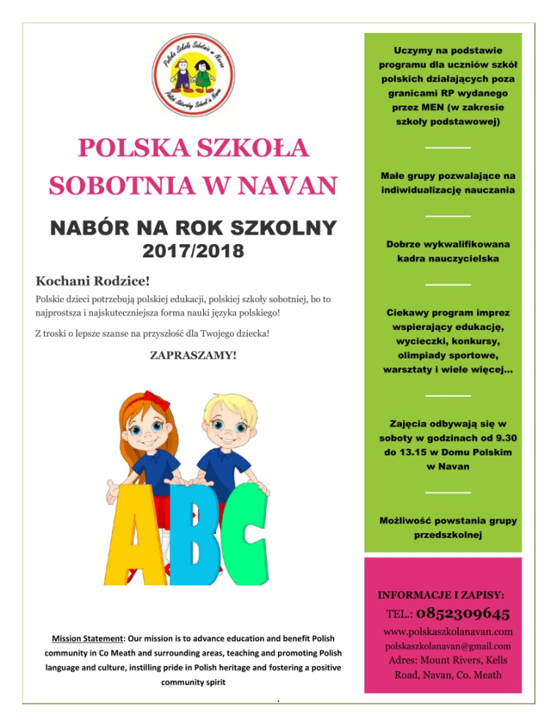

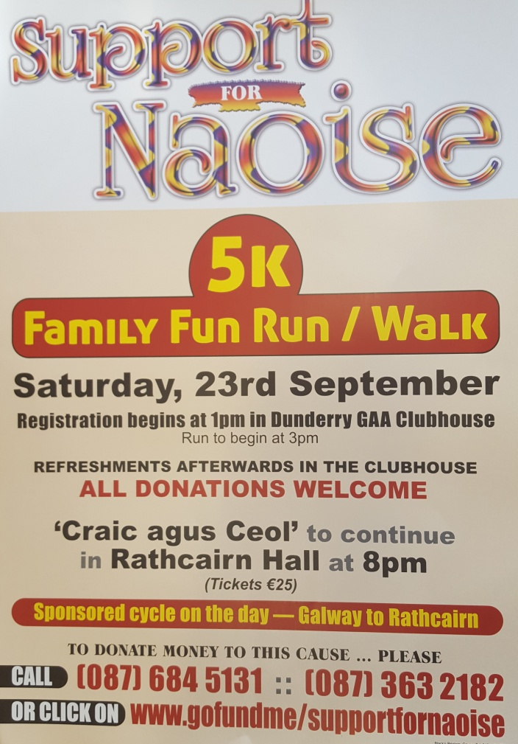

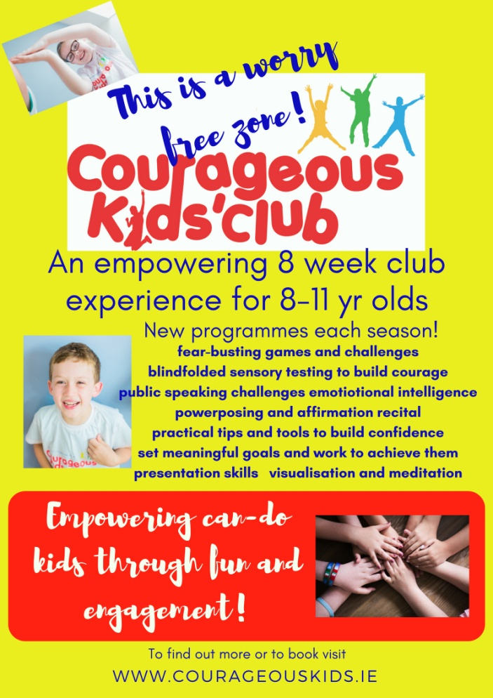

Courageous Kids Club is coming to the Aura Centre in Trim! Our 8 week Autumn/Winter programme aims to boost your child's courage and confidence as well as increase their emotional intelligence.  Your child will learn about fear, set goals, build courage through undertaking a variety of challenges including the blindfold taste test and lots more! Also features visualisation and meditation.  Spaces are limited. To find out more or to book visit [www.courageouskids.ie](http://www.courageouskids.ie)



*Mugendo Martial Arts Academy is a locally run Family martial arts school operating in Trim since 2007. Mu-gen-do Kickboxing is a new and fun way for children and adults to stay healthy and safe, while learning at the same time to have respect for themselves and others.  We conduct our classes in Aura Leisure centre Trim Monday to Friday for adults and children.*

*For a Free trial class please see the voucher.*