***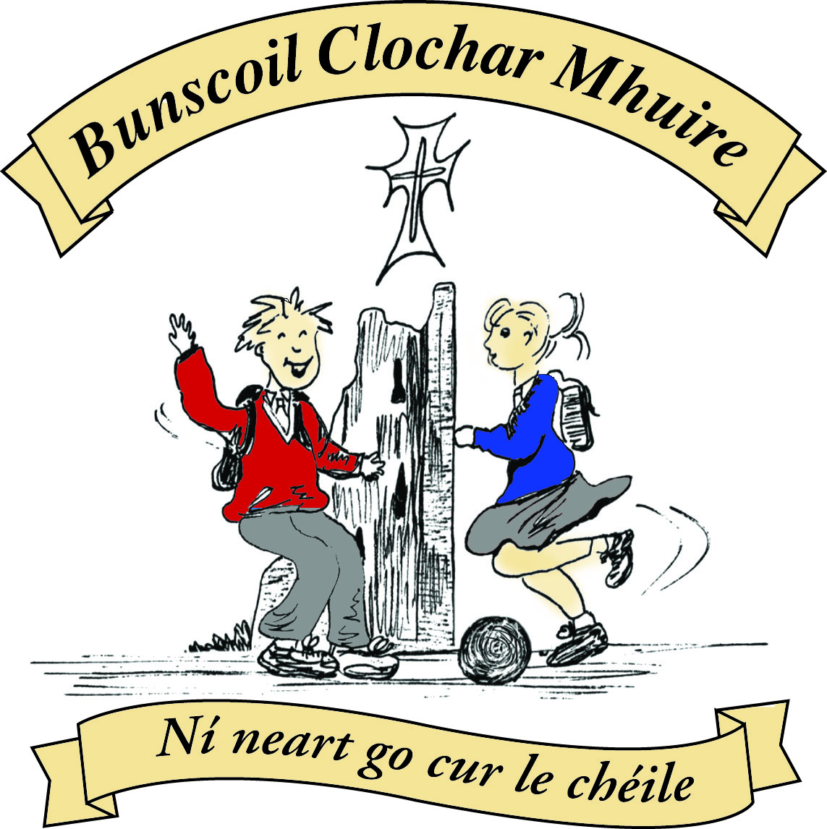* St Mary’s Convent Primary School**

***Bunscoil Clochar Mhuire***

***Trim, Co. Meath.  
Fón: (046) 9431919 ⦁ Faics: (046) 9437942  
Ríomhphost:*** [***marystrim@eircom.net***](mailto:marystrim@eircom.net) ***⦁ Website:*** [***www.stmarystrim.ie***](http://www.stmarystrim.ie) ***Uimhir Rolla: 16646O***

Awarded Green Flag  
June ‘05/’07/11/13

***Imlitir 31***

15th May, 2018

***Every Day Counts at St Mary’s Convent Primary School***

***30th April – 4th May 2018***

|  |  |  |  |  |  |  |  |
| --- | --- | --- | --- | --- | --- | --- | --- |
| **Room** | **Attendance** | **Room** | **Attendance** | **Room** | **Attendance** | **Room** | **Attendance** |
| 01 | 95.2% | 08 | 94.1% | 16 | 94.7% | 26 | 90.4 % |
| 02 | 90.7% | 09 | 93.1% | 17 | 88.3% | 27 | 94.1% |
| 03 | 95.2% | 10 | 92.8% | 18 | 95% | 30 | 96% |
| 04 | 95.9% | 12 | 97.5% | 19 | 92.9% | 31 | 91.7% |
| 05 | 90.4% | 13 | 99.2% | 20 | 97.7% |  |  |
| 06 | 80.8% | 14 | 89.3% | 23 & 24 | 90% |  |  |
| 07 | 91.7% | 15 | 95.9% |  |  |  |  |

*Congratulations to room 13 on nearly having full attendance last week of school. Their teachers will let them know their reward. Please note that notification in writing, with the reason for all absences, to the teacher is required. A letter or note in the homework journal will suffice.*

A chairde,

**First Holy Communion:** Congratulations to all the girls in Second Class who received the Body of Jesus for the first time on Saturday May 5th. They collected €214 for Trócaire and this was brought to the altar during the offertory procession. Thanks also to Fr Seán and Fr Warren who celebrated this special occasion with the children. Thanks to Fr Seán also for the time that he gives to faith formation in our school. We are most grateful to all staff who helped make this a special day:

·       Mrs Roche and Mrs Mc Gale had everything and everybody prepared to perfection

·       Ms Patricia for all her assistance

·       Helen, Rebecca and Ms Debby for all their help with the booklet and posters etc.

·       Frank, our Caretaker, for all "the running around"!

**Other helpers**:

·       Do This in Memory of Me Committee for the sacramental preparation

·       Our Parents' Association and the volunteer parents from First Class who organised the celebration in The Dr Eileen Reilly Hall after the ceremony-a very important social occasion in the life of our school.

·       The altar servers

·       Bernie the church Sacristan.

·       The Lay Ministers

I would also like to thank Mrs Nally for all the support she gave everyone, in my absence, leading up to and including the day.

**School Closures:** Referendum: Friday May 25th

New Language Curriculum Training: Tuesday May 29th

**Gaelbhratach:** *Tá áthas orainn* to announce that we have been granted a further flag for the promotion of the Irish language and culture, in our school. *Comhghairdeachas* to all involved and a special word of thanks to Mrs Nally and all the pupils, teachers and parents on the committee. *Maith sibh ar fad.*

**Security Advance Notice:** Please note that a release slip is required to be handed to the teacher prior to children being released, but that for Sports Day, group release will be facilitated. It must be done in the classroom and nowhere else. The children will return to their classes before 2.00 and be released from there. Teacher will have a sheet to be signed.

**All-Weather Pitch:** We hope to have a start date very soon but at this stage it is unlikely to be finished before the current Sixth Classes and First Class Boys leave us. If that is the case, we will organise something for next year to also include other classes who helped in the fundraising. We really do appreciate the support and I think that when we see the finished product, we will appreciate even more the great addition to our facilities.

**Before                                                                         After**

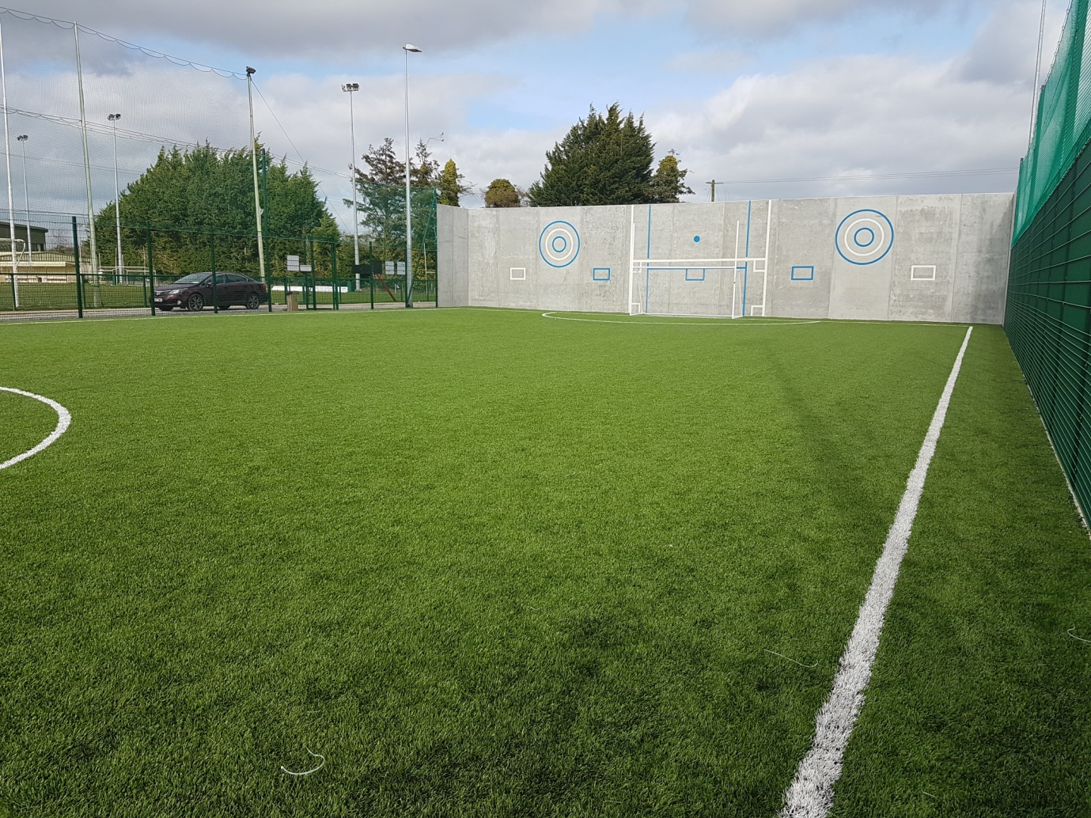

**

This is what the fundraising monies will build.  It will be worth it!

**Mobile Phones**: Please note that they should not be switched on, once pupils enter the school grounds.

*“If it’s out, it’s on.  If it’s on it’s gone!”* Phones will only be returned to parents/guardians. If it happens a second time, the student will not be allowed bring the phone to school.

Agreed Report from Board of Management Meeting 24/04/18

Following the recent B.O.M. meeting the calendar for next year 2018/2019 was finalised, students will return to school on Monday 3rd of September. (see below)

Changes were also made to the Enrolment/Admissions Policy. Baptismal certs will no longer be required with enrolment forms, birth certs will suffice. Names were also removed from the policy, as it was agreed these may change from year to year. Finally the school will be deemed full when the figure produced by multiplying the number of mainstream classes by 26 is reached.

Works will commence on the All-Weather Pitch in the coming weeks, following a delay with access to the site via the back pitch.

Barbara Munnelly

|  |  |
| --- | --- |
| **School Calendar 2018/19** | |
| Return: | Monday 3rd September 2018 |
| Mid-Term: | Monday 29th October - Friday 2nd November 2018 |
| Christmas Break: | Monday 24th December – Friday 4th January 2019 |
| Spring Mid-term Break | Thursday 21st – Friday 22nd February 2019 |
| St Patrick’s Day: | Friday 15th – Tuesday 19th March 2019 |
| Easter Break | Monday 15th April - Friday 26th April 2019 |
| May Bank Holiday: | Monday 6th May 2019 |
| June Bank Holiday: | Monday 3rd June 2019 |
| School closes | Friday 28th June 2019 |

### There are only ten days remaining for our school musical. Tickets are available for adults €10, children €8 and a family of two adults and two children €30. We cannot guarantee that tickets will be available, on the night, so book before then to avoid disappointment. If the last musical is a guide, we expect to sell out on the Friday and Saturday, so please bear this in mind. The practices are going really well and the staff and children have put every effort and no small amount of time into their preparations. To quote The Black Eyed Peas: its gonna be a good, good night!

**BOOK GRANT SCHEME**: If any parent has a genuine need due to neither parent/guardian working or prolonged illness, they may apply for help with buying books for the ***next*** school year. All applicants may be means tested. Please apply on the form below and return to the school no later than FRIDAY 8th JUNE.   No forms will be accepted after that date.

**Be Active Week & Sports Day**

Please note Sports Day is on Friday June 8th, weather permitting. Otherwise it will be on Friday June 15th.

Be Active Week will be starting on Monday 11th – Thursday 14th June. If you know of anyone who would be interested in doing dance, gymnastics, yoga, boxing, tennis, golf, orienteering or any form of physical activity with any age group, we would be delighted to hear from you. Please contact Ms Murray about your availability. Ms Murray & Ms Maguire



We are now on the count down to our school musical Seussical Jr. This is the story of the Cat in the Hat, Horton the Elephant who hears a Who!

The girls and staff have worked incredibly hard on this show and I have it on good authority that it is not one to be missed. So please support us by telling your family and friends. Tickets can be purchased from Helen in the office.

Ms Debby

Mise le meas,



Cóilín Ó Coigligh, Príomh Oide.

**Green News**

**Community News**

***Nath na Seachtaine:*  Comhghairdeachas!**

***Seanfhocal na Míosa:* Bíonn cluasa fada ag muca beaga**

**Dates to Remember**

**Assembly:** Green Flag Seniors @ 9.20

**Meitheal:** Every Tuesday morning 9.30-10.30.

**Drama Club:** Every Thursday 3-4pm for 5th Class

**Banna:** Tuesday 3.00 – 4.00

**Mini Rounders:** Monday for 3rd & 4th Class 3.00 – 4.00pm

**Referendum:**  Friday 25th May **School Closed**

**New Language Curriculum In-service:** Tuesday May 29th **School Closed for pupils**

**1st Class Boys Graduation Ceremony:** Friday 22nd June

**6th Class Girls Graduation Ceremony:** Wed 27th June

St Mary’s Parents’ Association

Many thanks to all the parents who helped out with the preparation of the First Holy Communion**.** We are most grateful to all volunteers who helped make this a special day.

<https://www.facebook.com/stmarysparentsassoc/>

Caroline Smith

Secretary

**Community Notices**

Limelight Theatrics will hold auditions on Sunday 20th of May for our upcoming musical 'We Are Monsters'. The musical will be staged early October. Rehearsals are each Tuesday evening in Trim, Co Meath at 6.30pm to 7.30pm for the remainder of our term, last class is June 19th. We will then break for summer returning with two one day workshops, preferably in August. We will revert back to each Tuesday evenings for rehearsals in September. Some parts have already been cast, remaining parts/chorus are open to actors/singers age 8 to 12 years.  If interested in participating and joining a fun ensemble just email Carmel at  [limelighttheatrics@gmail.com](mailto:limelighttheatrics@gmail.com)

 I will forward you on an audition sign up sheet and details of where the auditions will be held.

 Carmel McKiernan BA, LIBSD

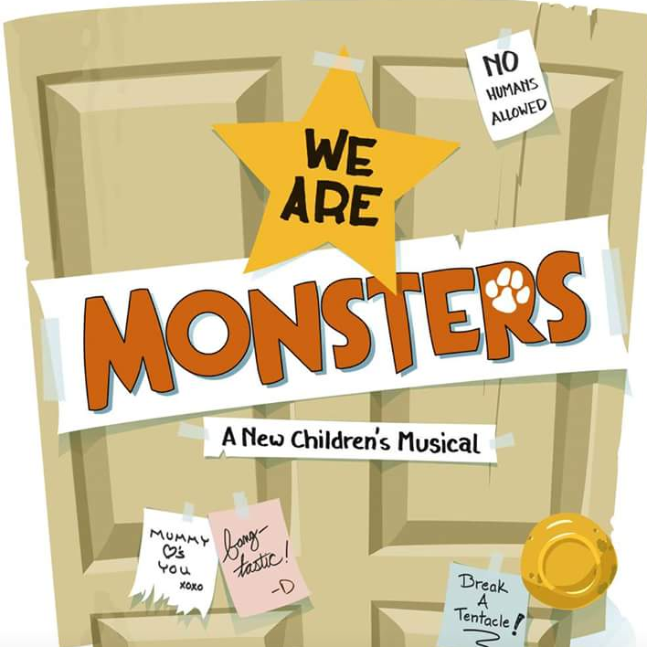

Limelight Theatrics will hold auditions on Sunday 20th of May for our upcoming musical 'We Are Monsters'. The musical will be staged early October. Rehearsals are each Tuesday evening in Trim, Co Meath at 6.30pm to 7.30pm for the remainder of our term, last class is June 19th. We will then break for summer returning with two one day workshops, preferably in August. We will revert back to each Tuesday evenings for rehearsals in September. Some parts have already been cast, remaining parts/chorus are open to actors/singers age 8 to 12 years.  If interested in participating and joining a fun ensemble just email Carmel at  [limelighttheatrics@gmail.com](mailto:limelighttheatrics@gmail.com)

 I will forward you on an audition sign up sheet and details of where the auditions will be held.

 Carmel McKiernan BA, LIBSD

**St Marys Summer Camp**: We will be running our Summer Camp again! Dates 2nd – 6th July €65 family discounts will apply. We look forward to seeing all our little friends aged between 4 – 12 again.

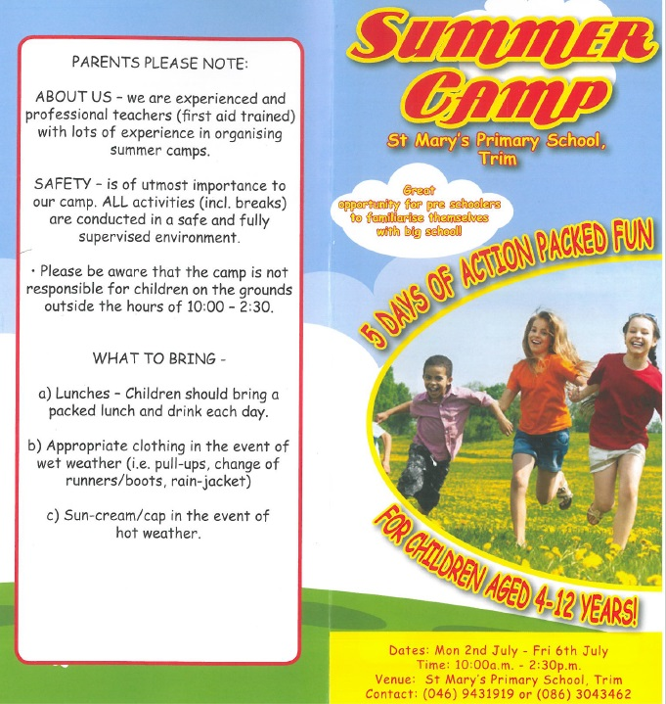

ZUMBA  :   MONDAY / WEDNESDAY  8pm  TRIM GAA,   €8 per class pay as you go,  suitable for all fitness levels  Contact : Lorraine 086 8693546

ZUMBA KIDS  :  New 3 week term beginning Thursday 17th May, St. Patrick's hall (under snooker club)

2.15pm - 3pm,   €15 for 3 weeks,  school pick-up available.    Contact :  Lorraine  086 8693546

**AFTER SCHOOL CLUB** Taking place in St. Mary's School Trim from 2-3pm Mon - Friday in room 5. Only €6 a day or €25 for 5 days Mon-Fri Application forms available from reception. Booking required a week in advance of start date to insure space, and rebooking and payment made the previous Thursday each week after. Kids will be provided a small snack and entertained with Lego, Art & Craft, Board games, quizzes, card games, puzzles and lots more fun activities! Run by an experienced Childcare Professional Parent who is fully Garda Vetted and Insured. Contact Julie O'Donohue to book your child's space by texting 0868505310, emailing [juliekerins@hotmail.com](mailto:juliekerins@hotmail.com) or via a PM on the Facebookpage:[www.facebook.com/TrimAfterSchoolClub](http://www.facebook.com/TrimAfterSchoolClub)

**Homework Club** in St Mary’s for children from 1st – 6th Classes. Application Forms are available from Ms Conaty Room 11 or Ms Lynch Room 31.

**Searsol Touch Typing Course**

**Age Group**: 8 years +

**Day/Time**:  Mondays, 4.30pm

**Location**: ST MARYS NS, TRIM

**Contact**: Jackie 086-3780842

**Website**:  [www.searsol.com](https://searsol.com/)

A touch-typing course designed to develop the typing skills of children 8 years & upwards in a classroom environment with a qualified tutor. You can join the course any time as your child works at their own pace in a small class environment so each child gets the  individual attention they need.  Free trial first lesson!

***This class is for all children but particularly helpful to kids with learning differences such as Dyslexia, Dyspraxia and Autism.***



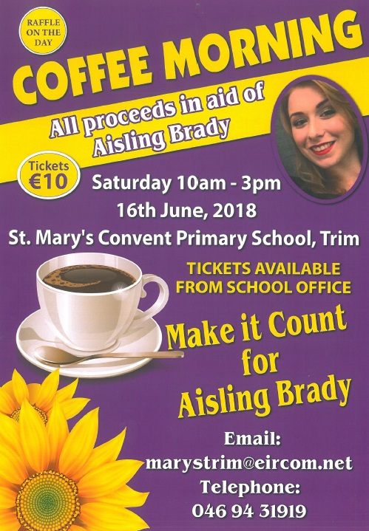

|  |
| --- |
| **Information for Class Planning 2018/2019**    In order for the school to have accurate information for forward planning for 2018/2019, please complete and return the following sheet.  This information is not binding, it is for class planning purposes.    Surname:                __________________________  Student/s Name/s:   __________________________  __________________________  __________________________  **will not** be returning to St. Mary’s in September 2018.    Signed:_____________________________________ Parent/Guardian |

## BOOK GRANT SCHEME

If any parent has a genuine need due to neither parent/guardian working or prolonged illness, they may apply for help with buying books for the next school year. **All applicants may be means tested.** Please apply on the form below and return to the school no later than FRIDAY 8TH JUNE. No forms will be accepted after that date.

**-----------------------------------------------------------------**

**APPLICATION FORM**

I wish to apply for assistance from the Book Grant Scheme for the year 2018/2019 due to the following circumstances.

Signed: _______________________ Parent/Guardian. Date: ________________

|  |  |  |
| --- | --- | --- |
| **Child’s Name** | **Present Child’s Class**  **June 2018**  **(e.g. Junior Infants,**  **Senior Infants,**  **1st Class………)** | **Present Room Number**  **June 2018** |
|  |  |  |
|  |  |  |
|  |  |  |
|  |  |  |