***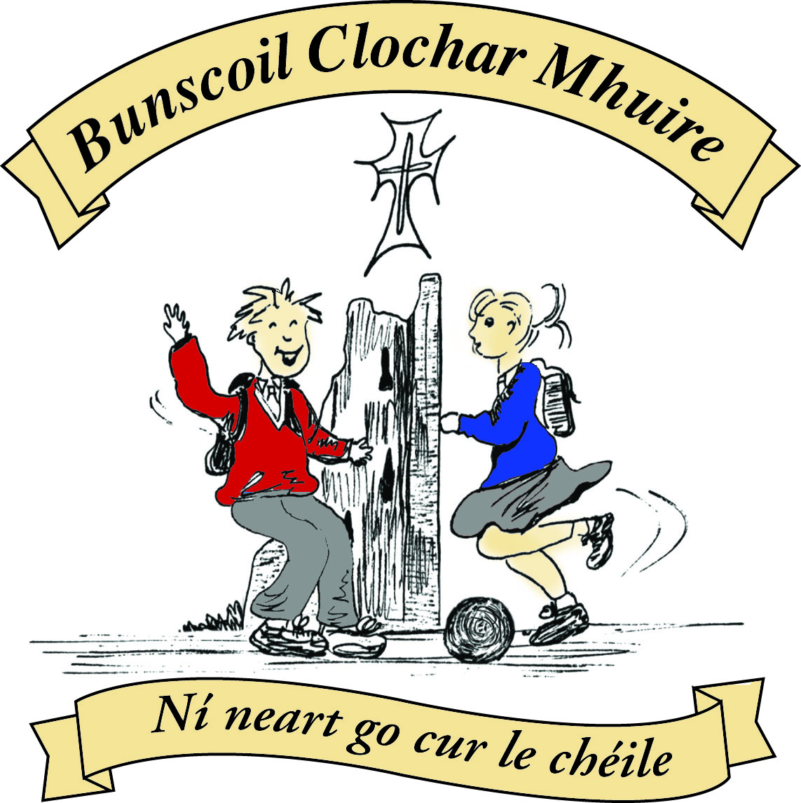* St Mary’s Convent Primary School**

***Bunscoil Clochar Mhuire***

***Trim, Co. Meath.  
Fón: (046) 9431919 ⦁ Faics: (046) 9437942  
Ríomhphost:*** [***marystrim@eircom.net***](mailto:marystrim@eircom.net) ***⦁ Website:*** [***www.stmarystrim.ie***](http://www.stmarystrim.ie) ***Uimhir Rolla: 16646O***

Awarded Green Flag  
June ‘05/’07/11/13

***Imlitir 30***

30th April, 2018

***Every Day Counts at St Mary’s Convent Primary School***

***23rd – 27th April 2018***

|  |  |  |  |  |  |  |  |
| --- | --- | --- | --- | --- | --- | --- | --- |
| **Room** | **Attendance** | **Room** | **Attendance** | **Room** | **Attendance** | **Room** | **Attendance** |
| 01 | 96.6% | 08 | 95.6% | 16 | 96.7% | 26 | 97 % |
| 02 | 98% | 09 | 93.8% | 17 | 98.3% | 27 | 97% |
| **03** | **100%** | 10 | 98.4% | 18 | 95.7% | 30 | 92% |
| 04 | 94.5% | 12 | 96.7% | 19 | 98.6% | 31 | 95% |
| 05 | 89.6% | 13 | 95.8% | 20 | 98.5% |  |  |
| 06 | 97.5% | 14 | 90% | **23 & 24** | **100%** |  |  |
| 07 | 88.3% | 15 | 97.2% |  |  |  |  |

*Congratulations to rooms 3, 23 & 24 on having full attendance last week. Their teachers will let them know their reward. Please note that notification in writing, with the reason for all absences, to the teacher is required. A letter or note in the homework journal will suffice.*

A chairde,

School closes for the mid-term next week. Please encourage your children to play outside and to mix with other children. Digital technology has many advantages but it cannot replace the benefits of normal childhood play and social interactions.

Please note that **school will be closed** for the pupils on Tueday, May 29th, as the teachers are undergoing training in The New Primary Language Curriculum. Please make the necessary arrangements.

Parents/guardians who have children on a **school bus** are reminded to have an arrangement with the bus driver so that s/he knows when your child will not be using the service. In particular, if s/he is expecting your child that they know to contact you immediately if they do not appear.

Best wishes to all our children who are making their **First Holy Communion** on Saturday next. Their teachers Mrs Gale and Mrs Roche had prepared them excellently with great support from Fr Seán and Fr Warren. The children are looking forward to this special day in their lives.

**Active Schools’ Week** this year will bethe week of June 5th. The date for our **Sport For All Day** will be 8th June, weather permitting.

**School Uniform:** May I remind parents and pupils that fashion shoes and fashion socks/tights are not part of our school uniform. Shoes with very high heels and non-supportive runners also present a safety risk.

Can I draw the attention of parents/guardians with children in the lower half of the school, to check that they can tie their shoe laces. If they cannot, please show them and give them an old shoe to practise on. Check also that they can use a scissors. Thanks.



**Health Promoting Schools**

We are working on Action 4 of our healthy schools programme at the moment. This is to promote the importance of oral hygiene

Senior Infants and Third Class are completing the Mighty Mouths and Looking After your Teeth programmes respectively. The overall aim of these programmes are to focus attention on the importance of oral health for children who are at greatest risk of developing dental disease. These programmes concentrate on the value of good dental care as part of childrens’ overall health and wellbeing. In particular they emphasise the essential role of tooth-friendly foods and drinks, and of supervised regular effective tooth brushing with fluoride toothpaste. They are delivered in conjunction with the HSE.

Mary Carr from the HSE will be giving a presentation to parents on the importance of oral hygiene on **Thurs.** **May 3rd at 1pm in the school hall.** . All parents are invited. This will be followed by an award ceremony for both Senior Infants and Third Class.

Sinéad Minogue



Tickets are now on sale for our school musical “Seussical” which takes place on Thursday May 24th, Friday May 25th and Saturday May 26th. Tickets are: €10 for adults, €8 for children and €30 for a family ticket for two adults and two children. We are expecting to sell out at least two of the three nights, so do not leave it too late to book your tickets. The children started practicing before Easter and are currently practicing three times a week. It is going to be a top class show. Huge thanks due to Ms Debby, Ms Mc Kenna and Ms O Connor for giving so generously of their time.

**Spelling Bee County Final:** About forty primary school pupils took part in County Meath’s Spelling Bee Final last Monday morning in St Paul’s National School, Ratoath. The event began at 11am and there was great excitement in the air. Our Spelling Bee Champion performed brilliantly during the tense competition and we are very proud of her. Comhghairdeachas Kate!! Mr Galligan

**Lost and Found**

Below are some items in lost and found. Unclaimed items will be donated to the St Vincent De Paul. Please call to the school before we close Friday to check for missing items.

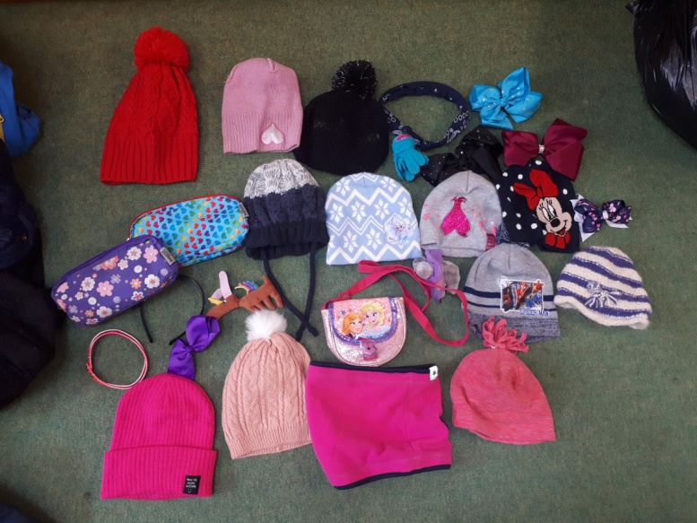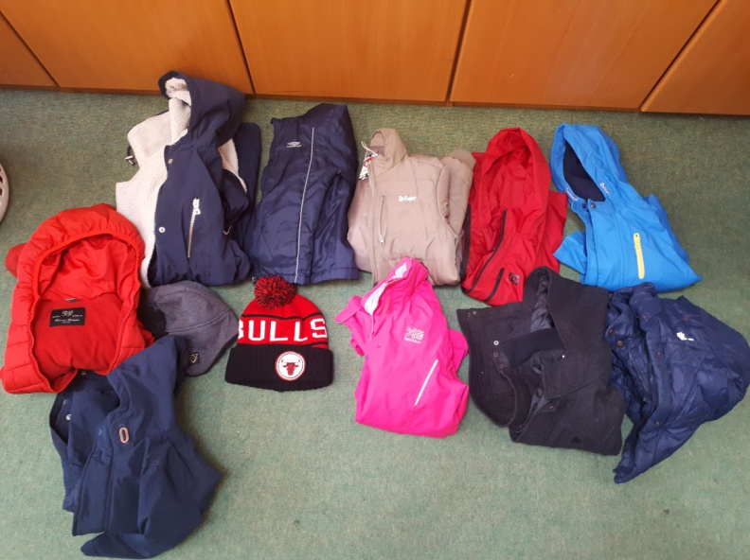

**First Holy Communion**

This gift set is available in the Parish Office and Church sacristy at €7 each.



**Facebook.** Don’t forget that St Mary’s Primary School has set up a Facebook group to highlight and celebrate the wonderful work and achievements going on in our school. It can be found at Saint Mary’s Convent Primary School, Trim. <https://www.facebook.com/groups/370589240043494/>

The page is completely school managed and access to the page is restricted to parents of current pupils only. Parents must answer 3 school related questions to join and sharing of posts is completely prohibited. Any violation of this rule will result in the parent being banned from the group!

Facebook protocols for our group are as follows:

No negative comments.

No inappropriate content.

No advertising.

No sharing outside the group

We don’t allow parents “tag” their children but we can tage other members of the group.

The school has the right to delete any comments e.g. a long conversation on a post which may not be relevant.

**Remember** to set your notifications to “All Posts” so that you don’t miss any notices.

Enjoy! Ms Dixon

**Trócaire Boxes** may be returned through the school or the Parish Office.

Mise le meas,



Cóilín Ó Coigligh, Príomh Oide.

**Green News**

**Community News**

***Nath na Seachtaine:*  Cad é an Ghaeilge ar.....**

***Seanfhocal na Míosa:*** Mol an óige agus tiocfaidh sí

**Dates to Remember**

**Assembly: None this week**

**Meitheal:** Every Tuesday morning 9.30-10.30.

**Drama Club:** Every Thursday 3-4pm for 5th Class

**Banna: Tuesday 3.00 – 4.00**

**Mini Rounders:** Monday for 3rd & 4th Class 3.00 – 4.00pm

**Communion: Saturday 5th May @ 11.00**

**New Language Curriculum In-service:** Tuesday May 29th **School Closed for pupils**

St Mary’s Parents’ Association

**May 4th:** PA members will be in the hall from 9am to collect buns made for Communion reception**.**

**May 5th**: Second Class girls will make their First Holy Communion.

**May 7th-11th:** School Closed ☺

<https://www.facebook.com/stmarysparentsassoc/>

Caroline Smith

Secretary

**Community Notices**

**May Monkey Madness Camp** taking place in St Mary’s Primary School from May 8th – 11th. 9.30 – 2.30pm daily. It promises to be a fun filled week of arts, crafts, sports, games and much more. Cost is €50 per child or €45 for two children or more. Contact Ms Cullinane or Ms McKenna for more info.

**St Marys Summer Camp**: We will be running our Summer Camp again! Dates 2nd – 6th July €65 family discounts will apply. We look forward to seeing all our little friends aged between 4 – 12 again.

ZUMBA  :   MONDAY / WEDNESDAY  8pm  TRIM GAA,   €8 per class pay as you go,  suitable for all fitness levels  Contact:Lorraine [0868693546](tel:086%208693546)

ZUMBA KIDS  :  New 4 week term beginning this Thursday 12th April, St. Patrick's hall (under snooker club)   [2.15pm - 3pm](x-apple-data-detectors://6),   €20 for 4 weeks,  school pick-up available.  Limited places,  Contact :  Lorraine  [086 8693546](tel:086%208693546)

**AFTER SCHOOL CLUB** Taking place in St. Mary's School Trim from 2-3pm Mon - Friday in room 5. Only €6 a day or €25 for 5 days Mon-Fri Application forms available from reception. Booking required a week in advance of start date to insure space, and rebooking and payment made the previous Thursday each week after. Kids will be provided a small snack and entertained with Lego, Art & Craft, Board games, quizzes, card games, puzzles and lots more fun activities! Run by an experienced Childcare Professional Parent who is fully Garda Vetted and Insured. Contact Julie O'Donohue to book your child's space by texting 0868505310, emailing [juliekerins@hotmail.com](mailto:juliekerins@hotmail.com) or via a PM on the Facebookpage:[www.facebook.com/TrimAfterSchoolClub](http://www.facebook.com/TrimAfterSchoolClub)

**Homework Club** in St Mary’s for children from 1st – 6th Classes. Application Forms are available from Ms Conaty Room 11 or Ms Lynch Room 31.



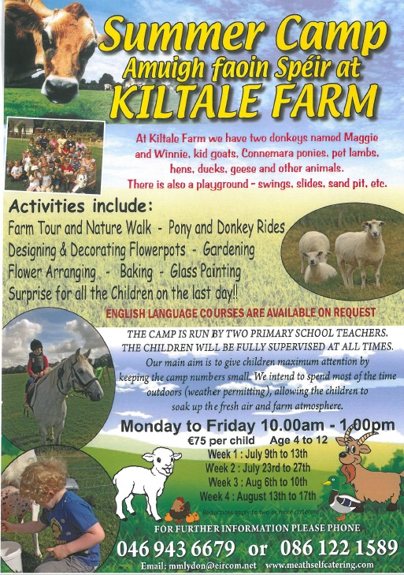



**Searsol Touch Typing Course**

**Age Group**: 8 years +

**Day/Time**:  Mondays, 4.30pm

**Location**: ST MARYS NS, TRIM

**Contact**: Jackie 086-3780842

**Website**:  [www.searsol.com](https://searsol.com/)

A touch-typing course designed to develop the typing skills of children 8 years & upwards in a classroom environment with a qualified tutor. You can join the course any time as your child works at their own pace in a small class environment so each child gets the  individual attention they need.  Free trial first lesson!

***This class is for all children but particularly helpful to kids with learning differences such as Dyslexia, Dyspraxia and Autism.***

|  |
| --- |
| **Information for Class Planning 2018/2019**    In order for the school to have accurate information for forward planning for 2018/2019, please complete and return the following sheet.  This information is not binding, it is for class planning purposes.    Surname:                __________________________  Student/s Name/s:   __________________________  __________________________  __________________________  **will not** be returning to St. Mary’s in September 2018.    Signed:_____________________________________ Parent/Guardian |