 St Mary’s Convent Primary School**

***Bunscoil Clochar Mhuire***

***Trim, Co. Meath.  
Fón: (046) 9431919 ⦁ Faics: (046) 9437942  
Ríomhphost:*** [***marystrim@eircom.net***](mailto:marystrim@eircom.net) ***⦁ Website:*** [***www.stmarystrim.ie***](http://www.stmarystrim.ie) ***Uimhir Rolla: 16646O***

Awarded Green Flag  
June ‘05/’07/11/13

***Imlitir 30***

2nd May, 2017

***Every Day Counts at St Mary’s Convent Primary School***

***24th April to 28th April 2017***

|  |  |  |  |  |  |  |  |
| --- | --- | --- | --- | --- | --- | --- | --- |
| **Room** | **Attendance** | **Room** | **Attendance** | **Room** | **Attendance** | **Room** | **Attendance** |
| 01 | 97.7 % | 08 | 97.6% | 16 | 91.9% | 26 | 96% |
| 02 | 76% | 09 | 94.8% | 17 | 98.5% | 27 | 97.5% |
| 03 | 96.5% | 10 | 94.3% | 18 | 93.3% | 30 | 93.8% |
| 04 | 95.6% | 12 | 94.7% | 19 | 96.4% | 31 | 98.6% |
| 05 | 94.6% | 13 | 96% | 20 | 99.3% |  |  |
| 06 | 93.8% | 14 | 98.6% | **23 & 24** | **100%** |  |  |
| 07 | 96.8% | 15 | 96.4% |  |  |  |  |
|  |  |  |  |  |  |  |  |

*Well done Rooms 23&24 on having full attendance last week. Their teacher will let them know their reward. And to room 20 on nearly making it. Please note that notification in writing to the teacher is required. A letter or note in the homework journal will suffice.*

A chairde,

Congratulations to our Green Flag Committee and to our school community on securing our eight(!) Green Flag. The Award Ceremnony takes place on Thursday 25th May in Gormanstown. We are indebted to Mrs Nally for co-ordinating the whole project and for keeping us all on the straight and narrow. *Míle buíochas.* Don't forget to read her Green News below, it always has some great nugets of information.

Our many **extra-curricular activities** have restarted, please check the days, times and age groups below.

**Aquatics for First Class** children will commence on 6th June and will continue for 4 weeks. The cost is €16. This payment can be made in full or by installments through our Banking Online System or to the teacher, on or before 31st May.

At the end of this Imlitir is a draft copy of a new Health Eating Policy. Please email any suggestions or comments to marystrim@eircom.net by Friday May 12th for consideration. The Student Council (*An Chomhairle Scoile)* were consulted today and had a lot of suggestions for us. We welcome this feedback. The staff consultation takes place on Wednesday May 10th at our staff meeting. We hope to have our new policy finalised in time for inclusion in next year's Homework Journal.

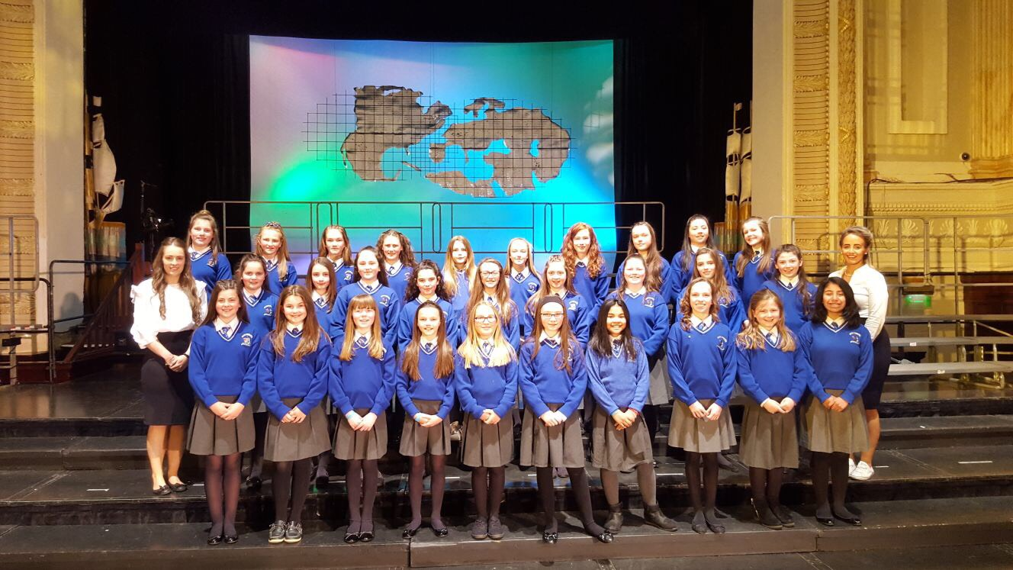

Our performance choir had a wonderful experience at The Cork International Choral Festival last week. I have included a photo and short sound file. I would like to wish them every success at The Navan Choral Festival tomorrow.

Ava and Ella received a medal of commendation for their entry to a national competition on computer programming (Scratch). There were over 600 entries and they made it to the final 30. Well done again girls. You can check out the programme they created here: <https://scratch.mit.edu/projects/145639131/>

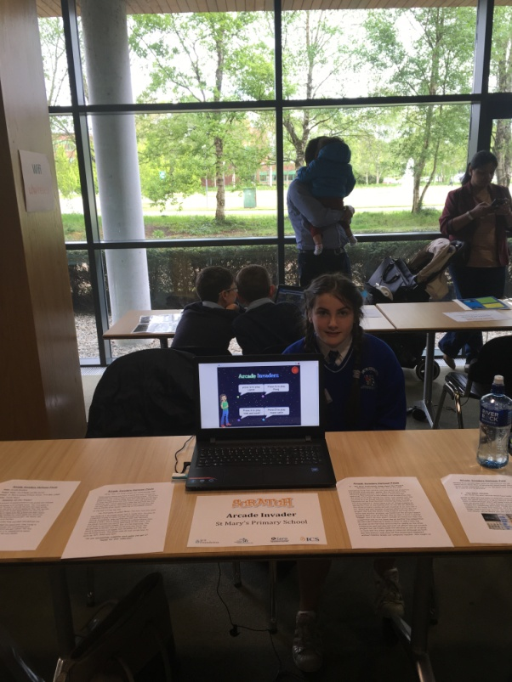

Tickets for The OsKars are now on sale (€25) through the school, as well as from the actors.

Thanks to all who supported our Parents' Association Bun Sale on Friday last and to our P.A. for organising and supporting our school so well.

***Dublin Youth Orchestra***

*We were honoured last Friday with a visit from The Dublin Youth Orchestra and every pupil in our school was treated to an amazing performance of their delightfully varied repertoire. A huge congratulations to our own Banna Ceoil who rehearsed so well and played two pieces splendidly with the Dublin Youth Orchestra while Mrs McGale ably conducted! It was a proud day for our school as two of our pupils, Tara and Caoimhe are members of the orchestra. Our other Tara was asked to play drums with the orchestra for some of their repertoire! Maith sibh go léir!*

*A reminder to anyone who is interested in learning the violin, it is possible to rent instruments through the school. More information is available from Ms McGale if necessary. Our Banna Ceoil will be open to new members in September so that might be a great time to consider taking up an instrument and playing with our band.*

*The Banna Ceoil are now busy preparing for the First Communion.* ***Pupils from 4th, 5th and 6th will be playing at the Communion Mass on May 13th. So next week (May 8th) only these pupils need to come to rehearsal.*** *On May 16th there will be no Banna Ceoil for any pupils as they deserve a well-earned break!*

***Do This In Memory Mass***

*The final Do This In Memory Mass for this year’s Communion Classes was held on Sunday. As usual the girls acquitted themselves really well. The classes performed a beautiful Andrew Chin song which linked perfectly to the Gospel on Sunday. Congratulations to Sophie, Mya, Diana, Ellen, Layla and Emma for their lovely prayers and to Sarah, Nikola, Aisling and Hannah for presenting the Offertory gifts. We take this opportunity now to commend the classes, their teachers, The Do This In Memory Committee and Fr Declan for all their hard work and dedication all year and we wish the girls the best of luck over the next two weeks as they prepare for their First Communion Day.*

*Mrs Nally*

*This Friday the Parents’ Association are holding a Crazy Hair/Crazy Colours Day. The children are asked to do some crazy hairstyles or they can wear some crazy colour clothes to school. A contribution of €2 will go towards the Parents’ Association Fund. Denise Watson*

Mise le meas,



Cóilín Ó Coigligh, Príomh Oide.

**Green News**

**Community News**

**Nathanna na Seachtaine:** Is féidir liom siúl, is féidir liom rothaíocht (I can walk, I can cycle!)

**Seanfhocal na Míosa:** Bíonn Cluasa Móra ag Muca Beaga

**Dates to Remember**

**Assembly: Friday @ 9.30** Green Flag &

**Banna Ceoil:** Tuesday 3.00-4.00

**Meitheal:** Every Tuesday morning 9.30-10.30.

**Communion:**  Sat May 13th @ 11.00am

**Football Training:** Wednesday 3.00 - 4.00 for 3rd – 6th Classes

**Mini-Rounders:** Mondays for 3rd to 6th Classes 3.00 – 4.00pm

**Green News**

We have wonderful Green News this week.....Last week we received notification of our being awarded the Green Flag for Global Citizenship. Congratulations to all who contributed in any way to this great achievement. It is a marvellous accomplishment and we are so delighted to be part of the Green Schools Programme which promotes good values and respect for our world, our Common Home. We will attend a special ceremony to receive our Green Flag on May 25 and then we will celebrate the raising of the flag at a later date. Maith sibh go léir. Ní neart go cur le chéile!

WOW continues this Wednesday. Meet up at Mornington House or at the Matchbox at 9:00am. The teachers will escort the pupils from there to the school. Míle buíochas to the teachers who keep this initiative going every week.

COW resumed last week also. Children from Fourth Class up are encouraged to participate. Younger children may join in if they are accompanied by a grown-up. High viz vests and helmets are essential. Cyclists meet up just inside Steeple Manor at 8:55am and the route is along by the river. Hope we see a few enthusiasts out there tomorrow. We are a Healthy School and walking and cycling to school are all part of being healthy. We hope to see a lot of new walkers and cyclists this term.

Recycling continues at St Marys. Waste Management is part of our Global Citizenship theme this year. It is wonderful to see how vigilant the pupils are about recycling and how much more of a life habit it has become since the start of the Green Flag campaign in St Mary’s. We recycle the following materials: batteries, ink cartridges, small plastic bottles, cans, postage stamps, footwear, card and toilet rolls.

The pledge we are revising this month is the energy pledge...

**Remember Green is cool at home and at school and around the globe!**

**Community Notices**



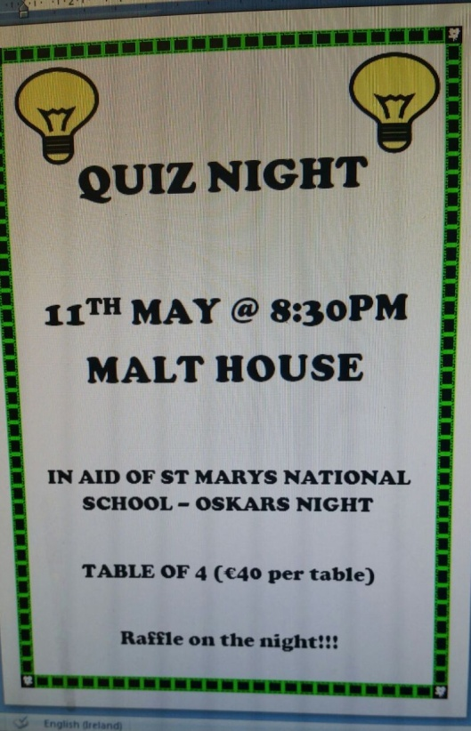

**Jigsaw Supporting Young People's Mental Health** This is a 60 minute workshop for parents/guardians and other adults interested or concerned about young people's mental health. Where: TFRC2 When 25th April 2017 Time 7pm            Contact Lisa 046 9438850

**Serendipity for Charity, Watergate Street, Trim**.We are looking for volunteers at the moment to help out in our shop in Trim. We support various local charities each year. If you are interested in giving a couple of hours during the week please contact Miriam on 0868548202. You can also find us on Facebook at Serendipity for Charity.

**Mu-gen-do Martial Arts Academy** is a locally run Family Martial Arts school operating in Trim since 2008. Mu-gen-do Kickboxing is a new, fun way for children and adults to stay healthy & safe, while learning at the same time to have respect for themselves and others. We conduct our classes In Aura Leisure Centre in Trim. For a free trial class please see below:

