***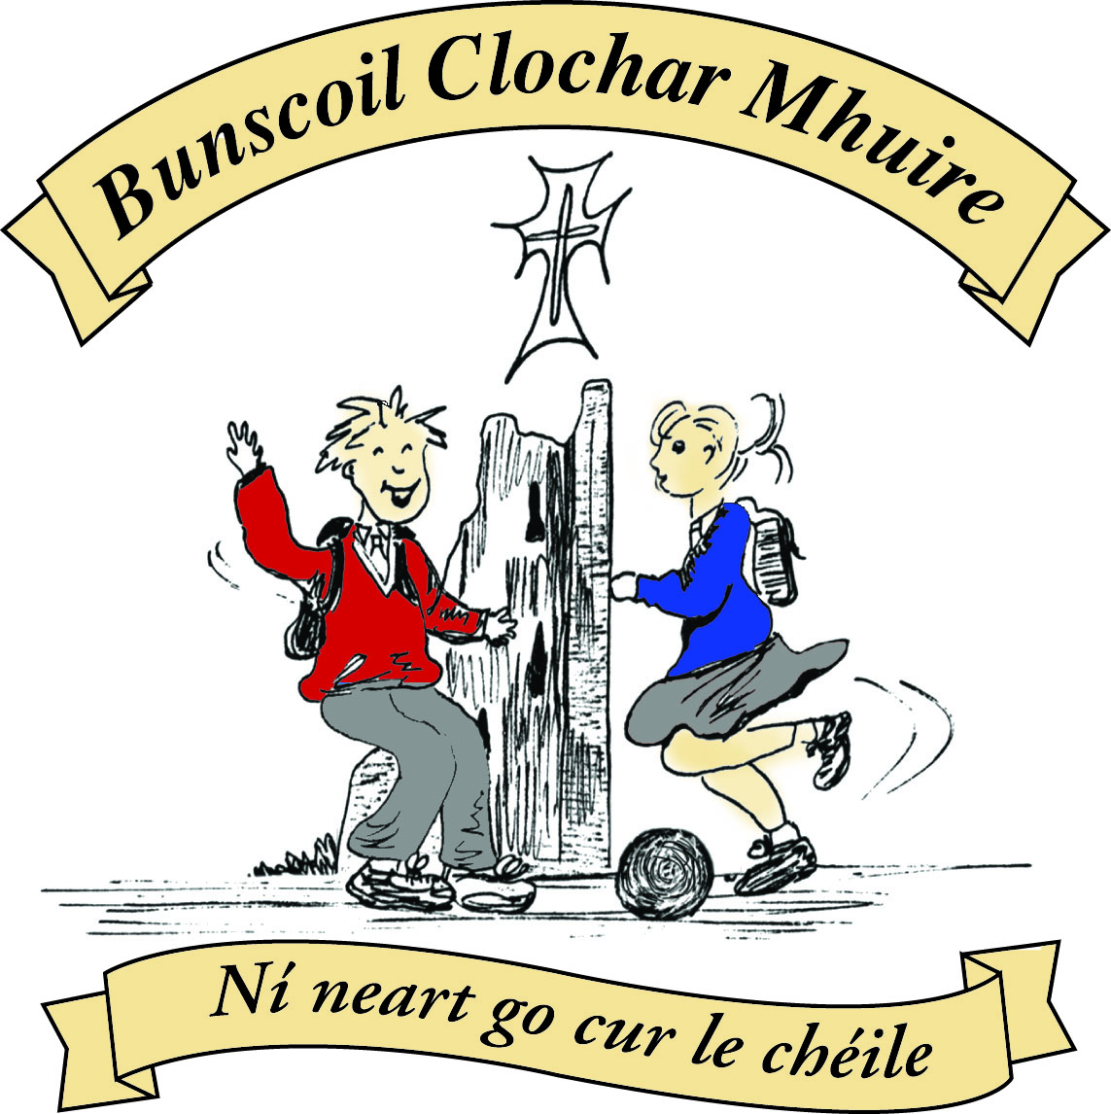* St Mary’s Convent Primary School**

***Bunscoil Clochar Mhuire***

***Trim, Co. Meath.  
Fón: (046) 9431919 ⦁ Faics: (046) 9437942  
Ríomhphost:*** [***marystrim@eircom.net***](mailto:marystrim@eircom.net) ***⦁ Website:*** [***www.stmarystrim.ie***](http://www.stmarystrim.ie) ***Uimhir Rolla: 16646O***

Awarded Green Flag  
June ‘05/’07/11/13

***Imlitir 30***

20th April, 2016

***Every Day Counts at St Mary’s Convent Primary School***

***11th – 15th April, 2016***

|  |  |  |  |  |  |  |  |
| --- | --- | --- | --- | --- | --- | --- | --- |
| **Room** | **Attendance** | **Room** | **Attendance** | **Room** | **Attendance** | **Room** | **Attendance** |
|  |  |  |  |  |  |  |  |
| 01 | 93.3 % | 08 | 97.1% | 16 | 91.1% | 26 | 97% |
| 02 | 93.1% | 09 | 97.8% | 17 | 94% | 27 | 90% |
| 03 | 96.8% | 10 | 95% | 18 | 97.1% | 30 | 89% |
| 04 | 96.9% | 12 | 99.2% | 19 | 95% | 31 | 89% |
| 05 | 96.4% | 13 | 90% | 20 | 97.5% |  |  |
| 06 | 97.9% | 14 | 94.6% | 23 | 91.4% |  |  |
| 07 | 95.6% | 15 | 99.2% | **24** | **100%** |  |  |

A Chairde,

Congratulations to Room **24** on having full attendance. Their teacher will let them know this week what their prize is.

Our many extra-curricular activities have restarted, please check the days, times and age groups below. Please note the lunchtime senior Rounder’s practice. Our internal Rounder’s schools league started yesterday and will continue for the next few weeks.

Enrolments for next year: As mentioned last week, we would be grateful to families (excepting Sixth Classes and first Class Boys) who know for sure that they will **not** be returning, to let us know in the form below. Thanks.

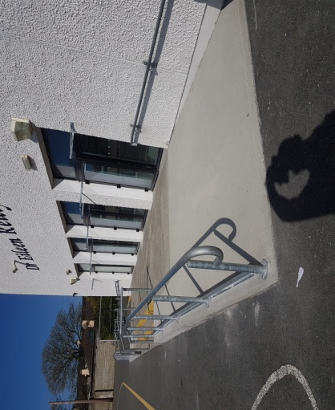As mentioned last week, works took place to improve our yard drainage and disability access over the Easter Holidays. I have included some photos.

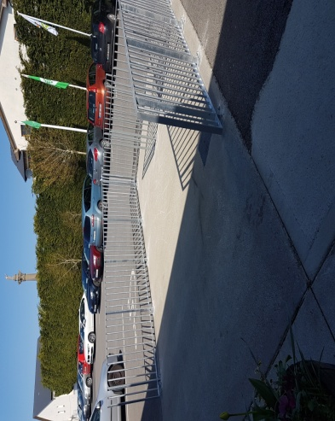

We also had some major works done to The Dr Eileen Reilly Hall. We installed two sets of basketball boards, a divider net to enable two classes use the space if necessary and finally lines and posts for Olympic Handball as well as lines for Basketball/Tennis/Volleyball and P.E. This work was completed this week and I have included some photos below.

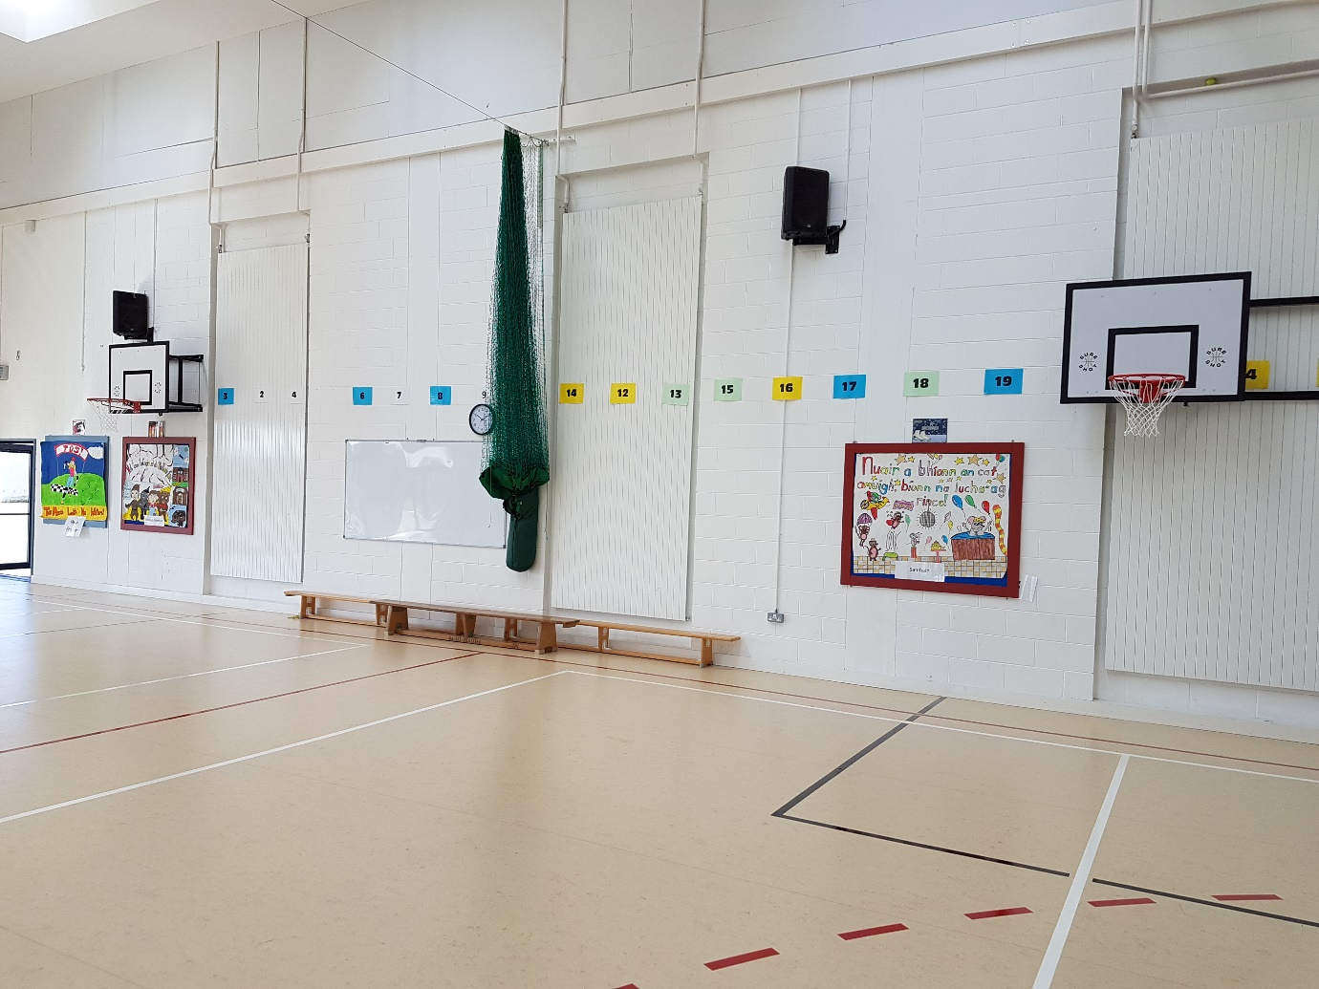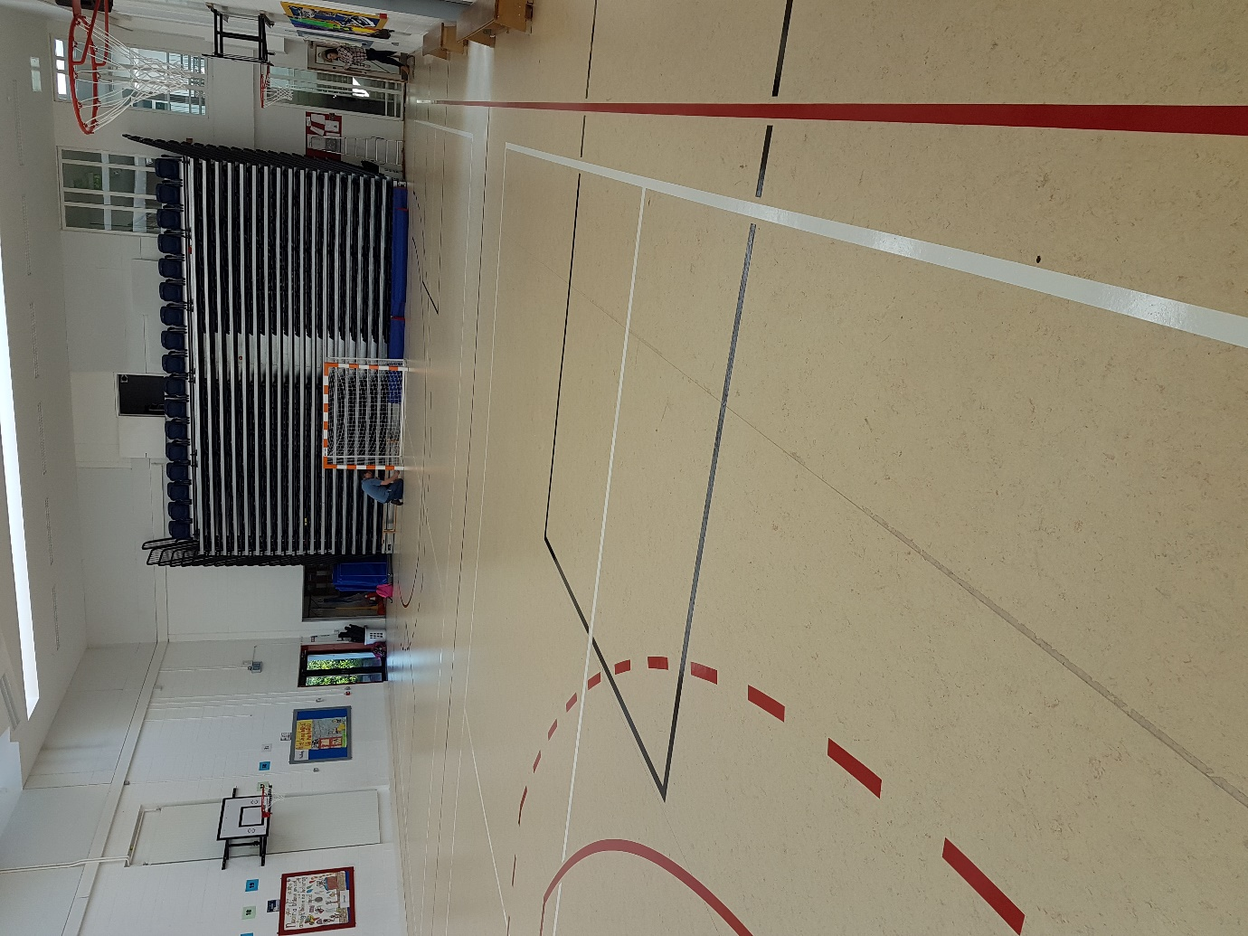

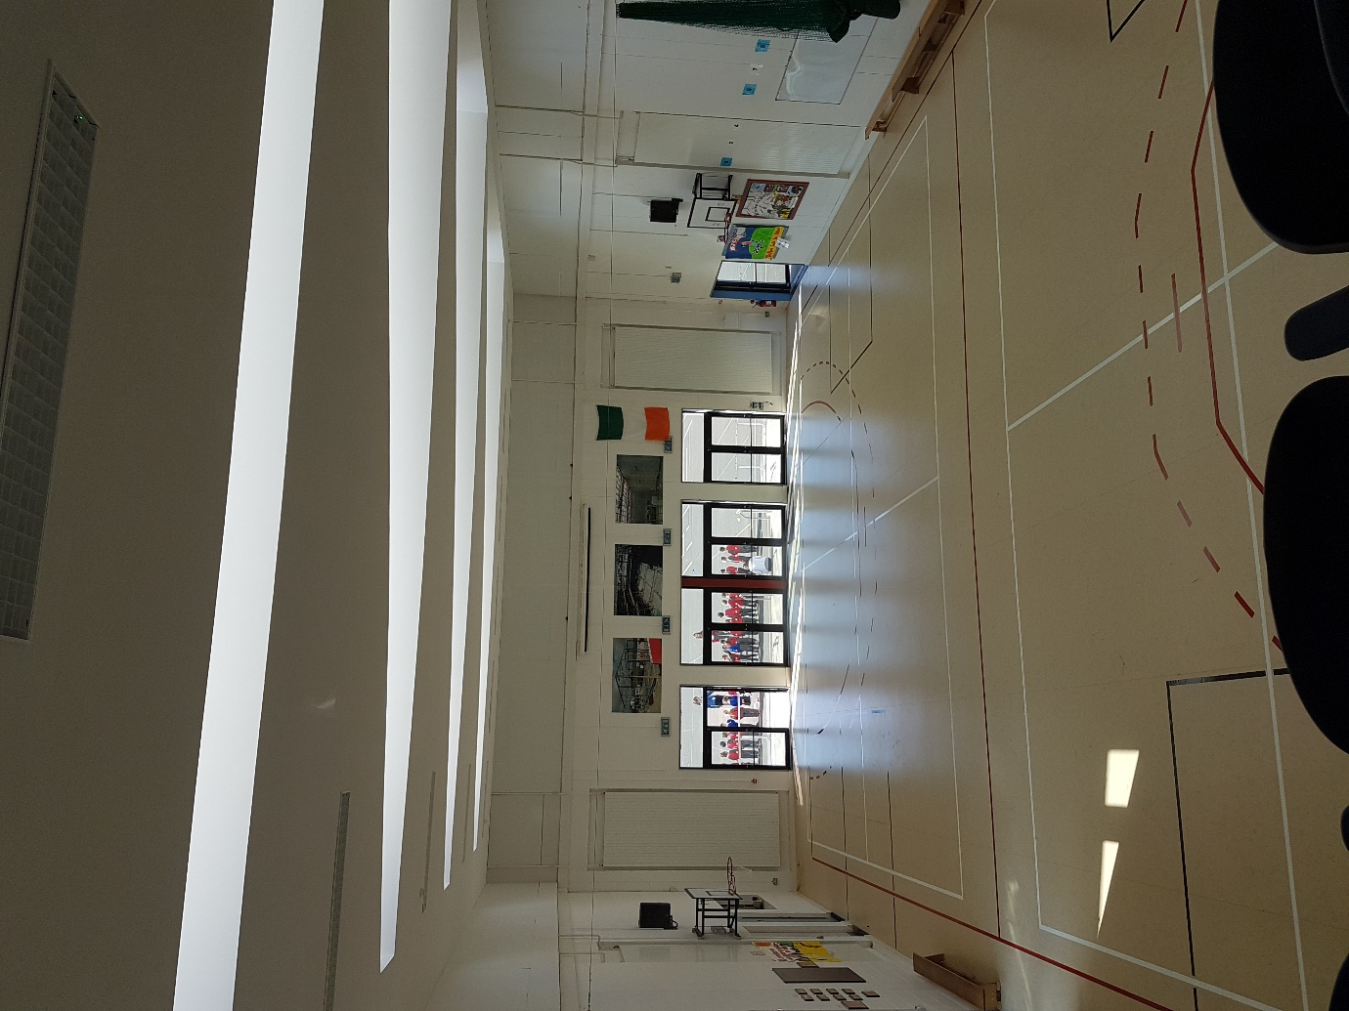

***County Meath Spelling Bee 2016****: Congratulations to Shona Kiely (6th Class) after her performance in the Meath County Final of the Spelling Bee. The final was held yesterday in St Paul's National School in Ratoath. There were 34 participants in the competition and Shona bowed out on the word "asphalt" - leaving only 11 others in the competition. Well done Shona!! D. Galligan*

***Active School Week:*** *This year we have been putting a huge emphasis on children becoming more active in their daily lives. We are hoping to hold our Active School Week on Monday 23rd - 27th of May. The Active School Week initiative is about providing Fun and inclusive physical activity opportunities for all members of the school community. In order for the initiative to work well we need parent volunteers and members of our community to help out that week.*

*Last year we had an array of volunteers giving up their time to promote children becoming more active from Zumba dancing for children, Gym instructors from local gyms, rugby, boxing, games etc.*

*This year we really want to highlight the importance of physical activity. If you would like to give up your time to demo a sample sport or would like to help out during the week, please contact the office or contact Ms Maguire or Ms Murray.*

*Ms Maguire*

|  |  |
| --- | --- |
| **School Calendar 2016/2017** | |
| Return: | Wednesday 31st August 2016 |
| Mid-Term: | Monday 31st October - Friday 4th November 2016 |
| Christmas Break: | Friday 23rd December - Friday 6th January 2017 |
| Spring Mid-term Break | Thursday 23rd - Friday 24th February 2017 |
| Mid-term: | Monday 13th - Friday 17th March 2017 |
| Easter Break | Monday 10th April - Friday 21st April 2017 |
| May Bank Holiday: | 1st May 2017 |
| June Bank Holiday: | 5th June 2017 |
| School closes | Friday 30th June 2017 |

**Information for Class Planning 2016/2017**

In order for the school to have accurate information for forward planning for 2016/2017, please complete and return the following sheet. This information is not binding, it is for class planning purposes.

Surname: __________________________

Student/s Name/s: __________________________

__________________________

__________________________

**will not** be returning to St. Mary’s in September 2016.

Signed:_____________________________________ Parent/Guardian

Mise le meas,



Cóilín Ó Coigligh, Príomh Oide.

**Green News**

**Community News**

**Nath na Seachtaine**: **Nach breá an lá é! / Tá an lá go breá (Isn't it a nice day/It's a nice day)**

**Seanfhocal na Míosa: Ní chrónaítear an t-uisce go dtriomaítear an tobar**

**(We don't miss the water until the well runs dry)**

**Dates to Remember**

**Assembly:** Friday @ 9.30 for Juniors “Noah’s Ark”

**Meitheal:** Every Tuesday morning 9.30-10.30.

**Banna Ceoil:** Every Tuesday @ 3pm in the Dr. Eileen Reilly Hall.

**School Choir:** Friday 3.00 – 4.00p.m

**Mini-Rounders:** 3rd & 4th Classes Mondays 3.00-4.00p.m.

- D. Galligan & S. Conaty, Teachers

**Rounders:** 5th & 6th Classes Mondays 3.00-4.00p.m.

– Ms Coakley & Mrs Munnelly, Teachers.

Thursdays lunchtime in Dr. Eileen Reilly Hall

**Camogie:** Wednesday 3.00-4.00 p.m. Third – Sixth Classes

**First Communion:** Saturday 28th May @ 11.00 a.m.

**Green News**

The weather is finally improving. Signs of spring are appearing. Some classes have gotten out and about to try to spot these signs. They have found bird nests high in the branches and buds popping out on the trees. Earlier in the school year, pupils planted flowers with Frank Dalton, our visiting gardener. These flowers are blooming at the moment and give us a lovely sense of spring when we walk in past them every morning. Our own Frank planted a tree which was gifted to the school last autumn. It was really only a very delicate sapling at the time. It is amazing to see a bud opening up now that nature is springing to life!

Our recycling continues at school. We accept batteries, cardboard, small plastic bottles, ink cartridges, nespresso coffee pods, footwear, toilet rolls and postage stamps.

Our Green Theme over the next two years is **Global Citizenship** and we are discovering lots about the various cultures in our school. We will be highlighting these cultures during Intercultural week this term. Some of you might like to come in and share information with your child’s class. We look forward to that. Please contact your child’s class teacher before then.

**WOW** (Walking on Wednesdays) is going very well. Sincere thanks to the dedicated teachers who sustain this initiative by being there to walk with the children every week. Numbers have been steady. Now that the weather is improving, perhaps more children might get involved.

**COW** (Cycling on Wednesdays) will begin after the May Bank holiday when it is warmer, drier (hopefully) and safer for cycling. Hope your bicycles will be in good order by then.

Remember April is Clean up month so let’s make an effort to keep our environs clean and dispose of our litter in the correct and most green way.

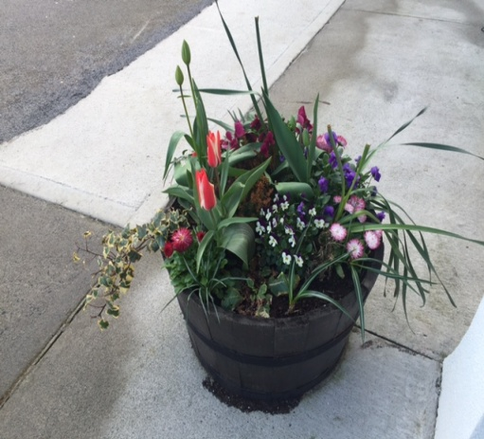

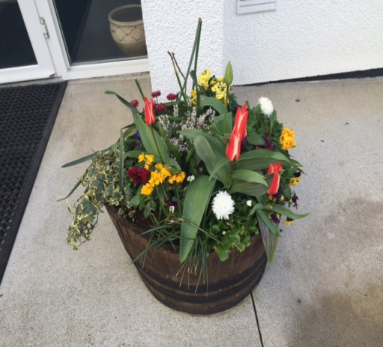

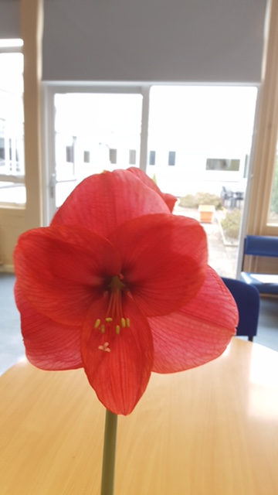

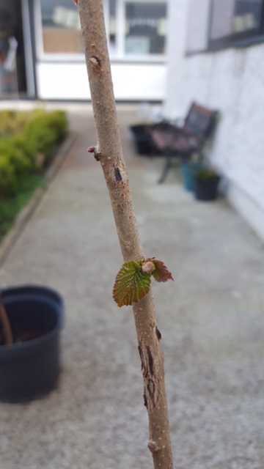

***Remember Green is cool, at home and at school and around the globe***

**Community Notices**

**ZUMBA**  :-   No experience, partner or booking required -      **SUMMER IS JUST AROUND THE CORNER**:- MONDAY   8pm   Trim GAA,   €8 per class     Contact :  Lorraine  086 8693546

**ZUMBA  KIDS**:-        Ages 5-8   TUESDAY    3.15pm    TRIM GAA    €6 per class  (Sibling rate €5)

Zumba,  Hip-Hop,  Rock 'n Roll,  Jive.............             Contact :  Lorraine  086 8693546 / JoJo  086 3381159

**JIGGLE 'N' JUMP** - has moved to the Trim GAA from April 5th. Music and Movement classes will be held in the front room upstairs (Where the parent & toddler group takes place) on a Tuesday at 9.45am and Saturdays at 10.30am. There will also be a new class starting for ASD kids or kids who suffer with anxiety, offering a more routine class where parents can see the progress each week. This will be held on Saturdays at 9.30am. Classes also on Wednesday 10am in Summerhill Community Centre. Please call Julie to enquire or book in!

Jiggle 'n' Jump also provide party entertainment, in your home, the GAA or other venue. Various characters available for Face Painting, Tattoos, Nails, Singing, Dance Routines, fun Bingo, Pass the Parcel and lots of other fun party games! :)

**Carney School of Irish Dancing** Classes in St. Patricks Hall every Tuesday. 2pm – 3pm & 3pm – 4pm. Every Friday @ 5.30pm. Infants and Senior infants can be collected from class rooms @ 2pm and left back to the buses @ 3pm. €5 per pupil per class. Contact Ann Carney 087-6336495