***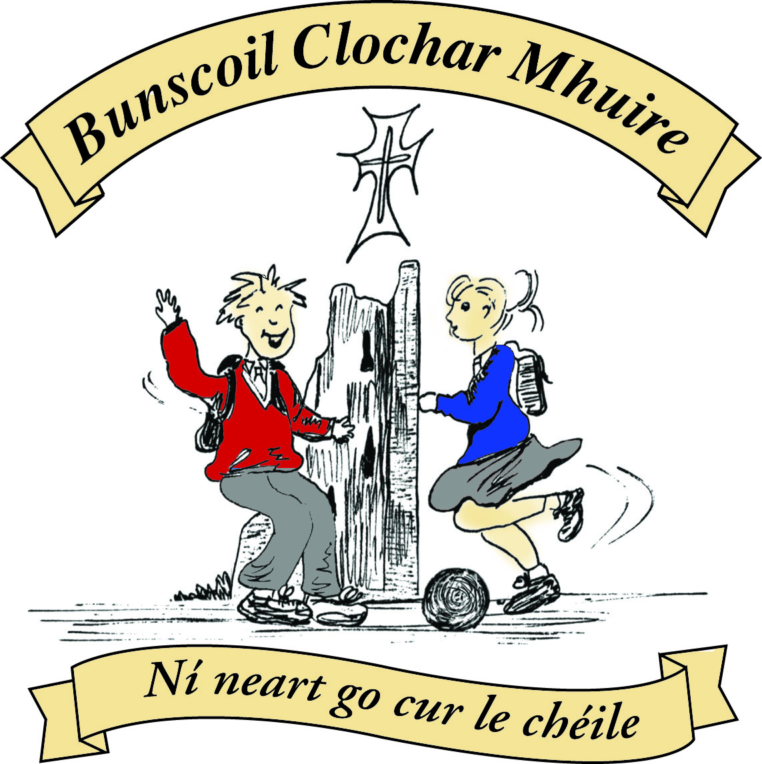* St Mary’s Convent Primary School**

***Bunscoil Clochar Mhuire***

***Trim, Co. Meath.  
Fón: (046) 9431919 ⦁ Faics: (046) 9437942  
Ríomhphost:*** [***marystrim@eircom.net***](mailto:marystrim@eircom.net) ***⦁ Website:*** [***www.stmarystrim.ie***](http://www.stmarystrim.ie) ***Uimhir Rolla: 16646O***

Awarded Green Flag  
June ‘05/’07/11/13

***Imlitir 29***

23rd April, 2018

***Every Day Counts at St Mary’s Convent Primary School***

***16th – 20th April 2018***

|  |  |  |  |  |  |  |  |
| --- | --- | --- | --- | --- | --- | --- | --- |
| **Room** | **Attendance** | **Room** | **Attendance** | **Room** | **Attendance** | **Room** | **Attendance** |
| 01 | 94.5% | 08 | 88.9% | 16 | 99.3% | 26 | 94.8 % |
| 02 | 97.3% | 09 | 93.1% | 17 | 91.6 % | 27 | 99.3% |
| 03 | 92.4% | 10 | 95.2% | 18 | 90.7% | 30 | 95.2% |
| 04 | 89% | 12 | 98.3% | 19 | 97.1% | 31 | 95% |
| 05 | 89.6% | 13 | 95% | 20 | 93.1% |  |  |
| 06 | 90.8% | 14 | 96.4% | 23 & 24 | 97.1% |  |  |
| 07 | 95% | 15 | 99.3% |  |  |  |  |

*Well done to rooms 15, 16 & 27 for nearly having full attendance last week. Please note that notification in writing, with the reason for all absences, to the teacher is required. A letter or note in the homework journal will suffice.*

A chairde,

Congratulations to all involved in our **Digital Fair** on Thursday last. It was magnificent and the pupils were extraordinary, in how well they explained the various initiatives undertaken by the various classes. We had guests from three other primary schools and one secondary school and they made many nice comments and paid many compliments. I would like to thank in particular the Digital Schools’ Committee:

(Teachers) Mrs Nally, Mrs Dixon, Mr Galligan, Debby Walsh, Ms Coakely, Ms Conaty, Ms Dalton, (Parents) Mrs E Duffy, Mrs S Allut, Mrs G Wilson, (Students) Ella Wilson, Ella Casey, Nikole Kehoe, Emma Crawford, Ciara Elhinney, Isabella Keohoe, Chloe Belle and Isobel McCrory.

Have a look at our website ([www.stmarystrim.ie](http://www.stmarystrim.ie)) for photos and other information.

Our many **extra-curricular activities** have restarted, please check the days, times and age groups below. Senior Rounders has been postponed until after our Musical.

**Aquatics for First Class** children will commence on Wednesday 16th May and will continue for 6 weeks. Our costs have increased this year and we have to pass them on. It means one euro per week of an increase. That is a total of €30 for six weeks. This payment can be made in full, on-line or to the teacher, or by installments to the teacher, on or before Wednesday 2nd May.

**Computer Room News**

Our Digital Fair was an amazing success last week and it was wonderful to see the girls taking charge of all the different stations around the hall. From talking about the 3D printer and how it works, demonstrating Scratch and the Raspberry Pi’s we were able to see just how much the students know and enjoy being part of the Digital age.

Debby Walsh



**The Irish Cancer Society would like to issue a huge heartfelt thanks to all the children and parents who contributed to the Daffodil campaign this year again. Beside is our certificate.**

**Trócaire Boxes** may be returned through the school or the Parish Office.

Mise le meas,



Cóilín Ó Coigligh, Príomh Oide.

**Green News**

**Community News**

***Nath na Seachtaine:*  Cad é an Ghaeilge ar.....**

***Seanfhocal na Míosa:*** Mol an óige agus tiocfaidh sí

**Dates to Remember**

**Assembly: Senior Infants Assembly Friday @ 9.20**

**Meitheal:** Every Tuesday morning 9.30-10.30.

**Drama Club:** Every Thursday 3-4pm for 5th Class

**Banna: Tuesday 3.00 – 4.00**

**Mini Rounders:** Monday for 3rd & 4th Class 3.00 – 4.00pm

**Communion: Saturday 5th May @ 11.00**

**New Language Curriculum In-service:** Tuesday May 29th **School Closed for pupils**

**Green News**

WOW (Walking on Wednesday) will continue as usual this week. Meet up at Mornington House or at the Matchbox at 9:00am. The teachers will escort pupils to the school from there.

COW (Cycling on Wednesday) will resume after the mid-term break.

Recycling continues at St Mary’s. We accept batteries, cans, small plastic bottles, postage stamps, card, toilet rolls and mobile phones. Many thanks to all the pupils who contribute to this initiative.

The next Global Goal of the 17 goals is Affordable and Clean Energy. Energy is our Global Citizenship theme this year and next. We will be learning a lot about clean and renewable energy over the two years.

April is National Clean Up month. Let’s all try to keep our vicinity nice and clean. We have a beautiful town and we attract many tourists. The classes at school are doing their bit around the school grounds.



***Remember Green is cool at home, at school and around the globe!***

St Mary’s Parents’ Association

**May 5th**: Second Class girls will make their First Holy Communion.

This year we are asking the girls from 3rd class to bake some buns which will be used at the First Holy Communion Reception, held every year in the school following the Ceremony. The girls from 3rd class enjoyed the ceremony last year and we are hoping the girls in 2nd class will enjoy it this year. It is a lovely reception where families can mingle before everyone goes to their own special celebrations. Each girl in 3rd class will be sent home with a note re the baking this week. Your support with this is hugely appreciated.

**Next PA Meeting: Date to be confirmed.**

<https://www.facebook.com/stmarysparentsassoc/>

Caroline Smith

Secretary

**Community Notices**

**St Marys Summer Camp**: We will be running our Summer Camp again! Dates 2nd – 6th July €65 family discounts will apply. We look forward to seeing all our little friends aged between 4 – 12 again.

ZUMBA  :   MONDAY / WEDNESDAY  8pm  TRIM GAA,   €8 per class pay as you go,  suitable for all fitness levels  Contact:Lorraine [0868693546](tel:086%208693546)

ZUMBA KIDS  :  New 4 week term beginning this Thursday 12th April, St. Patrick's hall (under snooker club)   [2.15pm - 3pm](x-apple-data-detectors://6),   €20 for 4 weeks,  school pick-up available.  Limited places,  Contact :  Lorraine  [086 8693546](tel:086%208693546)

**AFTER SCHOOL CLUB** Taking place in St. Mary's School Trim from 2-3pm Mon - Friday in room 5. Only €6 a day or €25 for 5 days Mon-Fri Application forms available from reception. Booking required a week in advance of start date to insure space, and rebooking and payment made the previous Thursday each week after. Kids will be provided a small snack and entertained with Lego, Art & Craft, Board games, quizzes, card games, puzzles and lots more fun activities! Run by an experienced Childcare Professional Parent who is fully Garda Vetted and Insured. Contact Julie O'Donohue to book your child's space by texting 0868505310, emailing [juliekerins@hotmail.com](mailto:juliekerins@hotmail.com) or via a PM on the Facebookpage:[www.facebook.com/TrimAfterSchoolClub](http://www.facebook.com/TrimAfterSchoolClub)

**Homework Club** in St Mary’s for children from 1st – 6th Classes. Application Forms are available from Ms Conaty Room 11 or Ms Lynch Room 31.

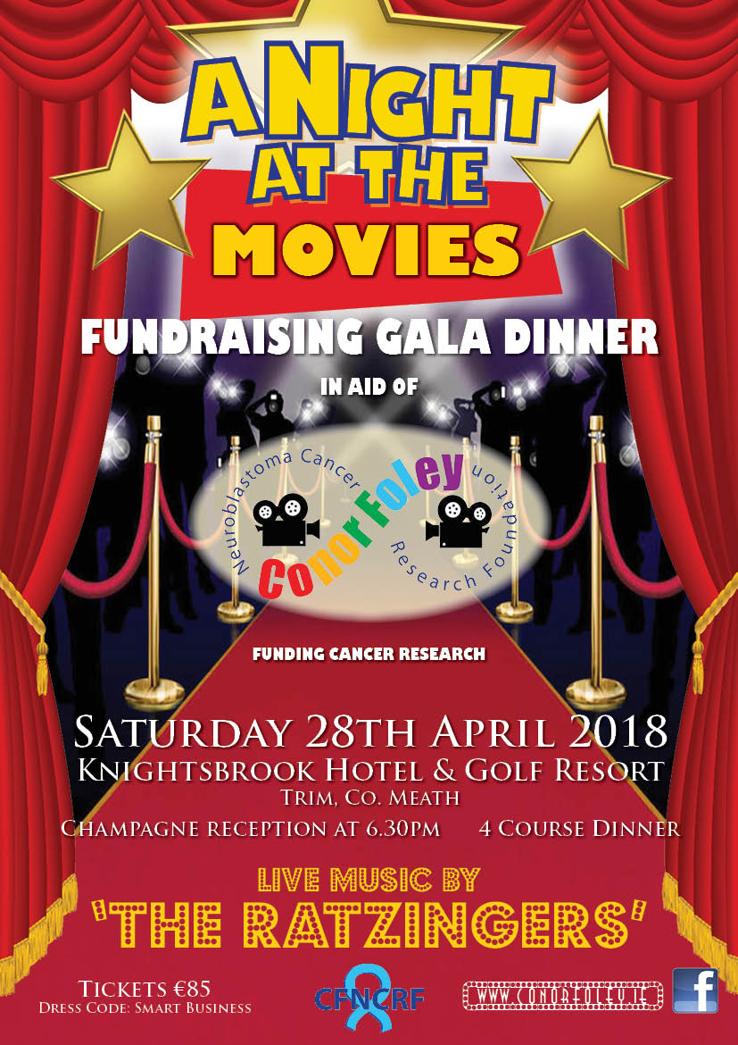

**Searsol Touch Typing Course**

**Age Group**: 8 years +

**Day/Time**:  Mondays, 4.30pm

**Location**: ST MARYS NS, TRIM

**Contact**: Jackie 086-3780842

**Website**:  [www.searsol.com](https://searsol.com/)

A touch-typing course designed to develop the typing skills of children 8 years & upwards in a classroom environment with a qualified tutor. You can join the course any time as your child works at their own pace in a small class environment so each child gets the  individual attention they need.  Free trial first lesson!

***This class is for all children but particularly helpful to kids with learning differences such as Dyslexia, Dyspraxia and Autism.***

|  |
| --- |
| **Information for Class Planning 2018/2019**    In order for the school to have accurate information for forward planning for 2018/2019, please complete and return the following sheet.  This information is not binding, it is for class planning purposes.    Surname:                __________________________  Student/s Name/s:   __________________________  __________________________  __________________________  **will not** be returning to St. Mary’s in September 2018.    Signed:_____________________________________ Parent/Guardian |