***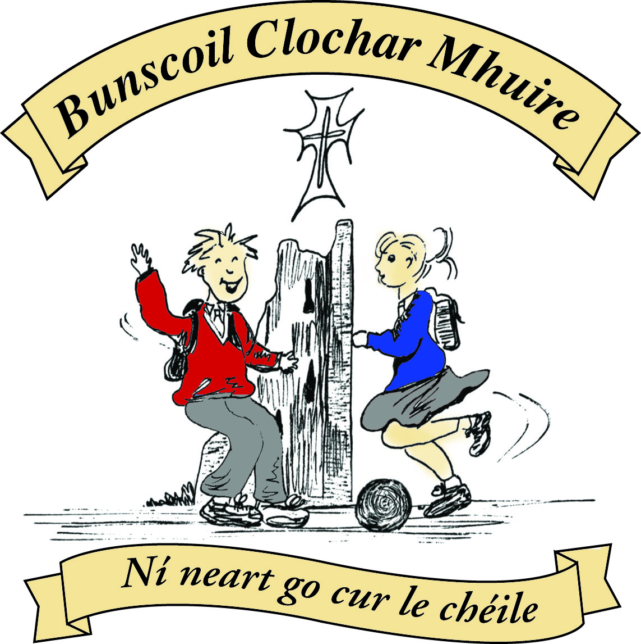* St Mary’s Convent Primary School**

***Bunscoil Clochar Mhuire***

***Trim, Co. Meath.  
Fón: (046) 9431919 ⦁ Faics: (046) 9437942  
Ríomhphost:*** [***marystrim@eircom.net***](mailto:marystrim@eircom.net) ***⦁ Website:*** [***www.stmarystrim.ie***](http://www.stmarystrim.ie) ***Uimhir Rolla: 16646O***

Awarded Green Flag  
June ‘05/’07/11/13

***Imlitir 29***

12th April, 2016

***Every Day Counts at St Mary’s Convent Primary School***

***4th – 8th April, 2016***

|  |  |  |  |  |  |  |  |
| --- | --- | --- | --- | --- | --- | --- | --- |
| **Room** | **Attendance** | **Room** | **Attendance** | **Room** | **Attendance** | **Room** | **Attendance** |
|  |  |  |  |  |  |  |  |
| 01 | 95.6 % | 08 | 91.4% | 16 | 92.6% | 26 | 97% |
| 02 | 93.8% | 09 | 88.1% | 17 | 94% | 27 | 94.3% |
| 03 | 96% | 10 | 97.9% | 18 | 97.9% | 30 | 89.7% |
| 04 | 93.1% | 12 | 96.2% | 19 | 87.5% | 31 | 93.1% |
| 05 | 96.4% | 13 | 93.1% | **20** | **100%** |  |  |
| 06 | 97.1% | 14 | 95.4% | 23 | 94.2% |  |  |
| 07 | 97.8% | 15 | 96% | 24 | 96.7% |  |  |

A Chairde,

Congratulations to Room **20** on having full attendance. Their teacher will let them know this week what their prize is.

The **school closures for next year**, subject to approval by our BOM, are listed below. Please keep in mind when organising vacations. Thanks.

**Skipathon:** please support as best you can, our Parents’ Association fundraiser on Friday next. Only returned cards may take part but they do not have to include sponsorship. Don’t forget!

**Twitter as Gaeilge**: We have set up a school Twitter account ( @bunscoilmhuire ) for communicating in Irish. We have used it to communicate with other schools and welcome use by parents/guardians, as long as it is in the Irish language! Go raibh mile maith agaibh.

**Trócaire Boxes** may be returned through the school or the Parish Office.

Please note the course of dyslexia detailed in the Community Notices below.

Tomorrow is the last day to order a D.V.D of “*Is Cuimhin Linn 1916”* our excellent drama performed on Proclamation Day. €15 can be given to Helen or class teachers.

|  |  |
| --- | --- |
| **School Calendar 2016/2017** | |
| Return: | Wednesday 31st August 2016 |
| Mid-Term: | Monday 31st October - Friday 4th November 2016 |
| Christmas Break: | Friday 23rd December - Friday 6th January 2017 |
| Spring Mid-term Break | Thursday 23rd - Friday 24th February 2017 |
| Mid-term: | Monday 13th - Friday 17th March 2017 |
| Easter Break | Monday 10th April - Friday 21st April 2017 |
| May Bank Holiday: | 1st May 2017 |
| June Bank Holiday: | 5th June 2017 |
| School closes | Friday 30th June 2017 |

**Information for Class Planning 2016/2017**

In order for the school to have accurate information for forward planning for 2016/2017, please complete and return the following sheet. This information is not binding, it is for class planning purposes.

Surname: __________________________

Student/s Name/s: __________________________

__________________________

__________________________

**will not** be returning to St. Mary’s in September 2016.

Signed:_____________________________________ Parent/Guardian

Mise le meas,



Cóilín Ó Coigligh, Príomh Oide.

**Green News**

**Community News**

**Nath na Seachtaine:** **An bhfuil ocras ort? Tá ocras orm/Níl ocras orm**

**Seanfhocal na Míosa: Ní chrónaítear an t-uisce go dtriomaítear an tobar**

**(We don't miss the water until the well runs dry)**

**Dates to Remember**

**Assembly:** Green Flag Friday @ 9.20 for Seniors & 9.40 for Juniors

**Meitheal:** Every Tuesday morning 9.30-10.30.

**Banna Ceoil:** Every Tuesday @ 3pm in the Dr. Eileen Reilly Hall.

**School Choir:** Friday 3.00 – 4.00p.m

**Mini-Rounders:** 3rd & 4th Classes Mondays 3.00-4.00p.m.

- D. Galligan, Teacher

**Rounders:** 5th & 6th Classes Mondays 3.00-4.00p.m.

– Ms Coakley & Mrs Munnelly, Teachers.

Thursdays lunchtime in Dr. Eileen Reilly Hall

**Camogie:** Wednesday 3.00-4.00 p.m. Third – Sixth Classes

**First Communion:** Saturday 28th May @ 11.00 a.m.

**Green News**

April is National Clean-Up Month. We usually take this opportunity to clean up around the school and Church grounds. An Taisce has supplied us with special gloves and lit-picks to ensure proper hygiene. This Clean-up operation helps to highlight the importance of respecting our environs and the damage litter can cause. We live in a delightful heritage town and it is up to us to keep it as beautiful as it can be.

WOW continues on Wednesday. There are now two meeting points: Mornington House and the car park behind the Matchbox. Well done to the pupils and teachers who are keeping this initiative going. The Score on the Door was won last month by Room 30! Well done girls!

COW will resume in May as the weather is still not conducive to cycling.

Recycling continues at school. We accept ink cartridges, batteries, cardboard, toilet rolls, postage stamps, small plastic bottles and footwear.

Global Citizenship is our green theme this year with the specific emphasis on litter and waste management. Our International day will be coming up in a month or so and we will celebrate the different cultures in our school. We are so lucky to have a diverse pupil population. We can learn so much about other cultures.



***Remember Green is cool, at home and at school and around the globe***

**Community Notices**

**Dyslexia Support Courses: Navan Education Centre**

**\*Seminar for Parents- 14th of April 2016 from 6-9 pm**

A parent of a child with dyslexia is keen to unlock the inner potential of the child. Often after a diagnosis the parent is unsure where to turn and how to give the child the extra support which is required for them to progress. The seminar for parents of children with dyslexia will equip the parent with a better knowledge of what dyslexia is and its effects on learning.

◾Parents will be shown how to use proven support strategies, templates and resource materials which will benefit the child.

◾Examples of Assistive technology including Computers, Apps for Tablets / Smartphones will be discussed and their usefulness for the learner with dyslexia will be demonstrated.

◾Parents will be informed of the status of dyslexia in the education system and given knowledge of the various steps to take to ensure your child is receiving the support available.

◾We will look at ways to boost your child’s self-esteem and make them a more confident and successful learner.

◾You will receive a resource pack which will enable you to immediately support your child with the latest research into dyslexia.

Tea and coffee will be provided. The fee per person is €45-booking can be made through PayPal on the website: [www.dyslexiaconsultant.com](http://www.dyslexiaconsultant.com) Facebook: Dyslexia Consultant Kathleen Sweeney Mobile:085 7820221 EMAIL: [kathleen@dyslexiaconsultant.com](mailto:kathleen@dyslexiaconsultant.com)

**ZUMBA**  :-   No experience, partner or booking required -      **SUMMER IS JUST AROUND THE CORNER**:- MONDAY   8pm   Trim GAA,   €8 per class     Contact :  Lorraine  086 8693546

**ZUMBA  KIDS**:-        Ages 5-8   TUESDAY    3.15pm    TRIM GAA    €6 per class  (Sibling rate €5)

Zumba,  Hip-Hop,  Rock 'n Roll,  Jive.............             Contact :  Lorraine  086 8693546 / JoJo  086 3381159

**Starcamp Summer Camp**. For boys and girls aged 4-13 on the 4th – 8th July in Trim GAA. 9.30am – 2.30pm 5 days. Free t-shirt, certificate and surprise. €90 per child, €160 for 2 siblings, €220 for 3 siblings. Book now online at [**www.starcamp.ie**](http://www.starcamp.ie)or pick up leaflet in school office.

**JIGGLE 'N' JUMP** - has moved to the Trim GAA from April 5th. Music and Movement classes will be held in the front room upstairs (Where the parent & toddler group takes place) on a Tuesday at 9.45am and Saturdays at 10.30am. There will also be a new class starting for ASD kids or kids who suffer with anxiety, offering a more routine class where parents can see the progress each week. This will be held on Saturdays at 9.30am. Classes also on Wednesday 10am in Summerhill Community Centre. Please call Julie to enquire or book in!

Jiggle 'n' Jump also provide party entertainment, in your home, the GAA or other venue. Various characters available for Face Painting, Tattoos, Nails, Singing, Dance Routines, fun Bingo, Pass the Parcel and lots of other fun party games! :)

**Carney School of Irish Dancing** Classes in St. Patricks Hall every Tuesday. 2pm – 3pm & 3pm – 4pm. Every Friday @ 5.30pm. Infants and Senior infants can be collected from class rooms @ 2pm and left back to the buses @ 3pm. €5 per pupil per class. Contact Ann Carney 087-6336495