***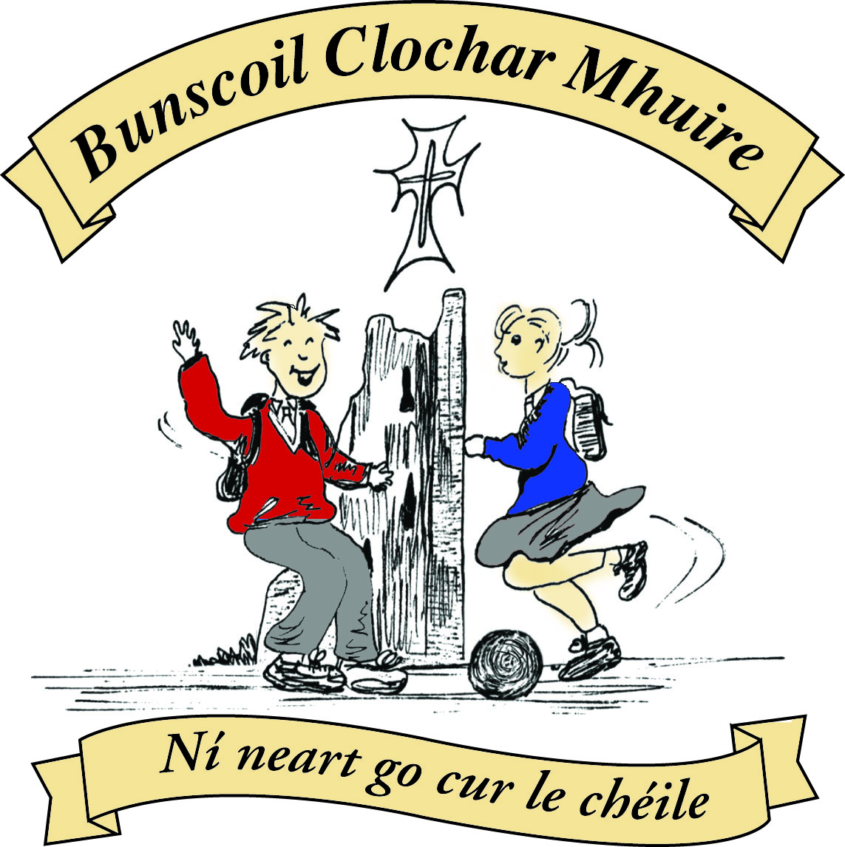* St Mary’s Convent Primary School**

***Bunscoil Clochar Mhuire***

***Trim, Co. Meath.  
Fón: (046) 9431919 ⦁ Faics: (046) 9437942  
Ríomhphost:*** [***marystrim@eircom.net***](mailto:marystrim@eircom.net) ***⦁ Website:*** [***www.stmarystrim.ie***](http://www.stmarystrim.ie) ***Uimhir Rolla: 16646O***

Awarded Green Flag  
June ‘05/’07/11/13

***Imlitir 28***

5th April, 2017

***Every Day Counts at St Mary’s Convent Primary School***

***28th March – 31st March, 2017***

|  |  |  |  |  |  |  |  |
| --- | --- | --- | --- | --- | --- | --- | --- |
| **Room** | **Attendance** | **Room** | **Attendance** | **Room** | **Attendance** | **Room** | **Attendance** |
| 01 | 97.6 % | 08 | 95.2% | 16 | 94.8% | 26 | 96% |
| 02 | 91.2% | 09 | 93.5% | 17 | 90.7% | 27 | 98.3% |
| 03 | 92.2% | 10 | 94.3% | 18 | 97.5% | 30 | 95.4% |
| 04 | 94.1% | 12 | 91.3% | 19 | 92.1% | 31 | 90% |
| 05 | 99.2% | 13 | 95.3% | 20 | 96.4% |  |  |
| 06 | 95.2% | 14 | 93.6% | 23 & 24 | 90% |  |  |
| 07 | 96% | 15 | 97.1% |  |  |  |  |
|  |  |  |  |  |  |  |  |

*Congratulations to Room 5 on nearly having full attendance last week of school. Please note that notification in writing to the teacher is required for all absences. A letter or note in the homework journal will suffice.*

A chairde,

School closes on Friday April 7th @ 12.30 (12.15 Language Classes) for the Easter Holidays. Please make the necessary arrangements. We re-open @ 9.20am on Monday April 24th. I would like to take this opportunity to wish everyone a very Happy Easter.

The School Closures for next year, subject to approval by our Board of Management, are listed below. Please keep in mind when organising vacations. Thanks.

|  |  |
| --- | --- |
| **School Calendar 2017/2018** | |
| Return: | Thursday 31st August 2017 |
| Mid-Term: | Monday 30th October –Friday 3rd Nov 2017 |
| Christmas Break: | Monday 25th Dec 2017 - Friday 5th January 2018 |
| Feb Mid-term Break | Thursday 15th & Friday 16th Feb 2018 |
| St. Patrick’s Day | 19th March 2018 (Monday) |
| Easter Break | Monday 26th March – Friday 6th April 2018 |
| May Bank Holiday: | Week Monday 7th – Friday 11th May 2018 |
| June Bank Holiday: | Monday 4th June 2018 |
| School closes | Friday 29th June 2018 |
|  |  |

***Parents’ Association.*** *The next* ***PA meeting*** *will be held this Friday 7th April at 9.30am in the staff room. All parents/guardians welcome to attend. Caroline Smith*

***Spelling Bee 2017****: Last Thursday morning, forty primary school pupils from all over Co. Meath gathered for the county final in Ratoath. Lucy Clavin (Room 26)  was our representative in the competition and she finished in 3rd place overall. We thank Lucy for her dedicated preparation and we congratulate her on a solid performance in the contest! Mr Galligan*

Finally, a big thank you to all 50 actors who have committed to The OsKars for our school. Tickets are now on sale from them and not through the school, for the moment:

|  |  |  |  |
| --- | --- | --- | --- |
| Derek Allen  Siobhan Allut  Anthony Blair  Laura Cahill  Sarah Canny  Thomas Carmody  Mary Carr  Méabh Coakley  Tony Conlon  Linda Coogan  Kim Cosgrave  Anthony Crinion  Lorraine Cullinane | Ken Davis  Keith Doran  Wayne Duff  Edel Dugdale  Judy Eivers  Jamie Fay  Kylie Fay  Claire Flynn  Sean Fox  Jonathan Fuller  Aisling Heffernan  Neil Heffernan  Anne Hughes | Cormac Joyce  Aidan Joyce  Joanne Kennedy  Dara Kenny  Eoin Kenny  John Leonard  Cormac Madden  Peter Madden  Elaine Maguire  Alan Malone  Sarah Mannix  Rebecca Marmion  Shelagh McKenna | Barbara Mulvihill  Maeve Murray  Siobhan Nally  Sean O'Boyle  Siobhan O'Connor  Julie O'Donoghue  Conor O'Mahony  Seamie Rochford  Denise Watson  Michelle Watson Halo  Michelle Wilson |

Mise le meas,



Cóilín Ó Coigligh, Príomh Oide.

**Green News**

**Community News**

**Nathanna na Seachtaine:** Thit mé sa chlós. Ghortaigh mé mo glúin,/mo cheann /mo lámh

(I fell in the yard. I hurt my knee/my head/my hand)

**Seanfhocal na Míosa:** Tír gan teanga, tír gan anam, Scoil gan Ghaeilge, Scoil gan chroí

**Dates to Remember**

**Assembly:**  Green Flag Friday @ 9.30 Seniors

**Banna Ceoil:** Tuesday 3.00-4.00

**Meitheal:** Every Tuesday morning 9.30-10.30.

**Communion:**  Sat May 13th @ 11.00am

**Football Training:** **THURSDAY THIS WEEK** 3.00 - 4.00 for 3rd – 6th Classes

**Mini-Rounders:** Mondays for 3rd to 6th Classes 3.00 – 4.00pm

**Green News**

April is National Clean up month. It will be a priority for our Green team to clean up the school and church grounds this month. Our town is so beautiful, it is important to keep it clean and tidy. Trim Tidy Towns committee have always been a huge support to us. This is one way we can help those dedicated people to keep our part of Trim tidy.

WOW continues this Wednesday. Meet up at Mornington House or at the Matchbox at 9:00am. The teachers will escort the pupils from there to the school. Míle buíochas to the teachers who keep this initiative going every week.

COW will resume after Easter when the weather is more reliable. Over the next few weeks bicycles can be checked and serviced in advance of COW starting up after the Easter break. April 26th will be our first outing hopefully. Children from Fourth Class up are encouraged to participate. Younger children may join in if they are accompanied by a grown-up. High viz vests and helmets are essential. Cyclists meet up just inside Steeple Manor at 8:55am and the route is along by the river.

Recycling continues at St Marys. Waste Management is part of our Global Citizenship theme this year. It is wonderful to see how vigilant the pupils are about recycling and how much more of a life habit it has become since the start of the Green Flag campaign in St Mary’s. We recycle the following materials: batteries, ink cartridges, small plastic bottles, cans, postage stamps, footwear, card and toilet rolls.

Our Green Pledge is being revised this month:

***We the pupils of this school***

***promise to REDUCE, REUSE, RECYCLE***

***in our Race Against Waste***

***and to keep ‘GREEN COOL’***

***in St Mary’s School.***

***Remember green is cool at home, at school and around the globe!***

**Community Notices**

**Dyslexia Seminar for Parents and Teachers**

Date: Monday 24th April  Time: 6-9pm Booking through:  [www.dyslexiaconsultant.com/](http://www.dyslexiaconsultant.com/) ph: 085 7820221 Facilitator: Kathleen Sweeney MSc. Education and Training, B.A.,Hdip. ED, Hdip. Resource and Learning Support

A parent/teacher of a child with dyslexia is keen to unlock the inner potential of the child. Often after a diagnosis the parent/teacher is unsure where to turn and how to give the child the extra support which is required for them to progress. The seminar for children with dyslexia will equip you with a better knowledge of what dyslexia is and its effects on learning.

**St Marys Primary School Easter Camp** is back again this year with another fun filled week in store! Monday 10th – Thursday 13th April. 10.00am – 2.30pm. €50 per child. Activities: Arts & crafts, sports and games, dance, baking, science and much more. **For a booking form or further information please contact The Office, Ms Carr or Ms Leavy.**

**Starcamp Summer Camp.** Open to ALL boys & girls aged 4-12 of ALL levels and abilities.

9.30 – 2.30 for 5 days.10th – 14th July. Free t-shirt, certificate & surprises. Fully trained, Garda-vetted professional leaders. €90 per child, €160 for 2 siblings, €220 for 3 siblings. Book now at [www.starcamp.ie](http://www.starcamp.ie) or ring 021-4377900

**Easter Eggstravaganza** @ Trim GAA Clubhouse is back again for another year. Monday 10th - Thursday 13th April. Art, Craft, Sports, Science Experiments and lots more. For more information please contact Ms. Maguire Room 12.

**ZUMBA  :-**

MONDAY  &  WEDNESDAY  8pm  TRIM GAA.  No booking, partner or experience required......just grab your water and your smile and get ready to dance your cares away!        €8 per class       Contact  :  Lorraine  [086 8693546](tel:086%208693546)

**ZUMBA KIDS :-**     TUESDAY  3.15pm  TRIM PLEASE  NOTE : FINAL CLASS !!!!!  No booking required,  €6 per class     Contact :  Lorraine [086 8693546](tel:086%208693546)

**Jigsaw Supporting Young People's Mental Health** This is a 60 minute workshop for parents/guardians and other adults interested or concerned about young people's mental health. Where: TFRC2 When 25th April 2017 Time 7pm            Contact Lisa 046 9438850

**Parents Plus Early Years Programme**   6 week course. A practical and positive parenting course promoting confidence, learning and good behaviour in young children aged 1-6 years. Where: TFRC2

Time 10.00am - 12.30pm Commencing 28th April Contact Lisa 046 9438850

Lost and Found.

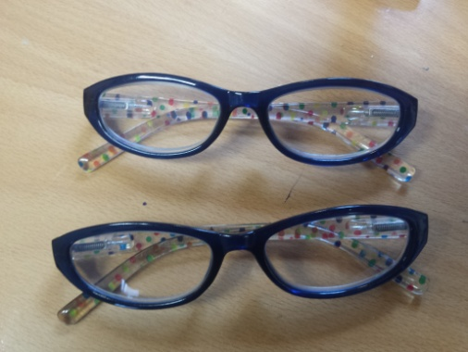

2 pair of glasses in Lost and Found.