***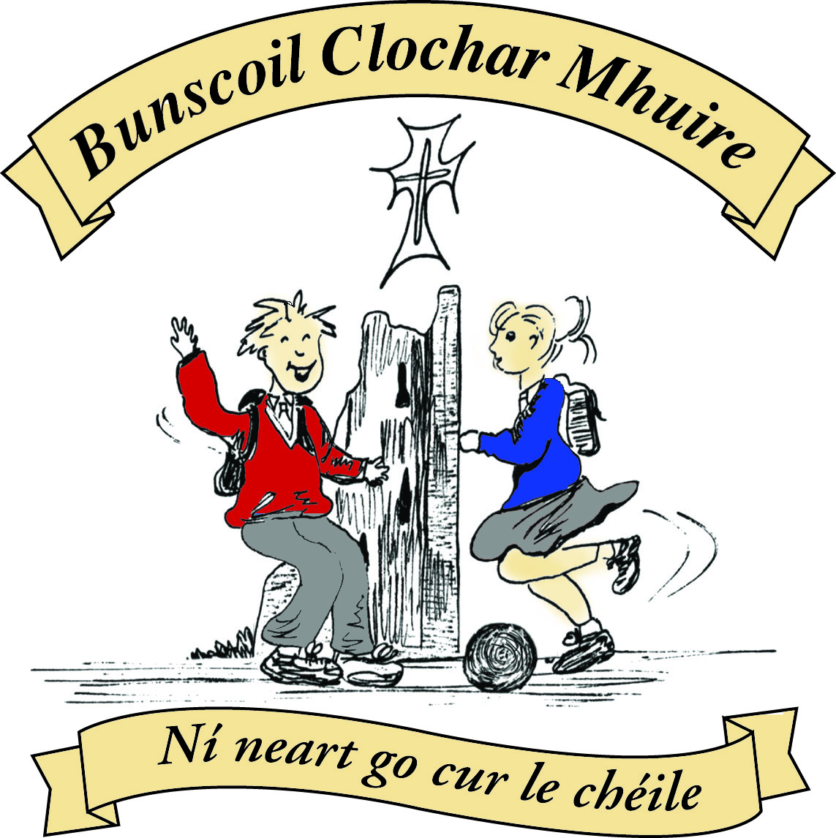* St Mary’s Convent Primary School**

***Bunscoil Clochar Mhuire***

***Trim, Co. Meath.  
Fón: (046) 9431919 ⦁ Faics: (046) 9437942  
Ríomhphost:*** [***marystrim@eircom.net***](mailto:marystrim@eircom.net) ***⦁ Website:*** [***www.stmarystrim.ie***](http://www.stmarystrim.ie) ***Uimhir Rolla: 16646O***

Awarded Green Flag  
June ‘05/’07/11/13

***Imlitir 28***

4th April, 2016

***Every Day Counts at St Mary’s Convent Primary School***

***14th – 16th March 2016***

|  |  |  |  |  |  |  |  |
| --- | --- | --- | --- | --- | --- | --- | --- |
| **Room** | **Attendance** | **Room** | **Attendance** | **Room** | **Attendance** | **Room** | **Attendance** |
|  |  |  |  |  |  |  |  |
| 01 | 90.1 % | 08 | 79.8% | 16 | 92.6% | 26 | 91.4% |
| 02 | 84.6% | 09 | 97.5% | 17 | 83.3% | 27 | 94% |
| 03 | 90.7% | 10 | 91.7% | 18 | 96.4% | 30 | 87.4% |
| 04 | 92.3% | 12 | 88.5% | **19** | **100%** | 31 | 85.1% |
| 05 | 90.5% | 13 | 93.6% | **20** | **100%** |  |  |
| 06 | 96.4% | 14 | 93.6% | 23 | 95.2% |  |  |
| 07 | 93.8% | 15 | 94.7% | **24** | **100%** |  |  |

A Chairde,

Congratulations to Rooms 1**9, 20 & 24** on having full attendance. Their teachers will let them know this week what their prize is.

Our many extra-curricular activities have restarted, please check the days, times and age groups below.

Comhghairdeachais ar an méid Gaeilge a labhair na páistí i Seachtain na Gaeilge. Congrats to all our pupils who really entered into the spirit of *“****Seachtain na Gaeilge*”** before Easter. It was great to hear so much of our native tongue being spoken. Congrats to the winners of our Tráth na gCeist. The standard was very high and the scores were very close but bhuaigh Molly Lanney, Holly Meehan, Martyna Miliuskyte & Jill McInerney an chéad duais. In second place were Sophie Rispin, Cliodhna Vaughan, Jessica Varley & Méabh Tully.

Our **Proclamation Day** was an outstanding success. Our drama in particular really brought home the significance of the occasion. Copies of the dvd (*Is Cuimhin Linn 1916*/We Remember 1916) will be available @ €15 each for those who were unable to attend, as well as for those who would like a souvenir. Please give your names to Helen. I would like to thank Mr Galligan who wrote the drama and all the staff members who assisted in creating such a wonderful memory. The school band and choir added poignancy to the occasion as well as the many costumes and props. Thanks to all the parents and guardians for their efforts. The children deserve great thanks for their efforts with the drama, the Flag Raising and Lowering Ceremonies and the many relevant projects that were on display. *Dia go deo le gach duine!*

*Buíochas freisin* to all the staff and pupils who gave their time during the holidays to participate in the Saint Patrick’s Day Parade: they all looked so well on the telly! Mrs Nally has more details (and a few photos) below.

Over the Easter break the Emergency Works were completed: drainage and special needs access. This means, among other things, that the flooding of our yard will now be a thing of the past.

Enrolments for next year: The end of May has been stipulated by our Board of Management as the cut-off date for new enrolments for Junior Infants. To help free up some places, we would be grateful to families (excepting Sixth Classes and first Class Boys) who know for sure that they will **not** be returning, to let us know in the form below. Thanks.

Please note that school begins at 9.20 and pupils are required to be on time and to line up in the yard not outside the classroom doors. Your co-operation is earnestly requested.

*Morning Lap: Well done to all children who do the lap each morning. Please continue to encourage your children to do it. Exercise before school calms and settles children and studies show they concentrate better after exercise. Also 1 lap a day = 1 kilometre by the end of the week. We’re hoping to increase it to 2 laps so please remind your child and if they don’t make the morning run they can do a lap with friends at break times. Let’s get our kids Active.*

*Ms Carr*

**Information for Class Planning 2016/2017**

In order for the school to have accurate information for forward planning for 2016/2017, please complete and return the following sheet. This information is not binding, it is for class planning purposes.

Surname: __________________________

Student/s Name/s: __________________________

__________________________

__________________________

**will not** be returning to St. Mary’s in September 2016.

Signed:_____________________________________ Parent/Guardian

Mise le meas,



Cóilín Ó Coigligh, Príomh Oide.

**Green News**

**Community News**

**Nath na Seachtaine:** **An bhfuil cead agam dul go dtí an leithreas?/ Leithreas le do thoil.**

**(May I go to the toilet?)**

**Seanfhocal na Míosa: Ní chrónaítear an t-uisce go dtriomaítear an tobar**

**(We don't miss the water until the well runs dry)**

**Dates to Remember**

**Meitheal:** Every Tuesday morning 9.30-10.30.

**Banna Ceoil:** Every Tuesday @ 3pm in the Dr. Eileen Reilly Hall.

**School Choir:** Friday 3.00 – 4.00p.m

**Mini-Rounders:** 3rd & 4th Classes returns Monday 11th April. 3.00-4.00p.m. - D. Galligan, Teacher

**Rounders:** 5th & 6th Classes returns Monday 11th April 3.00-4.00p.m. – M Coakley, Teacher

**Camogie:** Wednesday 3.00-4.00 p.m. Third – Sixth Classes

**First Communion:** Saturday 28th May @ 11.00 a.m.

**Green News**



Welcome back to our final term. We will continue with our Global Citizenship theme (Year 1) and our various green initiatives. Recycling continues at school. We accept batteries, cardboard, toilet rolls, postage stamps, ink cartridges and footwear. Our Siopa Glas which recycled books, toys and other goods raised over €1,000 which is going directly to Sr Claudia’s Flamboyant Special Need’s school in Zambia. Sincere thanks to all those who contributed to this great cause. There are 86 children in Flamboyant Special Needs school. Food is scarce and there is no more support for the school from their Government.

WOW continues every Wednesday and the Score on the Door competition will resume. The Senior girls were making great strides. The March winners will be announced today. WOW meeting points and times are a) At Mornington House at 9:00am b) In the car park behind the Matchbox at 9:00am. The WOW teachers will meet the pupils there and proceed up to the school. Míle buíochas to the teachers who assist with this great green and active initiative every week.

COW (Cycling on Wednesday) will resume when the weather clears up a bit. Perhaps you could dust off your bikes and check the brakes and tyres and get them ready for when COW starts in a few weeks.

Our Global Citizenship banner and representation at the St Patrick’s Day Parade was shown on the RTE news and looked really effective. The county colours and costumes were fantastic. Thank you to all those pupils, parents and teachers who came along that day and represented St Mary’s so well. Below are some pictures from the day and a short video. Ní neart go cur le chéile!



***Remember Green is cool, at home and at school and around the globe***



**Community Notices**

**ZUMBA**  :-   No experience, partner or booking required -     **TIME TO DANCE OFF ALL THE EASTER EGGS**:-

MONDAY   8pm   Trim GAA,  €8 per class     Contact :  Lorraine  086 8693546

**ZUMBA  KIDS**:-  **NO CLASS THIS WEEK  -  CLASS STARTS BACK TUESDAY 12th APRIL**

**Knightsbrook Ladies Golf Club** are starting beginner’s lessons this Wednesday 6th April & Friday 8th from 6.00pm. 4 sessions available. Ring our Pro-Shop on 046-9482102 to book in your place. Give it a try. Get into Golf.

**Starcamp Summer Camp**. For boys and girls aged 4-13 on the 4th – 8th July in Trim GAA. 9.30am – 2.30pm 5 days. Free t-shirt, certificate and surprise. €90 per child, €160 for 2 siblings, €220 for 3 siblings. Book now online at [**www.starcamp.ie**](http://www.starcamp.ie)or pick up leaflet in school office.

**JIGGLE 'N' JUMP** - Classes running in the Oaktree Business Park and moving to the GAA after Easter

Running Tuesday's 9.50am and Saturdays [10am](x-apple-data-detectors://2)  €7 to pay as you go or €25 for 4 Classes.

Also fun Characters available for Parties & Events to Face Paint, play Party Games, Singing, Dancing, Prizes and lots of fun! Call Julie : [086 8505310](tel:086%208505310)

**Carney School of Irish Dancing** Classes in St. Patricks Hall every Tuesday. 2pm – 3pm & 3pm – 4pm. Every Friday @ 5.30pm. Infants and Senior infants can be collected from class rooms @ 2pm and left back to the buses @ 3pm. €5 per pupil per class. Contact Ann Carney 087-6336495