***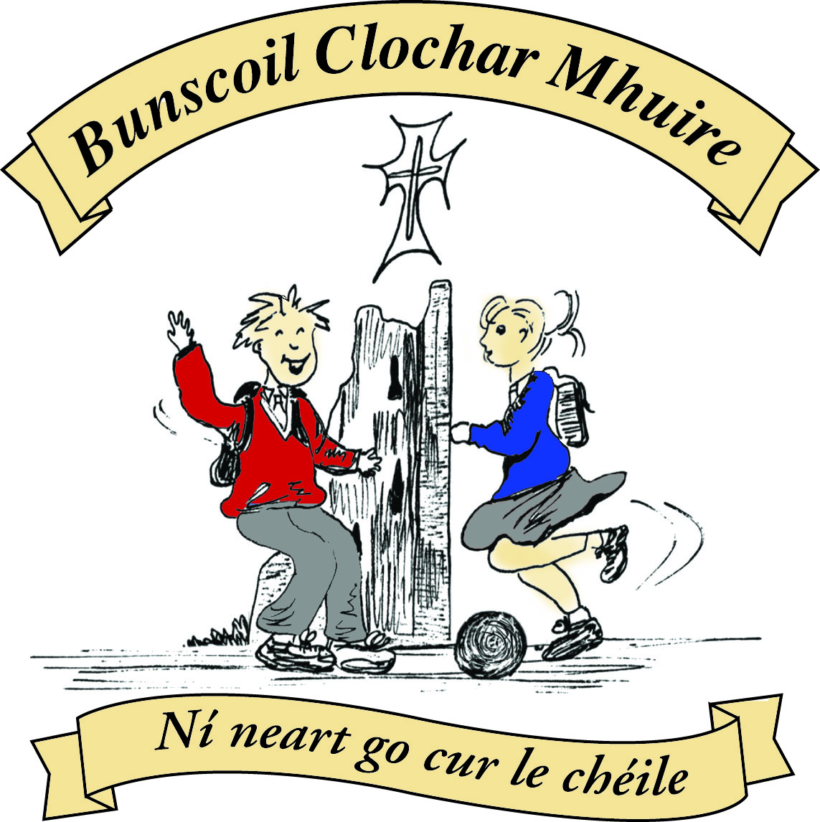* St Mary’s Convent Primary School**

***Bunscoil Clochar Mhuire***

***Trim, Co. Meath.  
Fón: (046) 9431919 ⦁ Faics: (046) 9437942  
Ríomhphost:*** [***marystrim@eircom.net***](mailto:marystrim@eircom.net) ***⦁ Website:*** [***www.stmarystrim.ie***](http://www.stmarystrim.ie) ***Uimhir Rolla: 16646O***

Awarded Green Flag  
June ‘05/’07/11/13

***Imlitir 27***

27th March, 2017

***Every Day Counts at St Mary’s Convent Primary School***

***20th March – 24th March, 2017***

|  |  |  |  |  |  |  |  |
| --- | --- | --- | --- | --- | --- | --- | --- |
| **Room** | **Attendance** | **Room** | **Attendance** | **Room** | **Attendance** | **Room** | **Attendance** |
| 01 | 96.8 % | 08 | 98% | 16 | 96.3% | 26 | 94.4% |
| 02 | 96% | 09 | 94.2% | 17 | 90.7% | 27 | 89.2% |
| 03 | 99.1% | 10 | 99.3% | 18 | 93.3% | 30 | 96.9% |
| 04 | 95.6% | 12 | 98% | 19 | 93.6% | 31 | 97.1% |
| 05 | 94.6% | 13 | 99.3% | 20 | 98.6% |  |  |
| 06 | 94.4% | 14 | 92.9% | 23 & 24 | 94.2% |  |  |
| 07 | 96.8% | 15 | 98.6% |  |  |  |  |
|  |  |  |  |  |  |  |  |

*Congratulations to Rooms 3,10 and 13 on nearly having full attendance last week of school. Please note that notification in writing to the teacher is required for all absences. A letter or note in the homework journal will suffice.*

A chairde,

We have received correspondence from Meath County Council regarding illegal parking at school times in the vicinity of **The Ambulance Centre.** In the interest of public safety, parents/guardians are requested to desist from parking illegally in this area. Meath County Council have asked the traffic warden to monitor the situation and fines may issue.

**Don't Be mean Behind Your Screen Workshops** will be held on Thursday next 9.30-11.45 for Fourth Classes and 1.00-3.00 for Fifth Classes.

**First Penance:** Best wishes to our Second Class pupils who make their First Confession on Wednesday @ 7.00 in St Patrick's Church. Thanks to teachers Mrs Roche and Mrs Mc Gale who prepared them so well and to Ms Patricia and Fr Declan for all their help. All sacraments are celebrations so I hope that the occasion will be celebrated appropriately.

*A big congratulations to all the musicians from the* ***Banna Ceoil*** *who turned up on Saturday to play at the Ceolathon in Navan Shopping Centre. It was a beautiful day full of sunshine and it was difficult to be indoors. But the girls really did the school proud ! There were many positive comments from shoppers , parents and especially the teachers from the Trim Comhaltas branch who were really amazed at the high standard of so many very young musicians. The girls looked well in their school uniform and their behavior was of course excellent. Maith sibh go léir !! The Ceolathon was to promote and fundraise for the Fleadh na Mí which is being held in Trim this year from 19th - 21st May. We will keep you updated with more details as they are finalised. Watch this space !! Ms McGale*

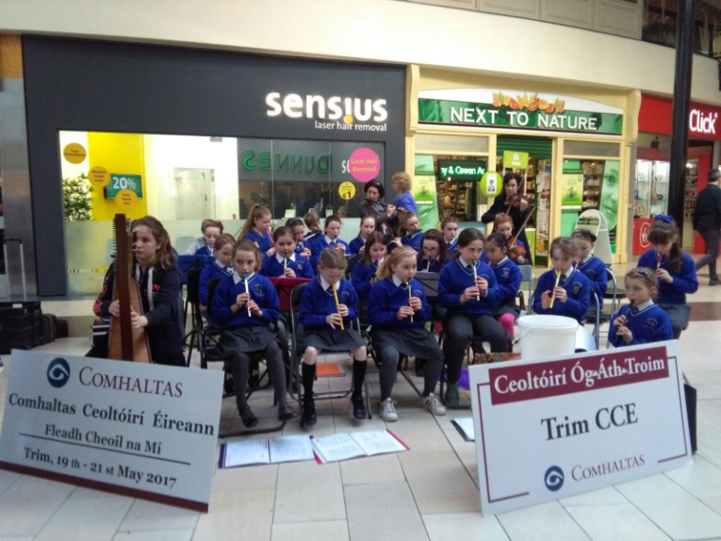

St Mary's Banna Ceoil doing the school proud @ Ceolathon na Mí in Navan Shopping Centre Saturday 25th March

***Spelling Bee County Final****: Best wishes to Lucy Clavin (5th Class) who will represent St Mary’s at the county final of the National Spelling Bee in Ratoath this Thursday (March 30th). The competition begins at 11am and primary schools from all parts of Co. Meath will be represented. The winner will go on to represent Leinster in the next stage of the contest. D Galligan*

***Do This in Memory Meeting****: The next Do This in Memory Committee meeting is on tonight @7.00pm in the Parish Centre. All parents welcome to attend. Fr Declan*

Mise le meas,



Cóilín Ó Coigligh, Príomh Oide.

**Green News**

**Community News**

**Nathanna na Seachtaine: Tá brón orm**

**Seanfhocal na Míosa:** Ní neart go cur le chéile

**Dates to Remember**

**Assembly:** Anti-Bullying 6th Class @ 9.20

**Banna Ceoil:** Tuesday 3.00-4.00

**Meitheal:** Every Tuesday morning 9.30-10.30.

**First Confession:** Wed 29th March @ 7pm

**Communion:**  Sat May 13th @ 11.00am

**Football Training:** **Wednesday 3.00 - 4.00 for 3rd – 6th Classes**

**Mini-Rounders: Starting Monday 27th for 3rd & 4th Classes 3.00 – 4.00pm**

**Starting Monday 27th for 5th & 6th Classes 3.00 – 4.00pm**

**Green News**

What wonderful weather for the outdoors! It was great to see so many people walking to school this morning!

WOW will continue on Wednesday! Meet up at Mornington House or at The Matchbox at 9:00 am. COW will resume after the Easter break when the good weather may be more consistent.

April will be clean up month. Some classes will be cleaning up the school and church environs. We thank them for their good work in advance.

Last week the Meath County Council Environmental Officer met with our Green Flag Committee and represented the school very well. They were so eloquent on their green matters and seemed so passionate about their roles. They explained to her all the ways we have been working on Global Citizenship. The Environmental Officer was very impressed. Hopefully she will nominate us for a Green Flag. We will hear very soon.

***Remember green is cool at home, at school and around the globe!***

**Community Notices**

**St Marys Primary School Easter Camp** is back again this year with another fun filled week in store! Monday 10th – Thursday 13th April. 10.00am – 2.30pm. €50 per child. Activities: Arts & crafts, sports and games, dance, baking, science and much more. **For a booking form or further information please contact The Office, Ms Carr or Ms Leavy.**

**Easter Eggstravaganza** @ Trim GAA Clubhouse is back again for another year. Monday 10th - Thursday 13th April. Art, Craft, Sports, Science Experiments and lots more. For more information please contact Ms. Maguire Room 12.

**ZUMBA  :-** MONDAY  &  WEDNESDAY  8pm  TRIM GAA.

No booking, partner or experience required......just grab your water and your smile and get ready to dance your cares away!        €8 per class       Contact  :  Lorraine  086 8693546

**ZUMBA KIDS** :-     TUESDAY  3.15pm  TRIM GAA No booking required,  €6 per class     Contact :  Lorraine 086 8693546

**Trim Camogie Club** training for all girls from u8 to u12 very Monday evening from 6-7. New members welcome.  Contact Caroline on 0868197647 or email [trim.meath@camogie.ie](mailto:trim.meath@camogie.ie)

