***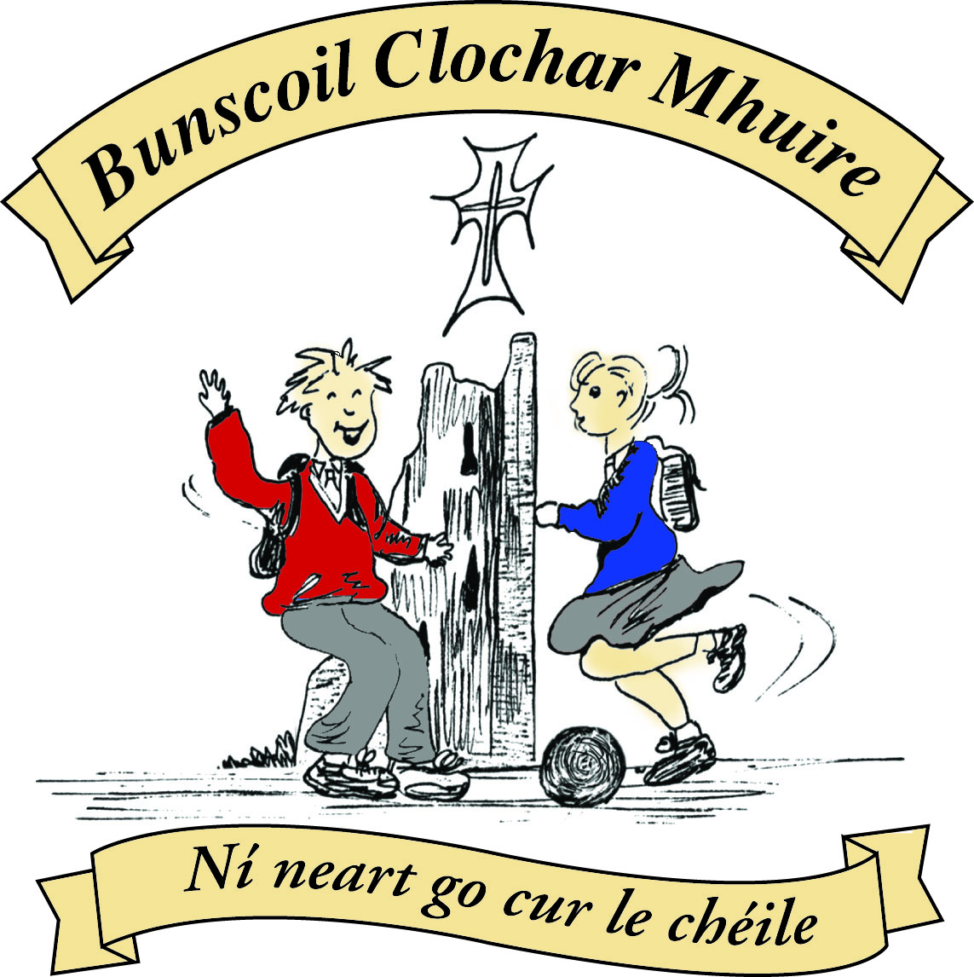* St Mary’s Convent Primary School**

***Bunscoil Clochar Mhuire***

***Trim, Co. Meath.  
Fón: (046) 9431919 ⦁ Faics: (046) 9437942  
Ríomhphost:*** [***marystrim@eircom.net***](mailto:marystrim@eircom.net) ***⦁ Website:*** [***www.stmarystrim.ie***](http://www.stmarystrim.ie) ***Uimhir Rolla: 16646O***

Awarded Green Flag  
June ‘05/’07/11/13

***Imlitir 26***

7th March, 2016

***Every Day Counts at St Mary’s Convent Primary School***

***29th Feb - 4th March 2016***

|  |  |  |  |  |  |  |  |
| --- | --- | --- | --- | --- | --- | --- | --- |
| **Room** | **Attendance** | **Room** | **Attendance** | **Room** | **Attendance** | **Room** | **Attendance** |
| 01 | 87.4% | 08 | 94.3% | 16 | 96.3% | 26 | 93.3% |
| 02 | 91.5% | **09** | **100%** | 17 | 94% | 27 | 97.9% |
| 03 | 96% | 10 | 89.3% | 18 | 91.4% | 30 | 89% |
| 04 | 90% | 12 | 93.1% | 19 | 99.2% | 31 | 86.2% |
| 05 | 93.6% | 13 | 93.1% | 20 | 89.2% |  |  |
| 06 | 94.3% | 14 | 94.6% | 23 | 97.1% |  |  |
| 07 | 95.6% | 15 | 90.4% | **24** | **100%** |  |  |

A Chairde,

Congratulations to Rooms **9 & 24** on having full attendance last week. Their teachers will let them know this week what their prize is.

**Easter Holidays:** This year, due to Easter being so close to St Patricks Day, our holidays begin @ 12.30 on Wednesday March 16th. See School Calendar. Spare copies of our calendar are available from the office or our Sponsors Ted Murtagh’s, Haggard Street.

*Seo* ***Seachtain na Gaeilge*** and we are encouraging our pupils to speak a little Irish this week. If you have some Irish we would encourage you to use this opportunity to practise, even if only to say ‘hello’ ‘*Dia dhuit’* and ‘goodbye’ ‘*slán*’ or ‘please’ ‘*más é do thoil é’* and ‘thank you’ ‘*go raibh maith agat’*.

We have a few events planned for the week that might interest you. Today, pupils in the older classes will be reading in Irish to pupils in the younger classes. Tomorrow @ 9.30 there will be *Tráth na gCeist* (Table Quiz) in the Dr Eileen Reilly Hall @ 9.30, for Third to Sixth Classes inclusive. *Ranganna Trí*(Third Classes) will be doing *an* ***Tionóil***(the assembly) on Thursday morning @ 9.30. On Wednesday Morning we will have our *Siopa Glass*-see more details below. We also have a *Céili* on Thursday and *Puc Fada* as well as a walk (*Siúlóid*) on Friday.

***Maidin Caife:*** Parents/guardians who are available are invited to have a cup of coffee in the staffroom on Thursday after the 9.30 *Tionóil* (Assembly) and to chat to each other *as Gaeilge.* (in Irish) It will be an informal occasion and whatever you feel that your standard in Irish is will be fine and if you need to use English words mixed in, that will be fine too! *Fáilte roimh chách-*All welcome.

**Proclamation Day-Tuesday 15th of March:** This day has been set aside nationally to commemorate 1916. We will have a special flag raising ceremony in the morning and a very special drama @ 1.00 in the afternoon. We will also have some ancestry projects and other pupil work on display. More exact details will be sent by email on Thursday after we finalise times etc at Wednesday’s Staff Meeting.

**First Confession:** Congratulations to the Second Classes who made their First Confession on Wednesday last. Thanks to their teachers Mrs McGale and Mrs Roche for their excellent preparation. Thanks also to Fr Declan and Fr Sean who presided over a very meaningful Ceremony.

**Internet Safety:** Parents/Guardians are advised to supervise your child’s internet use and do not allow usage during late evening and during the night.  Please note that children under the age of thirteen may not use Facebook. Please talk to your child about appropriate internet use and if you have any serious concerns, contact your local Garda station.

***Daffodil Day*** *is this Friday, March 11. This year we are offering a host of handcrafted knitted and crocheted daffodils to be purchased by the children for €2 each during the week. They come as bobbins, clips and brooches. They were created by a group of local ladies who do great work for the cause of Cancer Research. Please support if you can.*

*Ms. Nally*

***Super Troopers Homework****. Just a reminder that I will be going around with certificates to every child who has completed their Be Active homework next week, before the Easter holidays. Thank you.*

*Ms. Murray*

Mise le meas,



Cóilín Ó Coigligh, Príomh Oide.

**Green News**

**Community News**

**Nath na Seachtaine:** Cad í an Ghaeilge ar __________? nó Is maith liom an Ghaeilge

(What is the Irish for____________? or I like Irish)

**Seanfhocal na Míosa**: **Ní neart go cur le chéile!**

**Dates to Remember**

**Assembly: “An*****Tionóil”***Third ClassesAssembly on Thursday @ 9.30 All Welcome

**Meitheal:** Every Tuesday morning 9.30-10.30.

**Banna Ceoil:** Every Tuesday @ 3pm.

**First Communion:** Saturday 28th May @ 11.00 a.m.

**Siopa Glass:**  Wednesday 9th March

**Green News**

Seo í Seachtain na Gaeilge! Our annual Siopa Glas is happening on Wednesday. There is still time to send in items for it. The children will be given a chance to make their purchases on Wednesday morning and the proceeds will go directly to Sr Claudia’s Flamboyant Special Needs School in Zambia. Thank you in advance for your support.

Our St Patrick’s Day Parade group have met up and rehearsed their song. Thank you to all the children who have signed up to take part. We would encourage everyone to come out and cheer us along as we represent St Mary’s and Global Citizenship at the parade.

Please continue to recycle at school and at home.

***Remember Green is cool, at home, at school and around the globe!***

**Community Notices**

**Easter Activity Camp** in St Mary’s School. Dates: 21st Mar – 24th Mar (Mon-Thur) 10am – 2.30pm. Cost: €50 per child. Creative Easter themed arts & crafts activities. Wide variety of games & Sports. Baking tasty treats to eat and take home. Easter egg hunt.

Contact Ms Leavy (Rm 19) or the office 046-9431919/086-3536837

**ZUMBA**  :-   No experience, partner or booking required -  2 classes to choose from:-

MONDAY   8pm   Trim GAA, THURSDAY  8pm  Dance Force Academy €8 per class     Contact :  Lorraine  086 8693546

**KIDS DANCE CLASS** :-        Ages 5-8          TUESDAY    3.15pm    TRIM GAA

 €6 per class  (Sibling rate €5) Zumba,  Hip-Hop,  Rock 'n Roll,  Jive...    Contact :  Lorraine  086 8693546 / Jo  086 3381159

**PUPPET MAKING WORKSHOP** - Fancy doing something creative over the Easter break. Why not come along to a puppet making workshop on Monday 21st March. Learn how to make your own puppets and build your own puppet stage too.

Session A: 11.00am - 1.30pm (Ages 6 - 8)

Session B: 2.00pm - 4.30pm  (Ages 9 - 12)

All materials and a puppet show is included in the workshop price of €20

To book a place contact Carmel - [limelighttheatrics@gmail.com](mailto:limelighttheatrics@gmail.com) / 0863923334l

**JIGGLE 'N' JUMP** - Classes running in the Oaktree Business Park and moving to the GAA after Easter

Running Tuesday's 9.50am and Saturdays [10am](x-apple-data-detectors://2)  €7 to pay as you go or €25 for 4 Classes.

Also fun Characters available for Parties & Events to Face Paint, play Party Games, Singing, Dancing, Prizes and lots of fun! Call Julie : [086 8505310](tel:086%208505310)