***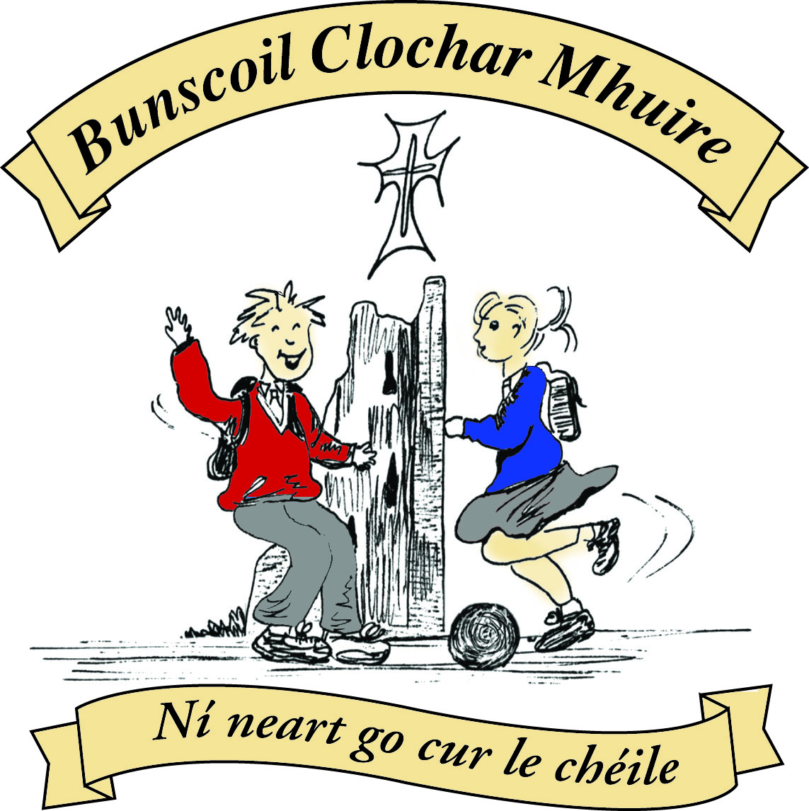* St Mary’s Convent Primary School**

***Bunscoil Clochar Mhuire***

***Trim, Co. Meath.  
Fón: (046) 9431919 ⦁ Faics: (046) 9437942  
Ríomhphost:*** [***marystrim@eircom.net***](mailto:marystrim@eircom.net) ***⦁ Website:*** [***www.stmarystrim.ie***](http://www.stmarystrim.ie) ***Uimhir Rolla: 16646O***

Awarded Green Flag  
June ‘05/’07/11/13

***Imlitir 26***

20th March, 2017

***Every Day Counts at St Mary’s Convent Primary School***

***6th March – 10th March, 2017***

|  |  |  |  |  |  |  |  |
| --- | --- | --- | --- | --- | --- | --- | --- |
| **Room** | **Attendance** | **Room** | **Attendance** | **Room** | **Attendance** | **Room** | **Attendance** |
| 01 | 97.6 % | 08 | 92.8% | 16 | 90.4% | 26 | 99.2% |
| 02 | 93.6% | 09 | 92.9% | 17 | 93.8% | 27 | 95% |
| 03 | 97.4% | 10 | 97.9% | 18 | 98.3% | 30 | 98.5% |
| 04 | 97% | 12 | 98.6% | 19 | 93.6% | **31** | **100%** |
| 05 | 96.2% | 13 | 96% | 20 | 95% |  |  |
| 06 | 98.4% | 14 | 92.9% | **23 & 24** | **100%** |  |  |
| 07 | 94.4 % | 15 | 97.1% |  |  |  |  |
|  |  |  |  |  |  |  |  |

*Congratulations to Rooms 23, 24 & 31 on having full attendance the last week of school. Their teachers will let them know their reward. Please note that notification in writing to the teacher is required for all absences. A letter or note in the homework journal will suffice.*

A chairde,

Congratulations to all the girls in Sixth Class who made their **Confirmation** on Saturday 11th . It was a lovely ceremony and we hope that the Holy Spirit will make a difference in their lives. Thanks to Mr Galligan and Ms Lynch for all their great preparations, to Mrs Mc Gale who helped with the music and of course to Bishop Smith for presiding over the ceremony.

May I draw your attention to a one hour presentation on Mental Health Awareness for parents/guardians on Thursday April 25th in Navan Education Centre. More details under Community Notices below.

Please note that pupils who are late to school need to come in the front door and sign the Late Book. This is also for security reasons, as their class may be on a field trip, at PE etc. We can make the necessary arrangements from the office.

For P.E. pupils are required to wear sports runners that give proper support rather than fashion runners.

Paula O Connor has been re-scheduled to talk to our Fourth and Fifth Classes about internet safety and safe use of social media on Thursday March 30th. The cost will be covered by our Board of Management. This has been an annual event for the past few years for our Sixth Classes but we have been advised that we need to do it with younger pupils also as the age profile has dropped significantly. Next year it will be from Third to Sixth Classes and the cost will be included on the booklists.

The school are looking for CD players, if anyone has old ones at home that they are no longer using.

**Health and Safety**: Please note that it is school policy to inform parents/guardians if we are aware that your child gets a bump on the head. You will be asked to come in and examine the bump and to then decide to bring your child home or leave him/her in school. Please understand that we have to err on the side of caution.

We have a large amount of clothes in **Lost & Found** at the moment. Please check for any missing items by Friday 24th March. All unclaimed items will be donated to charity.

***Parents’ Association.*** *The next* ***PA meeting*** *will be held tomorrow Tuesday 21st March at 7.30pm in the staff room. All parents/guardians welcome to attend.*

*Caroline Smith*

***Confirmation DVD****: This year’s Confirmation DVD will be available shortly for €15. All orders, with money, will be accepted until Wednesday, March 22nd.*

*Mr Galligan*

***Meath Primary Schools’ Cross Country Event***

*Congratulations to the forty two students from First to Sixth Class that participated in the Meath Primary Schools’ Cross Country Event in Navan Racecourse on Friday, March 10th 2017. The pupils represented the school very well, running in damp and muddy conditions.  We were delighted to bring a boys and girls team from First Class  and a Second class girls team with us for the first time this year.  They really enjoyed the experience and did St Mary's proud. We had a very successful day at the races with our Fourth class team securing second place overall in their age group and our Sixth Class team coming third in their age category. Congratulations to Sarah Caulfield, Fifth Class, who came third place in her race.*

*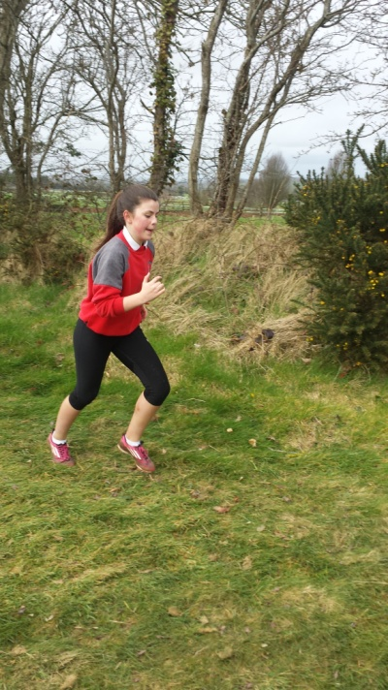Many thanks to Ms Coakley and Ms Cullinane for all their help and support on the day.*

*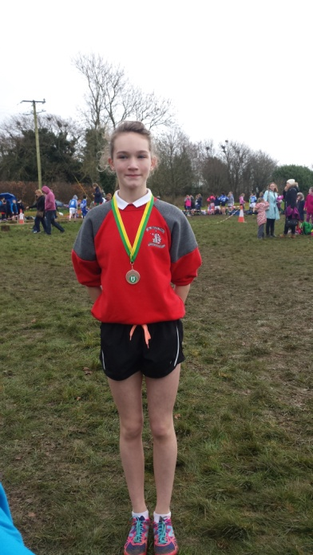 Mrs O’Hare*





Mise le meas,



Cóilín Ó Coigligh, Príomh Oide.

**Green News**

**Community News**

**Nathanna na Seachtaine: Tá an ghrian ag taitneamh**

**Seanfhocal na Míosa:** Ní neart go cur le chéile

**Dates to Remember**

**Assembly: Friday 9.20 Green Flag for Seniors**

**Banna Ceoil:** Tuesday 3.00-4.00

**Meitheal:** Every Tuesday morning 9.30-10.30.

**First Confession:** Wed 29th March @ 7pm

**Communion:**  Sat May 13th @ 11.00am

**Football Training:** **Thursday this week 3.00 - 4.00 for 3rd – 6th Classes**

**Mini-Rounders: Starting Monday 27th for 3rd & 4th Classes 3.00 – 4.00pm**

**Starting Monday 27th for 4th & 5th Classes 3.00 – 4.00pm**

**Green News**

We hope that you all had a very nice week off. Unfortunately the weather had deteriorated by the time St Patrick’s Day came around so the girls and teachers didn’t have a chance to walk in the St Patrick’s Day parade to proclaim their green message of **Global Citizenship**. They had a lovely song ready and a series of green chants but never got to perform them. They will, however, give a rendition of their songs and chants at the Green Flag assembly on Friday.

Mr Madden’s Fourth Class recently completed a lovely project to help children in the developing world. It was called Mary’s meals. See the photos below.

WOW continues on Wednesday. Now that the weather has improved perhaps more children will start to walk to school. The WOW teachers will meet pupils at the Matchbox or Mornington House at 9 am and escort them to the school from there.

Recycling continues in St Mary’s. We accept batteries, small plastic bottles, ink cartridges, card, toilet rolls, cans, postage stamps and mobile phones.

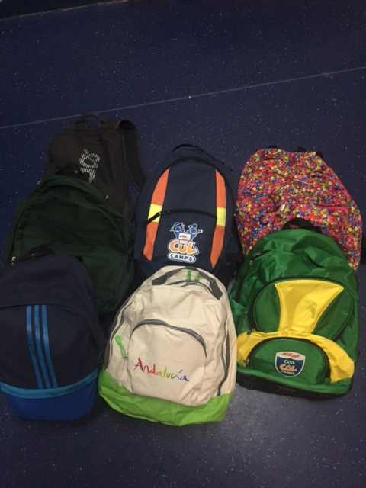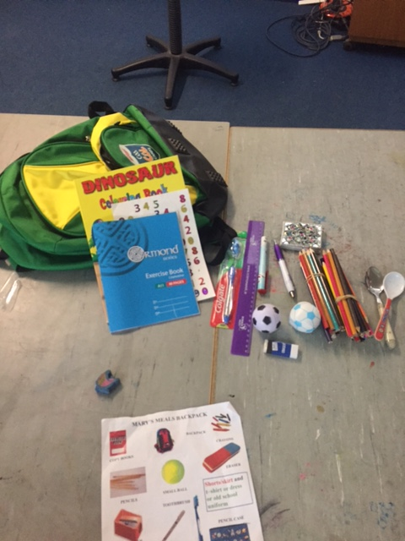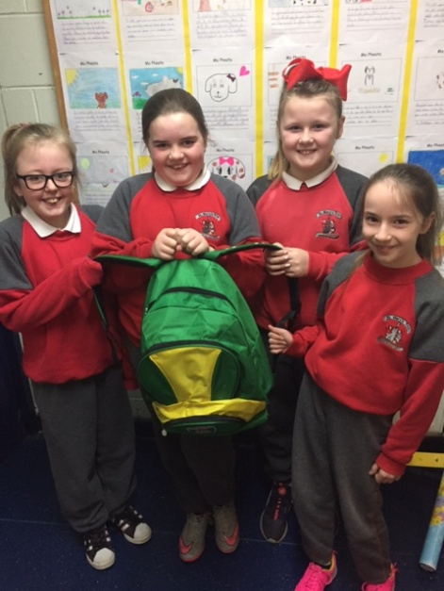

***Remember green is cool at home, at school and around the globe!***

**Community Notices**

**Limelight Theatrics** senior students will take to the stage this Friday 24th March. A Little Box Of Oblivion by Stephen Bean will be held in Brogans Bar, Bakers Loft.  A One Act play directed by Carmel McKiernan,  a play full of absurdity and hilarity. All for a great cause, The Joan Fagan Memorial Trust in aid of St  Francis Hospice. Tickets are €15 and are sold at the door on the night or contact 0863923334. Doors open at 7.30pm

**St Marys Primary School Easter Camp** is back again this year with another fun filled week in store! Monday 10th – Thursday 13th April. 10.00am – 2.30pm. €50 per child. Activities: Arts & crafts, sports and games, dance, baking, science and much more. **For a booking form or further information please contact The Office, Ms Carr or Ms Leavy.**

**Easter Eggstravaganza** @ Trim GAA Clubhouse is back again for another year. Monday 10th - Thursday 13th April. Art, Craft, Sports, Science Experiments and lots more. For more information please contact Ms. Maguire Room 12.

**Go Bounce bouncy castle hire**. Based in Trim, fully insured and safety certified. Check out our Facebook page [www.Facebook.com/gobouncemeath](http://www.facebook.com/gobouncemeath), website [www.gobounce.ie](http://www.gobounce.ie/), contact us on 086-8398099 or email [enquiries@gobounce.ie](mailto:enquiries@gobounce.is) Dates in May are filling up so don't delay, get your booking in sooner rather than later.

**ZUMBA  :-**    MONDAY  &  WEDNESDAY  8pm  TRIM GAA. No booking, partner or experience required......just grab your water and your smile and get ready to dance your cares (and Christmas treats !!) away!        €8 per class       Contact  :  Lorraine  086 8693546

**ZUMBA KIDS :-**   Tuesday  3.15pm  Trim GAA No booking required,  €6 per class      Contact : Lorraine  086 8693546

