***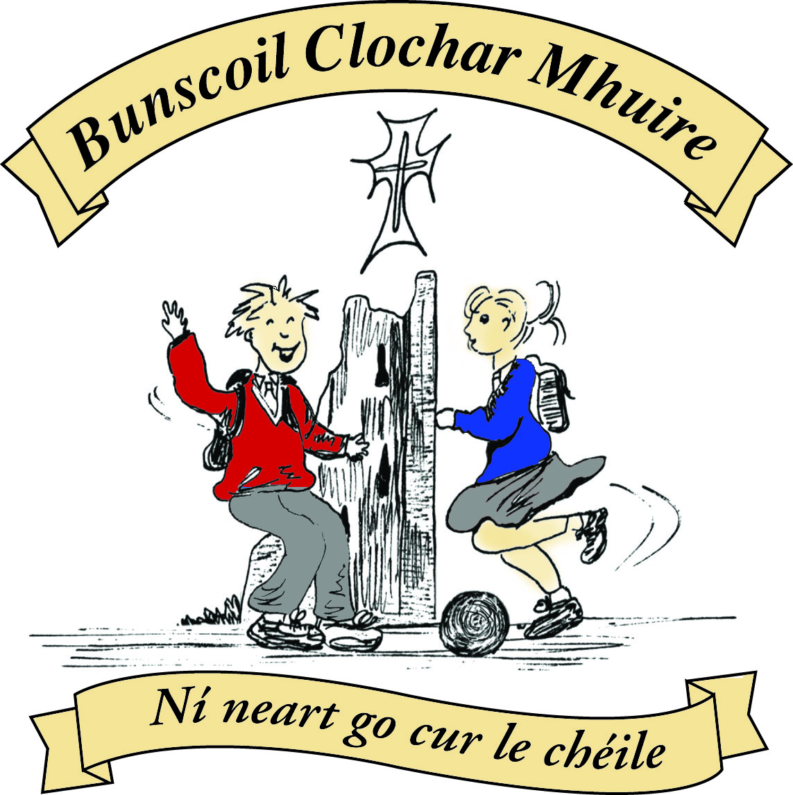* St Mary’s Convent Primary School**

***Bunscoil Clochar Mhuire***

***Trim, Co. Meath.  
Fón: (046) 9431919 ⦁ Faics: (046) 9437942  
Ríomhphost:*** [***marystrim@eircom.net***](mailto:marystrim@eircom.net) ***⦁ Website:*** [***www.stmarystrim.ie***](http://www.stmarystrim.ie) ***Uimhir Rolla: 16646O***

Awarded Green Flag  
June ‘05/’07/11/13

***Imlitir 25***

6th March, 2017

***Every Day Counts at St Mary’s Convent Primary School***

***27th February – 3rd March, 2017***

|  |  |  |  |  |  |  |  |
| --- | --- | --- | --- | --- | --- | --- | --- |
| **Room** | **Attendance** | **Room** | **Attendance** | **Room** | **Attendance** | **Room** | **Attendance** |
| 01 | 97.6 % | 08 | 95.2% | 16 | 97% | 26 | 99.2% |
| 02 | 88.8% | 09 | 94.2% | 17 | 93.8 % | 27 | 95% |
| 03 | 94.8% | 10 | 94.8% | 18 | 99.2% | 30 | 96.2% |
| 04 | 95.6% | 12 | 99.3 % | 19 | 95.7% | 31 | 95.7% |
| 05 | 96.2% | 13 | 96.7% | 20 | 92.9% |  |  |
| 06 | 97.6% | 14 | 96.4% | 23 & 24 | 90 % |  |  |
| 07 | 96.8 % | 15 | 95.7% |  |  |  |  |
|  |  |  |  |  |  |  |  |

*Well done to Rooms 12, 18 and 26 on nearly having full attendance last week. Please note that notification in writing to the teacher is required for all absences. A letter or note in the homework journal will suffice.*

A chairde,

*Seo* ***Seachtain na Gaeilge*** and we are encouraging our pupils to speak a little Irish this week. If you have some Irish we would encourage you to use this opportunity to practise, even if only to say ‘hello’ ‘*Dia dhuit’* and ‘goodbye’ ‘*slán*’ or ‘please’ ‘*más é do thoil é’* and ‘thank you’ ‘*go raibh maith agat’*.

We have a few events planned for the week that might interest you. Today, pupils in the older classes will be reading in Irish to pupils in the younger classes. Tomorrow @ 1.30 there will be *Tráth na gCeist* (Table Quiz) in the Dr Eileen Reilly Hall, for Third to Sixth Classes inclusive. *Ranganna Trí*(Third Classes) will be doing *an* ***Tionóil***(the assembly) on Thursday morning @ 9.20. We also have a *Céili* on Friday morning.

***Maidin Caife:*** Parents/guardians who are available are invited to have a cup of coffee in the staffroom on Thursday after the 9.20 *Tionóil* (Assembly) and to chat to each other *as Gaeilge.* (in Irish) It will be an informal occasion and whatever you feel that your standard in Irish is will be fine and if you need to use English words mixed in, that will be fine too! *Fáilte roimh chách-*All welcome.

Best wishes to our two Sixth Classes who make their Confirmation on Saturday next. Many thanks to teachers Mr Galligan and Ms Lynch who have prepared them so well and to Mr Nally and Mrs Mc Gale who assisted with the band.

Many thanks to the Leach family of Kitchenwise who have agreed to sponsor a new set of jerseys for the school. Our old ones were over ten years old and it showed. We will post a photo of the new jersey when available. Why not check out the website: http://www.kitchenwise.ie/

**Internet Safety:** Parents/Guardians are advised to supervise your child’s internet use and do not allow usage during late evening and during the night.  Please note that children under the age of thirteen may not use Facebook. Please talk to your child about appropriate internet use and if you have any serious concerns, contact your local Garda station.

Our Non-Uniform Day on Wednesday 22nd February for The Cleft Palate Team in Crumlin Hospital raised €690.00. Many thanks to all who contributed.

***Daffodil Day*** *is Friday, March 24th This year we are offering bookmarks and key rings as well as daffodils to be purchased by the children for €2 each during the week. Please support if you can.*

*Ms. Nally*

***Countdown to Cork !!!***

*This year the competition choir will be attending the Cork Choral Festival 2017. We are all buzzing with excitement about it. We started practicing last Friday. The song we are learning is called ‘After-Beeps.’ The song is so fun to learn as it changes a lot to different styles of music. We will be leaving on the 26th of April 2017. We are also doing a second song, so stay tuned for the next update.*

*Ms O’Connor*

*In room 19 we prepared back packs for the “****Back Pack Project****” for the charity Mary’s Meals. We collected old back packs that we had at home and filled them with school supplies. We all had lots of unwanted school supplies at home. These will be sent to children in Malawi who have no pens, pencils, copies, rubbers etc for school. We really enjoyed helping the children on Malawi and came to realise how lucky we are here in St Mary’s. Mr Madden*

*Well done to the Second Class girls who took part in the Do This In Memory Mass yesterday in St. Patrick’s Church. It was the first Sunday of Lent and the girls sang a song called “Peace and Forgiveness” to remind us of God’s love for all of us as we prepare to celebrate in a few weeks.*

*The prayers of the faithful were read by Sarah Ryan, Kayla Clarke, Victoria Stokes, Aoife Glennon, Alanna Leonard and Lea Koegler Sirijotaviciute. The offertory gifts were brought up by Emily Sloan, Sophie Daly, Isabella Kehoe and Amy O’Keeffe. The girls are preparing now for their First confession which takes place on Wednesday 29th March. Please keep the girls and families in your prayers at this special time for them. Many thanks to Fr Declan who is helping them prepare. Second Class Teachers*

***Confirmation 2017****: Bishop Michael Smith will visit Trim next Saturday, March 11th, to administer the Sacrament of Confirmation. Over one hundred and fifty pupils will receive Confirmation in St Patrick’s Church and among them will be fifty-two pupils from St Mary’s. Confirmation Day is always a special occasion for pupils, their families and the parish community. A photographer will come to the school on March 20th and the Confirmation pupils can wear their Confirmation outfits on that day.*

*Ms Lynch and Mr Galligan*

**Spelling Bee 2017**:Congratulations to the twenty-four pupils from 5th and 6th Classes who took part in the final of this year's Spelling Bee in front of over two hundred pupils from 3rd, 4th, 5th and 6th Classes. The atmosphere in the PE Hall was very tense throughout the competition. Two girls entered the final battle and what a battle it proved to be! The girls played ping-pong with letters and words for quite some time before the champion speller for 2017 was eventually crowned. The champion received a Spelling Bee Dictionary, a voucher for Antonia's Bookstore and her name will forever be etched on our Spelling Bee wall-plaque. She will represent us at the Meath Spelling Bee in Ratoath on March 30th! Well done to our new champion and to all the other participants! Mr Galligan

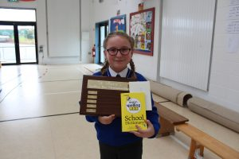

**PE and Sport Resources**: For the past few months, members of the Parents’ Association have been fundraising in aid of our depleted Sport’s Fund and their hard work has paid off. It is now possible for us to purchase new resources for use during PE lessons and during extra-curricular sports activities. We are very appreciative of the efforts of our Parents’ Association. In addition to the above mentioned purchases, we will be replacing our school jerseys and we are very grateful to the official sponsor of these new jerseys, Kitchenwise.ie (Wessley Leech). A “Presentation of Jerseys” ceremony will take place in due course and all the new resources will be displayed that day. It would be impossible for the school to make any of these purchases without the generous support of parents and the local community. Míle buíochas daoibh go léir! Mr Galligan

Mise le meas,



Cóilín Ó Coigligh, Príomh Oide.

**Green News**

**Community News**

**Nathanna na Seachtaine:** Is maith liom an Ghaeilge

**Seanfhocal na Míosa:** Ní neart go cur le chéile

**Dates to Remember**

**Assembly: Seachtain na Gaeilge (Críoch)** Thursday @ 9.20

**Banna Ceoil:** Tuesday 3.00-4.00

**Meitheal:** Every Tuesday morning 9.30-10.30.

**Football Training:** Wed 3.00 - 4.00 for 3rd – 6th Classes

**First Confession:** Wed 29th March @ 7pm

**Communion:**  Sat May 13th @ 11.00am

**Confirmation:**  Sat 11th March @ 11.00am

**Green News**

Green News

Last Friday we held our Green Flag Action Day. While it was a dreadful day outside, we didn’t let that stop us! The day began with a very informative Assembly about Fairtrade conducted by the pupils in Room 30 coupled with a presentation on Waste Management by three pupils with family in the countries Poland, Lithuania and India. Well done Olivia, Martina and Dania and all the girls in Room 30! We learned a lot and we even tried to say a few words in Polish, Lithuanian and Hindi.

The award-winning Down to Earth Theatre Company put on a show for the senior half of the school entitled ‘Life on Earth’ courtesy of Meath County Council. Inspired by the environment and the Biosphere, the show communicated key environmental issues through the use of puppetry, song, dance and audience participation. The pupils enjoyed it immensely.

Our whole school activity was to be a Water Walk around the environs of the school but unfortunately the weather dictated otherwise. However the teachers, SNAs and pupils remained undeterred! They conducted the walk indoors by walking a few laps of the hall and of the school, upstairs and downstairs with water containers in hand (and in some cases on head!!). Maith sibh! The point of this exercise was to afford us with some idea of what people in Third World countries have to endure to get water. We take this valuable resource for granted.

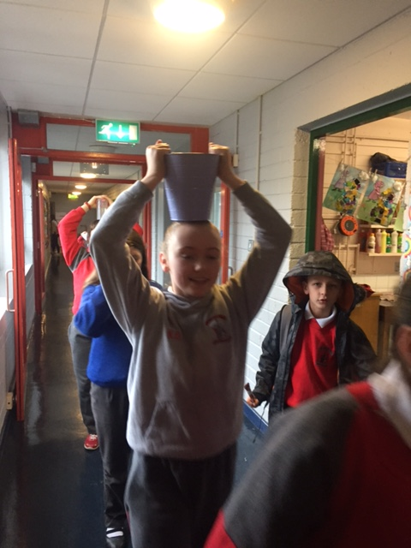

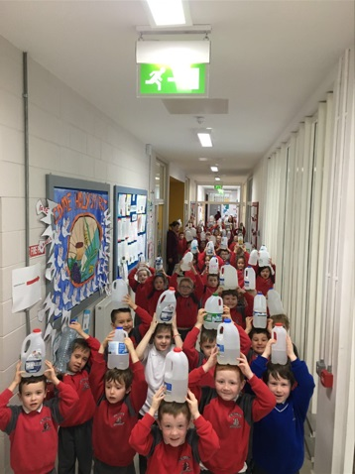

We have really appreciated what it means to be a global citizen with the various green activities this year. We are mindful of protecting our ‘Common Home’ as Pope Francis says.

Our next Global Citizenship project is the St Patrick’s Day parade. Ms O’Hare and Ms Debby are busy choreographing the St Mary’s routine! Thanks to all the teachers and staff members who give up their time to ensure that St Mary’s are part of the parade every year proclaiming their Green Message.

WOW continues this week and COW will resume when the weather is more suitable! Walkers meet the teachers at either Mornington house or The Matchbox shop at 9:00 am.

Recycling continues in St Mary’s. We accept batteries, small plastic bottles, ink cartridges, card, toilet rolls, cans, postage stamps and mobile phones.

***Remember green is cool at home, at school and around the globe!***

**Community Notices**

**Trim Camogie Club** registration night for all girls from 6.30 to 8 on Monday 6th March. Contact Caroline on 0868197647 or email [trim.meath@camogie.ie](mailto:trim.meath@camogie.ie) for more information.

**“Funny Bunnies” Easter Camp** of arts & crafts, fun and games takes place in St Mary’s Primary School from 18th – 21st April. Cost is €45 per child or €80 for two children or more. For further information please contact Ms McKenna or Ms Cullinane.

**St Marys Primary School Easter Camp** is back again this year with another fun filled week in store! Monday 10th – Thursday 13th April. 10.00am – 2.30pm. €50 per child. Activities: Arts & crafts, sports and games, dance, baking, science and much more. **For a booking form or further information please contact The Office, Ms Carr or Ms Leavy.**

**Shamrockers Camp** of arts & crafts, sports, fun and games will take place from 13th – 16th March in St Mary’s School. Places are filling up fast so we would encourage you to get your booking in to avoid disappointment. For more information please contact Ms McKenna or Ms Cullinane.

**Easter Eggstravaganza** @ Trim GAA Clubhouse is back again for another year. Monday 10th - Thursday 13th April. Art, Craft, Sports, Science Experiments and lots more. For more information please contact Ms. Maguire Room 12.

**Go Bounce bouncy castle hire**. Based in Trim, fully insured and safety certified. Check out our Facebook page [www.Facebook.com/gobouncemeath](http://www.facebook.com/gobouncemeath), website [www.gobounce.ie](http://www.gobounce.ie/), contact us on 086-8398099 or email [enquiries@gobounce.ie](mailto:enquiries@gobounce.is) Dates in May are filling up so don't delay, get your booking in sooner rather than later.

**ZUMBA  :-**    MONDAY  &  WEDNESDAY  8pm  TRIM GAA. No booking, partner or experience required......just grab your water and your smile and get ready to dance your cares (and Christmas treats !!) away!        €8 per class       Contact  :  Lorraine  086 8693546

**ZUMBA KIDS :-**   Tuesday  3.15pm  Trim GAA No booking required,  €6 per class      Contact : Lorraine  086 8693546

**ST. PATRICKS FUN DAY!**

Big Bounce, Flawless Face Paint & Jiggle 'n' Jump are teaming up to bring you fun and entertainment for you family on St. Patrick's Day.  12.30-3.30pm in the Diocesan Hall on Loman St.  Bouncy Castles, face painting, spot prizes, music, dancing, party entertainer and free entry into a raffle.

**STRUGGLING WITH YOUR SLEEP?**

**Too much, or too little, Animo TV want to hear from you!**

Are you always tired, but find yourself awake all night? Can you exist on hardly any sleep? Is your child having sleeping problems that you just can’t seem to solve? Is your partner’s chronic snoring keeping you awake all night… every night? Are you a shift-worker who struggles to catch up on sleep? Or would you like to take part in a fascinating sleep experiment? *“Awake – The Science of Sleep”* is a new documentary for RTÉ One, which takes a snapshot of our sleeping patterns as a nation. From new parents to shift workers – we want to represent all of the issues people have with their sleep. If you think you have an undiagnosed problem or want help from Irelands top sleep experts please get in touch!

If you would like to participate in this series, please email [sleep@animotv.ie](mailto:sleep@animotv.ie) with your name and contact details for more information.

**Meath Local Sports Partnership** are running the following courses, if interested please see meathsports.ie for more information.

* Concussion in Sport Awareness Workshop
* Safeguarding 2 & 3 Child Protection Workshops
* Meath Running Group – Block 1
* Community Walking Groups
* Sport in the Park
* Come ‘n’ Try Dance (for over 50’s)
* Games for Life Boccia League
* SAY – Special Yoga & Athletics
* Paratriathlon Talent ID Day
* Dates for your Diary