 St Mary’s Convent Primary School**

***Bunscoil Clochar Mhuire***

***Trim, Co. Meath.  
Fón: (046) 9431919 ⦁ Faics: (046) 9437942  
Ríomhphost:*** [***marystrim@eircom.net***](mailto:marystrim@eircom.net) ***⦁ Website:*** [***www.stmarystrim.ie***](http://www.stmarystrim.ie) ***Uimhir Rolla: 16646O***

Awarded Green Flag  
June ‘05/’07/11/13

***Imlitir 25***

5th March, 2018

***Every Day Counts at St Mary’s Convent Primary School***

***26th – 27th Feb 2018***

|  |  |  |  |  |  |  |  |
| --- | --- | --- | --- | --- | --- | --- | --- |
| **Room** | **Attendance** | **Room** | **Attendance** | **Room** | **Attendance** | **Room** | **Attendance** |
| 01 | 93.1 % | 08 | 96.3% | 16 | 89.7% | 26 | 94.4 % |
| 02 | 78.3% | 09 | 90.4% | 17 | 93.3% | 27 | 96.2% |
| 03 | 96.6% | **10** | **100%** | 18 | 94.6% | 30 | 90% |
| 04 | 87.9% | **12** | **100%** | **19** | **100%** | 31 | 98% |
| 05 | 94.2% | 13 | 89.6% | 20 | 94.2% |  |  |
| 06 | 95.8% | 14 | 94.6% | 23 & 24 | 98.5% |  |  |
| 07 | 95.7% | **15** | **100%** |  |  |  |  |

*Well done to rooms 10, 12, 15 & 19 on having full attendance last week. Their teachers will let them know their reward. Please note that notification in writing, with the reason for all absences, to the teacher is required. A letter or note in the homework journal will suffice.*

A chairde,

Don’t forget our Family Fun Bingo on Sunday March 18th @ 3.00 in The Dr Eileen Reilly Hall, organised by our Parents’ Association. Many thanks to our main sponsors Trim Credit Union and all the local businesses who have also helped out. Proceeds for our MUGA Fund (All Weather Pitch).

**Siúlaimis:** All pupils now have cards to record walking to and from school or WOW or use of Slí na Sláinte (our walking track in the school yard). Please encourage them to do so and where relevant, please sign if they walk to or from school. To date we have travelled as far as Yakutsk, Russia.

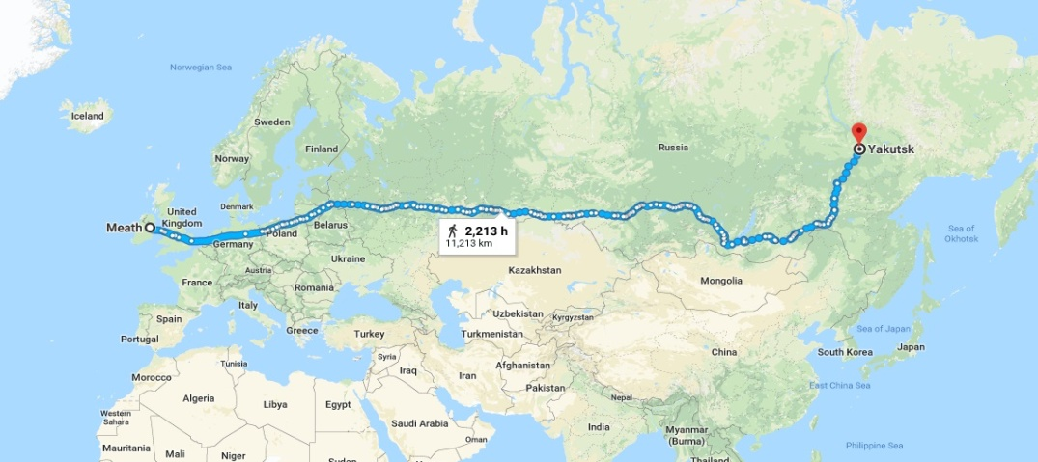

**Meath Spelling Bee:** The Spelling Bee Meath County Final has been rescheduled for Monday the 23rd of April. The County Final will be held in St.Paul’s N.S, Ratoath, Co.Meath at 11 am. We wish Kate every success! Mr Galligan

**Computer Room News:** This week projects are being done on ‘Our Snow Days’. 1st and 2nd classes will learn how to ‘make their snowman melt’ while 3rd – 6th classes will create stories for the younger classes. Please encourage your children to tell you what they are doing each week and if you have downloaded Scratch ask them to try to recreate what they are doing in class.

Debby Walsh

*Next week is* ***Seachtain na Gaeilge*** and we are encouraging our pupils to speak a little Irish over the next few weeks. If you have some Irish we would encourage you to use this opportunity to practise, even if only to say ‘hello’ ‘*Dia dhuit’* and ‘goodbye’ ‘*slán*’ or ‘please’ ‘*más é do thoil é’* and ‘thank you’ ‘*go raibh maith agat’*.

We have a few events planned for next week that might interest you. Room 10 will be doing a Tionóil (Assembly) this Friday @ 9.30am to launch the week. *Ranganna Trí*(Third Classes) will be doing *an* ***Tionóil***(the assembly) on Friday 16th followed by a *Céili* for 2nd, 3rd and 4th classes on Friday morning.

***Maidin Caife:*** Parents/guardians who are available are invited to have a cup of coffee in the staffroom on Friday 16th after the *Tionóil* (Assembly) and to chat to each other *as Gaeilge.* (in Irish) It will be an informal occasion and whatever you feel that your standard in Irish is will be fine and if you need to use English words mixed in, that will be fine too! *Fáilte roimh chách-*All welcome.

**Internet Safety:** Parents/Guardians are advised to supervise your child’s internet use and do not allow usage during late evening and during the night.  Please note that children under the age of thirteen may not use Facebook. Please talk to your child about appropriate internet use and if you have any serious concerns, contact your local Garda station.

**Daffodil Day** is Friday, March 23rd. Crocheted daffodils and other crafts may be purchased by the children for €2 each during the week. Please support if you can.

Ms. Nally

Mise le meas,



Cóilín Ó Coigligh, Príomh Oide.

**Green News**

**Community News**

***Nath na Seachtaine: Tá mé críochnaithe***

***Seanfhocal na Míosa: Tír gan teanga, tír gan anam, Scoil gan Ghaeilge, scoil gan chroí***

**Dates to Remember**

**Assembly: Launch of Seachtain na Gaeilge. Friday @ 9.30**

**Meitheal:** Every Tuesday morning 9.30-10.30.

**Drama Club:** Every Thursday 3-4pm for 5th Class

**Banna:** Tuesdays @ 3.00 – 4.00

**First Confession:** Wed 7th March @ 7.30pm

**Communion: Saturday 5th May @ 11.00**

**Family Fun Bingo:** Sunday March 18th @ 3.00pm

**New Language Curriculum In-service:** Tuesday May 29th **School Closed for pupils**

**Green News**

Hope everyone has come through the bad weather without any damage to themselves or to their property. In the interest of health and safety, we will cancel WOW for this week as the snow hasn’t thawed entirely yet and there may be icy conditions on Wednesday. Thank you to all those who keep this initiative going especially Ms Finn and Ms Flattery.

Recycling continues in our school. We accept batteries, ink cartridges, mobile phones, card, toilet rolls, cans, footwear and postage stamps. Remember the batteries are now going towards the Barretstown charity. Children helping children. Many charities benefit from our recycling and it is a great habit to cultivate in our pupils**.** Our Siopa glas money has gone to help Sr Claudia’s Special needs school. I will attach her card thanking you all for your generosity. This is also a good time to remind people about the Trócaire box campaign which has been helping to tackle global poverty and has heightened awareness of injustices in the developing world since 1973.

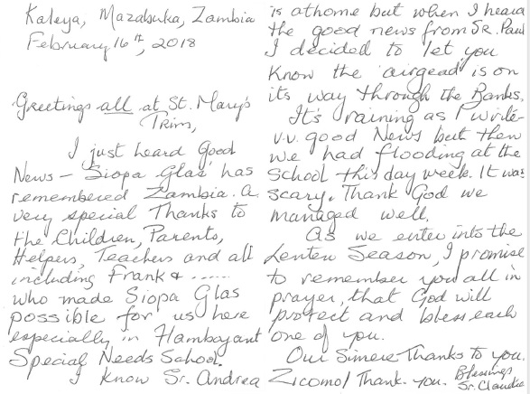

As part of our Global Citizenship theme, we will be examining the 17 Global goals which world leaders agreed on to create a better world by 2030. We will attach them again at the end of this Imlitir. The third of these goals relates to good health and wellbeing which St Mary’s is passionate about. Once again through our generosity we can contribute to health and nourishment of those less fortunate than ourselves. We can also learn about keeping our environment healthy and become aware of how our life habits can have far reaching affects.

The following video has been recommended. If you haven’t viewed it yet, here’s another chance:

<https://vimeo.com/138852758>

Finally the St Patrick’s Day parade is approaching. We always like to represent St Mary’s Green Flag Theme at the parade. We would invite any pupils from 2nd class up who are not walking with other groups to join us this year. (If any younger pupils are interested in being a part of our Green Brigade, they may join in if they are accompanied by a parent/guardian). More details to follow.



***Remember Green is cool at home and at school!***

***Some of the Houses made by Senior Infants***

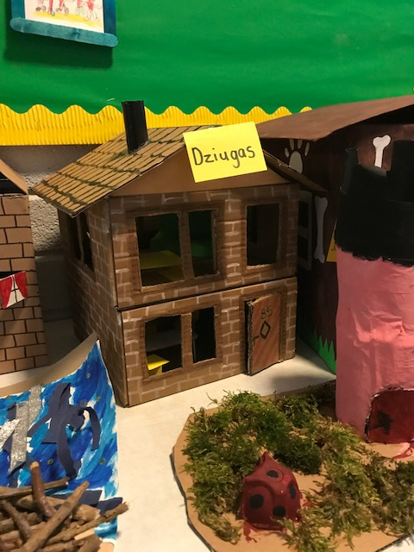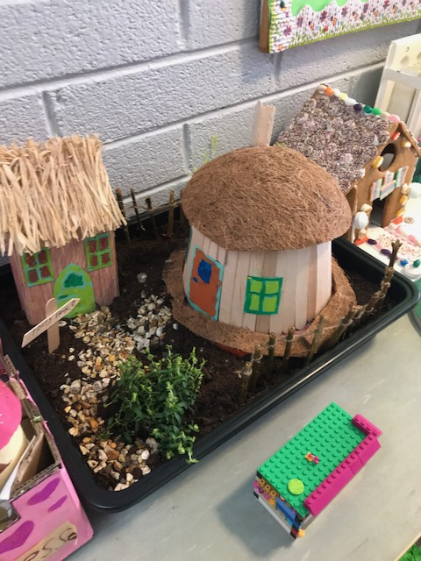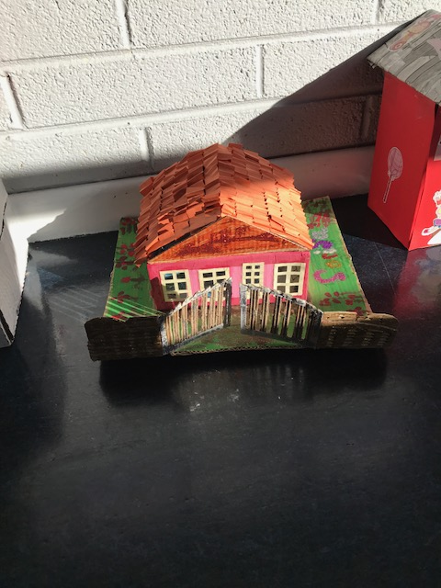

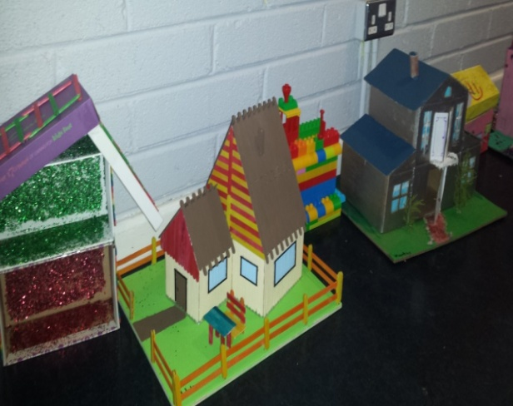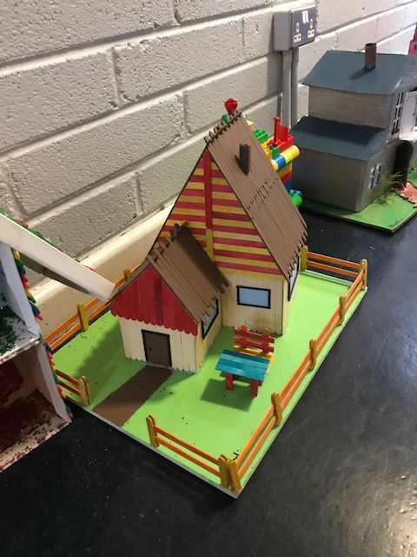

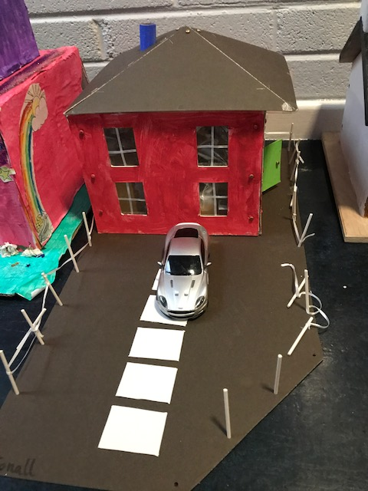

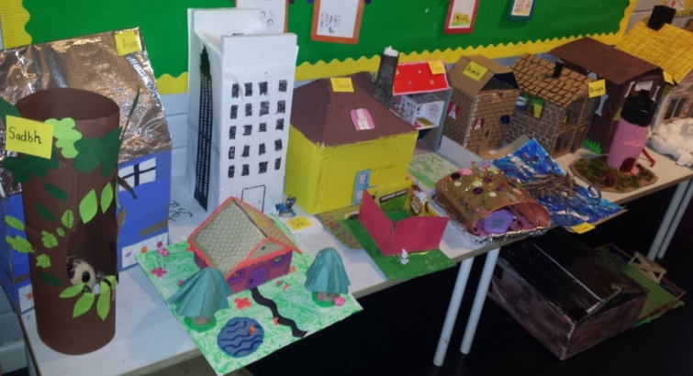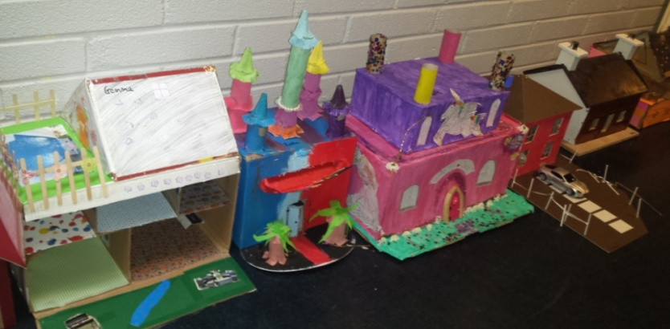

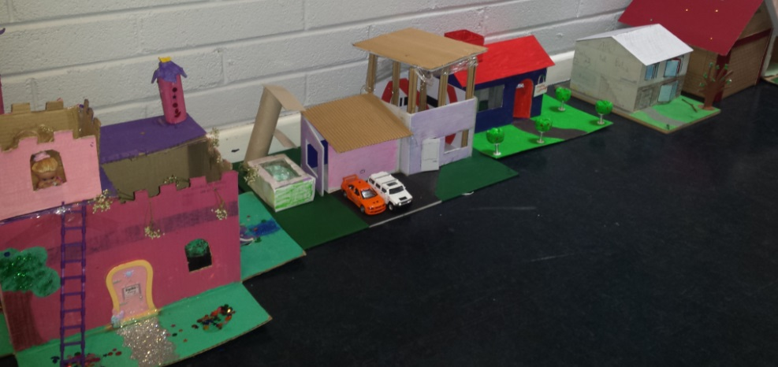

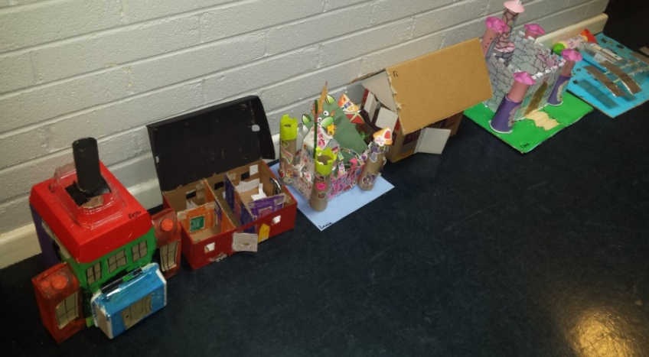

St Mary’s Parents’ Association

Dates for Your Diary:

**March 6th:** PA meeting at 7.30pm in staffroom. All parents/guardians welcome to attend.

**March 9th**: Bingo books will be available to buy in the school from 9.30am-11am. Books are €10 for adult books and €5 for kids books.

**March 18th**: Family Fun Day Bingo with all funds raised going towards the MUGA fund. The Bingo will be held in the Dr. Eileen Reilly hall from 3-6pm. All welcome to attend what promises to be a great afternoon. Apologies for the error in previous Imlitirs regarding time.

<https://www.facebook.com/stmarysparentsassoc/>

Caroline Smith

Secretary

**Community Notices**

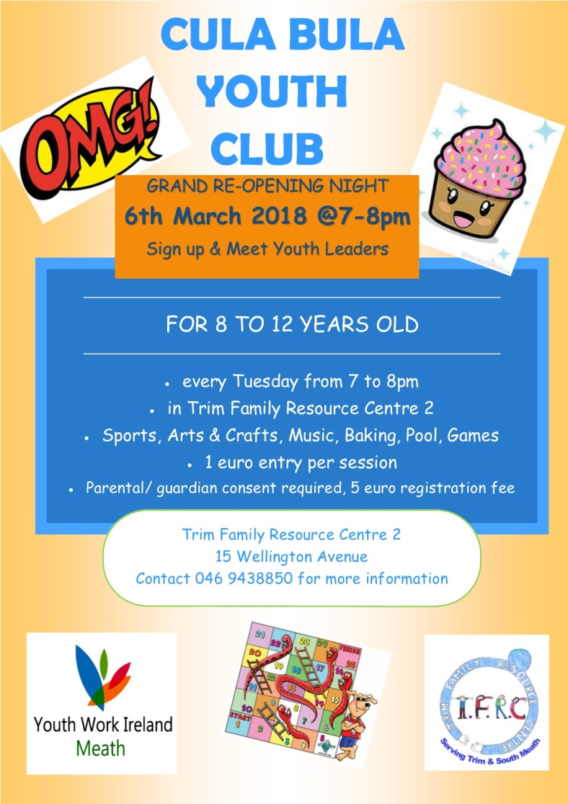



**Searsol Touch Typing Course**

**Age Group**: 8 years +

**Day/Time**:  Mondays, 4.30pm

**Location**: ST MARYS NS, TRIM

**Contact**: Jackie 086-3780842

**Website**:  [www.searsol.com](https://searsol.com/)

A touch-typing course designed to develop the typing skills of children 8 years & upwards in a classroom environment with a qualified tutor. You can join the course any time as your child works at their own pace in a small class environment so each child gets the  individual attention they need.  Free trial first lesson!

***This class is for all children but particularly helpful to kids with learning differences such as Dyslexia, Dyspraxia and Autism.***

**AFTER SCHOOL CLUB** Taking place in St. Mary's School Trim from 2-3pm Mon - Friday in room 5. Only €6 a day or €25 for 5 days Mon-Fri Application forms available from reception. Booking required a week in advance of start date to insure space, and rebooking and payment made the previous Thursday each week after. Kids will be provided a small snack and entertained with Lego, Art & Craft, Board games, quizzes, card games, puzzles and lots more fun activities! Run by an experienced Childcare Professional Parent who is fully Garda Vetted and Insured. Contact Julie O'Donohue to book your child's space by texting 0868505310, emailing [juliekerins@hotmail.com](mailto:juliekerins@hotmail.com) or via a PM on the Facebookpage:[www.facebook.com/TrimAfterSchoolClub](http://www.facebook.com/TrimAfterSchoolClub)

**ZUMBA  :**   MONDAY / WEDNESDAY  8pm  TRIM GAA,   €8 per class pay as you go,  suitable for all fitness levels  Contact : Lorraine 086 8693546

**ZUMBA KIDS**  :  New 3 week term beginning this Thursday 8th March,  St. Patrick's hall (under snooker club)   2.15pm - 3pm,   school pick-up available.  **Limited places**,  Contact :  Lorraine  086 8693546

**St Marys Easter Camp**. Dates 26th – 29th March 10.00 – 2.30 for children aged 4-12. €55. Lots of fun activities planned. Leaflets will be distributed next week. Contact Ms Carr or Ms Leavy.

**Homework Club** in St Mary’s for children from 1st – 6th Classes. Application Forms are available from Ms Conaty Room 11 or Ms Lynch Room 31.

**Under 12 Camogie** Starting back in Trim GAA on Monday Feb 5th @ 6pm. New players welcome. Enquiries: 086-8795233 (Michelle)

**Trim Badminton club** - looking for new members age 9-15 year olds- takes place in Trim GAA on Thursday nights from 7-8.30 - the first hour is coaching with an external coach. Pop in and try it. **First night is a FREE Trial.** Then €5 a night.

**GK Stage Academy**, Performing Arts Easter Camp comes to Trim GAA this March 26th - 29th from 10am - 1pm. A jam packed four days of dance, drama, song and fun for boys and girls ages 3 - 12years. Places strictly limited and filling fast! Call 0863566061 or message [Facebook.com/GKStageAcademy](http://facebook.com/GKStageAcademy) to book yours!

