***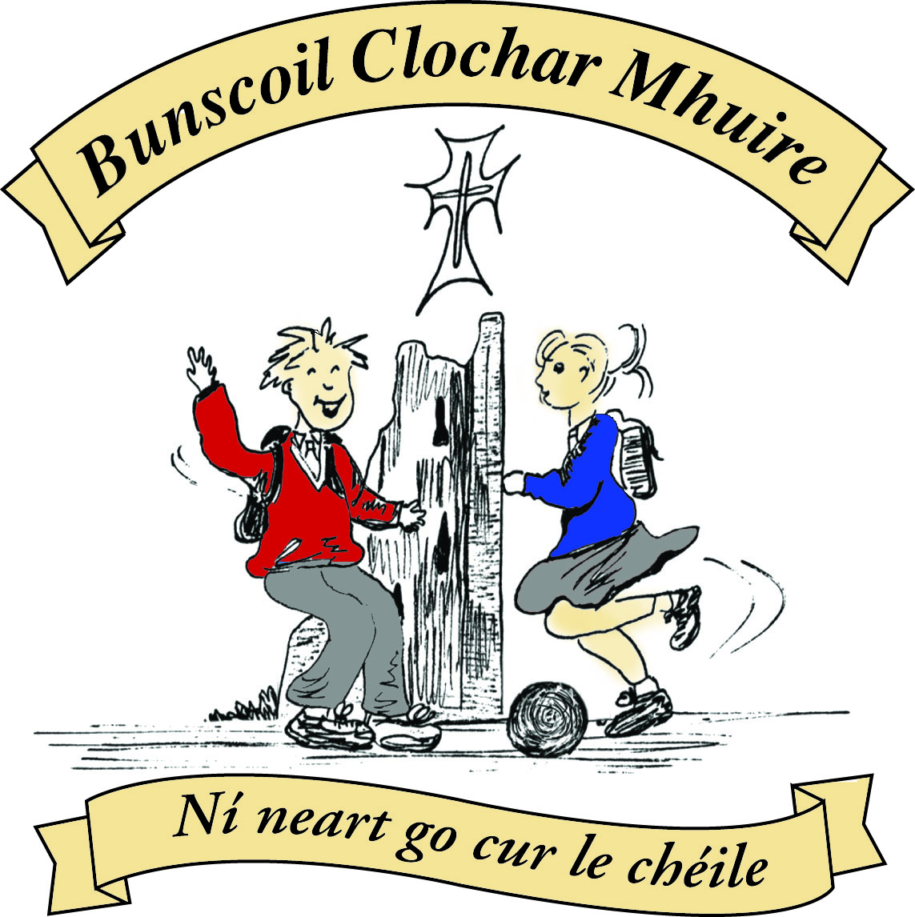* St Mary’s Convent Primary School**

***Bunscoil Clochar Mhuire***

***Trim, Co. Meath.  
Fón: (046) 9431919 ⦁ Faics: (046) 9437942  
Ríomhphost:*** [***marystrim@eircom.net***](mailto:marystrim@eircom.net) ***⦁ Website:*** [***www.stmarystrim.ie***](http://www.stmarystrim.ie) ***Uimhir Rolla: 16646O***

Awarded Green Flag  
June ‘05/’07/11/13

***Imlitir 25***

29th February, 2016

***Every Day Counts at St Mary’s Convent Primary School***

***22th – 25th February 2016***

|  |  |  |  |  |  |  |  |
| --- | --- | --- | --- | --- | --- | --- | --- |
| **Room** | **Attendance** | **Room** | **Attendance** | **Room** | **Attendance** | **Room** | **Attendance** |
| 01 | 95.4% | 08 | 97.3% | 16 | 92.6% | 26 | 99.1% |
| 02 | 91.3% | 09 | 98.1% | 17 | 92% | 27 | 83.9% |
| 03 | 91% | 10 | 92.9% | 18 | 89.3% | 30 | 95.7% |
| 04 | 94.2% | 12 | 92.3% | 19 | 98.6% | 31 | 97.4% |
| 05 | 98.2% | 13 | 87.5% | **20** | **100%** |  |  |
| 06 | 93.8% | 14 | 91.3% | **23** | **100%** |  |  |
| 07 | 97.1% | 15 | 88% | 24 | 91.7% |  |  |

A Chairde,

Congratulations to Rooms **20&23** on having full attendance last week. Their teachers will let them know this week what their prize is.

Best wishes to our children who will make their First Penance on Wednesday next @ 7.00 in St Patrick’s Church. Thanks to the teachers Mrs Roche and Mrs McGale, and to Fr Declan for the great preparation work. All sacraments are celebrations, so I hope the occasion is enjoyed and celebrated by all.

*A big thank you to all the children who took part in the Children in Crossfire (C.I.C.) Maths challenge for charity. We raised €78. C.I.C. offers a chance to make a new start in life, delivering an Early Childhood Development in Tanzania and Ethiopia.*

*The challenge provided an active shared learning experience, while supporting less fortunate children in other parts of the world. Thank you for your support.*

*Mrs Hoey*

I would like to draw your attention to the misuse of Facebook and Viber. The legal age for these sites is thirteen but we are aware that some children younger than thirteen are members. We are urging parents to monitor their children’s use of cyber media to ensure that inappropriate content is not being used towards or by their child.

**Seachtain na Gaeilge** will be next week and for the week we will all be making a special effort to speak more Irish and to partake in Irish activities.

Mise le meas,



Cóilín Ó Coigligh, Príomh Oide.

**Green News**

**Community News**

**Nath na Seachtaine:** **Tá brón orm. (I am sorry)**

**Seanfhocal na Míosa**: **Ní neart go cur le chéile!**

**Dates to Remember**

**Assembly:** “Mothers Day” Assembly @ 9.20 for Junior Classes.

All Welcome

**Meitheal:** Every Tuesday morning 9.30-10.30.

**Banna Ceoil:** Every Tuesday @ 3pm.

**First Communion:** Saturday 28th May @ 11.00 a.m.

**First Confession:**  Wednesday 2nd March @ 7.00pm

**Please keep an eye on the Parish Bulletin for any changes.**

**Green News**

Great to see the Green voice back again in Dáil Éireann!

**Siopa Glas**

Next week we will be hosting our annual *Siopa Glas* (Green Shop).Sr Claudia, a former Principal and teacher at St Mary’s is now operating a Special Needs School in Zambia. Flamboyant Special Needs School is a newly developed facility and is badly in need of resources. This is our opportunity to do some good with our recycling. The pupils and teachers of St Mary’s donate clothes, toys, books, bric-a-brac and anything that might be of use to someone else. These items will be sold at our Siopa Glas, the proceeds from which will be sent directly to Sr Claudia for her school. We welcome the opportunity to offer our support through our green initiatives in St Mary’s. We would ask anyone who has a suitable item for a raffle to send it in to us.

Recycling continues at St Mary’s. We recycle batteries, ink cartridges, Nespresso Pods, footwear, small plastic bottles, card, toilet rolls and postage stamps. The local Optician has enough eye-glasses for her Third World project for now so we won’t be collecting them for another while.

**Global Citizenship**

The theme of our Green Schools Programme this year is Global Citizenship. We are paying particular attention to Litter and Waste Management. Each class is ensuring that they recycle as much as possible and that the bin for non-recyclable waste is kept to a minimum. All leftover food is brought home in lunchboxes.

Linked to this theme we will be putting forward a delegation to walk in the St Patrick’s Day parade. We would like to have all the nationalities of our school population represented there. Many people have returned their permission slips. If you haven’t sent yours in yet, you are still encouraged to do so. Remember we need pupils and parents to represent Ireland too! It should be a lovely kaleidoscope of colour!

**WOW**

The number of pupils walking to school is increasing. The new meeting point in the car park behind the Matchbox is proving to be a success. We would encourage more people to join us every Wednesday. The Scores on the Doors are beginning to soar! Well done to Room 31 who scored the highest for February. Our Siúlaimis campaign is also underway so there are lots of people choosing the healthy, environmentally-friendly way to get to school. Maith sibh!

We will resume our COW campaign after Easter when the weather improves.

Well done everyone who is keeping as green as can be!

***Remember Green is cool at home, at school and around the Globe!***

**Community Notices**

**ZUMBA**  :-   No experience, partner or booking required -  2 classes to choose from:-

MONDAY   8pm   Trim GAA, THURSDAY  8pm  Dance Force Academy €8 per class     Contact :  Lorraine  086 8693546

**KIDS DANCE CLASS** :-        Ages 5-8          TUESDAY    3.15pm    TRIM GAA

 €6 per class  (Sibling rate €5) Zumba,  Hip-Hop,  Rock 'n Roll,  Jive...    Contact :  Lorraine  086 8693546 / Jo  086 3381159

**Boyne Comm. School Parents’ Association** invite you to a Talk on Understanding the Emotional Well Being of Teenagers, Children and the Family on Wed 2nd March at 7.45pm by Dr Fergus Heffernan. It is suited to Parents/Guardians/Families and those who play a key role in supporting the emotional well-being of teenagers and young children. It also highlights how Parents/Guardians/Families need to care for themselves in these challenging roles. All welcome, bring your friends and neighbours.

**Carney School of Irish Dancing** Classes in St. Patricks Hall every Tuesday. 2pm – 3pm & 3pm – 4pm. Every Friday @ 5.30pm. Infants and Senior infants can be collected from class rooms @ 2pm and left back to the buses @ 3pm. €5 per pupil per class. Contact Ann Carney 087-6336495