***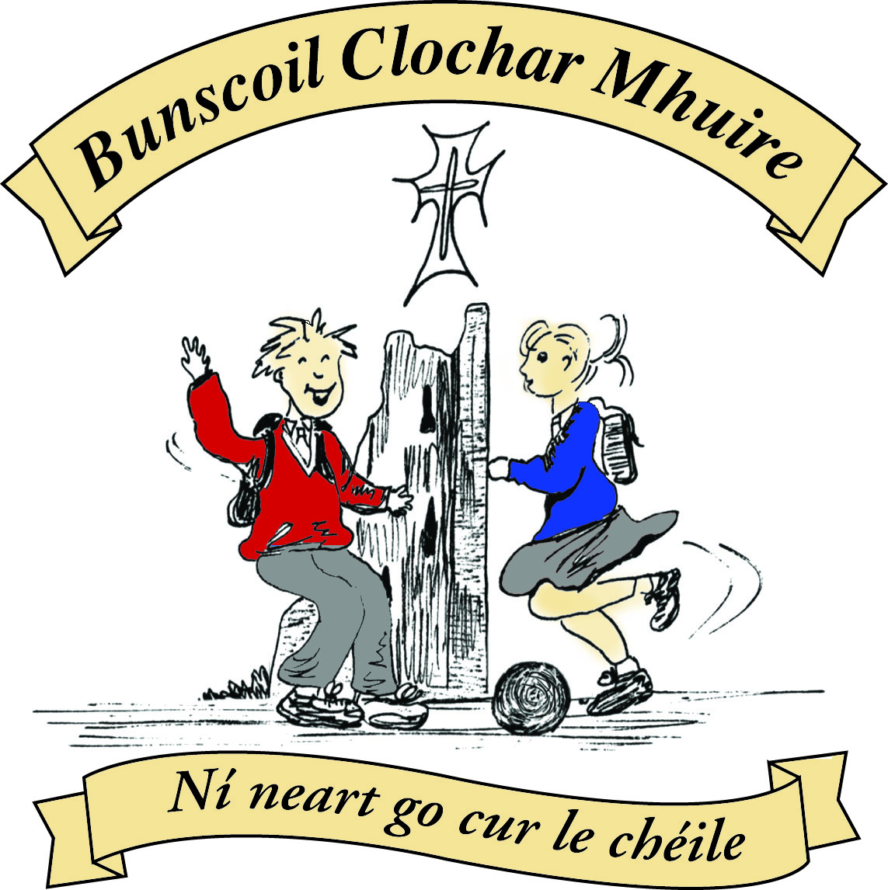* St Mary’s Convent Primary School**

***Bunscoil Clochar Mhuire***

***Trim, Co. Meath.  
Fón: (046) 9431919 ⦁ Faics: (046) 9437942  
Ríomhphost:*** [***marystrim@eircom.net***](mailto:marystrim@eircom.net) ***⦁ Website:*** [***www.stmarystrim.ie***](http://www.stmarystrim.ie) ***Uimhir Rolla: 16646O***

Awarded Green Flag  
June ‘05/’07/11/13

***Imlitir 24***

27th February, 2017

***Every Day Counts at St Mary’s Convent Primary School***

***20th February – 22nd February, 2017***

|  |  |  |  |  |  |  |  |
| --- | --- | --- | --- | --- | --- | --- | --- |
| **Room** | **Attendance** | **Room** | **Attendance** | **Room** | **Attendance** | **Room** | **Attendance** |
| 01 | 92.6 % | 08 | 93.3% | 16 | 97.5% | 26 | 92% |
| 02 | 86.7% | 09 | 91.4% | 17 | 86.1% | 27 | 95.8% |
| 03 | 95.7% | 10 | 92.6% | 18 | 95.8% | 30 | 97.4% |
| 04 | 84% | 12 | 95.4% | 19 | 95.2% | 31 | 89.3% |
| 05 | 91% | 13 | 97.8% | 20 | 92.9% |  |  |
| 06 | 96% | 14 | 97.6% | 23 & 24 | 90% |  |  |
| 07 | 96% | 15 | 95.2% |  |  |  |  |
|  |  |  |  |  |  |  |  |

*Please note that notification in writing to the teacher is required for all absences. A letter or note in the homework journal will suffice.*

A chairde,

Please note that this week is Fairtrade Week. Green Action Day is on Friday, further details below under Green News.

***Fairtrade is a global co-operative – If we want a better world for all humans***

***then we must all work together as a collective “us”!***

I would like to draw your attention to the misuse of Facebook and Viber. The legal age for these sites is thirteen but we are aware that some children younger than thirteen are members. We are urging parents to monitor their children’s use of cyber media to ensure that inappropriate content is not being used towards or by their child.

*Many thanks to all the classes who took part in the recent “****Children in Crossfire****” (C.I.C.) maths online quiz. The C.I.C. charity helps to deliver Early Childhood Development initiatives mainly in Tanzania and Ethiopia where many people are illiterate and live below the poverty line. It helps to assist the training of health care workers and teachers and to educate families and communities as well as providing services to improve early childhood practise.*

*Rather than ask the children to donate €1 each, to participate in the quiz, it was decided this year to tie it in with this year’s Green Flag theme “Global Citizenship”. A donation of €50 was given out of our Green Flag Fund. Many Thanks again to all involved. M. Hoey*

**Seachtain na Gaeilge** will be next week and for the week we will all be making a special effort to speak more Irish and to partake in Irish activities.

***Spelling Bee 2017****: This week twenty-four pupils from our 5th and 6th Classes will participate in St Mary’s Spelling Bee Final. The action takes place on Wednesday afternoon and the winner will represent us at the county final in Ratoath on March 30th. Go n-éirí libh a chailíní! Mr Galligan*

***Book Mark Competition:***

*Pupils from St Mary’s School participated in the recent Meath County Council Library Service World Book Day Bookmark Competition. The competition was open to pupils from First to Sixth classes. The standard in the school was very high and a lot of creativity was evident in the bookmark designs. Ten entries were selected from all the school’s competitors and prizes were given to these pupils. The school’s top five entries were then chosen and sent forward for the final to the Library Headquarters in Navan. The overall Meath winner will be announced on March 2nd.*

*Congratulations to the following pupils whose entries were selected for the Meath finals: Ava O’Reilly (6th Class), Ella Bannon (5th Class), Katie Devine (4th Class), Kayla Clarke (2nd Class) and Tadhg Clavin (1st Class). Good luck to you all in the final competition!*

*School Runners up: Orla Murphy (6th Class), Róisin Tully (5th Class), Amber Clarke (3rd Class), Katie Keogh (3rd Class) and Shauna McEnroe (2nd Class)*

***World Book Day is on Thursday, March 2nd****. To celebrate this special occasion we are having a* ***Book Character Dress up Day****, open to all pupils and staff.  Participants are invited to dress up as a book character of their choice. This is completely optional and free of charge. The emphasis is on promoting the reading of books and engaging in some fun activities during the day. There are some ideas for costumes on bookaid.org/worldbookday.*

*World Book Day tokens will be distributed to classes this week. They are valid from 27th February to 28th March and may be redeemed in independent bookshops and participating stores nationwide. The tokens give the bearer a discount of €1.50 off any book or audiobook costing €3.99 or more or they can claim a free €1.50 specially reduced World Book Day book. Ms O’Hare*

***Banna Ceoil:*** *Please note there will be* ***no Banna Ceoil*** *tomorrow Tuesday 28th February. Banna Ceoil will resume again on Tuesday 7th March. Ms McGale*

***Do This in Memory Meeting****: The next Do This in Memory Committee meeting is on tonight @7.00pm in the Parish Centre. All parents welcome to attend. The next Do This in Memory Mass is this Sunday 5th @ 11.00. Fr. Declan*

Mise le meas,



Cóilín Ó Coigligh, Príomh Oide.

**Green News**

**Community News**

**Nathanna na Seachtaine:** Le do thoil/Más é do thoil é (Please)

**Seanfhocal na Míosa: Giorraíonn beirt bothar** (It’s great to have someone to share the journey with!)

**Dates to Remember**

**Assembly:** Green Flag Friday @ 9.20am

**Banna Ceoil:** **No Banna Tomorrow 28th Feb**

**Resumes next Tuesday 7th March**

**Meitheal:** Every Tuesday morning 9.30-10.30.

**Football Training:** Wed 3.00 - 4.00 for 3rd – 6th Classes

**First Confession:** Wed 29th March @ 7pm

**Communion:**  Sat May 13th @ 11.00am

**Confirmation:**  Sat 11th March @ 11.00am

**Green News**

Green News

March is nearly upon us and is making its entrance like a lion! We hope the weather will cooperate with our Walk for Water on Friday next. As part of our Action Day for Global Citizenship, all the children in the school will carry a container of water around the river walk in solidarity with their counterparts in poorer parts of the world. Some children in Third World countries walk for miles to get water. We take this valuable resource for granted. Our Action Day will open with a Green Flag Assembly. After the 11 o clock break classes from 2nd to 6th will be given a theatrical presentation entitled ‘Life on earth’ which will be held in our school hall. Our Water Walk will take place in the afternoon weather permitting.

This week is also Fair Trade Week at school. Fair Trade is an alternative approach to conventional trade and is based on a partnership between producers and consumers. Fair prices are paid to the producers and companies are able to provide workers with a stable income that can improve their lives. It aims to benefit small-scale famers and workers through trade which helps them to maintain their livelihoods and reach their potential.

Fair Trade operates in 74 countries and across four continents. In our daily shopping we can look for the Fair Trade logo on products. Coffee is the most well-known fair trade product but there are others: bananas, rice, cocoa, honey, dried fruit, tea, wine and others. Keep an eye out for the logo and see if you can introduce Fair Trade products into your shopping basket. There isn’t really much of a price difference and you can consume with a clear conscience! It’s one of the many small ways to make a global difference by doing some local. Fair Trade fortnight has begun nationally so there may be more Fair Trade products available in stores. The theme of the fortnight is ‘The Power of You! This links in so nicely with our Global Citizenship theme.

Some further articles you may like to read are:

*‘How to consume with a clear conscience’* by Conor Pope (Irish Times)

‘*The drop in sales of Fairtrade cotton in Europe’* by Dustan Burke (The Journal)

Ray Ryan’s interview with Alison Roberts from Clonakilty Chocolate in the Irish Examiner relating to their experience of supporting Fairtrade.

The St Patrick’s Day preparations are in full swing. We will proclaim our Green message to the town to help protect our world and those in it, whether on our side of the globe or the other. ‘Protecting our common home’ as Pope Francis says.

WOW will continue as normal this week. Meet the teachers at either Mornington House or the Matchbox at 9:00 am. The WOW teachers will escort the children to the school from there.

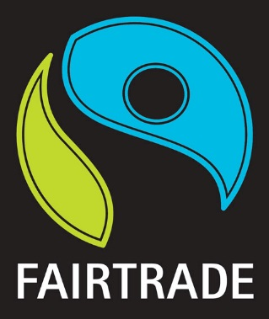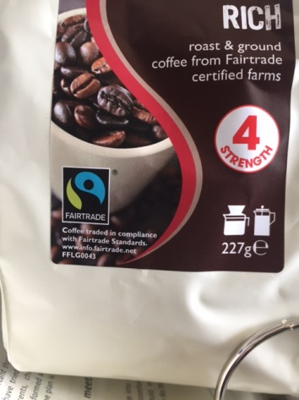

***Remember green is cool at home, at school and around the globe!***

**Community Notices**

**St Marys Primary School Easter Camp** is back again this year with another fun filled week in store! Monday 10th – Thursday 13th April. 10.00am – 2.30pm. €50 per child. Activities: Arts & crafts, sports and games, dance, baking, science and much more. **For a booking form or further information please contact The Office, Ms Carr or Ms Leavy.**

**Shamrockers Camp** of arts & crafts, sports, fun and games will take place from 13th – 16th March in St Mary’s School. Places are filling up fast so we would encourage you to get your booking in to avoid disappointment. For more information please contact Ms McKenna or Ms Cullinane.

**Easter Eggstravaganza** @ Trim GAA Clubhouse is back again for another year. Monday 10th - Thursday 13th April. Art, Craft, Sports, Science Experiments and lots more. For more information please contact Ms. Maguire Room 12.

**Go Bounce bouncy castle hire**. Based in Trim, fully insured and safety certified. Check out our Facebook page [www.Facebook.com/gobouncemeath](http://www.facebook.com/gobouncemeath), website [www.gobounce.ie](http://www.gobounce.ie/), contact us on 086-8398099 or email [enquiries@gobounce.ie](mailto:enquiries@gobounce.is) Dates in May are filling up so don't delay, get your booking in sooner rather than later.

**ZUMBA  :-**    MONDAY  &  WEDNESDAY  8pm  TRIM GAA. No booking, partner or experience required......just grab your water and your smile and get ready to dance your cares (and Christmas treats !!) away!        €8 per class       Contact  :  Lorraine  086 8693546

**ZUMBA KIDS :-**   Tuesday  3.15pm  Trim GAA No booking required,  €6 per class      Contact : Lorraine  086 8693546

**Play Therapy & Psychotherapy** is an effective developmental suitable form of therapy for children. It is suitable for children dealing with family breakdown, anxiety, low self esteem, bereavement, behavioural problems and delayed development. Contact Emer for information 086-1969152

**Elegance Gymnastics Club** continue enrolling the Girls from 5 to 12 years old to the Gymnastics classes which will be held every Tuesday and Wednesday from 5 to 6 pm for the girls from 5 to 7 years old, and from 6 to 7 pm for the Girls from 8 to 12 years old. All welcome! Please call to register: 0879134334 or 0876339498.

**Basketball classes** every Tuesday from 4 to 5 pm for the Boys from 8 to 12 years old, and Wednesday from 4 to 5 pm for the Girls from 5 to 7 years old. All Welcome! Please call: 0879134334 Robert.

Conor was a local young boy and a past pupil of St Mary’s who unfortunately lost his battle with this rare childhood cancer called Neuroblastoma, after it returned for the 3rd time in 2015.

Conor loved life to the full and was our Brilliant Shining Star and so to continue on this brilliant’s the Conor Foley Neuroblastoma Cancer Research Foundation was founded, with the objective and mission to fund research into finding a cure for this childhood cancer. **#CFNCRF** **#TOINFINITYANDBEYOND #FIGHTINGFORACURE**

Please support our annual dinner dance on **Sat 8th April** in Trim Castle Hotel tickets available online, to purchase now please visit [www.conorfoley.ie](http://www.conorfoley.ie)

