 St Mary’s Convent Primary School**

***Bunscoil Clochar Mhuire***

***Trim, Co. Meath.  
Fón: (046) 9431919 ⦁ Faics: (046) 9437942  
Ríomhphost:*** [***marystrim@eircom.net***](mailto:marystrim@eircom.net) ***⦁ Website:*** [***www.stmarystrim.ie***](http://www.stmarystrim.ie) ***Uimhir Rolla: 16646O***

Awarded Green Flag  
June ‘05/’07/11/13

***Imlitir 24***

26th February, 2018

***Every Day Counts at St Mary’s Convent Primary School***

***19th Feb – 23rd Feb 2018***

|  |  |  |  |  |  |  |  |
| --- | --- | --- | --- | --- | --- | --- | --- |
| **Room** | **Attendance** | **Room** | **Attendance** | **Room** | **Attendance** | **Room** | **Attendance** |
| 01 | 95.9 % | 08 | 91.1% | 16 | 93.8% | 26 | 93.3 % |
| 02 | 94% | 09 | 84.6% | 17 | 90% | 27 | 93.8% |
| 03 | 93.8% | 10 | 93.6% | 18 | 97.9% | 30 | 98.4% |
| 04 | 95.2% | 12 | 96% | 19 | 91.9% | 31 | 91.2% |
| 05 | 93.8% | 13 | 85.8% | 20 | 94.6% |  |  |
| 06 | 92.7% | 14 | 90% | 23 & 24 | 94.2% |  |  |
| 07 | 91.3% | 15 | 95.2% |  |  |  |  |

*Please note that notification in writing, with the reason for all absences, to the teacher is required. A letter or note in the homework journal will suffice.*

A chairde,

We would like to draw your attention to the misuse of Facebook and Viber. The legal age for these sites is thirteen but we are aware that some children younger than thirteen are members. We are urging parents to monitor their children’s use of cyber media to ensure that inappropriate content is not being used towards or by their child.

**All-Weather Pitch Update**: A company (PST Sport) has been appointed and there is a lead-in period of about ten weeks to begin construction. We are hoping to have it completed before the summer holidays but we cannot guarantee this. Our second fundraising venture, this school year, is the Family Fun Day Bingo on Sunday March 18th, in the school. We have three remaining fundraisers: Family Fun Day Bingo, Sponsored Walk (September/October 2018) and Concert (February/March 2019). The BoM have agreed to give us an advance against these monies, as well as funding the shortfall. Our thanks to them. Our Parents’ Association have been very supportive of the project, from the beginning, and we are most grateful to them for this support. If you are looking for a good family day out on March 18th, you know where to go!

**Meath Spelling Bee:** Recently, twenty-four senior pupils took part in an internal Spelling Bee at St Mary's. The event was both exciting and tense. Our Spelling Bee Champion, Kate O'Reilly (Room 26), will now represent us at the Meath Spelling Bee. The competition was scheduled to take place in St Paul's National School (Ratoath) this coming Thursday but has now been **postponed** due to the weather reports. We wish Kate every success! Mr Galligan

**Weather Warning**: It is our intention to open the school unless there is a Red Alert in place. We will text and email you to keep you up to date, but there can be a delay on these services when the volume of use increases.

Mise le meas,



Cóilín Ó Coigligh, Príomh Oide.

**Green News**

**Community News**

***Nath na Seachtaine: An féidir liom deoch a fháil?***

***Seanfhocal na Míosa: Giorraíonn beirt bóthar (Two shorten the journey)***

**Dates to Remember**

**Assembly: “**Mothers Day” Friday @ 9.20 Juniors

**Meitheal:** Every Tuesday morning 9.30-10.30.

**Drama Club:** Every Thursday 3-4pm for 5th Class

**Banna:** Tuesdays @ 3.00 – 4.00

**First Confession:** Wed 7th March @ 7.30pm

**Communion: Saturday 5th May @ 11.00**

**Family Fun Bingo:** Sunday March 18th @ 3.00pm

**New Language Curriculum In-service:** Tuesday May 29th **School Closed for pupils**

**Green News**

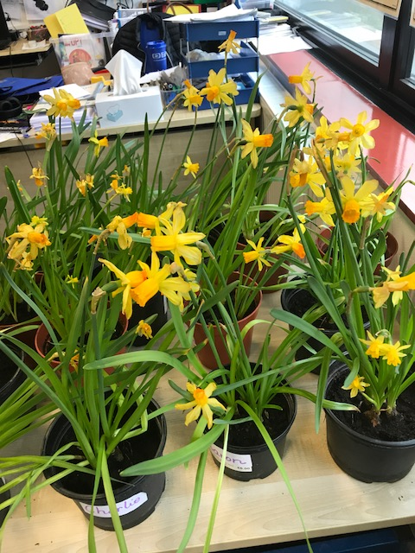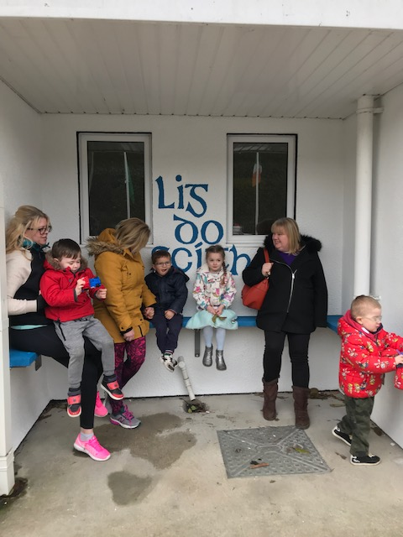

*Room 23’s daffodils*

***Remember Green is cool at home and at school!***

St Mary’s Parents’ Association

Dates for Your Diary:

**March 2nd**: Bingo Committee meeting at 9.30am in the staffroom. If you want to help out at all come along and see what we are planning.

**March 6th:** PA meeting at 7.30pm in staffroom. All parents/guardians welcome to attend.

**March 18th**: Family Fun Day Bingo with all funds raised going towards the MUGA fund. The Bingo will be held in the Dr. Eileen Reilly hall from 3-6pm. All welcome to attend what promises to be a great afternoon. Apologies for the error in previous Imlitirs regarding time.

<https://www.facebook.com/stmarysparentsassoc/>

Caroline Smith

Secretary

**Community Notices**

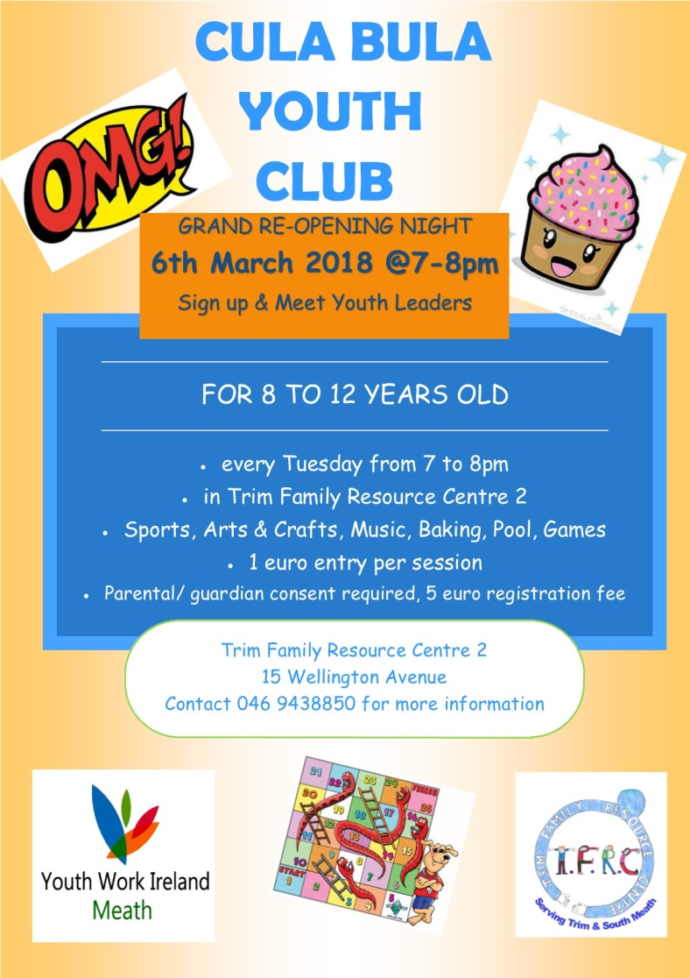



**Searsol Touch Typing Course**

**Age Group**: 8 years +

**Day/Time**:  Mondays, 4.30pm

**Location**: ST MARYS NS, TRIM

**Contact**: Jackie 086-3780842

**Website**:  [www.searsol.com](https://searsol.com/)

A touch-typing course designed to develop the typing skills of children 8 years & upwards in a classroom environment with a qualified tutor. You can join the course any time as your child works at their own pace in a small class environment so each child gets the  individual attention they need.  Free trial first lesson!

***This class is for all children but particularly helpful to kids with learning differences such as Dyslexia, Dyspraxia and Autism.***

**ZUMBA  :**   MONDAY / WEDNESDAY  8pm  TRIM GAA,   €8 per class pay as you go,  suitable for all fitness levels  Contact : Lorraine 086 8693546

**ZUMBA KIDS**  :  New 4 week term beginning this Thursday 1st March,  St. Patrick's hall (under snooker club)   2.15pm - 3pm,   school pick-up available.  Limited places,  Contact :  Lorraine  086 8693546

**St Marys Easter Camp**. Dates 26th – 29th March 10.00 – 2.30 for children aged 4-12. €55. Lots of fun activities planned. Leaflets will be distributed next week. Contact Ms Carr or Ms Leavy.

**Homework Club** in St Mary’s for children from 1st – 6th Classes. Application Forms are available from Ms Conaty Room 11 or Ms Lynch Room 31.

**Under 12 Camogie** Starting back in Trim GAA on Monday Feb 5th @ 6pm. New players welcome. Enquiries: 086-8795233 (Michelle)

**Trim Badminton club** - looking for new members age 9-15 year olds- takes place in Trim GAA on Thursday nights from 7-8.30 - the first hour is coaching with an external coach. Pop in and try it. **First night is a FREE Trial.** Then €5 a night.

**GK Stage Academy**, Performing Arts Easter Camp comes to Trim GAA this March 26th - 29th from 10am - 1pm. A jam packed four days of dance, drama, song and fun for boys and girls ages 3 - 12years. Places strictly limited and filling fast! Call 0863566061 or message [Facebook.com/GKStageAcademy](http://facebook.com/GKStageAcademy) to book yours!

