***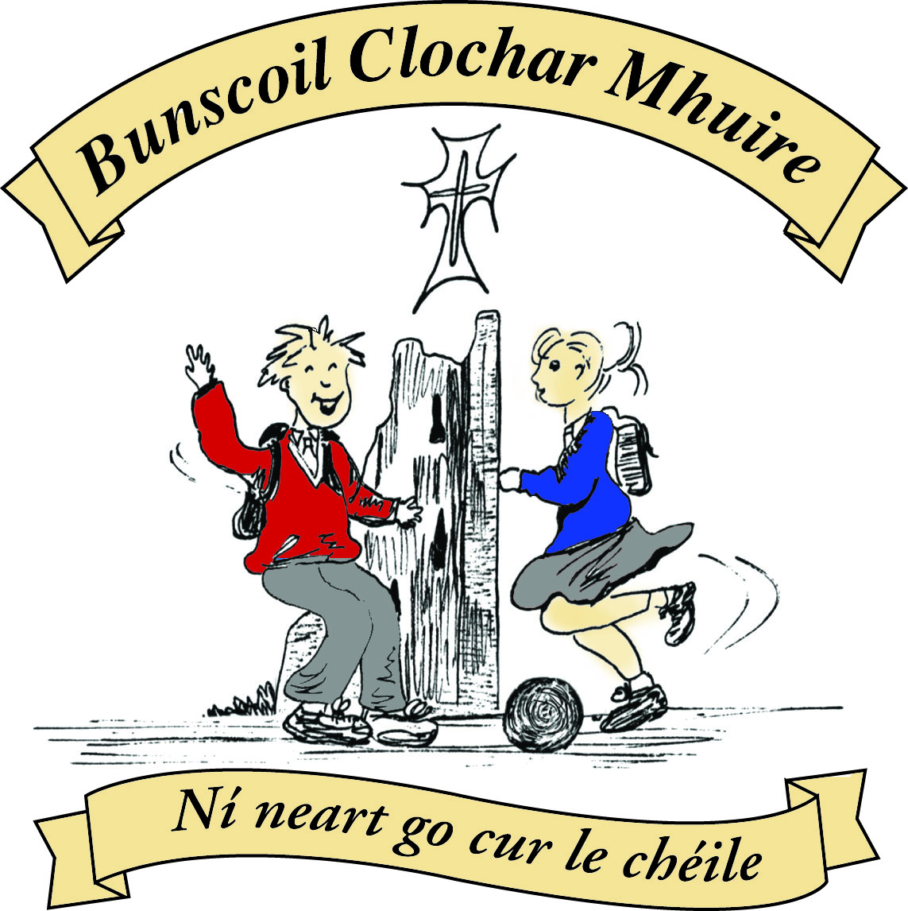* St Mary’s Convent Primary School**

***Bunscoil Clochar Mhuire***

***Trim, Co. Meath.  
Fón: (046) 9431919 ⦁ Faics: (046) 9437942  
Ríomhphost:*** [***marystrim@eircom.net***](mailto:marystrim@eircom.net) ***⦁ Website:*** [***www.stmarystrim.ie***](http://www.stmarystrim.ie) ***Uimhir Rolla: 16646O***

Awarded Green Flag  
June ‘05/’07/11/13

***Imlitir 24***

22nd February, 2016

***Every Day Counts at St Mary’s Convent Primary School***

***15th – 17th February 2016***

|  |  |  |  |  |  |  |  |
| --- | --- | --- | --- | --- | --- | --- | --- |
| **Room** | **Attendance** | **Room** | **Attendance** | **Room** | **Attendance** | **Room** | **Attendance** |
| 01 | 90.1% | 08 | 98.8% | 16 | 98.8% | 26 | 93.8% |
| 02 | 97.4% | 09 | 95.1% | 17 | 90% | 27 | 92.9% |
| 03 | 96% | 10 | 95.2% | 18 | 94% | 30 | 62.1% |
| 04 | 89.7% | 12 | 91% | 19 | 98.6% | 31 | 65.5% |
| 05 | 96.4% | 13 | 75.6 % | 20 | 80.6% |  |  |
| 06 | 96.4% | 14 | 87.2% | **23** | **100%** |  |  |
| 07 | 92.3% | 15 | 94.7% | **24** | **100%** |  |  |

A Chairde,

Congratulations to Rooms **23&24** on having full attendance last week. Their teacher will let them know this week what their prize is.

*It is "****Safety Week”*** *this week in our school. All the classes will be concentrating on road safety. The Junior infants will be receiving hi vis vests,  First Class will be learning about The Seatbelt Sheriff and Second Class will be participating in the Hi Glo Silver programme. These programmes are school road safety initiatives promoted by the RSA.*   
 *S. Minogue*

***Spelling Bee 2016****: Congratulations to all twenty-four competitors from 5th and 6th Classes who took part in the St Mary’s Spelling Bee Final last Wednesday. The overall winner was Shona Kiely for Room 31, with her classmate Aisling O’Toole finishing in second place. Our newly crowned 2016 Spelling Bee Champion has jumped the first hurdle and is now looking forward to the county final. Maith thú Shona and go n-éirí leat sa dara babhta!*

*D. Galligan*

***Credit Union Schools Quiz 2016****: Round Two (Chapter Level) of the Credit Union Schools Quiz Competition will take place in Navan this coming Friday night. We wish Emma, Emily, Anna and Lucy every success in the U-11 section of the competition. Go n-éirí libh a chailíní!*

*D. Galligan*

Please remember to use the car park appropriately and remind your child/ren to use the footpaths. Ask them to sing “The Safe cross Code”. Check out [www.rsa.ie](http://www.rsa.ie)

We welcome the impending removal of the mast in Mornington Heights, near our school, and thank all those who campaigned for its removal, over the years.

**Siúlaimis:** All pupils now have cards to record walking to and from school or WOW or use of Slí na Sláinte (our walking track in the school yard). Please encourage them to do so and where relevant, please sign if they walk to or from school.

**Twitter:** We will be opening a Twitter school account soon for use in the Irish language only! Keep an eye out for the note in the next week or so. We plan on using it to converse with pupils from other schools and to ommunicate, *as Gaeilge* only, with families who wish to.

As stated in last week’s Imlitir, offers of places for September next year will be posted on 24th February. The volume of applications is not as high as last year and the cut-off date will not be as early.

**Timekeeping:** Please note that pupils are expected to be in school by 9.20am. I would like to take this opportunity to thank parents/guardians and children who arrive on time. Pupils who are regularly late are sent to the office where their name is entered into a Late Book and a White Card is sent home to inform the parents/guardians. If this persists a meeting will be called to address the situation.

**Healthy Lunches:** Please be aware of our policy. Copies are available from our website and there is also a copy in our Dialann Scoile (Homework Journal)

**Headlice:** Please check your child’s hair on a regular basis. If there has been a case reported, we send a letter to that class. Please check your child’s bag regularly for letters and notes. Imlitirs are usually sent on Mondays or Tuesdays.

Mise le meas,



Cóilín Ó Coigligh, Príomh Oide.

**Green News**

**Community News**

**Nath na Seachtaine:** Bí Cúramach! Bí slán! (Be careful, Be safe)

**Seanfhocal na Míosa**: Bíonn cluasa móra ag muca beaga! (Little pigs have big ears!!)

**Dates to Remember**

**Assembly: “Safety Week”** Assembly Thursday @ 9.20 for whole school. All Welcome

**Meitheal:** Every Tuesday morning 9.30-10.30.

**Banna Ceoil:** Every Tuesday @ 3pm.

**First Communion:** Saturday 28th May @ 11.00 a.m.

**First Confession:**  Wednesday 2nd March @ 7.00pm

**Please keep an eye on the Parish Bulletin for any changes.**

**Green News**

**Siopa Glas**

In two weeks time we will be hosting our annual *Siopa Glas* (Green Shop). This is our opportunity to do some good with our recycling. The pupils and teachers of St Mary’s donate clothes, toys, books, bric-a-brac and anything that might be of use to someone else. These items are then sold at our Siopa Glas and the proceeds are sent to a school in Zambia. Sr Claudia, a former Principal and teacher at St Mary’s is now operating a Special Needs School in Zambia. Flamboyant Special Needs School is a newly developed facility and is badly in need of resources. We welcome the opportunity to offer our support through our green initiatives in St Mary’s. If anyone has a suitable item for a raffle, we would really appreciate it.

At St Mary’s we continue to recycle batteries, ink cartridges, Nespresso Pods, footwear, small plastic bottles, card, toilet rolls, postage stamps and eye glasses.

Our theme this year for the Green Schools Programme is Global Citizenship with a particular emphasis on Litter and Waste Management. Each class is ensuring that they recycle as much as possible and that the bin for non-recyclable waste is kept to a minimum. All leftover food is brought home in lunchboxes.

**WOW**

Our numbers for WOW are increasing. The new meeting point in the car park behind the Matchbox is proving to be a success. We would encourage more people to join us every Wednesday. The Scores on the Doors are beginning to soar! Our Siúlaimis campaign is also underway so there are lots of people choosing the healthy, environmentally-friendly way to get to school. Maith sibh!

As this is Safety Week, we would like to highlight the importance of keeping safe as you walk or cycle. Pay attention to the Safe Cross Road when walking and to the rules of the road when cycling. Everyone should have their own hi-viz vest which should be worn for extra safety. Helmets are mandatory when cycling.

By now, children from 3rd Class up should have received their permission slips for participation in the St Patrick’s Parade. This year as part of our Global Citizenship theme, we will need participants whose family’s roots are in a different country as well as those who are from Ireland. We hope to celebrate the international profile of our school by representing the culture of the different nationalities of our pupils. We will be contacting you about your country colours, flags, national dress etc. It should be a very nice spectacle in the St Patrick’s Day Parade this year.

***Remember Green is cool at home, at school and around the Globe!***

**Community Notices**

**ZUMBA**  :-   No experience, partner or booking required -  2 classes to choose from:-

MONDAY   8pm   Trim GAA, THURSDAY  8pm  Dance Force Academy €8 per class     Contact :  Lorraine  086 8693546

**KIDS DANCE CLASS** :-        Ages 5-8          TUESDAY    3.15pm    TRIM GAA

 €6 per class  (Sibling rate €5) Zumba,  Hip-Hop,  Rock 'n Roll,  Jive...    Contact :  Lorraine  086 8693546 / Jo  086 3381159

**Trim Coder Dojo:** I amcurrently trying to set this up for 7-17 year olds to teach them to write “Computer Code” I need two important elements “Teachers & Learners” I expect that I won’t have a shortage of learners so if anyone knows of friends or relatives who can write computer code, please let them know that Trim Coder Dojo needs them. Call 046-9438850 or [ittutortrimfrc@gmail.com](mailto:ittutortrimfrc@gmail.com). Peter Dilworth