***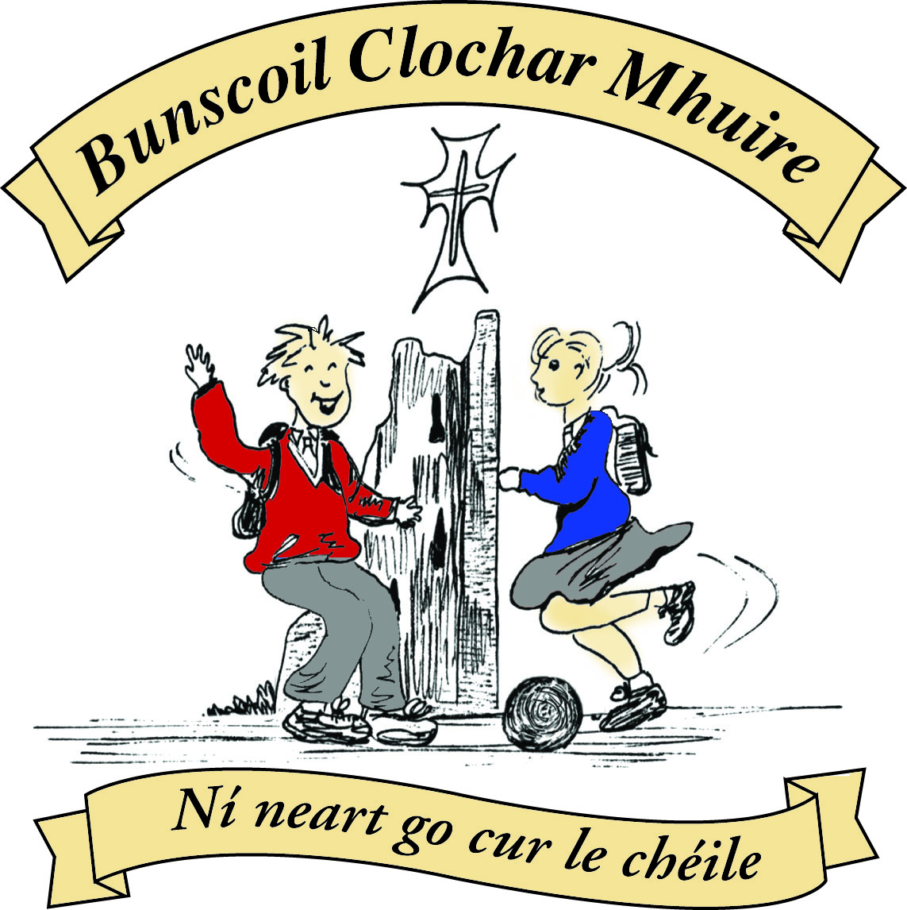* St Mary’s Convent Primary School**

***Bunscoil Clochar Mhuire***

***Trim, Co. Meath.  
Fón: (046) 9431919 ⦁ Faics: (046) 9437942  
Ríomhphost:*** [***marystrim@eircom.net***](mailto:marystrim@eircom.net) ***⦁ Website:*** [***www.stmarystrim.ie***](http://www.stmarystrim.ie) ***Uimhir Rolla: 16646O***

Awarded Green Flag  
June ‘05/’07/11/13

***Imlitir 23***

19th February, 2018

***Every Day Counts at St Mary’s Convent Primary School***

***12th Feb – 14th Feb 2018***

|  |  |  |  |  |  |  |  |
| --- | --- | --- | --- | --- | --- | --- | --- |
| **Room** | **Attendance** | **Room** | **Attendance** | **Room** | **Attendance** | **Room** | **Attendance** |
| 01 | 89.7 % | 08 | 81.5% | 16 | 90.5% | 26 | 82.7 % |
| 02 | 86.7% | 09 | 70.5% | 17 | 86.6% | 27 | 97.4% |
| 03 | 83.9% | 10 | 88% | 18 | 97.6% | 30 | 64% |
| 04 | 88.5% | 12 | 92% | 19 | 88.9% | 31 | 65.3% |
| 05 | 98.7% | 13 | 90.3% | 20 | 89.7% |  |  |
| 06 | 91.7% | 14 | 89.3% | 23 & 24 | 98.5% |  |  |
| **07** | **100%** | 15 | 85.1% |  |  |  |  |

*Well done to room 7 on having full attendance last week. The teacher will let them know their reward. Please note that notification in writing, with the reason for all absences, to the teacher is required. A letter or note in the homework journal will suffice.*

A chairde,

Please note that we will be closed @ 12.30 on Friday for the pupils, as staff have Child Protection training.

**Junior Infant Classes**: Parent Teacher meetings will be on Wednesday and Thursday of this week

Please remember to use the car park appropriately and remind your child/ren to use the footpaths. Ask them to sing “The Safe cross Code”. Check out [www.rsa.ie](http://www.rsa.ie)

**Siúlaimis:** All pupils now have cards to record walking to and from school or WOW or use of Slí na Sláinte (our walking track in the school yard). Please encourage them to do so and where relevant, please sign if they walk to or from school.

**Timekeeping:** Please note that pupils are expected to be in school by 9.20am. I would like to take this opportunity to thank parents/guardians and children who arrive on time. Pupils who are regularly late are sent to the office where their name is entered into a Late Book and a White Card is sent home to inform the parents/guardians. If this persists a meeting will be called to address the situation.

**Healthy Lunches:** Please be aware of our policy. Copies are available from our website and there is also a copy in our Dialann Scoile (Homework Journal)

**Headlice:** Please check your child’s hair on a regular basis. If there has been a case reported, we send a letter to that class. It is a good idea to tie up long hair.

Mise le meas,



Cóilín Ó Coigligh, Príomh Oide.

**Green News**

**Community News**

***Nath na Seachtaine: Lig do scíth (Take a rest*)**

***Seanfhocal na Míosa: Giorraíonn beirt bóthar (Two shorten the journey)***

**Dates to Remember**

**Assembly:** Green Flag. Friday @ 9.20

**Meitheal:** Every Tuesday morning 9.30-10.30.

**Drama Club:** Every Thursday 3-4pm for 5th Class

**Banna:** Tuesdays @ 3.00 – 4.00

**First Confession:** Wed 7th March @ 7.30pm

**Communion: Saturday 5th May @ 11.00**

**Family Fun Bingo:** Sunday March 18th @ 3.00pm

**Child Protection Training:**  Friday Feb 23rd. **School Closes @ 12.30**

**New Language Curriculum In-service:** Tuesday May 29th **School Closed for pupils**

**Green News**

**Last week we talked about the** 17 Global Goals we will be examining as part of our Global Citizenship theme. Some of you may have viewed the video clip:

<https://vimeo.com/138852758>

The second of the global goals on the poster is ‘Zero Hunger’. In this day and age, when we all have plenty of food (and even an excess at times) in our part of the world, it is shameful to think that there are so many people in the developing countries who are starving. A survey over two years, 2014-2016 estimated that one in nine people were suffering from undernourishment. On a local level we can become more cognisant of how much food we waste and commit to helping eliminate hunger in the developing countries. The Trócaire campaign is running at the moment. If you haven’t received your Trocaire box this Lent, they are available from the church. It is a nice reminder of how a little help goes a long way. The Trócaire campaign has been supporting vulnerable people in the developing world and raising awareness of injustice and global poverty since 1973.

Recycling continues in school. We accept batteries, ink cartridges, mobile phones, card, toilet rolls, cans, footwear and postage stamps. Remember the batteries are now going towards the Barretstown charity. Children helping children. Many charities benefit from our recycling and it is a great habit to cultivate in our pupils.

WOW will continue as normal this week. Meet up at Mornington House or at the Matchbox at 9:00am. Well done to all the pupils and parents who continue to support this initiative and of course to the WOW teachers who make it all possible. Ní neart go cur le chéile!

***Remember Green is cool at home and at school!***

St Mary’s Parents’ Association

Dates for Your Diary:

**February 23rd**: Bingo Committee meeting at 9.30am in the staffroom. If you want to help out at all come along and see what we are planning.

**March 18th**: Family Fun Day Bingo with all funds raised going towards the MUGA fund. The Bingo will be held in the Dr. Eileen Reilly hall from 3-6pm. All welcome to attend what promises to be a great afternoon. Apologies for the error in previous Imlitirs regarding time.

<https://www.facebook.com/stmarysparentsassoc/>

Caroline Smith

Secretary

**Community Notices**

**Searsol Touch Typing Course**

**Age Group**: 8 years +

**Day/Time**:  Mondays, 4.30pm

**Location**: ST MARYS NS, TRIM

**Contact**: Jackie 086-3780842

**Website**:  [www.searsol.com](https://searsol.com/)

A touch-typing course designed to develop the typing skills of children 8 years & upwards in a classroom environment with a qualified tutor. You can join the course any time as your child works at their own pace in a small class environment so each child gets the  individual attention they need.  Free trial first lesson!

***This class is for all children but particularly helpful to kids with learning differences such as Dyslexia, Dyspraxia and Autism.***

**St Marys Easter Camp**. Dates 26th – 29th March 10.00 – 2.30 for children aged 4-12. €55. Lots of fun activities planned. Leaflets will be distributed next week. Contact Ms Carr or Ms Leavy.

**Homework Club** in St Mary’s for children from 1st – 6th Classes. Application Forms are available from Ms Conaty Room 11 or Ms Lynch Room 31.

**Trim** : Free Walking group name **Walkies.** Meeting point, across from the garda station Trim. Time 10am to 11am Day : Friday Contact Dorenda  087 2726479

**Navan** : Buggy Buddies the free local walking group open to parents and carers of babies.  Meeting Point:  Blackwater Park  Time 9.30am-10.30am  Day Thursday. Contact Margo 0894576235

**Under 12 Camogie** Starting back in Trim GAA on Monday Feb 5th @ 6pm. New players welcome. Enquiries: 086-8795233 (Michelle)

**Trim Badminton club** - looking for new members age 9-15 year olds- takes place in Trim GAA on Thursday nights from 7-8.30 - the first hour is coaching with an external coach. Pop in and try it. **First night is a FREE Trial.** Then €5 a night.

**GK Stage Academy**, Performing Arts Easter Camp comes to Trim GAA this March 26th - 29th from 10am - 1pm. A jam packed four days of dance, drama, song and fun for boys and girls ages 3 - 12years. Places strictly limited and filling fast! Call 0863566061 or message [Facebook.com/GKStageAcademy](http://facebook.com/GKStageAcademy) to book yours!

