***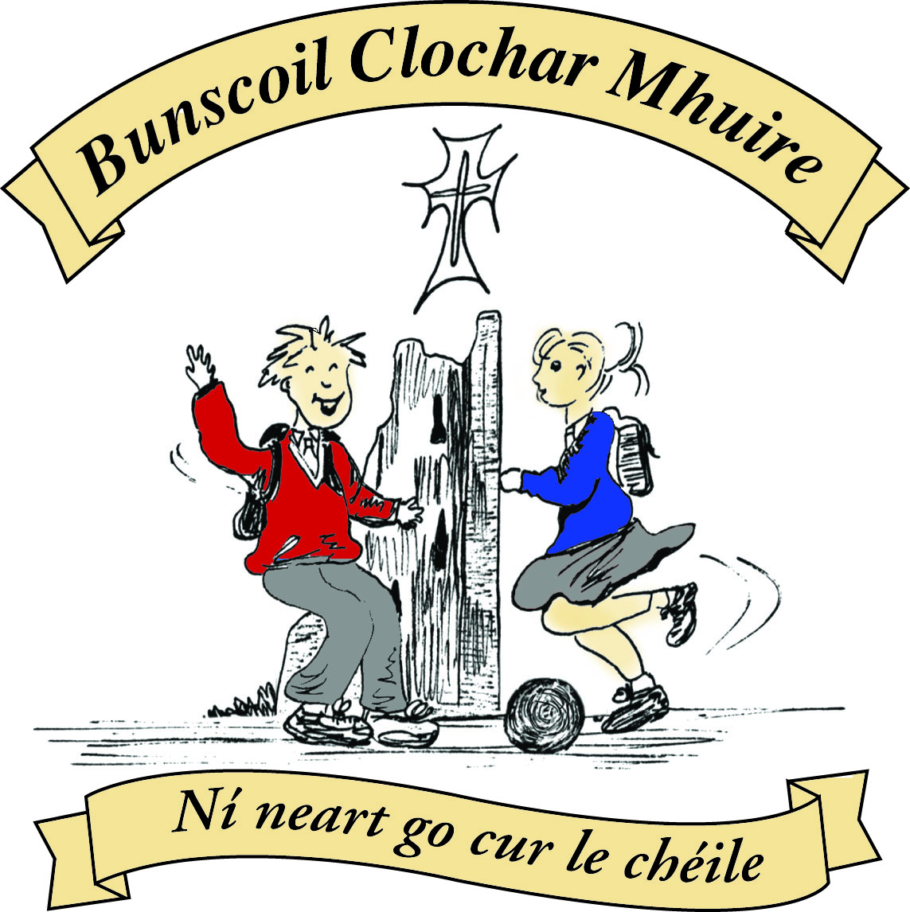* St Mary’s Convent Primary School**

***Bunscoil Clochar Mhuire***

***Trim, Co. Meath.  
Fón: (046) 9431919 ⦁ Faics: (046) 9437942  
Ríomhphost:*** [***marystrim@eircom.net***](mailto:marystrim@eircom.net) ***⦁ Website:*** [***www.stmarystrim.ie***](http://www.stmarystrim.ie) ***Uimhir Rolla: 16646O***

Awarded Green Flag  
June ‘05/’07/11/13

***Imlitir 22***

9th February, 2016

***Every Day Counts at St Mary’s Convent Primary School***

***1st – 5th February 2016***

|  |  |  |  |  |  |  |  |
| --- | --- | --- | --- | --- | --- | --- | --- |
| **Room** | **Attendance** | **Room** | **Attendance** | **Room** | **Attendance** | **Room** | **Attendance** |
| 01 | 87.4% | 08 | 92.9% | 16 | 98.5% | 26 | 90.4% |
| **02** | **100%** | 09 | 98.5% | 17 | 96% | 27 | 91.4% |
| 03 | 82.4% | 10 | 90% | 18 | 89.3% | 30 | 94.5% |
| 04 | 90% | 12 | 89.2% | 19 | 99.2% | 31 | 94.5% |
| 05 | 91.4% | 13 | 90.8% | 20 | 96.7% |  |  |
| 06 | 85.7% | 14 | 90.4% | 23 | 97% |  |  |
| 07 | 84.6% | 15 | 96% | 24 | 96.7% |  |  |

A Chairde,

Congratulations to Room **2** on having full attendance last week. Their teacher will let them know this week what their prize is.

Don’t forget free coffee etc. on Friday next at 9.30 in the Staffroom, as part of our *Maidin Caife.* As I explained to you last week, all you have to do is speak a little or even listen a little *as Gaeilge* (in Irish)!

Please support Pink and Red Day on Friday next organised by our Parents’ Association. They will be sending notes home with further details.

The gutters are currently being replaced, funded by the Department of Education and Skills (DES). We also have secured funding to sort the drainage problems in the yard and further funding to improve wheel chair access and facilities. We hope that these will start soon. Apologies for any inconvenience that these works may cause.

Every good wish and God’s blessing on our Sixth Class pupils who make their Confirmation on Saturday next. Many thanks to Ms Heffernan and Mr Galligan who have prepared them so well.

***Spelling Bee 2016****: The Eason Spelling Bee will take place across the island of Ireland over the coming weeks and months. The annual competition begins at school level and progresses to county, provincial and national level. It is open to pupils in 5th and 6th Classes. This will be our fifth consecutive year taking part in the popular competition. During the coming week, 5th and 6th Class pupils here at St Mary’s will participate in a Spelling Bee in their own classrooms. Those pupils who do not wish to participate at any stage of the competition can opt out. Representatives from each classroom will then progress to the school final in our PE Hall – this is scheduled to take place before mid-term and pupils from 3rd, 4th, 5th and 6th Classes are invited to attend. The overall winner of our school competition will represent St Mary’s at the county final (date and venue to be announced in due course). A commemorative wall-plaque has been purchased by the school to record the name of our school champion on an annual basis. Watch this space to find out who will become the St Mary’s Spelling Champion for 2016! D Galligan*

***Be Active Homework Journals:*** *Every child should have received their own Be Active homework journal and family wall chart. They also should have a letter for parents/guardians to explain all and how to access free Be Healthy materials online. Every 15 mins of physical activity means another part of the smiley face! Teachers will be checking these journals, which are to be kept in schoolbags. Thanks*

*Ms Murray & Ms Maguire*

**Registration Forms** for children starting school in September 2016 are available from Helen, in the office. Please note that the Submission Date for return of forms is 15th February.

**Green News**

**Community News**

Mise le meas,



Cóilín Ó Coigligh, Príomh Oide

**Nath na Seachtaine:** **Bí cúramach! (Be careful!)**

**Seanfhocal na Míosa**: **Bíonn cluasa móra ag muca beaga**

**Dates to Remember**

**Assembly:** Green Flag @ 9.20 Friday for Senior Classes

**Meitheal:** Every Tuesday morning 9.30-10.30.

**Banna Ceoil:** Every Tuesday @ 3pm.

**Confirmation:**  Saturday 13th February @ 11.00 a.m.

**First Communion:** Saturday 28th May @ 11.00 a.m.

**First Confession:**  Wednesday 2nd March @ 7.00pm

**Please keep an eye on the Parish Bulletin for any changes.**

**Green News**

Our WOW campaign is being revamped! As part of our Be Active campaign, every pupil who walks (or cycles) to school on Wednesdays will be counted and a ‘Score on the Door’ will be kept. The class that accumulates the highest score for the month will be rewarded. In this accumulative way, we are also trying to walk the length and breadth of Ireland and maybe further afield after that. More details about this Slí na Sláinte will be released soon. Ms Flattery and Ms Heffernan will continue to meet the WOW pupils and families up at Mornington House at 9:00am on Wednesdays. We are also going to add a new WOW meeting point. This will be in the carpark behind The Matchbox. Pupils and/or Parents are encouraged to meet here and 9.00am if they would like to participate.

COW will resume after Easter when the weather improves.

Our Green Blog has started up again, thanks to Ms Dalton. If you would like to view some posts, you may use the following link:

**stmarysgreenblog.blogspot.ie**

Our School will be participating in the Pride of Place (POP) initiative again this year. Anybody who is interested in Gardening is invited to help us. Please contact the office if you are interested.

Global Citizenship is our Green Schools Theme this year with a specific focus on Litter and Waste Management. At St Mary’s we encourage recycling. Among the materials we recycle at school are: batteries, small plastic bottles, footwear, spectacles, cardboard, postage stamps, ink cartridges, cans, Nespresso pods and toilet rolls.

To further highlight the theme of Global Citizenship, we intend to have a representation at the St Patrick’s Day parade of the different nationalities attending our school. It would be quite a spectacle to have lots of National colours and costumes that day. Permission slips will be sent home this week. We would be delighted if you would like to be involved on the day.

***Remember Green is cool, at home, at school and around the globe!***

**Community Notices**

**Trim Kempo Karate: Tue/Thursday** Beginners @ 6.00 Intermediate @ 7.00/8.00 Seniors @ 9.00/10.00 **Saturday** Begineers/Jun @ 10.00 Intermediate @ 11.00 Seniors @ 12.00/1.00

**ZUMBA**  :-   No experience, partner or booking required -  2 classes to choose from:-

MONDAY   8pm   Trim GAA, THURSDAY  8pm  Dance Force Academy €8 per class     Contact :  Lorraine  086 8693546

**KIDS DANCE CLASS** :-        Ages 5-8          TUESDAY    3.15pm    TRIM GAA

 €6 per class  (Sibling rate €5) Zumba,  Hip-Hop,  Rock 'n Roll,  Jive...    Contact :  Lorraine  086 8693546 / Jo  086 3381159

**Trim Family Resource Centre** invite you to participate our Parents Plus programme specific to parents of children in Primary School (6 to 11 years) Week starting Feb 15th Classes will be scheduled for morning or evening depending on numbers. Time: 10.30 am – 12.30 pm Venue: Trim FRC, Mornington. To register please contact Susan at 046-9438850