***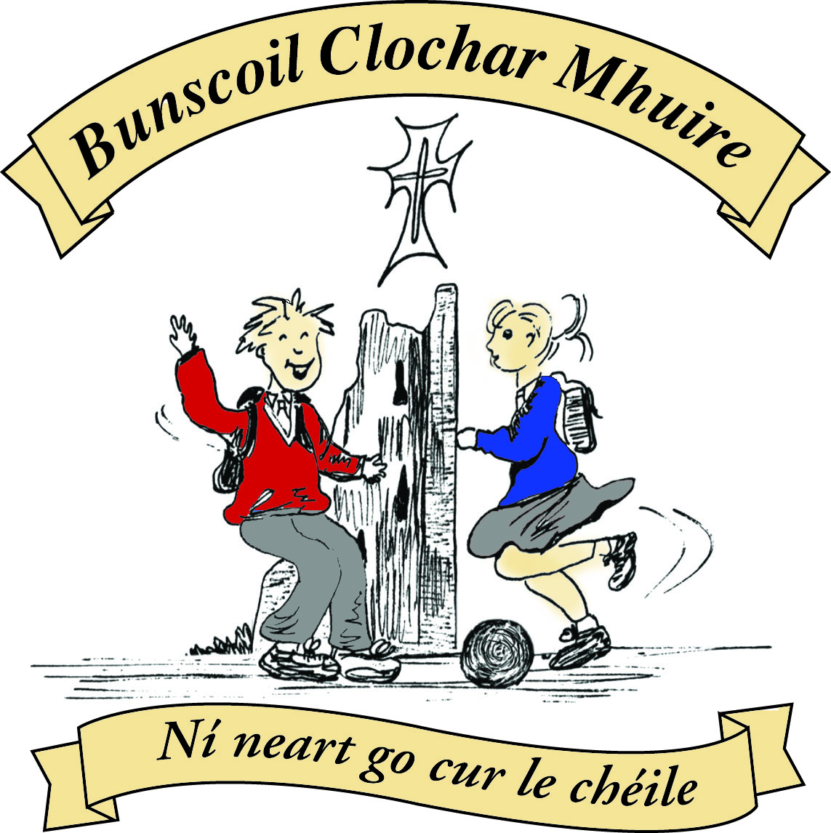* St Mary’s Convent Primary School**

***Bunscoil Clochar Mhuire***

***Trim, Co. Meath.  
Fón: (046) 9431919 ⦁ Faics: (046) 9437942  
Ríomhphost:*** [***marystrim@eircom.net***](mailto:marystrim@eircom.net) ***⦁ Website:*** [***www.stmarystrim.ie***](http://www.stmarystrim.ie) ***Uimhir Rolla: 16646O***

Awarded Green Flag  
June ‘05/’07/11/13

***Imlitir 22***

13th February, 2018

***Every Day Counts at St Mary’s Convent Primary School***

***5th Feb – 9th Feb 2018***

|  |  |  |  |  |  |  |  |
| --- | --- | --- | --- | --- | --- | --- | --- |
| **Room** | **Attendance** | **Room** | **Attendance** | **Room** | **Attendance** | **Room** | **Attendance** |
| 01 | 92.4 % | 08 | 94.1% | 16 | 94.3% | 26 | 93.3 % |
| 02 | 94.5% | 09 | 94.6% | 17 | 91.6% | 27 | 97.7% |
| 03 | 93.8% | 10 | 92.8% | 18 | 92.9% | 30 | 96.8% |
| 04 | 95.2% | 12 | 95.2% | 19 | 96.3% | 31 | 98.4% |
| 05 | 90% | 13 | 96.7% | 20 | 95.4% |  |  |
| 06 | 97.5% | 14 | 92.9% | 23 & 24 | 97.1% |  |  |
| 07 | 90.4% | 15 | 95.9% |  |  |  |  |

*Please note that notification in writing, with the reason for all absences, to the teacher is required. A letter or note in the homework journal will suffice.*

A chairde,

**Intercultural Week**

Intercultural Week in St Mary’s will be held this week February 12th – 16th. We celebrate the cultural diversity of all the pupils in our school. (Seachtain na Gaeilge will be in March !! )

We encourage parents/grandparents/minders  of international pupils to visit during the week , or at a time that suits them. They might like to talk about  their home country with reference to  similarities/differences in school, climate, food, music, dance, religious traditions and customs , sport etc.

Maybe you could help children with a common language listen to a story in their home language.  It can make a big difference to their self esteem to hear their own language spoken in front of their peers.

 We are hoping to have plenty of activities to celebrate all the different cultures in our school. If you can speak Polish/ Lithuanian/ Latvian/Tagalog/ Malayalam or another language maybe you could read a story in your childs’ classroom. If you have any ideas on sharing music/cookery/costumes/art with us please give your name to the class teacher - we would love to hear from you, in the next few days. Have you spent time living in another country? Maybe you could bring in some photos or posters and talk to the children – we can all learn from each other. R. McGale

The **B.O.M.** met on Tuesday 6th February. A number of maintenance repairs have been carried out on the school in the past few weeks, the front door, gates and skylight in the Dr.Eileen O'Reilly Hall to prevent glare. Five leaves of absence were granted for the coming school year which in turn will create five temporary jobs in September.  We are happy to announce that works on the MUGA will commence in the coming weeks. We look forward to using this excellent resource for sports and extra yard space at break time. Finally we are in the second and final year of the Health Promoting Schools initiative. As part of the initiative we will be running a Be Active and Well being week in June. We are working towards winning the Healthy Schools Flag before the summer holidays. B.Munnelly

**School Closures:** Please note that school will be closed on Thursday and Friday of this week, that is the 15th and 16th, for Mid-Term Break. Due to Staff Training on Child Protection, school will be closed for the pupils @ 12.30 on Friday February 23rd. Please also note that school will be closed for the pupils on Tuesday May 29th, all day. Teachers will be attending In-service on the New Language Curriculum. Please make the necessary arrangements.

**Paired Reading** continues for classes 1st to 3rd until the end of this month. Don’t forget to mark in the book what you have read and try to do it every night.

**Car Park:** All parents/guardians are asked not to park in the yellow box or the special needs spaces in the car park. Keep a careful eye for children and pedestrians and ensure that your children walk on the paths. The co-operation of all is needed to ensure the safety of our children.

**Siúlaimis (let us walk!):** As part of our Be Active Flag and Health Promoting Schools, all children were given a card at the beginning of the school year, to record if they walk to school, take part in WOW or use Slí na Sláinte. Teachers or walking buddies will record Slí na Sláinte & WOW and parents may record if their child walks to or from school. Each classroom will combine their individual progress as a class total on a map of Ireland. We will combine the class totals to “walk” all around the world.

**Seachtain Na Gaeilge**  is coming up in 3 weeks time. Some of the classes have started their Irish Dancing Lessons with Anne and Bobby, whom we are delighted to welcome back every year. Irish dancing is such an important part of our culture. We would encourage you to use the ‘cúpla focal’ especially over the next few weeks. You will notice our ***Nath na Seachtaine* on the Imlitr every week. It might be nice to discuss this with your child and use it in conversation.**

**Last week Ms Maguire painted a lovely Irish saying outside the school, “Lig do Scíth”, which means have a little rest. Maybe you could try this out and use the cúpla focal.**

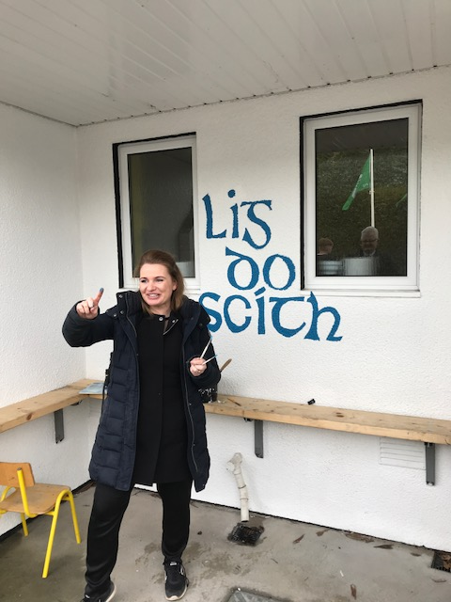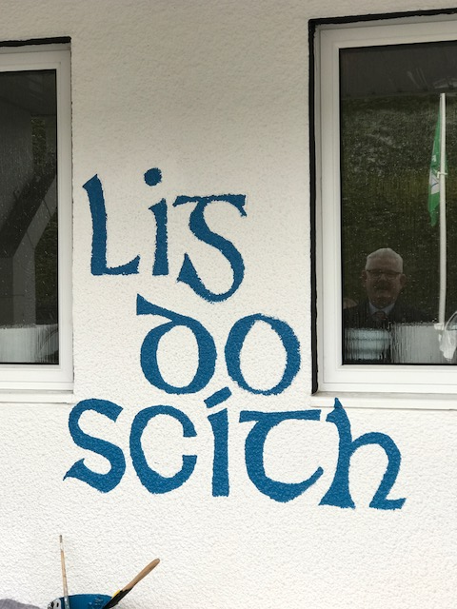

Ms Nally

**Computer Room News:** Scratch lessons continue. This week 1st and 2nd classes will learn to dress their Sprites by selecting various items of clothing which in turn will automatically move over their chosen main Sprite. 3rd – 6th classes will begin to ‘make magic’ in Scratch. Colours will automatically change, Sprites will turn into other things and students will learn how to do this without using ‘when the green flag is clicked’ icon.

Ms Debby

Mise le meas,



Cóilín Ó Coigligh, Príomh Oide.

**Green News**

**Community News**

***Nath na Seachtaine:* Tá mé i mo chónaí  I mBaile Átha Troim**

***Seanfhocal na Míosa: Giorraíonn beirt bóthar****(Giorraíonn sé dhuine is tríocha bóthar gan dabht!!)*

**Dates to Remember**

**Assembly:** Intercultural Week. Wed @ 9.20

**Meitheal:** Every Tuesday morning 9.30-10.30.

**Drama Club:** Every Thursday 3-4pm for 5th Class

**Banna:** Tuesdays @ 3.00 – 4.00

**First Confession:** Wed 7th March @ 7.30pm

**Communion: Saturday 5th May @ 11.00**

**Family Fun Bingo:** Sunday March 18th @ 3.00pm

**Child Protection Training:**  Friday Feb 23rd. **School Closes @ 12.30**

**New Language Curriculum In-service:** Tuesday May 29th **School Closed for pupils**

**Green News**

In our recent Teacher’s magazine, ‘Intouch’, our President Michael D. Higgins and the President of the INTO, Shiela Nunan have promoted global citizenship in our schools. ‘Teachers have always worked together to challenge injustice, tackle disadvantage and eliminate disadvantage’. Here at St Mary’s we try to do this locally and internationally through efforts to help those less fortunate in other parts of the world. Last year we learned so much about Fair Trade and lots of people changed their shopping habits as a result.

Every teacher in the country has been given a poster with the 17 Global Goals. As part of our Global Citizenship theme, we will be examining these as much as we can. Some of the themes are difficult for a primary school setting but there are aspects which can be simplified and made relevant to even the younger classes. See below picture.



The first of these goals is **‘No Poverty’**. This is a suitable time to introduce this idea as Lent starts tomorrow and it is a time for reflection and giving to the poor through campaigns such a Trócaire.

The following video has been recommended:

<https://vimeo.com/138852758>

WOW continues every Wednesday.

Recycling continues in school. We accept batteries, ink cartridges, mobile phones, card, toilet rolls, cans, footwear and postage stamps. Remember the batteries are now going towards the Barretstown charity. Children helping children. Many charities benefit from our recycling and it is a great habit to cultivate in our pupils**.**

WOW will continue as normal this week. Meet up at Mornington House or at the Matchbox at 9:00am. Well done to all the pupils and parents who continue to support this initiative and of course to the WOW teachers who make it all possible. Ní neart go cur le chéile!

Two weeks ago we had an Energy Action day. Third Class made windmills and discussed Wind Energy as an alternative energy source. The photos below show how proud they were of their windmills!

Last week Fourth Classes started a five week science programme with Cool Planets. Clare, the scientist, conducted experiments with the classes to show the Greenhouse effect. Over the next four weeks they will be investigating Climate Change and the factors contributing to it. The pupils will be conducting their own experiments. We will have photos in the next few imlitirs.

***Remember Green is cool at home and at school!***

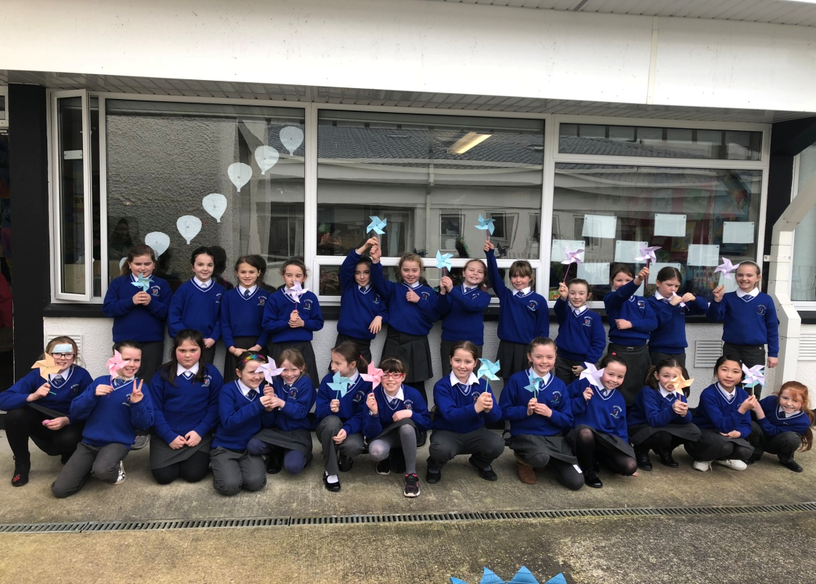

St Mary’s Parents’ Association

Dates for Your Diary:

**March 18th**: Family Fun Day Bingo with all funds raised going towards the MUGA fund. The Bingo will be held in the Dr. Eileen Reilly hall from 3-5pm. All welcome to attend what promises to be a great afternoon.

<https://www.facebook.com/stmarysparentsassoc/>

Caroline Smith

Secretary

**Community Notices**

**Searsol Touch Typing Course**

**Age Group**: 8 years +

**Day/Time**:  Mondays, 4.30pm

**Location**: ST MARYS NS, TRIM

**Contact**: Jackie 086-3780842

**Website**:  [www.searsol.com](https://searsol.com/)

A touch-typing course designed to develop the typing skills of children 8 years & upwards in a classroom environment with a qualified tutor. You can join the course any time as your child works at their own pace in a small class environment so each child gets the  individual attention they need.  Free trial first lesson!

***This class is for all children but particularly helpful to kids with learning differences such as Dyslexia, Dyspraxia and Autism.***

**St Marys Easter Camp**. Dates 26th – 29th March 10.00 – 2.30 for children aged 4-12. €55. Lots of fun activities planned. Leaflets will be distributed next week. Contact Ms Carr or Ms Leavy.

**Homework Club** in St Mary’s for children from 1st – 6th Classes. Application Forms are available from Ms Conaty Room 11 or Ms Lynch Room 31.

**Trim** : Free Walking group name **Walkies.** Meeting point, across from the garda station Trim. Time 10am to 11am Day : Friday Contact Dorenda  087 2726479

**Navan** : Buggy Buddies the free local walking group open to parents and carers of babies.  Meeting Point:  Blackwater Park  Time 9.30am-10.30am  Day Thursday. Contact Margo 0894576235

**Under 12 Camogie** Starting back in Trim GAA on Monday Feb 5th @ 6pm. New players welcome. Enquiries: 086-8795233 (Michelle)

**Trim Badminton club** - looking for new members age 9-15 year olds- takes place in Trim GAA on Thursday nights from 7-8.30 - the first hour is coaching with an external coach. Pop in and try it. **First night is a FREE Trial.** Then €5 a night.

**GK Stage Academy**, Performing Arts Easter Camp comes to Trim GAA this March 26th - 29th from 10am - 1pm. A jam packed four days of dance, drama, song and fun for boys and girls ages 3 - 12years. Places strictly limited and filling fast! Call 0863566061 or message [Facebook.com/GKStageAcademy](http://facebook.com/GKStageAcademy) to book yours!

