***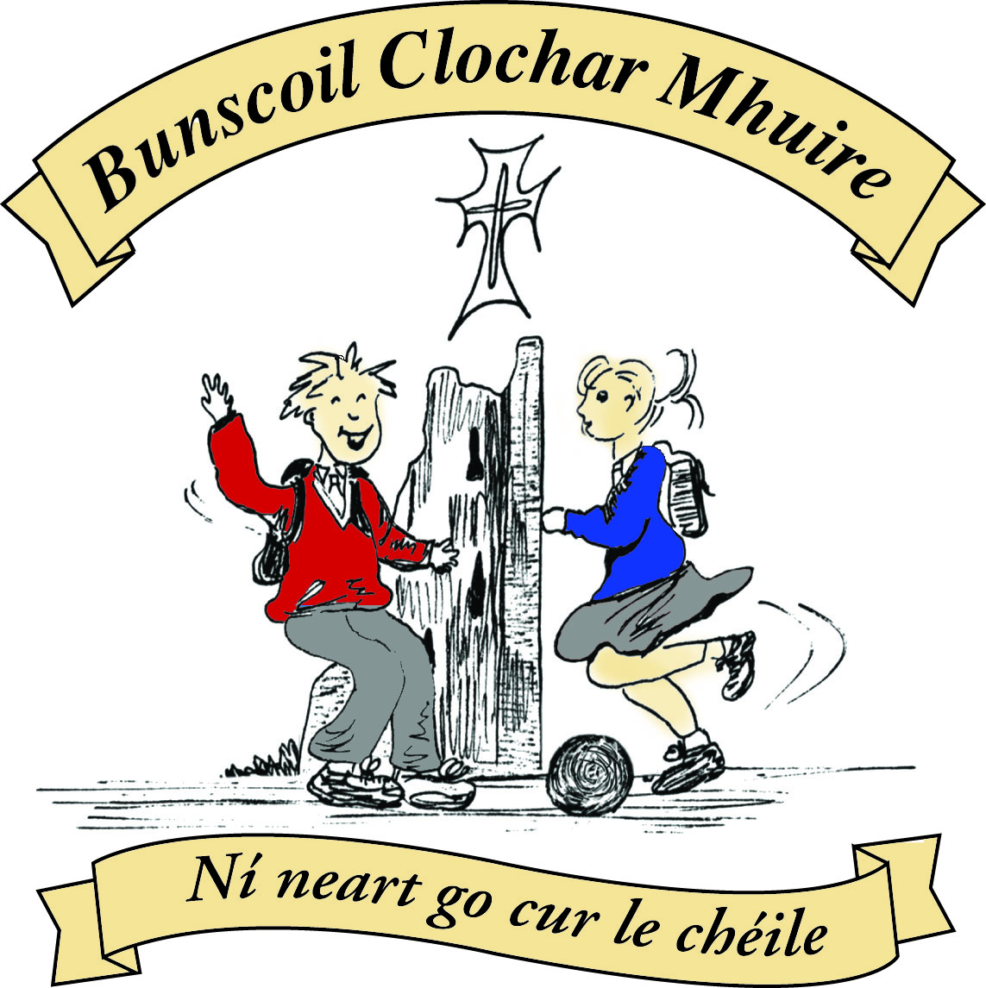* St Mary’s Convent Primary School**

***Bunscoil Clochar Mhuire***

***Trim, Co. Meath.  
Fón: (046) 9431919 ⦁ Faics: (046) 9437942  
Ríomhphost:*** [***marystrim@eircom.net***](mailto:marystrim@eircom.net) ***⦁ Website:*** [***www.stmarystrim.ie***](http://www.stmarystrim.ie) ***Uimhir Rolla: 16646O***

Awarded Green Flag  
June ‘05/’07/11/13

***Imlitir 21***

7th February, 2017

***Every Day Counts at St Mary’s Convent Primary School***

***30th January – 3rd Feb, 2017***

|  |  |  |  |  |  |  |  |
| --- | --- | --- | --- | --- | --- | --- | --- |
| **Room** | **Attendance** | **Room** | **Attendance** | **Room** | **Attendance** | **Room** | **Attendance** |
|  |  |  |  |  |  |  |  |
| 01 | 91.1 % | 08 | 98.4% | 16 | 94.8% | 26 | 99.2% |
| 02 | 92% | 09 | 98.7% | 17 | 93.8% | 27 | 95.8% |
| 03 | 93.9% | 10 | 98.5% | 18 | 94.2% | 30 | 93.8% |
| 04 | 94.1% | 12 | 97.2% | 19 | 94.3% | 31 | 94.3% |
| 05 | 96.9% | 13 | 98% | **20** | **100%** |  |  |
| 06 | 91.2% | 14 | 97.9% | **23 & 24** | **100%** |  |  |
| 07 | 97.6% | 15 | 88.6% |  |  |  |  |

*Congratulations to* ***Rooms 20, 23 & 24*** *on having full attendance last week, their teachers will let them know this week what their prize is. Also to room 26 on nearly making it. Please note that notification in writing to the teacher is required for all absences. A letter or note in the homework journal will suffice.*

A chairde,

***Safety Week Feb. 6th – 10th***

*This week is* ***Safety Week*** *in our school. All the Junior Infant classes will be given hi- vis vests. First Class will be completing the Seatbeat Sheriff programme, Second Class will participate in the Hi Glo Silver programme and the senior classes will learn cycling safety skills.*

*This year for* ***Safety Week*** *we also have an RSA education promotion coordinator coming to our school. Sarah will be visiting each class over three days, educating the children about all aspects of road safety.*

*Don’t forget to get involved in our WOW and COW days****.***

*S. Minogue*

Today, February 7th is Safer Internet Day, please check out this link for some great ideas: <http://www.esafetykit.net/index2.html> Please note that we have had issues in our school around Cyberbullying and that it is important to supervise your children’s use of the internet, in particular Viber, Facebook, Instagram, Snapchat, Whats app, Twitter etc. If you do come across inappropriate comments, remember to screen shot or take a photo of these comments, which could be helpful in resolving the matters.

**Meitheal:** On Tuesday mornings 9.30 – 10.30 a group of volunteers help with teaching materials and other work for the junior classes in particular. We wish to thank those who come in and invite more to join. If you have an hour to spare and would enjoy a cuppa and chat while working (!) please let me know. Thanks.

**Enrolment:** Offers of places were posted on Friday last. The cut-off date is May 31st for new Junior Infants i.e. four before that date. We did receive a large volume of applications in the last few days before the submission date and now have a waiting list for Junior Infants. We may be able to offer more places when the offers posted last Friday are responded to. There is no waiting list in any other class in the school. Please contact us if you were expecting a letter and it has not arrived by tomorrow’s post.

***SID****: February 7th is designated****Safer Internet Day****in Ireland. The internet and social media have undoubtedly many advantages, but we all need to be extremely mindful of the pitfalls, especially for our children. Webwise.ie is a resource promoting online safety in an increasingly technological world. It provides, amongst other things, valuable advice for parents on dealing with cyber-bullying and the sharing of personal information by children on social networking sites. Being familiar with our children's online interactions  is central keeping our youth safe online. Check out  [www.webwise.ie](http://www.webwise.ie/)  and* [*www.saferinternetday.ie*](http://www.saferinternetday.ie/)*for more parental information. Mr Galligan*

***Computer Room News****: Students are still working away in Scratch with 1st – 3rd classes learning how to correctly put together conversations between Sprites and 4th and 6th classes learning how to code basic games with a view to them beginning to experiment on how to make their own games. As it is Internet Safety Day today we will be focussing on ‘how to keep ourselves safe on the internet in social media and the uploading of selfies and photos etc’. It is important that all students know the pitfalls and there are some great sites that you as a parent can access in order to ensure that your children are safe.*

*Ms Debby*

***Spelling Bee 2017****: The launch of the National Spelling Bee took place recently. 5th and 6th Class pupils at St Mary’s are looking forward to choosing our representative in the competition. The process will begin very soon! Mr Galligan*

***Confirmation Classes:****A Mass for pupils at St Mary's who are preparing for Confirmation will  take place on Sunday, February 19th at 11am in St Patrick's Church. All are welcome.*

*Ms Lynch and Mr Galligan*

***Dublin Youth Orchestra:*** *We are delighted to announce that this string orchestra will visit our school on Friday 28th April. They will give a concert to all classes. They are all in 4th, 5th and 6th class and two of our pupils in St Mary’s are members – Tara Veale and Caoimhe Quinn. Please save the date as our Banna Ceoil will also perform on the day. Ms Mc Gale*

***Skipathon.*** *This year’s Skipathon will take place this Friday 10th February in the school hall. This year the Parents’ Association is pleased to announce that* ***all sponsorship cards along with money which are returned to the class teacher before Wednesday 8th February*** *will be entered into a draw for a voucher. Each year will have an individual draw. Parents’ Assosiation*

**Lost and found:** There is 2 pairs of children’s glasses in the office. They are both dark blue and one has coloured spots on the arms. They can be collected from Helen or Rebecca.

Mise le meas,



Cóilín Ó Coigligh, Príomh Oide.

**Green News**

**Community News**

**Nathanna na Seachtaine:**  Bí cúramach! (Be careful)

**Seanfhocal na Míosa: Giorraíonn beirt bothar** (It’s great to have someone to share the journey with!)

**Green News**

This year, as you know by now, we are concentrating on the theme of Global Citizenship with a specific emphasis on Waste management. As part of this programme we recycle in lots of ways at St Mary’s. On February 15th, we are hosting a textile and shoe collection on behalf of Liberty Freedom from Addiction Training and Rehabilitation services. We have helped with this company in the past and they are reputable. We would encourage you to drop in any fabrics, clothing/footwear next Wednesday morning, February 15th.

Our Siopa Glas beag will be coming up in a few weeks also. Please keep that in mind also. We sell recycled toys and books and help developing schools in poorer parts of the world.

Remember, we recycle batteries, mobile phones, small plastic bottles, cans, card, postage stamps and toilet rolls here at school. Well done to all the regular recyclers here at St Mary’s!

This Wednesday, February 8th, Joanna Parkes of Grass Roots Education will address 3rd and 4th Classes on the issue of Energy. Our school was one of the schools nominated by Meath County Council for this workshop. We look forward to this.

WOW (Walking on Wednesdays) continues every Wednesday. Well done to the teachers and pupils who sustain this initiative weekly despite the weather! COW (Cycling on Wednesdays) will resume in the spring when the weather continues.

***Remember green is cool at home, at school and around the globe!***

**Community Notices**

**St Marys Primary School Easter Camp** is back again this year with another fun filled week in store! Monday 10th – Thursday 13th April. 10.00am – 2.30pm. €50 per child. Activities: Arts & crafts, sports and games, dance, baking, science and much more. **For a booking form or further information please contact The Office, Ms Carr or Ms Leavy.**

**Shamrockers Camp** of arts & crafts, sports and fancy dress will take place from 13th – 16th March in St Mary’s School. For more information please contact Ms McKenna or Ms Cullinane.

**Homework Club** in St Marys. Monday, Tuesday and Thursdays. 3.00 – 4.00pm for 1st – 6th Class. €4 per day.

**Dyslexia Talk** by Kathleen Sweeney in the Education Centre in Navan on Feb 13th 6.00 – 9.00pm. It is geared towards Parents and Teachers. Contact 085-7820221 for more details.

**Elegance Gymnastics Club** continue enrolling the Girls from 5 to 12 years old to the Gymnastics classes which will be held every Tuesday and Wednesday from 5 to 6 pm for the girls from 5 to 7 years old, and from 6 to 7 pm for the Girls from 8 to 12 years old. All welcome! Please call to register: 0879134334 or 0876339498.

**Basketball classes** every Tuesday from 4 to 5 pm for the Boys from 7 to 12 years old, and Wednesday from 4 to 5 pm for the Girls from 7 to 12 years old. All Welcome! Please call: 0879134334 Robert.

**ZUMBA  :**-    MONDAY  &  WEDNESDAY  8pm  TRIM GAA.

No booking, partner or experience required......just grab your water and your smile and get ready to dance your cares (and Christmas treats !!) away!        €8 per class       Contact  :  Lorraine  086 8693546

**ZUMBA KIDS** :-   Tuesday  3.15pm  Trim GAA No booking required,  €6 per class      Contact : Lorraine  086 8693546

**Trim Family Resource Centre** are looking for volunteers to help welcome migrants into their local community through conversational English Classes. Do you have two hours per week, like to meet people, wish to make a difference and want to acquire some new skills. Contact Gina on 046-9438850 or [failteisteachfrc@gmail.com](mailto:failteisteachfrc@gmail.com).

**Trim Family Resource Centre:** Would you like to learn English? Come and meet others who are learning too. Thursday evenings 7pm – 9pm and Friday mornings 10.30 – 12.30am. Contact 046-9438850

**Play Therapy & Psychotherapy** is an effective developmental suitable form of therapy for children. It is suitable for children dealing with family breakdown, anxiety, low self esteem, bereavement, behavioural problems and delayed development. Contact Emer for information 086-1969152

