***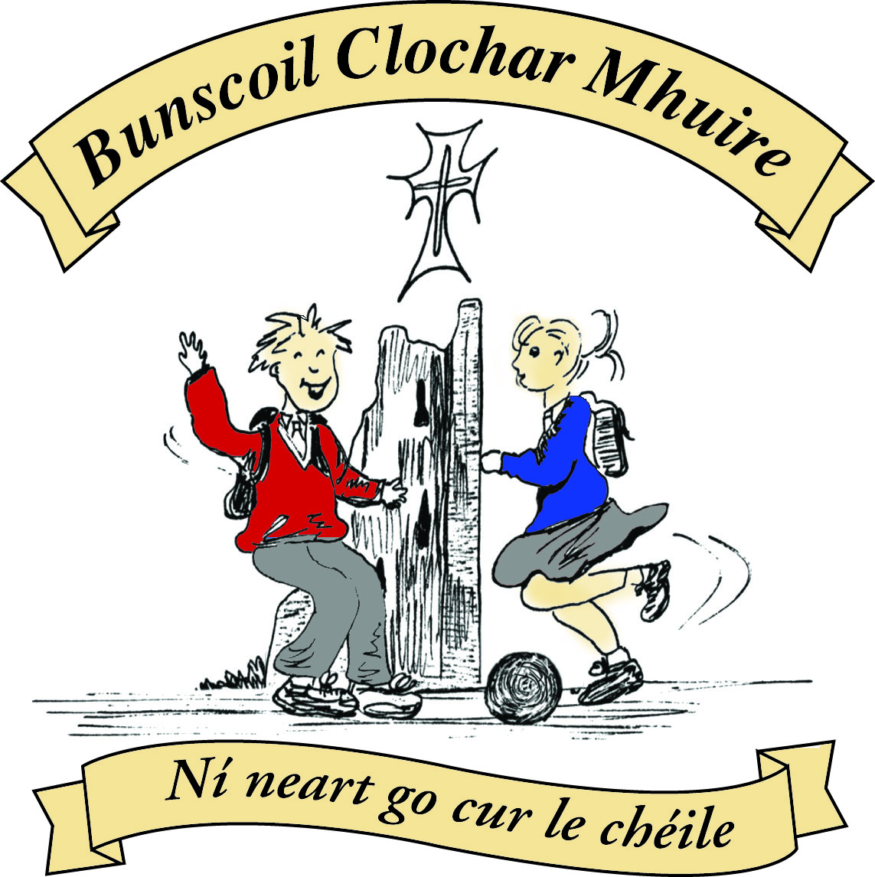* St Mary’s Convent Primary School**

***Bunscoil Clochar Mhuire***

***Trim, Co. Meath.  
Fón: (046) 9431919 ⦁ Faics: (046) 9437942  
Ríomhphost:*** [***marystrim@eircom.net***](mailto:marystrim@eircom.net) ***⦁ Website:*** [***www.stmarystrim.ie***](http://www.stmarystrim.ie) ***Uimhir Rolla: 16646O***

Awarded Green Flag  
June ‘05/’07/11/13

***Imlitir 21***

1st February, 2016

***Every Day Counts at St Mary’s Convent Primary School***

***25th - 29th January 2016***

|  |  |  |  |  |  |  |  |
| --- | --- | --- | --- | --- | --- | --- | --- |
| **Room** | **Attendance** | **Room** | **Attendance** | **Room** | **Attendance** | **Room** | **Attendance** |
| 01 | 89.6% | 08 | 82.1% | 16 | 93.3% | 26 | 87.4% |
| 02 | 93.1% | 09 | 95.6% | 17 | 62% | 27 | 93.6% |
| 03 | 98.4% | 10 | 95% | 18 | 93.6% | 30 | 89% |
| 04 | 56.9% | 12 | 86.2% | 19 | 98.3% | 31 | 92.4% |
| 05 | 73.6% | 13 | 92.3% | 20 | 97.5% |  |  |
| 06 | 95.5% | 14 | 91.9% | 23 | **100%** |  |  |
| 07 | 77.7% | 15 | 86.4% | 24 | 83.3% |  |  |

A Chairde,

Congratulations to Room **23** on having full attendance last week. Their teacher will let them know this week what their prize is.

All this week our school will be celebrating **Catholic Schools Week**. This week gives everyone involved in Catholic education the opportunity to acknowledge and celebrate the contribution that our Catholic schools make to Irish life. During this week we encourage you, as parents and families, to take time to reflect on what it means to have your child as part of a Catholic school community, and to consider how you can support the work being done in your child’s Catholic school.

This year’s theme is: Called to Proclaim God’s Mercy. Each class will be working with the children on this theme and encouraging them to show mercy to others, and exploring how they might do this. Room 26 started the week for us with an appropriate assembly for classes 1-6. Why not ask your child to tell you more? Room 19 will be doing an assembly on Wednesday morning for Grandparents Day.

This is also **Shared Reading Month**, when we ask that a member of the household sits down for a few minutes every night to listen to your child reading. You will be getting a pack today from Infant to Second Classes. Below are tips to help your child with reading for all classes.

Don’t forget **OPEN DAY** is this Thursday @11.00 in the Dr Eileen Reilly Hall. All parents and prospective parents are welcome to attend. The School Band and Choir will be singing and playing from 10.50. Then I will say a short few words which will be followed by group tours escorted by Rang 6. Refreshments will be provided by our Parents’ Association.

*Beidh Maidin Caife ar siúl sa scoil ar an Aoine 12ú Feabhra. Fáilte roimh chách.* You are all invited to the school @ 9.30 on Friday February 12th for a *Maidin Caife* i.e. free coffee and biscuits. All you have to do is speak Irish. It can be simple or broken Irish. Really, you don’t even have to speak Irish: you can listen in Irish instead! All welcome.

Well done to all who took part in the Trim area Credit Union Quiz on Friday last. A great night was had by all. Congratulations to our U-11 team who won after nail-biting extra time and tie-breakers.

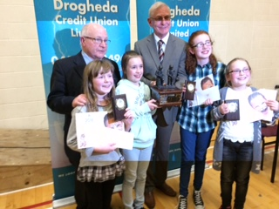

***ACTIVE AFTER SCHOOL PROGRAMME****The programme is for pupils in 2nd class. The programme will take place every Monday from 3pm- 4pm starting Thursday the 11th of February for 6 weeks. The aim of this programme is to promote physical activity in a fun and enjoyable way.****This programme is free of charge.*** *The Be Active programme relies on the dedication of its teacher and parent leaders. At the moment, we are trying to recruit parent volunteers. For this programme to work successfully it is significant that we have volunteers to help out.  Each child in second class will receive a Be Active Child Registration form and a Parent Leader Registration form, if your child would like to participate in the active after school programme please return form before Wednesday 3rd of February. (If you are interested in helping out please fill out the Parent Leader Registration form)*

*Ms. Elaine Maguire*

***Camogie Training****Training will start back on Wednesday 10th of February from 3pm -4pm. Please ensure to bring appropriate  training gear for training outside in the elements.*

*Ms.Maguire, Mr. O Mahony, Ms. McKenna*

*Well done to the 6th Class girls who participated so well at the Pre-Confirmation Mass yesterday. We wish them the very best as they put the final preparations in place for their Confirmation on Feb 13. A Faith Buddy system is being piloted for the 6th Classes with a group of 5th Year Scoil Mhuire pupils. We welcome and thank them and their teachers for their support and wish them every success with the programme.*

*S. Nally*

**Registration Forms** for children starting school in September 2016 are now available from Helen, in the office. Please note that the Submission Date for return of forms is 15th February.

**Green News**

**Community News**

Mise le meas,



Cóilín Ó Coigligh, Príomh Oide

**Nath na Seachtaine:** **In ainm an Athar, agus an Mhic agus an Spioraid Naoimh. Amen**

**Seanfhocal na Míosa**: **Bíonn cluasa móra ag muca beaga**

**Dates to Remember**

**Assembly: “**Grandparents Day” for the whole school @ 9.20

All are welcome to attend.

**Meitheal:** Every Tuesday morning 9.30-10.30.

**Banna Ceoil:** Every Tuesday @ 3pm.

**Confirmation:**  Saturday 13th February @ 11.00 a.m.

**First Communion:** Saturday 28th May @ 11.00 a.m.

**First Confession:**  Wednesday 2nd March @ 7.00pm

**Please keep an eye on the Parish Bulletin for any changes.**

**Reading with your child**

**Top Ten Tips for Parents /Guardians**

|  |  |  |
| --- | --- | --- |
| Infants – 1st Class | 2nd and 4th Class | 5th and 6th Class |
| **Reading**   1. Read to your child as often as you can 2. Talk about books / characters / plots 3. Enrol your child in the local library 4. Provide a good role model by reading yourself / other family members 5. Keep audio tapes of familiar stories to play in the car 6. Vary the type of books read – stories / poems / information 7. Accept your child’s efforts with praise 8. Concentrate on what he /she got right 9. Make reading together enjoyable 10. Take part in school based initiatives like ‘Shared Reading ’ | **Reading**   1. Continue to read to your child every day. 2. Read some of the books your child enjoys so you can discuss it with him/her. 3. Encourage your child to read to younger brothers/ sisters. 4. Ensure that your child knows that you value and enjoy reading yourself. 5. Make sure there is a wide variety of reading material in your home – newspapers, magazines, information, cookery books etc. 6. Enrol and encourage your child to visit the local library once a week... 7. Discuss favourite authors. 8. Encourage your child to read articles / headlines in newspapers. 9. Encourage your child to guess unknown words. 10. Take part in school based initiatives like ‘Shared Reading ’ | **Reading**   1. Encourage your child to visit the local library as often as possible. 2. Recognise and praise your child’s efforts in reading. 3. Ensure your child has access to a wide range of reading material –newspapers, magazines, guides etc. 4. Take an interest in different children’s authors. 5. Discuss ideas and points of view proposed by newspaper articles etc. 6. Provide a well lit study / reading area. 7. Ensure that you value and enjoy reading yourself. 8. Allow your child to choose his /her own reading material. 9. Encourage your child to read for information – timetables / weather forecasts / menus 10. Encourage your child to try and guess unknown words. |

**Green News**

*‘Saint Francis of Assisi reminds us that our common home is like a sister with whom we share our life and a beautiful mother who opens her arms to embrace us. This sister now cries out to us because of the harm we have inflicted on her by our irresponsible use and abuse of the goods with which God has endowed her.’ (Laudatso Si)*

For Catholic Schools Week, we look to the Pope’s guidance on taking care of our earth. In his Encyclical letter, *LAUDATO SI’,* Our Holy Father turns to the teachings of Saint Francis who was particularly concerned for God’s creation and for the poor and the outcast. St Francis loved, and was deeply loved for his joy, his generous self-giving and his openheartedness. He shows us just how inseparable the bond is between concern for nature, justice for the poor, commitment to society, and interior peace.

At St Mary’s we try to take responsibility for preserving earth’s gifts. We take small manageable steps that have direct relevance to the pupils’ lives. There is a very positive attitude to matters Green in our school and we try to carry on the Mercy ethos through our activities. We strive to enable our young people to have the kind of educational opportunities which will enable them to develop to their full potential and to be confident, caring citizens of the world we inhabit.

Global Citizenship is our Green Schools Theme this year with a specific focus on Litter and Waste Management. At St Mary’s we encourage recycling. Among the materials we recycle at school are: batteries, small plastic bottles, footwear, spectacles, cardboard, postage stamps, ink cartridges, cans, Nespresso pods and toilet rolls.

To further highlight the theme of Global Citizenship, we intend to have a representation at the St Patrick’s Day parade of the different nationalities attending our school. It would be quite a spectacle to have lots of National colours and costumes that day. Please watch out for the permission slips in your children’s bags and let us know if you would like to be involved on the day.

**WOW**

Our WOW campaign is being revamped! As part of our Be Active campaign, every pupil who walks (or cycles) to school on Wednesdays will be counted and a ‘Score on the Door’ will be kept. The class that accumulates the highest score for the month will be rewarded. In this accumulative way, we are also trying to walk the length and breadth of Ireland and maybe further afield after that. More details about this Slí na Sláinte will be released soon. Ms Flattery and Ms Heffernan will continue to meet the WOW pupils and families up at Mornington House at 9:00am on Wednesdays but you may also walk from your own destinations too.

COW will resume after Easter when the weather improves.

Our Green Blog has started up again, thanks to Ms Dalton. If you would like to view some posts, you may use the following link:

**stmarysgreenblog.blogspot.ie**

If you have any nice photos of nature or anything that is linked to our Green themes, please send them in to our Green Blog. We always welcome new ideas and observations. You can send them to the school email address:[**marystrim@eircom.net**](mailto:marystrim@eircom.net)

As Fr. Declan read today at the blessing of the St. Brigid’s Crosses “Father of all creation and Lord of Light, you have given us life and entrusted your creation to us to use it and to care for it” Help us to remember Green is cool, at home, at school and around the globe!

**Community Notices**

**Trim Kempo Karate: Tue/Thursday** Beginners @ 6.00 Intermediate @ 7.00/8.00 Seniors @ 9.00/10.00 **Saturday** Begineers/Jun @ 10.00 Intermediate @ 11.00 Seniors @ 12.00/1.00

You may have concerns about **cyber bullying and internet safety** – come be informed. St Michael’s Primary School and Centre for Autism Parents Association are hosting a talk on this topic. The talk is being delivered by Jeremy Pagden, the Managing Director of Schools Websites. He comes highly recommended. Venue: St. Michael’s School Hall on Wednesday February 10th @ 7.30pm. Admission Free. Protect your children.