***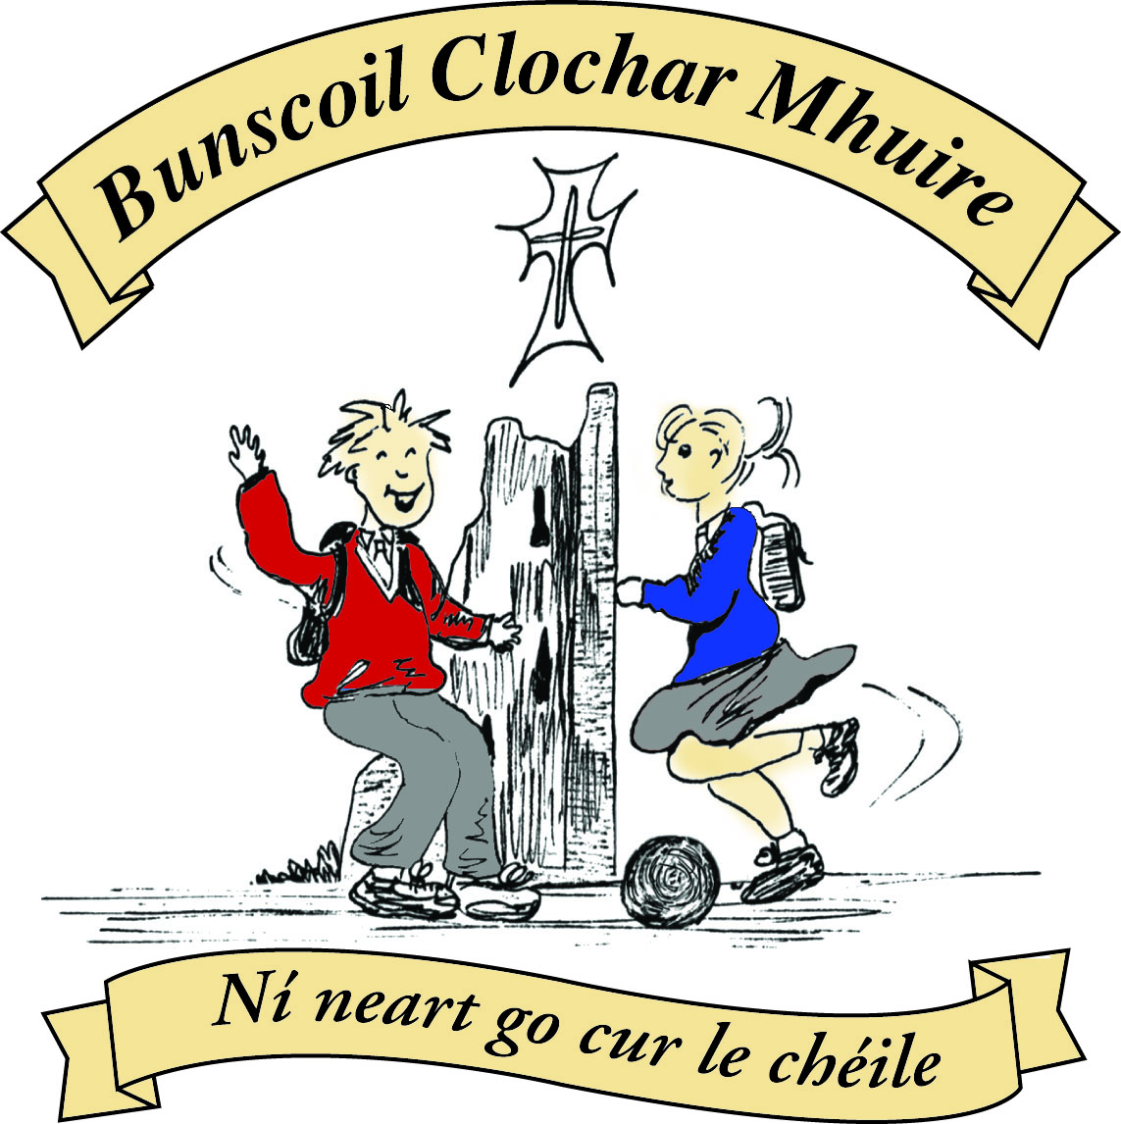* St Mary’s Convent Primary School**

***Bunscoil Clochar Mhuire***

***Trim, Co. Meath.  
Fón: (046) 9431919 ⦁ Faics: (046) 9437942  
Ríomhphost:*** [***marystrim@eircom.net***](mailto:marystrim@eircom.net) ***⦁ Website:*** [***www.stmarystrim.ie***](http://www.stmarystrim.ie) ***Uimhir Rolla: 16646O***

Awarded Green Flag  
June ‘05/’07/11/13

***Imlitir 20***

30th January, 2017

***Every Day Counts at St Mary’s Convent Primary School***

***23rd January – 27th January, 2017***

|  |  |  |  |  |  |  |  |
| --- | --- | --- | --- | --- | --- | --- | --- |
| **Room** | **Attendance** | **Room** | **Attendance** | **Room** | **Attendance** | **Room** | **Attendance** |
|  |  |  |  |  |  |  |  |
| 01 | 94.1 % | 08 | 90.4% | 16 | 90.4% | 26 | 94.4% |
| 02 | 92% | 09 | 95.5% | 17 | 96.9% | 27 | 97.5% |
| 03 | 90.4% | 10 | 95.4% | 18 | 96.7% | 30 | 96.2% |
| 04 | 91.1% | 12 | 97.2% | 19 | 93.6% | 31 | 95% |
| 05 | 96.2% | 13 | 94.7% | 20 | 96.4% |  |  |
| 06 | 92.8% | 14 | 95.7% | 23 & 24 | 97.1% |  |  |
| 07 | 99.2% | 15 | 94.3% |  |  |  |  |

*Congratulations to* ***Room 7*** *on nearly having full attendance last week. Please note that notification in writing to the teacher is required for all absences. A letter or note in the homework journal will suffice.*

A chairde,

All this week our school will be celebrating **Catholic Schools Week**. This week gives everyone involved in Catholic education the opportunity to acknowledge and celebrate the contribution that our Catholic schools make to Irish life. During this week we encourage you, as parents and families, to take time to reflect on what it means to have your child as part of a Catholic school community, and to consider how you can support the work being done in your child’s Catholic school.

This year’s theme is: **Learning with Pope Francis to Care for our Common Home.** Each class will be working with the children on this theme and encouraging them to show mercy to others, and exploring how they might do this. Room 26 started the week for us with an appropriate assembly for classes 1-6. Why not ask your child to tell you more? Grandparents Day will be on Wednesday.

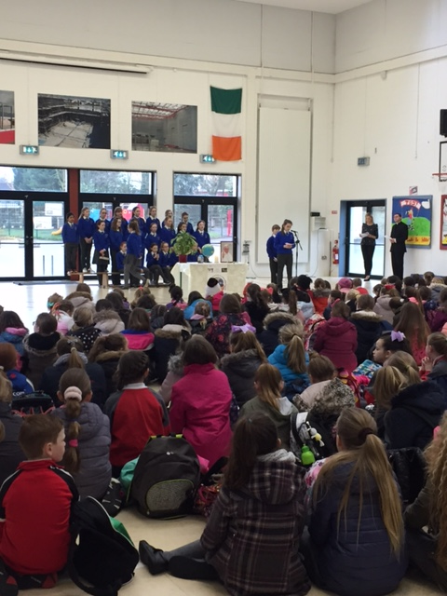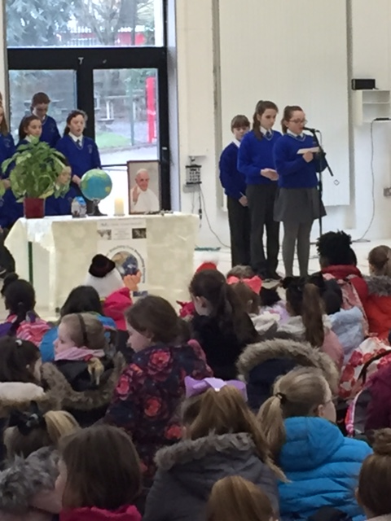

This is also **Shared Reading Month**, when we ask that a member of the household sits down for a few minutes every night to listen to your child reading. You will be getting a pack tomorrow from Infant to Second Classes. Below are tips to help your child with reading for all classes.

**Enrolments:** Offers for places will be posted on Friday February 3rd.

**Concussion:** Please inform the school if your child has had a concussion or other serious injury, out of school, on their return to school.

**Oskars:** Interested in being a participant or finding out what is involved? There will be a meeting in the staffroom on Thursday night next (February 2nd ) @ 7.00. Louise, from Kevin Rowe Events, will be there to explain and answer any questions. We still need five more participants. We are also looking for main sponsors and other sponsors. If you are in a position to help, please contact us.

***Parents’ Association****: A Coffee Morning hosted by the Parents’ Association will be held on the 17th Feb @ 9.30am in the Staff Room. All Welcome.*

***Credit Union Schools Quiz 2017:****Congratulations to the eight girls from 4th, 5th and 6th Classes who represented St Mary's at the Credit Union Schools Quiz in Drogheda last Friday. As a school community, we can be very proud of the achievement of each pupil. Our senior team finished in joint-3rd position, while our junior team, who performed to a very high standard, came home in 7th place overall. Comhghairdeachas a chailíní!   Mr Galligan*

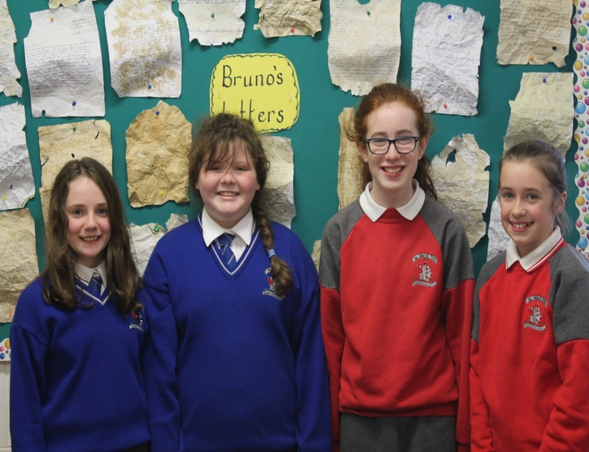

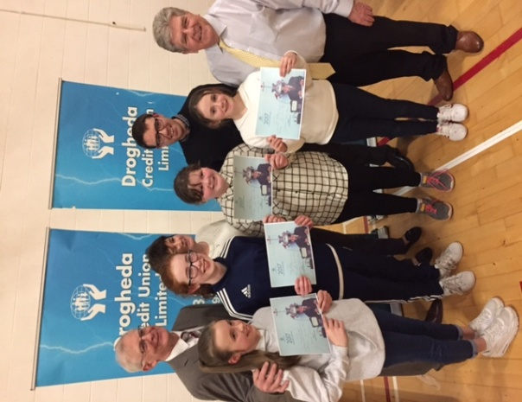

**Senior Team**

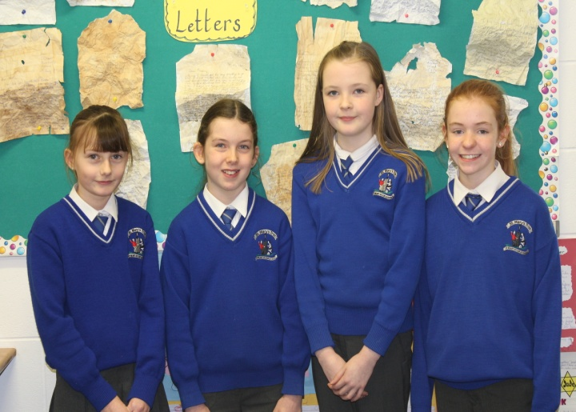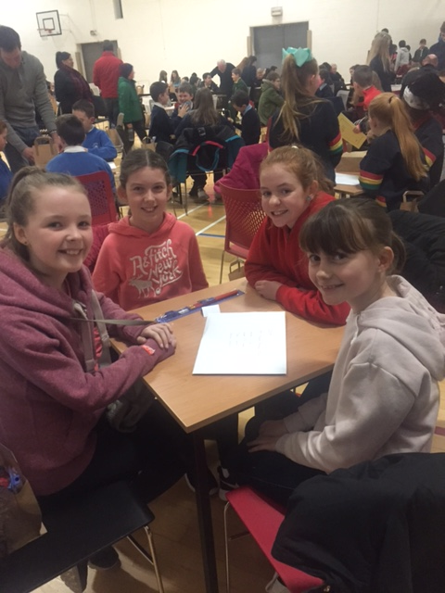

**Junior Team**

**Lost and found:** There was a pair of children’s glasses handed into the office. They are dark blue with coloured spots on the arms. They can be collected from the office.

***Football Training.*** *All 3rd, 4th, 5th and 6th class students - football training is starting this Wednesday 1st Feb after school from 3.00 – 4.00pm. Please bring runners and football boots. All new players welcome.*

*Ms. Carr*

Mise le meas,



Cóilín Ó Coigligh, Príomh Oide.

**Green News**

**Community News**

**Nathanna na Seachtaine:** In ainm an Athar, agus an Mhic agus an Spioraid Naoimh. Amen

**Seanfhocal na Míosa:** Ní hé lá na báistí, lá na páistí

**Dates to Remember**

**Assembly:**  Closing ceremony for Catholic Schools Week.

**Whole School @ 9.20 Friday 3rd**

**Banna Ceoil:** Tuesdays @ 3.00 – 4.00 pm

**Meitheal:** Every Tuesday morning 9.30-10.30.

**Badminton:** **Last class** today 30th Jan.

**Football Training:** Wed 3.00-4.00 for 3rd – 6th Classes

**First Confession:** Wed 29th March @ 7pm

**Communion:**  Sat May 13th @ 11.00

**Confirmation:**  Sat 11th March

**Top Ten Tips for Parents /Guardians**

|  |  |  |
| --- | --- | --- |
| Infants – 1st Class | 2nd and 4th Class | 5th and 6th Class |
| **Reading**   1. Read to your child as often as you can 2. Talk about books / characters / plots 3. Enrol your child in the local library 4. Provide a good role model by reading yourself / other family members 5. Keep audio tapes of familiar stories to play in the car 6. Vary the type of books read – stories / poems / information 7. Accept your child’s efforts with praise 8. Concentrate on what he /she got right 9. Make reading together enjoyable 10. Take part in school based initiatives like ‘Shared Reading ’ | **Reading**   1. Continue to read to your child every day. 2. Read some of the books your child enjoys so you can discuss it with him/her. 3. Encourage your child to read to younger brothers/ sisters. 4. Ensure that your child knows that you value and enjoy reading yourself. 5. Make sure there is a wide variety of reading material in your home – newspapers, magazines, information, cookery books etc. 6. Enrol and encourage your child to visit the local library once a week... 7. Discuss favourite authors. 8. Encourage your child to read articles / headlines in newspapers. 9. Encourage your child to guess unknown words. 10. Take part in school based initiatives like ‘Shared Reading ’ | **Reading**   1. Encourage your child to visit the local library as often as possible. 2. Recognise and praise your child’s efforts in reading. 3. Ensure your child has access to a wide range of reading material –newspapers, magazines, guides etc. 4. Take an interest in different children’s authors. 5. Discuss ideas and points of view proposed by newspaper articles etc. 6. Provide a well lit study / reading area. 7. Ensure that you value and enjoy reading yourself. 8. Allow your child to choose his /her own reading material. 9. Encourage your child to read for information – timetables / weather forecasts / menus 10. Encourage your child to try and guess unknown words. |

**Green News**

This week we celebrate Catholic Schools Week. The theme is *Caring for our common home with Pope Francis*. How wonderfully relevant our Pope’s message is, and at a time when other prominent world leaders are dismissive of and unconcerned with global issues.

We are stewards of creation and therefore it is our job to be aware of the many issues that damage our world: pollution, climate change, drought, loss of biodiversity and reducing respect for the dignity of all God’s creation.

Pope Francis’ letter Laudato Si calls us to act on this injustice by teaching us to see the world, every living thing and all of our fellow human beings differently.

Here at St Mary’s Mother Nature always comes up ‘trumps’! We have secured many Green Flags by paying attention to important Green issues and working hard to make life changes with a view to preserving what has been freely given to us. Our pupils, staff and school community have embraced the Green movement since its inception and we continue to keep our Green Flags flying.

Our Green theme this year is Global Citizenship with a specific emphasis on Waste management. Here at St Mary’s we recycle many items...batteries, small plastic bottles, postage stamps, ink cartridges, card and toilet rolls. We will be hosting a Clothes/Textile Drive on Feb 15th and encourage you to send in any textiles, shoes that you would like to recycle on Feb 15th. The company conducting the drive are Liberty Freedom from Addiction and run training programmes in Dublin for people struggling with addiction. Thank you in advance for your help. If you would like to check out what kinds of items they will accept you can look up their website [www.libertysrecycling.com](http://www.libertysrecycling.com)

On February 8th, Joanna Parkes of Grass Roots Education will address 3rd and 4th Classes on the issue of Energy. Our school was one of the schools nominated by Meath County Council for this workshop. We look forward to this.

WOW (Walking on Wednesdays) continues every Wednesday. Well done to the teachers and pupils who sustain this initiative weekly despite the weather! COW (Cycling on Wednesdays) will resume in the spring when the weather continues.

***Remember green is cool at home, at school and around the globe!***

**Community Notices**

**Shamrockers Camp** of arts & crafts, sports and fancy dress will take place from 13th – 16th March in St Mary’s School. For more information please contact Ms McKenna or Ms Cullinane.

**Homework Club** in St Marys. Monday, Tuesday and Thursdays. 3.00 – 4.00pm for 1st – 6th Class. €4 per day.

**Elegance Gymnastics Club** continue enrolling the Girls from 5 to 12 years old to the Gymnastics classes which will be held every Tuesday and Wednesday from 5 to 6 pm for the girls from 5 to 7 years old, and from 6 to 7 pm for the Girls from 8 to 12 years old. All welcome! Please call to register: 0879134334 or 0876339498.

**Basketball classes** every Tuesday from 4 to 5 pm for the Boys from 7 to 12 years old, and Wednesday from 4 to 5 pm for the Girls from 7 to 12 years old. All Welcome! Please call: 0879134334 Robert.

**ZUMBA  :**-    MONDAY  &  WEDNESDAY  8pm  TRIM GAA.

No booking, partner or experience required......just grab your water and your smile and get ready to dance your cares (and Christmas treats !!) away!        €8 per class       Contact  :  Lorraine  086 8693546

**ZUMBA KIDS** :-   Tuesday  3.15pm  Trim GAA No booking required,  €6 per class      Contact : Lorraine  086 8693546

**Confident Children A Workshop for Parents**, Wednesday 1st of February 2017 with Elfreda Manahan-Vaughan at the Elements Holistic Centre, Trim  €15. [www.metta-morphics.com](http://www.metta-morphics.com) or 0868373582

**RTÉ Cór na nÓg**. Your chance to sing with us. We rehearse twice a week during term time – Wed from 5.30 – 7pm and Sat from 10am – 12noon usually in RTÉ, Donnybrook. Auditions for 2017 – please fill in application online in the Sing With Us section on the RTÉ website: <https://orchestras.rte.ie/performinggroup/rte-cor-na-nog/>

**Trim Family Resource Centre** are looking for volunteers to help welcome migrants into their local community through conversational English Classes. Do you have two hours per week, like to meet people, wish to make a difference and want to acquire some new skills. Contact Gina on 046-9438850 or [failteisteachfrc@gmail.com](mailto:failteisteachfrc@gmail.com).

**Trim Family Resource Centre:** Would you like to learn English? Come and meet others who are learning too. Thursday evenings 7pm – 9pm and Friday mornings 10.30 – 12.30am. Contact 046-9438850

Ray Egan recorded the

**Christmas Pageant**

**Hallelujah**

**Performed by children from Fifth & Sixth Classes**



DVD’s are available @ €15 each.

Tomorrow Tuesday 31st is the final day to order one.