***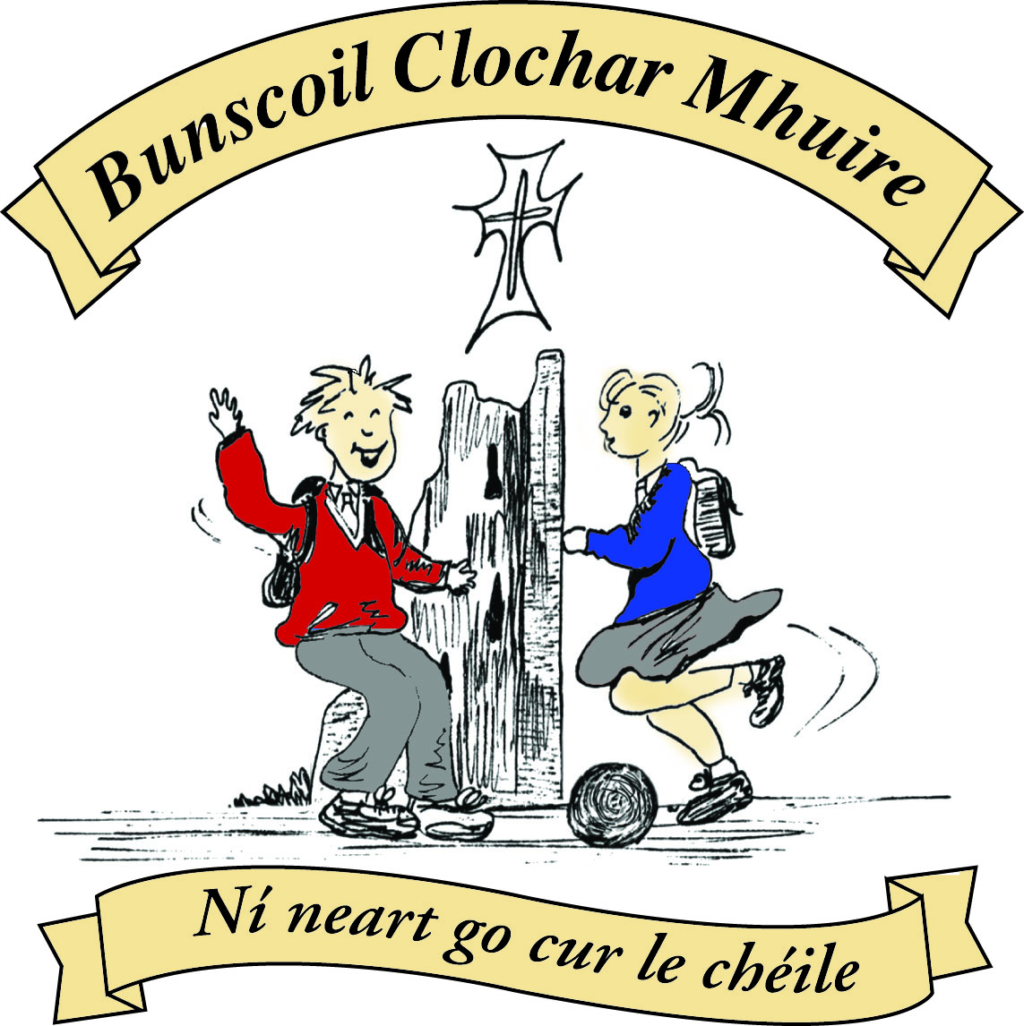* St Mary’s Convent Primary School**

***Bunscoil Clochar Mhuire***

***Trim, Co. Meath.  
Fón: (046) 9431919 ⦁ Faics: (046) 9437942  
Ríomhphost:*** [***marystrim@eircom.net***](mailto:marystrim@eircom.net) ***⦁ Website:*** [***www.stmarystrim.ie***](http://www.stmarystrim.ie) ***Uimhir Rolla: 16646O***

Awarded Green Flag  
June ‘05/’07/11/13

***Imlitir 20***

29th January, 2018

***Every Day Counts at St Mary’s Convent Primary School***

***22nd Jan – 26th Jan 2018***

|  |  |  |  |  |  |  |  |
| --- | --- | --- | --- | --- | --- | --- | --- |
| **Room** | **Attendance** | **Room** | **Attendance** | **Room** | **Attendance** | **Room** | **Attendance** |
| 01 | 97.2 % | 08 | 86.7% | 16 | 90% | 26 | 91.9% |
| 02 | 91% | 09 | 89.2% | 17 | 96.6% | 27 | 94.6% |
| 03 | 91.7% | 10 | 90.4% | 18 | 95% | 30 | 92.8% |
| 04 | 90.3% | 12 | 93.6% | 19 | 89.6% | 31 | 93.6% |
| 05 | 87.2% | 13 | 91.7% | 20 | 96.9% |  |  |
| 06 | 86.4% | 14 | 92.9% | 23 & 24 | 94.2% |  |  |
| 07 | 94.2% | 15 | 96.6% |  |  |  |  |

*Please note that notification in writing, with the reason for all absences, to the teacher is required. A letter or note in the homework journal will suffice.*

A chairde,

All this week our school will be celebrating **Catholic Schools Week**. This week gives everyone involved in Catholic education the opportunity to acknowledge and celebrate the contribution that our Catholic schools make to Irish life. During this week we encourage you, as parents and families, to take time to reflect on what it means to have your child as part of a Catholic school community, and to consider how you can support the work being done in your child’s Catholic school.

This year’s theme is: Called to be a Family of Families**.** Each class teacher will be working with the children on this theme. The programme invites Catholic schools to reflect on and celebrate the relationship that exists between home, school and parish. Room 13 started the week for us with an appropriate assembly on Friday last. Why not ask your child to tell you more? Grandparents Day will be on Wednesday.

**Computer Room News:** This week all students will continue to animate their stories. 1st & 2nd classes are busy putting together the perfect conversations while 4th & 5th classes are learning how to use more than one background and how to add different sprites (characters) to these stories. 6th classes are preparing for the Confirmation so are researching their Saint’s name and typing up this information up in Microsoft Word.

Ms Debby

February is **Shared Reading Month**, when we ask that a member of the household sits down for a few minutes every night to listen to your child reading. You will be getting a pack tomorrow from First to Third Classes. Below are tips to help your child with reading for all classes.

**Enrolments:** Offers for places will be posted on Monday February 5th.

**Concussion:** Please inform the school if your child has had a concussion or other serious injury, out of school, on their return to school.

**Cybersmarties** will be launched this week. It is a programme to train children on the proper use of multimedia, in a closed group environment. It also has a wellbeing and communication section. We are trialling it with Third to Sixth classes. An explanatory letter will be sent by separate email.

**Volunteers** needed to listen to the younger children reading. If you can spare even half an hour a week, please contact me.

**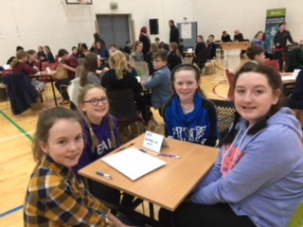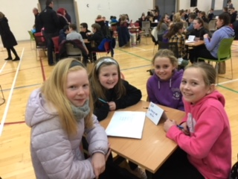Credit Union Quiz**: Congratulations to our representatives at the Credit Union Schools Quiz in Drogheda last Friday night. Despite some tough questions, the girls performed to a very high standard and represented themselves, their families and their school with distinction. Unfortunately, neither team managed to make it through to the next round, but as the expression goes, "it's not always about winning!" Maith sibh a chailíní!    Mr Galligan

Junior Team Senior Team

**Rainbows** is a peer support group for children in 1st - 6th classes who have experienced a death of a loved one or parental separation.

The aim of the programme is to assist the participants with an understanding of their new family unit. An application form will be sent in a separate email. Please compete and return to the school before Thursday 8th February.

Mrs O’Brien

We are having an **Energy Action Day** this Friday, Feb 2nd . Third to Sixth class will do a pedal energy workshop with Gavin Harte and use the energy they produce to make smoothies among other things. We also hope to make a trip to the Recycling Centre that day and we will take an aerial photo with our drone. We will have other exciting energy activities that day. Maybe you can ask your child about their Energy Action Day after school that day. Ms Nally

This week is **Catholic Schools Week**. Here at St Mary’s we celebrate our Catholic ethos and we pay special attention to the role of family – our family at home, our family living away and our family at school. We remember in a special way, our family members who have died and we thank God for the gift of belonging to our various family groups.

Dublin, Ireland, has been chosen by Pope Francis to host the World Meeting of Families 2018.  Parents are the primary educators of their children, but Catholic schools play a vital role in assisting parents in their duty to raise their children. We celebrate this partnership this week.

Grandparents are invited to visit the school on Wednesday. Some will be visiting their grandchildren’s classes but even if you’re not visiting a class, please join us for a cup of tea in the hall at 10:30am on Wednesday. Some grandparents may bring their grandchildren to Mass at 10 and when they return them to the school may have their cuppa then.

We have a few big days coming up on our Calendar... On February 10th, our Sixth Classes will receive the sacrament of Confirmation. In March, our Second Classes will receive the sacrament of Reconciliation.

We opened Catholic Schools Week with a lovely Assembly from Room 13 and will close the week with another Assembly next Friday. Our good friend, Sr Paul will lead us in prayer and the pupils from Room 7 and the Confirmation Choir will provide actions and songs.

Maybe you could ask your children to tell you about the activities this week and celebrate the family aspect of Catholic Schools’ week at home. Mrs Nally

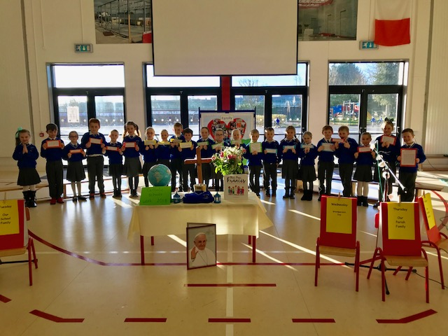

Mise le meas,



Cóilín Ó Coigligh, Príomh Oide.

[**Green News**](#greennews)

[**Community News**](#communitynews)

***Nathanna na Seachtaine: In ainm an Athar, agus an Mhic agus an Spioraid Naoimh, Amen****.*

***Seanfhocal na Míosa: Nuair a bhíonn an cat amuigh, bíonn an luch ag rince!***

**Dates to Remember**

**Assembly:** End of Catholic Schools Week Friday @ 9.20

**Meitheal:** Every Tuesday morning 9.30-10.30.

**Drama Club:** Every Thursday 3-4pm for 5th Class

**Banna:** Tuesdays @ 3.00 – 4.00

**Communion: Saturday 5th May @ 11.00**

**Confirmation: Saturday 10th Feb @ 11.00**

**Top Ten Tips for Parents /Guardians**

|  |  |  |
| --- | --- | --- |
| Infants – 1st Class | 2nd and 4th Class | 5th and 6th Class |
| **Reading**   1. Read to your child as often as you can 2. Talk about books / characters / plots 3. Enrol your child in the local library 4. Provide a good role model by reading yourself / other family members 5. Keep audio tapes of familiar stories to play in the car 6. Vary the type of books read – stories / poems / information 7. Accept your child’s efforts with praise 8. Concentrate on what he /she got right 9. Make reading together enjoyable 10. Take part in school based initiatives like ‘Shared Reading ’ | **Reading**   1. Continue to read to your child every day. 2. Read some of the books your child enjoys so you can discuss it with him/her. 3. Encourage your child to read to younger brothers/ sisters. 4. Ensure that your child knows that you value and enjoy reading yourself. 5. Make sure there is a wide variety of reading material in your home – newspapers, magazines, information, cookery books etc. 6. Enrol and encourage your child to visit the local library once a week... 7. Discuss favourite authors. 8. Encourage your child to read articles / headlines in newspapers. 9. Encourage your child to guess unknown words. 10. Take part in school based initiatives like ‘Shared Reading ’ | **Reading**   1. Encourage your child to visit the local library as often as possible. 2. Recognise and praise your child’s efforts in reading. 3. Ensure your child has access to a wide range of reading material –newspapers, magazines, guides etc. 4. Take an interest in different children’s authors. 5. Discuss ideas and points of view proposed by newspaper articles etc. 6. Provide a well lit study / reading area. 7. Ensure that you value and enjoy reading yourself. 8. Allow your child to choose his /her own reading material. 9. Encourage your child to read for information – timetables / weather forecasts / menus 10. Encourage your child to try and guess unknown words. |

St Mary’s Parents’ Association

Dates for Your Diary:

**January 31st**: Grandparents Day. Tea/Coffee and light refreshments will be served by the PA from 10.30am.

**March 18th**: Family Fun Day Bingo with all funds raised going towards the MUGA fund. The Bingo will be held in the Dr. Eileen Reilly hall from 3-5pm. All welcome to attend what promises to be a great afternoon.

<https://www.facebook.com/stmarysparentsassoc/>

Caroline Smith

Secretary

**[Community Notices](#communitynews)**

There will be International Students coming to our school in 3rd term and  [www.rockbrookinternational.com](http://www.rockbrookinternational.com/" \t "_blank)  is looking to find host Families, Please call 014936692 or check out the website if you are interested in hosting a student. Please see Flyer for information.

New Experience, Extra Income. Why not host a student? Competitive Rates Phone 01 493 6692 Rockbrook House, Edmondstown Road, Dublin 16, Ireland Email [info@rockbrookinternational.com](mailto:info@rockbrookinternational.com)  
• Host families needed to host students aged 9 - 16 from abroad in:  
• The Irish family should have children aged between 4 - 16.  
• Students attend local Primary and Secondary Schools from Monday to Friday.  
• Saturday a full day activity.New Experience, Extra Income.  
Why not host a student? Competitive Rates Phone 01 493 6692



**Homework Club** in St Mary’s for children from 1st – 6th Classes. Application Forms are available from Ms Conaty Room 11 or Ms Lynch Room 31.

**Searsol** touch typing in  St Mary's primary school. New term starting in January. Book a free trial with Jackie at 086-3780842

**Trim** : Free Walking group name **Walkies.** Meeting point, across from the garda station Trim. Time 10am to 11am Day : Friday Contact Dorenda  087 2726479

**Navan** : Buggy Buddies the free local walking group open to parents and carers of babies.  Meeting Point:  Blackwater Park  Time 9.30am-10.30am  Day Thursday. Contact Margo 0894576235

**The Meath Community Games** will take place at Kells swimming pool on Sunday March 4th, 2.30 start for girls and 5.00 start for boys, will get check in/warm up times closer to the date.

To practice and give the swimmers a chance to meet each other we are going to hold two 1 hour coaching sessions at Aura Trim as follows:

**Sunday 11th and Sunday 18th February from 5pm to 6pm**

We will have two lanes and an Aura coach available to us

Cost will be €3 per swimmer per week and that covers entry and coaching

I will be at the first session and Aoife Genocchi, our Treasurer will be at the second session

We would love to see you at these sessions and spread the word!

We can also use these sessions to select swimmers for each event ( we can enter two swimmers per event).

The following are the events at the Meath Final:

**Age Category**:  
Boys & Girls U/8 Over 6 1 length 25m Freestyle  
Boys & Girls U/10 Over 8 1 length 25m Freestyle  
Boys & Girls U/10 Over 8 1 length 25m Backstroke  
Boys & Girls U/12 Over 10 2 lengths 50m Freestyle  
Boys & Girls U/12 Over 10 2 lengths 50m Breaststroke  
Boys & Girls U/12 Over 10 2 lengths 50m Backstroke  
Boys & Girls U/14 Over 12 2 lengths 50m Freestyle  
Boys & Girls U/14 Over 12 2 lengths 50m Backstroke  
Boys & Girls U/14 Over 12 2 lengths 50m Breaststroke  
Boys & Girls U/14 Over 12 2 lengths 50m Butterfly  
Boys & Girls U/16 Over 14 2 lengths 50m Freestyle  
Boys & Girls U/16 Over 14 2 lengths 50m Backstroke  
Boys & Girls U/16 Over 14 2 lengths 50m Butterfly  
  
**Panel Details:**Boys & Girls U8 competitors must be able to swim one length of the pool

Find more information at <http://www.communitygames.ie/>