***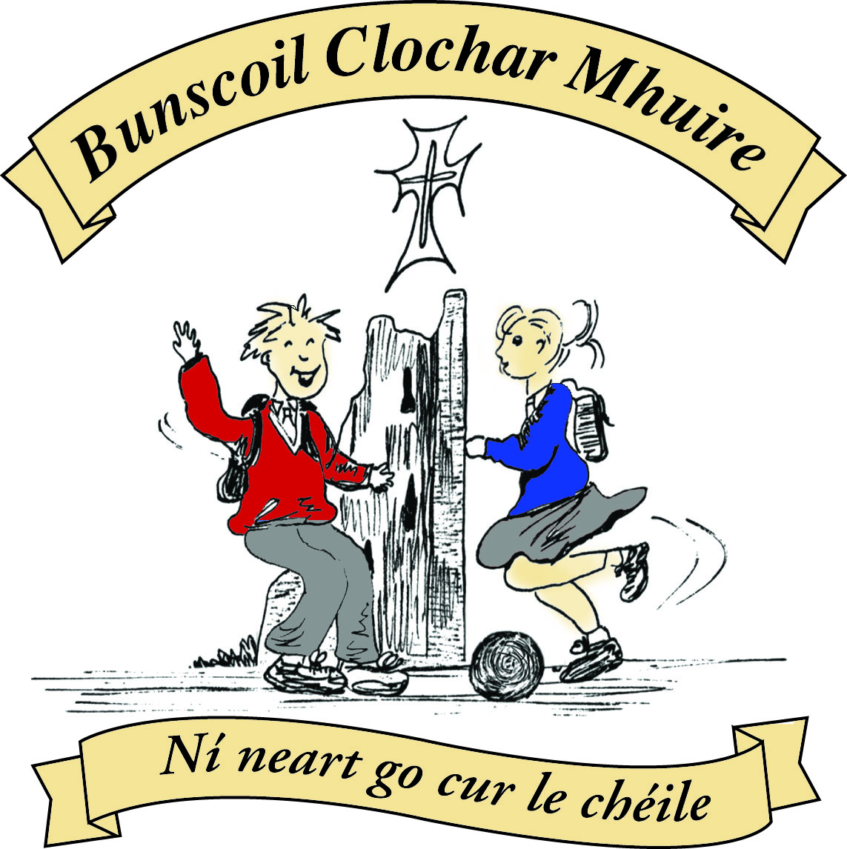* St Mary’s Convent Primary School**

***Bunscoil Clochar Mhuire***

***Trim, Co. Meath.  
Fón: (046) 9431919 ⦁ Faics: (046) 9437942  
Ríomhphost:*** [***marystrim@eircom.net***](mailto:marystrim@eircom.net) ***⦁ Website:*** [***www.stmarystrim.ie***](http://www.stmarystrim.ie) ***Uimhir Rolla: 16646O***

Awarded Green Flag  
June ‘05/’07/11/13

***Imlitir 19***

23rd January, 2017

***Every Day Counts at St Mary’s Convent Primary School***

***16th January – 20th January, 2017***

|  |  |  |  |  |  |  |  |
| --- | --- | --- | --- | --- | --- | --- | --- |
| **Room** | **Attendance** | **Room** | **Attendance** | **Room** | **Attendance** | **Room** | **Attendance** |
|  |  |  |  |  |  |  |  |
| 01 | 91.9 % | 08 | 95.8% | 16 | 98.5% | 26 | 89.6% |
| 02 | 84% | 09 | 92.3% | 17 | 89.2% | 27 | 99.2% |
| 03 | 97.4% | 10 | 92.6% | 18 | 99.2% | 30 | 97.7% |
| 04 | 96.3% | 12 | 97.2% | 19 | 96.4% | 31 | 96.4% |
| 05 | 98.5% | 13 | 97.3% | 20 | 92.9% |  |  |
| 06 | 97.6% | 14 | 98.6% | 23 & 24 | 97.1% |  |  |
| 07 | 96% | 15 | 98.6% |  |  |  |  |

*Congratulations to* ***Room 18 & 27*** *on nearly having full attendance last week. Please note that notification in writing to the teacher is required for all absences. A letter or note in the homework journal will suffice.*

A chairde,

Next week we will be celebrating **Catholic Schools Week**. This week gives everyone involved in Catholic education the opportunity to acknowledge and celebrate the contribution that our Catholic schools make to Irish life. This year’s theme is: ‘Catholic schools: Learning with Pope Francis to care for our common home’

**OPEN DAY** last week was a very well received and as usual the pupils stole the show. The Sixth Class girls received many compliments regarding their deportment and demeanour, and many people remarked on the magnificence of the Banna and Choir. Some current parents used the opportunity to have a walk around and see the school in action. I would like to thanks our Parents’ Association for their support and to thank all young and old who helped in any way.

**School Registration Forms** for children starting school in September 2017 are still available from Helen, in the office. Please note that the Final Submission Date for return of forms is this Friday 27th and that offers will be posted on Friday February 3rd.

Parent Teacher Meetings for Special Ed. Will take place on Friday 10th and Monday 13th February. This year we are experimenting with bookings on an online diary. You will be able to log in and chose your time for the day. Relevant parents/guardians will be given a note to explain the process later this week. We hope to use this system next year, for our Parent Teacher Meetings in early December.

***Computer Room News:*** *This week in computers sees students creating fish tanks and fish that will swim, race tracks with cars that follow the mouse pointer to the finish line, dinosaurs that dance to music and change colour and an animal race that allows for two players to compete at the same time. There is still a real buzz around the school from 1st class upwards and it is wonderful to see the reaction by each student to what is being learnt. Ms. Debby*

***Credit Union Schools Quiz 2017:****Every success to Kate O'Reilly, Rachel Hannon, Rose McInerney, Tara Veale, Jill Mahon, Ella Kiely, Emily Tully and Emma O'Neill at the Credit Union Schools Quiz this Friday evening. The girls, who will represent St Mary's, have been studying very hard for the past few weeks and are looking forward to working together as a team. Best of luck to all!   Mr Galligan*

*Well done to all our* ***Banna*** *musicians that played so well at the Open Day last Thursday. Some of our senior members joined the percussion section at the last minute and proved how versatile they can be ! Our new musicians in Second are really doing well with their polkas....keep up the practice at home but remember to find a quiet spot if you can. Thank you also to the teachers who help out every Tuesday and give of their time so freely. Can I remind you all to look after your folders and to bring them along to Banna every week please. Maith sibh. Ms McGale*

*There is a table quiz next Friday 27th January in Brogans run by the Trim branch of Comhaltas Ceoltóirí Eireann. It's a fundraiser in aid of Fleadh na Mí which is being held in Trim in May. Some of the members of our Banna attend classes on Thursdays with the branch and we would love to see as many of you as possible at the quiz. It starts at 8pm.  Ms McGale*

***Do This in Memory Meeting****: The next Do This in Memory Committee meeting is on tonight @7.00pm in the Parish Centre. Fr. Declan*

***Parents’ Association****: A Coffee Morning hosted by the Parents’ Association will be held on the 17th Feb @ 9.30am in the Staff Room. All Welcome.*

Finally, we are still looking for volunteer “Listeners” to listen to children’s reading in the younger classes (any time and any day) and also volunteers to help in the Library on Friday mornings. Please contact Helen for further information.

Mise le meas,



Cóilín Ó Coigligh, Príomh Oide.

**Green News**

**Community News**

**Nathanna na Seachtaine:** Tá mé críochnaithe! / Tá mé réidh I am finished/ I am ready

**Seanfhocal na Míosa:** Ní hé lá na báistí, lá na páistí

**Dates to Remember**

**Assembly:**  Catholic Schools Week Monday @ 9.20

**Banna Ceoil:** Tuesdays @ 3.00 – 4.00 pm

**Meitheal:** Every Tuesday morning 9.30-10.30.

**Badminton:** Mondays 3-4pm for 3rd & 4th Classes. No Fee.

**First Confession:** Wed 29th March @ 7pm

**Communion:**  Sat May 13th @ 11.00

**Confirmation:**  Sat 11th March

**Green News**

As you know by now, Global Citizenship is the Green Flag theme we are working towards at the moment. The emphasis is on Litter and Waste management. We are all global citizens and we have a common home. Our Catholic Schools theme this year coincidentally is ‘Caring for our Common Home with Pope Francis’. The Pope wrote a very thought-provoking and challenging letter last May entitled Laudato Si which dealt with many environmental issues including pollution, climate change, drought, loss of biodiversity and the decline of human life. He calls on ‘every person living on this planet’ to make changes in our lives to protect our planet. Here at St Mary’s we are working towards this common goal. We will start with our own immediate surroundings and hope our efforts resound globally. Last week’s Imlitir recommended the animated version of the Pope’s Laudato Si message. We will attach it again and encourage you to have a look at it and show it t your children.

<https://www.youtube.com/watch?v=KOgF2Kgel6k&sns=em>

Recycling continues at St Mary’s. We accept batteries, small plastic bottles, ink cartridges, card, toilet rolls, cans and mobile phones. Well done to all the regular recyclers….keep up the good work!!

On **February 15th** we will have another used textile recycling day. Liberty Freedom from Addiction Centre is in need of used textiles for their rehabilitation work with trainees who are trying to beat addiction. They will accept textiles and footwear. For more details log on to libertysrecycling.com

Please have your bags of recycled textiles in the school before 10 am on that day as the driver arrives early! Míle buíochas!

Our Walking on Wednesdays will continue every Wednesday. Meet up with the teachers at Mornington House or at the Matchbox at 9:00 am. Cycling will resume when the weather brightens up after Easter.

***Remember green is cool at home, at school and around the globe!***

**Community Notices**

**ART CLUB**  in St Marys on Thursday’s from 3.00 – 4.00pm for 2nd – 6th Classes. Contact Ms Carr or Ms Leavy for information.

**Homework Club** in St Marys. Monday, Tuesday and Thursdays. 3.00 – 4.00pm for 1st – 6th Class. €4 per day.

**ZUMBA  :-**MONDAY  &  WEDNESDAY  8pm  TRIM GAA.

No booking, partner or experience required......just grab your water and your smile and get ready to dance your cares (and Christmas treats !!) away!        €8 per class       Contact  :  Lorraine  086 8693546

**ZUMBA KIDS** :-   Tuesday  3.15pm  Trim GAA No booking required,  €6 per class      Contact : Lorraine  086 8693546

**Confident Children A Workshop for Parents**, Wednesday 1st of February 2017 with Elfreda Manahan-Vaughan at the Elements Holistic Centre, Trim  €15. [www.metta-morphics.com](http://www.metta-morphics.com) or 0868373582

**RTÉ Cór na nÓg**. Your chance to sing with us. We rehearse twice a week during term time – Wed from 5.30 – 7pm and Sat from 10am – 12noon usually in RTÉ, Donnybrook. Auditions for 2017 – please fill in application online in the Sing With Us section on the RTÉ website: <https://orchestras.rte.ie/performinggroup/rte-cor-na-nog/>

**Trim Family Resource Centre** are looking for volunteers to help welcome migrants into their local community through conversational English Classes. Do you have two hours per week, like to meet people, wish to make a difference and want to acquire some new skills. Contact Gina on 046-9438850 or [failteisteachfrc@gmail.com](mailto:failteisteachfrc@gmail.com).

**Trim Family Resource Centre:** Would you like to learn English? Come and meet others who are learning too. Thursday evenings 7pm – 9pm and Friday mornings 10.30 – 12.30am. Contact 046-9438850



Ray Egan recorded the

**Christmas Pageant**

**Hallelujah**

**Performed by children from Fifth & Sixth Classes**



DVD’s are available @ €15 each. Orders, with money, will be accepted on or before Monday next, 30th January.