***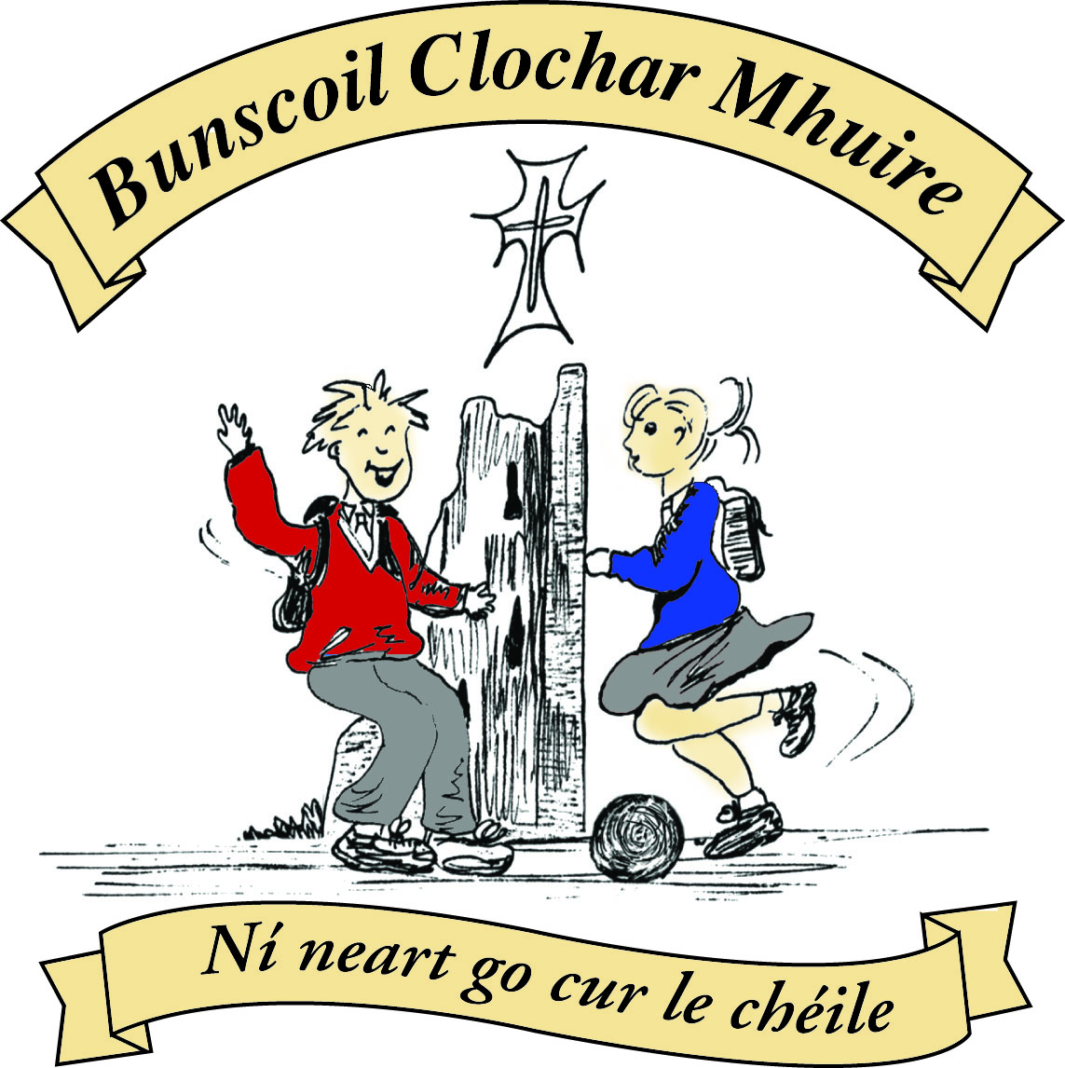* St Mary’s Convent Primary School**

***Bunscoil Clochar Mhuire***

***Trim, Co. Meath.  
Fón: (046) 9431919 ⦁ Faics: (046) 9437942  
Ríomhphost:*** [***marystrim@eircom.net***](mailto:marystrim@eircom.net) ***⦁ Website:*** [***www.stmarystrim.ie***](http://www.stmarystrim.ie) ***Uimhir Rolla: 16646O***

Awarded Green Flag  
June ‘05/’07/11/13

***Imlitir 19***

22nd January, 2018

***Every Day Counts at St Mary’s Convent Primary School***

***15th Jan – 19th Jan 2018***

|  |  |  |  |  |  |  |  |
| --- | --- | --- | --- | --- | --- | --- | --- |
| **Room** | **Attendance** | **Room** | **Attendance** | **Room** | **Attendance** | **Room** | **Attendance** |
| 01 | 97.2 % | 08 | 92.6% | 16 | 93.6% | 26 | 94.8% |
| 02 | 96.6% | 09 | 97.7% | 17 | 96.6% | 27 | 89.2% |
| 03 | 93.1% | 10 | 88.8% | 18 | 94.3% | 30 | 64.8% |
| 04 | 61.4% | 12 | 93.6% | 19 | 84.4% | 31 | 44.8% |
| 05 | 89.6% | 13 | 93.3% | 20 | 68.5% |  |  |
| 06 | 80% | 14 | 87.1% | 23 & 24 | 91.4% |  |  |
| 07 | 95% | 15 | 83.4% |  |  |  |  |

*Please note that notification in writing, with the reason for all absences, to the teacher is required. A letter or note in the homework journal will suffice.*

A chairde,

Next week we will be celebrating **Catholic Schools Week**. This week gives everyone involved in Catholic education the opportunity to acknowledge and celebrate the contribution that our Catholic schools make to Irish life. This year’s theme is: ‘Catholic Schools: Called to be a Family of Families.’ As a Catholic School we will be celebrating our Ethos by engaging in various activities over the week. On Friday Jan 26th, room 13 will launch Catholic Schools Week, and on Jan 31st we will have Grandparents’ Day. All grandparents’ are invited in from 10.30 to join us for a cup of tea in the School Hall. Some may wish to visit their grandchildren’s classes after this to talk about the good ole days.

As “Family” is the theme this year, any grandparent who wishes may collect their grandchildren and bring them to Mass at 10am on Jan 31st. Fr Seán will issue a special blessing for grandparents. When they leave the children back after Mass, they may have a cuppa in the school.

**OPEN DAY** last week was a very well received and as usual the pupils stole the show. The Sixth Class girls received many compliments regarding their deportment and demeanour, and many people remarked on the entertainment provided by the Banna (School Band). The security in our school was complimented also. Some current parents used the opportunity to have a walk around and see the school in action. I would like to thanks our Parents’ Association for their support and to thank all young and old who helped in any way.

**School Registration Forms** for children starting school in September 2018 are still available from Helen, in the office. Please note that the Final Submission Date for return of forms is this Friday January 26th and that offers will be posted on Friday February 2nd. I am awaiting final confirmation of numbers from the Department before I can give an indication on whether or not we will have a waiting list.

Parent Teacher Meetings for Special Ed. will take place on Friday 9th and Monday 12th February. Bookings will be done online like last year. You will be able to log in and chose your time for the day. Relevant parents/guardians will be given a note to explain the process today or tomorrow. Junior Infant classes meetings are on February 21st & 22nd , and they got their note today. Contact the school if you did not get your note.

**Please ensure that your child has a coat coming to school this weather. They will need to wear one in the yard also.**

**Dates for your diary**

1. Fundraiser for our All Weather Pitch: Sunday March 18th Bingo @ 3.00 in The Dr Eileen Reilly Hall.
2. Tuesday May 29th Teacher In-service Day on The Primary Language Curriculum. School closed for the pupils.

**Confirmation Classes**: The Sacrament of Confirmation will take place on Saturday, 10th February.  In conjunction with the Confirmation programme being taught in school, Fr Seán has invited the candidates in St Mary's to participate in a "Gifts of the Holy Spirit Mass" this coming **Sunday (Jan. 28th) at 11am in St Patrick's Church**. Pupils have been asked to wear full school uniforms and to sit with family/a family member near the altar. During the Mass, pupils will read from scripture, explain the Gifts of the Holy Spirit, present Prayers of the Faithful and carry forward offertory gifts. It is hoped that the Mass will enable the pupils to engage, in a meaningful way, with the presence of God in their lives.

Ms Lynch and Mr Galligan

**Credit Union Schools Quiz 2018:** Best wishes to Ella, Rebekah, Orlaith, Ciara, Lucy, Emma, Anna and Clíodhna at the CU Schools Quiz this coming Friday night in Drogheda. It all kicks off at 7pm!

Mr Galligan

**Be Active After School Programme for Second Class Pupils**

The second class pupils are invited to participate in a **FREE** after school programme for six weeks. It will be on every Monday from 3-4pm, beginning on Monday 5th February, 12th Feb, 19th Feb, 26th Feb, 5th March and 12th March. The Be Active Programme introduces children to a variety of fun, physical activities in a safe, familiar, structured setting, with an emphasis on enjoyment.

In order for this programme to run successfully, we need parent volunteers to support the teachers. No previous experience or knowledge in any sport is required, just a willing, interested person! The children in second class will receive the relevant application forms in order for them to participate and for parents to register to volunteer. Thank you. Ms Maguire & Ms Murray

**Digital Technology News:**

Conversations begin in Scratch this week with stories being animated and backgrounds being changed for various scenes in the stories. Please keep asking your child what they are doing each week and where possible download Scratch and allow them to practise at home. Ms Debby

Finally, we are still looking for volunteer “Listeners” to listen to children’s reading in the younger classes (any time and any day) and also volunteers to help in the Library on Friday mornings. Please contact Helen for further information.

Mise le meas,



Cóilín Ó Coigligh, Príomh Oide.

[**Green News**](#greennews)

[**Community News**](#communitynews)

***Nathanna na Seachtaine: Bain triail eile as! (Try again/ Have another go!)***

***Seanfhocal na Míosa: Nuair a bhíonn an cat amuigh, bíonn an luch ag rince!***

**Dates to Remember**

**Assembly:** Friday @ 9.20 Start of Catholic Schools Week

Junior Classes

**Meitheal:** Every Tuesday morning 9.30-10.30.

**Drama Club:** Every Thursday 3-4pm for 5th Class

**Banna:** Tuesdays @ 3.00 – 4.00

**Communion: Saturday 5th May @ 11.00**

**Confirmation: Saturday 10th Feb @ 11.00**

[**Green News**](#greennews)

Our Green Flag theme over these two years is Global Citizenship – Energy. Many years ago we worked with the energy theme and achieved a green flag for this. Now we are revisiting the energy theme with a global dimension. Climate change is a huge part of this theme and is a direct result of energy over-usage. We gave you this link before but in case you haven’t looked at it here it is again. It might be a nice way to discuss Climate change with your child. [www.bit.ly/globalcarbon](http://www.bit.ly/globalcarbon)

We are having an Energy Action Day on Feb 2. Third Class to Sixth will do a pedal energy workshop with Gavin Harte and use the energy they produce to make smoothies among other things. We also hope to make a trip to the Recycling Centre that day and we will take an aerial photo with our drone. We will have other exciting energy activities that day. Maybe you can ask your child about their Energy Action Day after school that day.

Recycling continues in St Marys. Congratulations to the pupils who keep this initiative going. We accept batteries, ink cartridges, mobile phones, card, toilet rolls, cans, footwear and postage stamps. Many charities benefit from our recycling and it is a great habit to cultivate in our pupils.

WOW will continue from the usual meeting points (Mornington House and the Matchbox) and COW will resume in the spring. Míle buíochas to Ms Flattery and Ms Finn for being there every week to escort the pupils up to the school. The weather has been very challenging lately so well done all who walk to school.

Last week the children in Rooms 5 and 6 did some planting. We look forward to seeing the fruits of their labour over the next few months. Check out the photos!

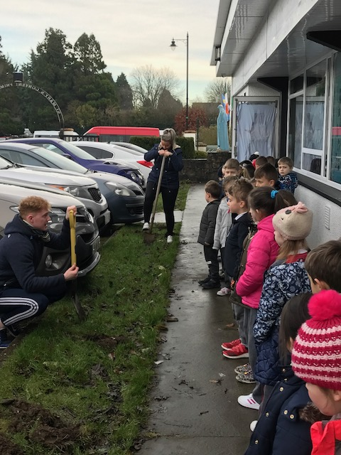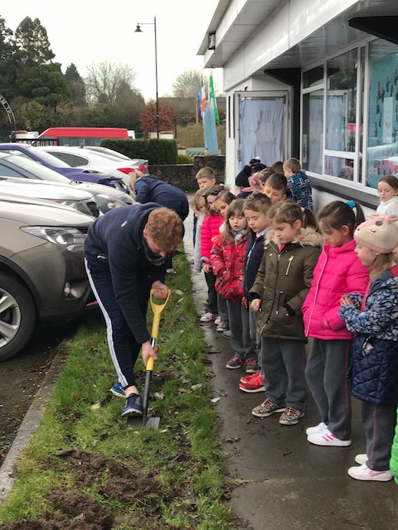

***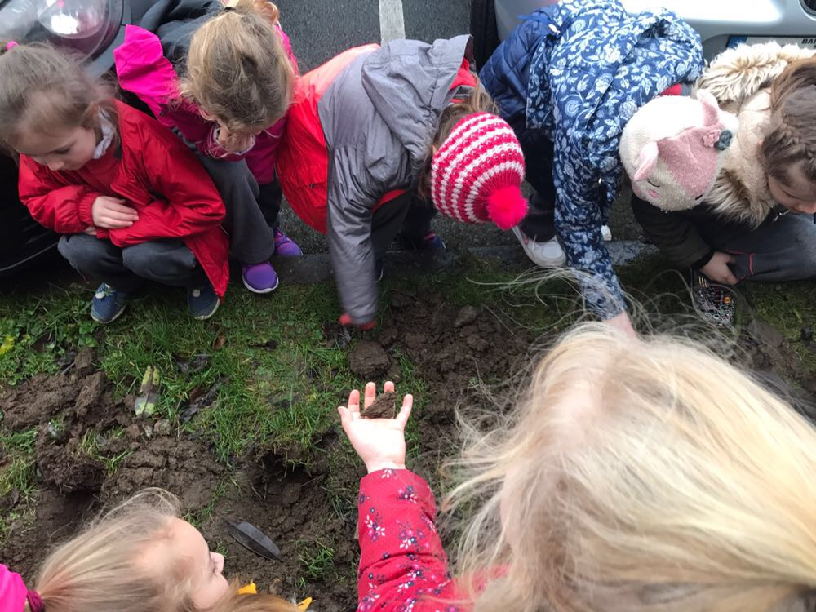***

***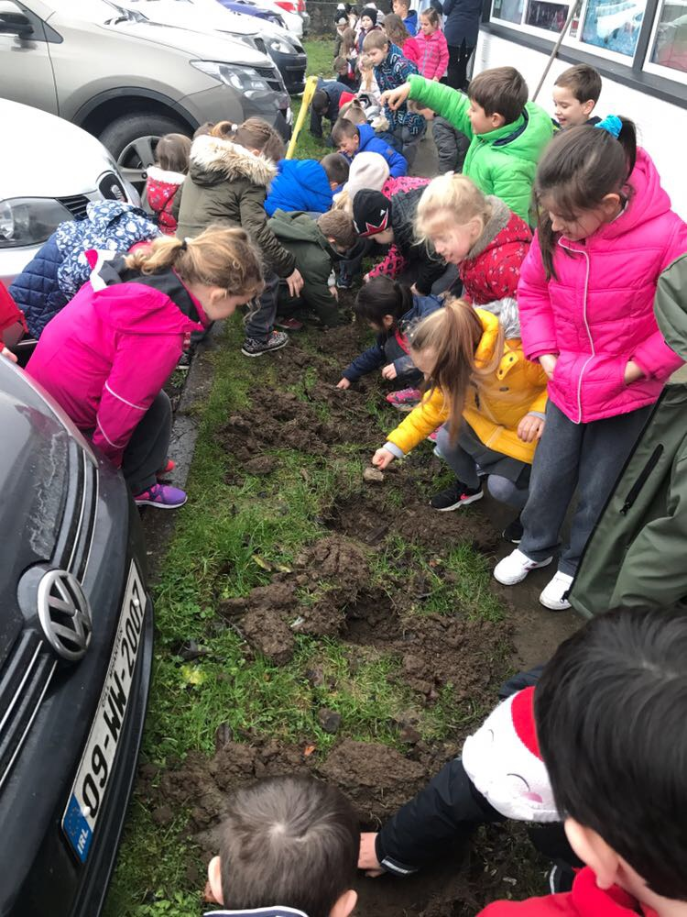***

***Remember Green is cool, at home, at school and around the globe!***

St Mary’s Parents’ Association

Dates for Your Diary:

**January 26th**: Parents’ Association meeting at 9.30am in the staffroom. All parents/guardians welcome to attend.

<https://www.facebook.com/stmarysparentsassoc/>Many thanks for your continued support.

Caroline Smith

Secretary

[**Community Notices**](#communitynews)

There will be International Students coming to our school in 3rd term and  [www.rockbrookinternational.com](http://www.rockbrookinternational.com/" \t "_blank)  is looking to find host Families, Please call 014936692 or check out the website if you are interested in hosting a student. Please see Flyer for information.

New Experience, Extra Income. Why not host a student? Competitive Rates Phone 01 493 6692 Rockbrook House, Edmondstown Road, Dublin 16, Ireland Email [info@rockbrookinternational.com](mailto:info@rockbrookinternational.com)  
• Host families needed to host students aged 9 - 16 from abroad in:  
• The Irish family should have children aged between 4 - 16.  
• Students attend local Primary and Secondary Schools from Monday to Friday.  
• Saturday a full day activity.New Experience, Extra Income.  
Why not host a student? Competitive Rates Phone 01 493 6692



**Homework Club** in St Mary’s for children from 1st – 6th Classes. Application Forms are available from Ms Conaty Room 11 or Ms Lynch Room 31.

**Searsol** touch typing in  St Mary's primary school. New term starting in January. Book a free trial with Jackie at 086-3780842

**ZUMBA**: -   Monday / Wednesday 8pm Trim GAA   -  €8 per class,  suitable for all fitness levels,  no booking/experience required.  Contact : Lorraine 086 8693546

**ZUMBA KIDS**:-   JANUARY TERM NOW BOOKING -  Ages  4-8 Thursdays  2.15pm - 3.00pm,  St. Patrick's Hall (Under snooker hall) Starting 11th January for 4 weeks,  €20 per child.  BOOKING REQUIRED  -  Please Contact :  Lorraine 086 8693546 / Jo  086 3381159