***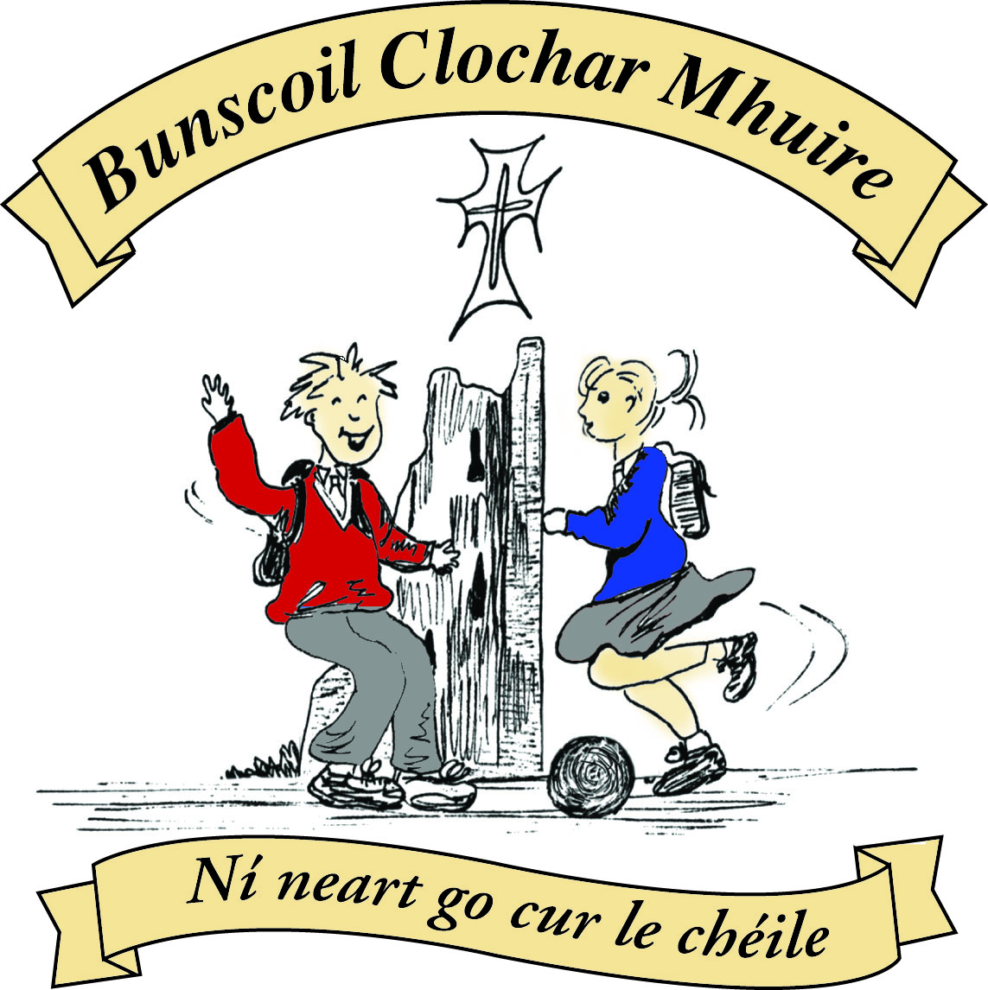* St Mary’s Convent Primary School**

***Bunscoil Clochar Mhuire***

***Trim, Co. Meath.  
Fón: (046) 9431919 ⦁ Faics: (046) 9437942  
Ríomhphost:*** [***marystrim@eircom.net***](mailto:marystrim@eircom.net) ***⦁ Website:*** [***www.stmarystrim.ie***](http://www.stmarystrim.ie) ***Uimhir Rolla: 16646O***

Awarded Green Flag  
June ‘05/’07/11/13

***Imlitir 19***

18th January, 2016

***Every Day Counts at St Mary’s Convent Primary School***

***11th -15th January 2016***

|  |  |  |  |  |  |  |  |
| --- | --- | --- | --- | --- | --- | --- | --- |
| **Room** | **Attendance** | **Room** | **Attendance** | **Room** | **Attendance** | **Room** | **Attendance** |
| 01 | 91.1% | 08 | 92.1% | 16 | 97.8% | 26 | 98.5% |
| 02 | 96.2% | 09 | 93.3% | 17 | 92% | 27 | 98.6% |
| 03 | 95.2% | 10 | 99.3% | 18 | 97.1% | 30 | 93.1% |
| 04 | 86.2% | 12 | 95.4% | 19 | 98.6% | 31 | 80.7% |
| 05 | 87.9% | 13 | 98.5% | 20 | 99.3% |  |  |
| 06 | 92.9% | 14 | 90.4% | 23 | **100%** |  |  |
| 07 | 89.2% | 15 | 92% | 24 | **100%** |  |  |

A Chairde,

Congratulations to Rooms **23 and 24** on having full attendance last week. Their teacher will let them know this week what their prize is.

Our Annual **Open Day** will be on Thursday February 4th 11:00- 12:30. All prospective and existing parents/ guardians are welcome to visit and see our school in action. Just come to the Dr Reilly Hall @ 11:00am.

You are all aware that we walk to school on Wednesdays (WOW!) and that when the weather improves will restart cycling (COW!) to school. These schemes promote our green agenda and also help with children’s fitness. Our thanks to Ms Flattery and Ms Heffernan for escorting the children from Mornington House @ 9.00a.m. on Wednesdays.

**Strictly St Mary’s:** We have 13 tickets for sale on a first come first served basis. Contact Helen, in the office.

**Registration Forms** for children starting school in September 2016 are now available from Helen, in the office. Please note that the Final Submission Date for return of forms is 15th February but we would appreciate if possible that forms be returned before the end of January for administration purposes.

Please read our Green News and Community Notices that follow.

*Yesterday the First Communion Class had a special Do This in Memory Mass. Emma, Amy, Alicja, Nicole and Cara read the Prayers of the Faithful. Saoirse and her dad and Eimante and her mum brought up the bread and wine at the Offetory. We all sang “These Hands” at the end of the Mass. The electricity cut out in the middle of the Mass so we all had to use our big voices!*

*Thank you to Fr Declan who had a difficult job with no microphone. The candles on the altar gently shone through the darkness. Please keep us in your prayers as we prepare for our First Confession on March 2nd.*

*By 2nd Class*

***Morning Jog on Sli na Slainte.*** *Starting tomorrow, Tuesday, Ms Carr will be jogging a daily lap around the track with any children who are in the yard at 9.10. This is part of our effort to "Be Active" but studies also show that exercise settles children and helps with their learning.*

*There are some concerns around managing this if there are a lot of children using the track at the same time so we are going to do it with juniors (jun inf-1st class) one day and seniors the next day and so on. This may not be necessary if numbers are small. We would also like to emphasise that children should not push or race around the track, the focus is on being active. We would also ask parents not to stand on the track while it is happening.*

*Hopefully this will grow into a daily habit for our children and encourage them to try and run more laps! Parents are welcome to do a few laps after the children have finished, 4 laps is approx kilometre!.*

*Mary Carr*

***Banna Ceoil***

*Banna Ceoil practices continue every Tuesday 3-4pm. Tomorrow Tuesday 19th* ***only*** *we will accept new members from 2nd – 6th. Just come along and collect a registration form and return. Please keep an eye on Imlitirs (emails) in case of cancelling a practice. Go raibh maith agaibh.*

*R Mc Gale*

**Green News**

**Community News**

Mise le meas,



Cóilín Ó Coigligh, Príomh Oide

Nath na Seachtaine: **Tá sé fuar. (Tá sioc ar an talamh/ Tá an clós sleamhain)**

**Seanfhocal na Míosa**: **Mol an Óige, agus tiocfaidh sí!**

**Dates to Remember**

**Assembly: “**Homes & Houses” Assembly for Junior Classes

All are welcome to attend.

**Meitheal:** Every Tuesday morning 9.30-10.30.

**Banna Ceoil:** Every Tuesday @ 3pm.

**Confirmation:**  Saturday 13th February @ 11.00 a.m.

**First Communion:** Saturday 28th May @ 11.00 a.m.

**Green News**

**Recycling**

Our Green Flag theme will be Global Citizenship over the next year and a half and will concentrate on Litter and Waste Management. Here at school we encourage the children and staff to recycle as much as possible. Each class has two bins, highlighting the fact that some materials can be reused while others may not. All food, not consumed, coupled with skins and peel, are to be brought home in the lunch boxes.

We recycle batteries, ink cartridges, mobile phones, postage stamps, card, toilet rolls, cans and eye glasses. Recently we discovered that Nespresso coffee pods are also recyclable so if you use them, and would like to send your used pods in to school we will take it from there. Renewed thanks to all those who recycle with us regularly. Remember if you would like to recycle your old Christmas cards, we will still accept them.

**WOW**

The WOW teachers will meet anyone who would like to walk down to school from Mornington House every Wednesday at 9am. To encourage more participants, we would like to set up another meeting point as part of our Be Active Campaign. If anyone would like to make a suggestion or get involved in the Walking on Wednesdays, please contact the school.

Our Green Blog has started up again, thanks to Ms Dalton. If you would like to contribute to it the email address is as follows:

If you have any nice photos of nature or anything that is linked to our Green themes, please send them in to our Green Blog. We always welcome new ideas and observations.

**St Patrick’s Day Parade**

We are currently working on a plan for our St Patrick’s Day Parade entry. Every year we have had a wonderful group of pupils representing the particular Green theme for that year. This year we are hoping to be very creative in what we are planning. More details later. We would like to thank the Trim Tidy Towns Committee who encourage us along the way.

**Global Citizenship** is the theme we will be concentrating on (and trying to say!!) for the next two years. As its name implies, it refers to our belonging to a greater world and to how our actions have global ramifications. We will be celebrating the different cultures we have in our school and learning more about them.

Under our Global Citizenship theme, we recently had a delegate from Trócaire come in to visit our Senior Classes to discuss the work Trócaire does abroad. Last year, this particular group organised a bun sale to help those affected by the earthquake in Nepal. It was fitting that Cassandra came in person to thank the girls and share some information with them.

***Remember Green is cool, at home, at school and around the globe!***

**Community Notices**

**ART CLASSES** with Ms Leavy and Ms Carr restart today Monday 18th January in rooms 8 & 19. Children can join on Mondays between 3-4pm. All welcome (from Senior Infants to 6th Class)

**ZUMBA**  :-   No experience, partner or booking required -  2 classes to choose from:-

MONDAY   8pm   Trim GAA, THURSDAY  8pm  Dance Force Academy €8 per class     Contact :  Lorraine  086 8693546

**KIDS DANCE CLASS** :-        Ages 5-8          TUESDAY    3.15pm    TRIM GAA

 €6 per class  (Sibling rate €5) Zumba,  Hip-Hop,  Rock 'n Roll,  Jive...    Contact :  Lorraine  086 8693546 / Jo  086 3381159

**JIGGLE 'N' JUMP** - Classes running in the Oaktree Business Park for kids aged 1-4 years.

> Running Tuesday's 9.50am and Saturdays 10am First Class only €6.50. €25 for 4 Classes.

> Also fun Characters available for Parties & Events to Face Paint, play Party Games, Singing, Dancing, Prizes and lots of fun! Call Julie : 086 8505310

**Mindfulness and Self Confidence** course for 10-13 year olds is back on Thursdays at 4.15pm in the Elements Holistic Centre 1 Oaktree Business Park, Trim. The course is for 12 weeks and costs €70. [www.metta-morphics.com](http://www.metta-morphics.com)  
<https://m.facebook.com/mettamorphics>