***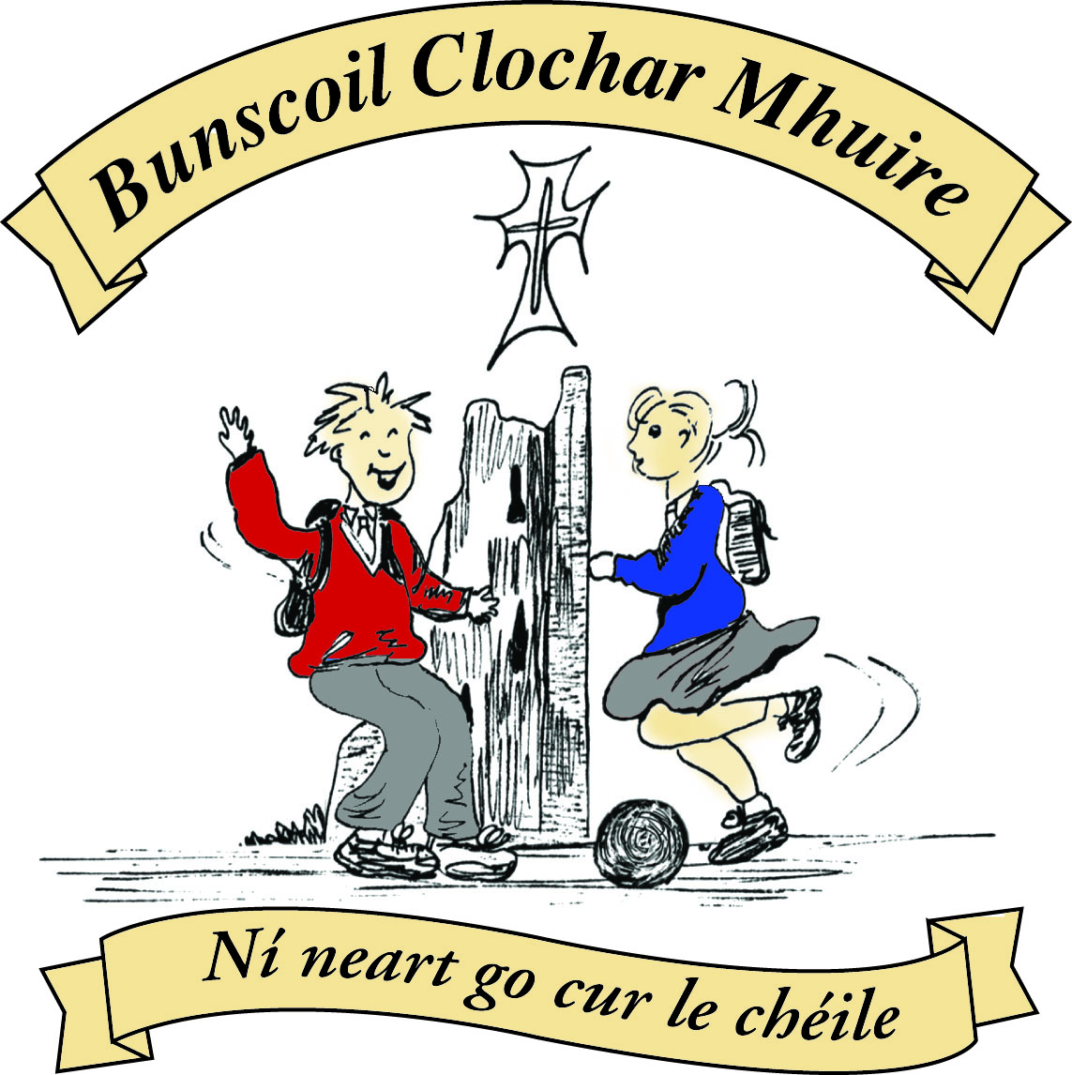* St Mary’s Convent Primary School**

***Bunscoil Clochar Mhuire***

***Trim, Co. Meath.  
Fón: (046) 9431919 ⦁ Faics: (046) 9437942  
Ríomhphost:*** [***marystrim@eircom.net***](mailto:marystrim@eircom.net) ***⦁ Website:*** [***www.stmarystrim.ie***](http://www.stmarystrim.ie) ***Uimhir Rolla: 16646O***

Awarded Green Flag  
June ‘05/’07/11/13

***Imlitir 18***

15th January, 2018

***Every Day Counts at St Mary’s Convent Primary School***

***8th Jan – 12th Jan 2018***

|  |  |  |  |  |  |  |  |
| --- | --- | --- | --- | --- | --- | --- | --- |
| **Room** | **Attendance** | **Room** | **Attendance** | **Room** | **Attendance** | **Room** | **Attendance** |
| 01 | 97.9 % | 08 | 96.3% | 16 | 92.1% | 26 | 94.8% |
| 02 | 93.8% | 09 | 79.2% | 17 | 98.3% | 27 | 94.6% |
| 03 | 95.2% | 10 | 91.2% | 18 | 91.4% | 30 | 98.4% |
| 04 | 95.2% | 12 | 93.6% | 19 | 79.3% | 31 | 97.6% |
| 05 | 93.6% | 13 | 99.2% | 20 | 91.5% |  |  |
| 06 | 92% | 14 | 90% | 23 & 24 | 94.2% |  |  |
| 07 | 98.3% | 15 | 94.5% |  |  |  |  |

*Well done to room 13 on nearly having full attendance last week. Please note that notification in writing, with the reason for all absences, to the teacher is required. A letter or note in the homework journal will suffice.*

A chairde,

Our Annual **Open Day** will be **this Thursday** January 18th 11:00 - 12:30. All prospective and existing parents/ guardians are welcome to visit and see our school in action. Just come to the Dr Reilly Hall @ 11:00am.

Our Junior Infant Parent Teacher Meetings take place on February 21st and 22nd. Appointments, this year will be online, and will be opened this week.

**Substitute Teacher Shortage:** Please note that we have not been in a position to get substitute teachers, when permitted, as easily this year as in previous years. There is a teacher shortage. Please also note that the Department of Education and Skills does not provide substitute cover for course days, marriage leave, court leave, graduation leave and the first day of Force Majeure. On these occasions, and on occasions when we are permitted to employ substitute teachers but cannot source them, classes are divided among other classes in the school for supervision purposes.

Small tables and chairs for sale @ €10 and €5 euros respectively. They are in very good condition and suitable for children aged five and younger. Old school desks for sale @ €45. Contact Helen or Rebecca in the office.

You are all aware that we walk to school on Wednesdays (WOW!) and that when the weather improves we will restart cycling (COW!) to school. These schemes promote our green agenda and also help with children’s fitness. Our thanks to Ms Flattery and Ms Finn for escorting the children from Mornington House @ 9.00a.m. on Wednesdays.

**Head Lice:** Parents/guardians are asked to be vigilant and to check your children’s hair regularly. It is best that long hair be tied up in school, especially if there has been an incidence in your child’s class. Please note the following advice:

<https://www.lyclear.ie/head-lice-tips-facts/what-are-head-lice/>

**Registration Forms** for children starting school in September 2018 are available from Helen, in the office. Please note that the Final Submission Date for return of forms is 26th January. Initial offers will be posted a week later.

**Digital Technology:**

Great excitement in the Computer Room this week – students from 2ndt class to 6th have begun using Scratch 1 once again and our 1st class students got their first introduction to animation and programming. Scratch 1 is a free piece of software that can be downloaded from the internet – if your child asks you to download this it will be to show you what they are learning each week and to continue to practise their Scratch skills. Watch out for their animated stories and basic games!

Ms Debby

Please read our Green News and Community Notices that follow. I would particularly like to draw your attention to the opportunity to host students from Spain who will be attending our school after Easter.

**Credit Union Schools Quiz 2018**: The 'local' stage of the Credit Union Schools Quiz 2018 will take place in Drogheda Institute of Further Education on Friday, 26th January at 7pm. Two teams of four from 4th, 5th and 6th Classes will represent St Mary's. Ella Casey, Rebekah Calvin, Orlaith Reilly and Ciara Ryan will represent the school in Category A, the Junior Section, while Lucy Clavin, Emma Crawford, Anna O'Hare and Clíodhna Vaughan will participate in Category B, the Senior Section. We wish them all the very best! Mr Galligan

Mise le meas,



Cóilín Ó Coigligh, Príomh Oide.

**Green News**

**Community News**

***Nathanna na Seachtaine: Gabh mo leathscéal***

***Seanfhocal na Míosa: Nuair a bhíonn an cat amuigh, bíonn an luch ag rince!***

**Dates to Remember**

**Assembly:** Friday 19th Green Schools.

**Meitheal:** Every Tuesday morning 9.30-10.30.

**Drama Club:** Every Thursday 3-4pm for 5th Class

**Banna:** Tuesdays @ 3.00 – 4.00

**Communion: Saturday 5th May @ 11.00**

**Confirmation: Saturday 10th Feb @ 11.00**

**Green News**

*‘A* ***global citizen*** *is someone who is aware of and understands the wider world - and their place it. They take an active role in their community, and work with others to make our planet more equal, fair and sustainable’. (*[*https://www.oxfam.org.uk/education*](https://www.oxfam.org.uk/education) *)*

Our Green Flag theme over the next two years is Global Citizenship – Energy. It is follows on from our work in the area of Litter and Waste Management. We will launch our Energy Theme on February 2. Gavin Harte of Pedal Energy will work with Classes from Third to Sixth. Through pedaling he will demonstrate how energy can be generated and used to do some very entertaining things. We will have a line-up of other exciting things that day for other classes too.

WOW will continue on Wednesdays. Meet up at Mornington House or at the Matchbox and join the Green Flag Teachers who will escort you to the school. Please wear your hi-viz vests. This makes it safer for everyone as you can seen more easily.

Recycling continues at St Marys. We accept batteries, mobile phones, ink cartridges, postage stamps, card, small plastic bottles, cans and toilet rolls.

***Remember Green is cool, at home, at school and around the globe!***

St Mary’s Parents’ Association

Dates for Your Diary:

**January 18th**: Open day for prospective parents/guardians. Light refreshments will be provided by the Parents’ Association.

**January 19th**: Parents’ Association meeting at 9.30am in the staffroom. All parents/guardians welcome to attend.

<https://www.facebook.com/stmarysparentsassoc/>Many thanks for your continued support.

Caroline Smith

Secretary

**Community Notices**

There will be International Students coming to our school in 3rd term and  [www.rockbrookinternational.com](http://www.rockbrookinternational.com/)  is looking to find host Families, Please call 014936692 or check out the website if you are interested in hosting a student. Please see Flyer for information.

New Experience, Extra Income. Why not host a student? Competitive Rates Phone 01 493 6692 Rockbrook House, Edmondstown Road, Dublin 16, Ireland Email [info@rockbrookinternational.com](mailto:info@rockbrookinternational.com)  
• Host families needed to host students aged 9 - 16 from abroad in:  
• The Irish family should have children aged between 4 - 16.  
• Students attend local Primary and Secondary Schools from Monday to Friday.  
• Saturday a full day activity.New Experience, Extra Income.  
Why not host a student? Competitive Rates Phone 01 493 6692



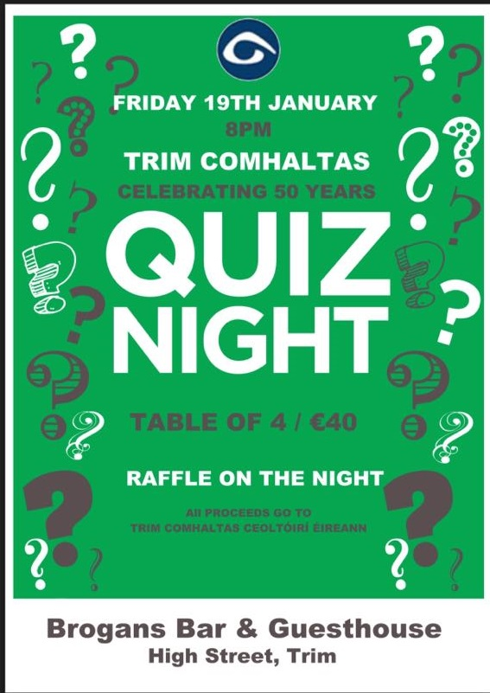

**Searsol** touch typing in  St Mary's primary school. New term starting in January. Book a free trial with Jackie at 086-3780842

**ZUMBA**: -   Monday / Wednesday 8pm Trim GAA   -  €8 per class,  suitable for all fitness levels,  no booking/experience required.  Contact : Lorraine 086 8693546

**ZUMBA KIDS**:-   JANUARY TERM NOW BOOKING -  Ages  4-8 Thursdays  2.15pm - 3.00pm,  St. Patrick's Hall (Under snooker hall) Starting 11th January for 4 weeks,  €20 per child.  BOOKING REQUIRED  -  Please Contact :  Lorraine 086 8693546 / Jo  086 3381159