***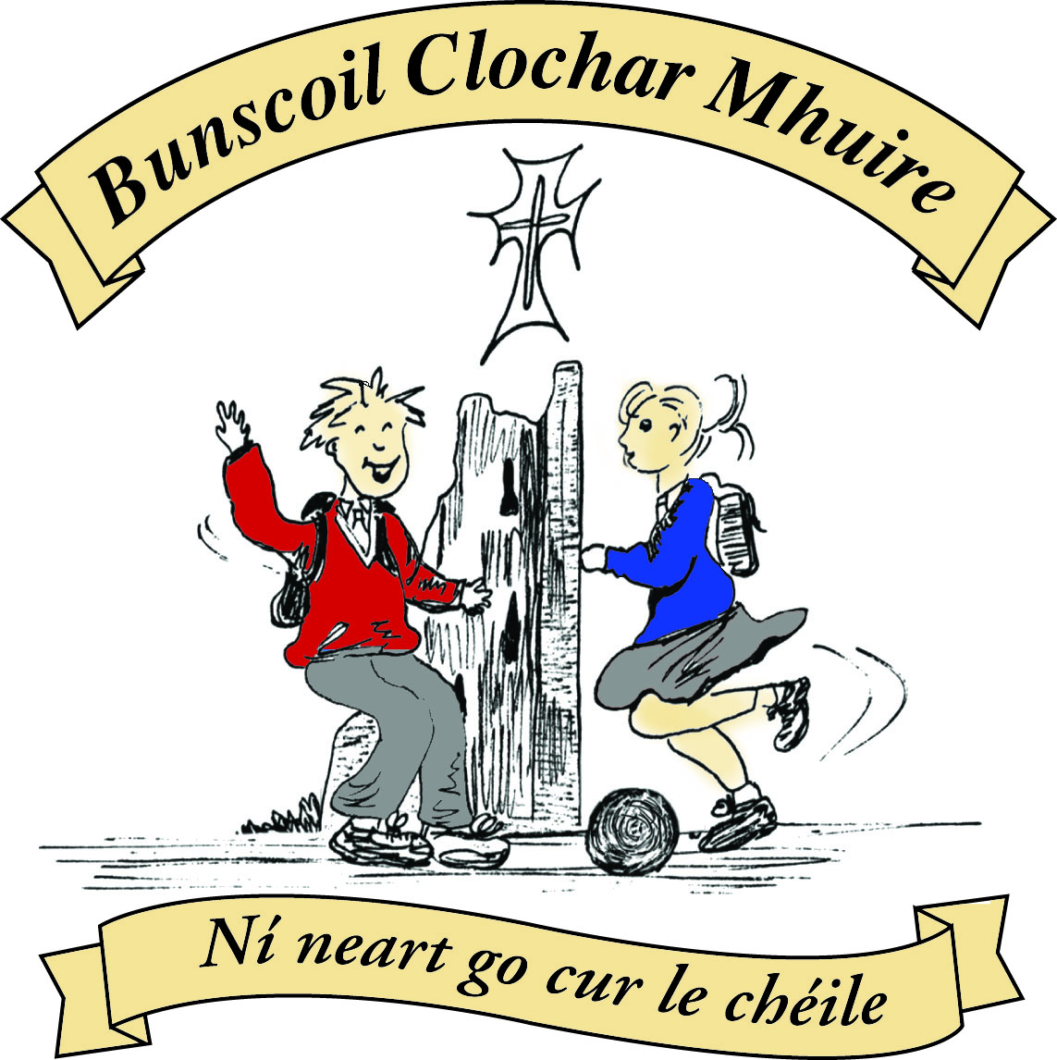* St Mary’s Convent Primary School**

***Bunscoil Clochar Mhuire***

***Trim, Co. Meath.  
Fón: (046) 9431919 ⦁ Faics: (046) 9437942  
Ríomhphost:*** [***marystrim@eircom.net***](mailto:marystrim@eircom.net) ***⦁ Website:*** [***www.stmarystrim.ie***](http://www.stmarystrim.ie) ***Uimhir Rolla: 16646O***

Awarded Green Flag  
June ‘05/’07/11/13

Imlitir 17

21st December, 2015.

A chairde,

I would like to take this opportunity to wish you all a very Happy Christmas and Joyous New Year.



**Maligayang pasko**

**Szczeslimych Swiat**

**ക്രിസ്തുമസ് ആശംസകള്‍**



**Nollaig Shona**

**Linksmu Kaliedu**

**کرسمَس مبارک**

**Счастливого рождества**

***Please note that School closes for the Christmas Holidays tomorrow (Tuesday) December 22nd @ 12.30 p.m. and re-opens on Wednesday 6th January 2016 @ 9.20 a.m.***

***Every Day Counts at St Mary’s Convent Primary School***

***14th Dec – 18th December 2015***

|  |  |  |  |  |  |  |  |
| --- | --- | --- | --- | --- | --- | --- | --- |
| **Room** | **Attendance** | **Room** | **Attendance** | **Room** | **Attendance** | **Room** | **Attendance** |
| 01 | 89.6% | 08 | 93.6% | 16 | 92.6% | 26 | 95.6% |
| 02 | 95.4% | 09 | 99.3% | 17 | 98% | 27 | 94.3% |
| 03 | 98.4% | 10 | 95.7% | 18 | 95.7% | 30 | 97.9% |
| 04 | 93.1% | 12 | 93.1% | **19** | **100%** | 31 | 87.6% |
| 05 | 93.6% | 13 | 93.8% | 20 | 95% |  |  |
| 06 | 95% | 14 | 85.9% | **23** | **100%** |  |  |
| 07 | 96.9% | 15 | 97.6% | 24 | 96.7% |  |  |

Well done to Rooms 19 and 23 on having full attendance last week. Their teacher will let them know this week what their prize is.

Congratulations to Room 24 for having the best attendance this term and to Rooms 18, 19, 23 and 27 who were next best. They have earned a homework pass for the week that they come back in January. The class decide which day that week. A total of 125 pupils have had perfect attendance since September which is excellent. Well done to all for their efforts. A cert has been presented to them. There will be another attendance assembly before the Easter and Summer Holidays and we hope that there will still be a large number by the end of the year.

Many thanks to all who contributed to our Readalong. A total of €2,160.00 was collected which has been lodged into our M.U.G.A. Fund. There are still a small number of cards not returned. Please return them ASAP. Thanks. Strictly St Mary’s will be our major fundraiser this year. All school tickets have been sold. The only tickets left are the ones taken by the dancers. If you are buying a ticket from a dancer please thank them for helping the school. We will be issuing sponsorship cards in the New Year to enable those who cannot attend to vote for a dancer. We are hoping to persuade the teachers and their dance partners to do a small performance for those who voted for them, closer to the time. Finally, we are exploring the possibility of a joint sports grant application with local sports bodies. The estimates to build the M.U.G.A. are far in excess of the €120,000 we were expecting it to cost and it will not be feasible to fundraise the whole amount.

Our new Board of Management met last week for the first time and the Agreed Report follows. I would like to take this opportunity of thanking them for giving of their time and to wish them every success over the next four years.

*The newly appointed Board of Management met last Tuesday, with each member being assigned a responsibility as follows:*

* *Peter Higgins- Chairperson*
* *Coilin o'Coigligh- Secretary*
* *Assumpta Harvey O'Dowd- Treasurer*
* *Barbara Munnelly-Agreed Report*
* *Fr.Declan- Legal matters*
* *Patrick O'Donnel-ICT*
* *John Leonard-Capitol Projects Officer*
* *Yvonne McElhinney- Safety Officer*

*Grants were granted from the Dept. to the school for emergency works on the surface water in the yard and a ramp to enable improved wheelchair access to the hall.*

*The board approved monies for basketball nets and a divider net in the hall.*

*Finally, the board have contacted the HSE to work out an agreement regarding speech therapy allocation in the Speech and Language Class for next year.*

B.Munnelly

***Santa Dash***

*Tuesday 22nd December, December, Junior Infants 🡪First Classes @ 9.45*

SANTA014

*Senior Classes 10.15 a.m.*

*All pupils must wear school tracksuit along with Santa Hat/Christmas themed*

*Jumper with runners. Parents/guardians are welcome to come and watch and*

*get into the festive spirit. One condition you need to wear a Santa Hat or*

*Christmas themed jumper. Wishing you a Merry Christmas.*

*Ms Elaine Maguire and Ms Eimear Murray.*

***Drama Club:*** *To celebrate the end of the term the girls from 4th class in St. Mary’s Drama Club had a well deserved party. The girls have been having great fun at Drama Club in recent times with lots of varied activities! Such activities included mime, script reading, improvisational work, memory games, story - telling and acting techniques.  The girls had great fun and it has been lovely to see their confidence grow! We would like to thank them all for their hard work and enthusiasm this term! Well done girls!*

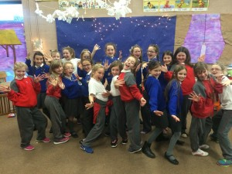

*C. O’Mahony & B. Mulvihill*

**Enrolment Forms** for September 2016 are now available from Helen in the office.

I hope everybody has a great “Santa Dash” tomorrow. Let’s hope the weather holds or we will end up “Dashing Through the Rain!”

***Nollaig faoi shéan agus ath-bhlian faoi mhaise daoibh go léir.***

Mise le meas,



Cóilín Ó Coigligh, Príomh Oide

**Community Notices**

**Green News**

***Nath na Seachtaine*** Beannachtaí na Nollag chugaibh! (Christmas Blessings to you all)

Seanfhocal na Míosa: Ní hé lá na báistí lá na bpáistí. A wet day is not for children (or adults)

**Dates to Remember**

**Meitheal:** Every Tuesday morning 9.30-10.30.

**Confirmation:**  Saturday 13th February

**First Communion:** Saturday 28th May @ 11 a.m.

**Santa Dash:**  Tuesday 22nd Dec

**Green News**

**Green News Dec 21, 2015**

Wishing everyone a very happy, peaceful and green Christmas. We trust that all the good green habits we have been encouraging all year will help everyone to remain green while on their Christmas holidays. Mary Robinson, former President of Ireland and former United Nations High Commissioner for Human Rights recently spoke about climate change and of the role we all can play in combating it. Many of the suggestions she made were those we are already carrying out in St Mary’s, we can proudly say.

Well done to all who have made 2015 a very successful green year. We acquired our Green Flag for Biodiversity before the summer and our pupils played a significant role in the acquisition of the Gold Medal status for Trim in L’Entente Florale.

This academic year is off to a great start also. Two of our students were among the prize-winners for the Meath County Council Anti-Litter Calendar competition. Well done Rachel and Orla!

**WOW** (Walk on Wednesdays) will continue in the New Year. Sincere thanks again to all the teachers, pupils and parents who make this work. We would like to expand this initiative in the New Year as part of our Be Active Flag. We hope more people will get involved.

Beannachtaí na Nollag chugaibh go léir!

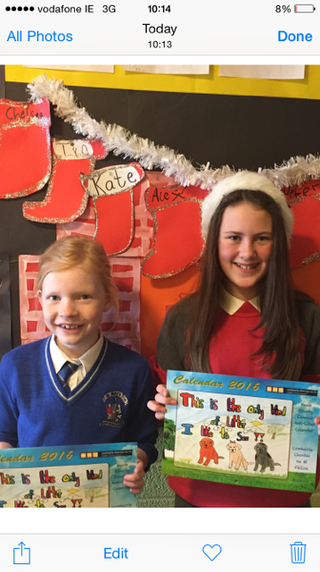

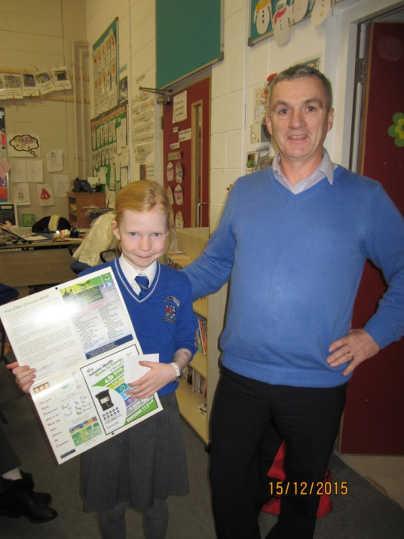

Two great Green Warriors! Highly commended for their pictures in the Meath County Council Anti-Litter Calendar Competition

Peter Brady and Orla O'Reilly highly commended for her picture submitted for the Meath County Council Anti Litter Calendar

**Remember Green is Cool at home and at school and all around the globe!**